UNITED STATES
SECURITIES AND EXCHANGE COMMISSION
Washington, D.C. 20549
FORM 8-K
CURRENT REPORT
Pursuant to Section 13 OR 15(d) of The Securities Exchange Act of 1934
Date of Report (date of earliest event reported): August 3, 2026
Commission file number 001-39482

GeneDx Holdings Corp.
(Exact name of registrant as specified in its charter)

Delaware |  |  | 85-1966622
(State or other jurisdiction of incorporation or organization) |  |  | (I.R.S. Employer Identification No.)
333 Ludlow Street, North Tower; 6th Floor
Stamford, Connecticut 06902
(Address of Principal Executive Offices) (Zip Code)
Registrant's telephone number, including area code: (888) 729-1206
Check the appropriate box below if the Form 8-K filing is intended to simultaneously satisfy the filing obligation of the registrant under any of the following provisions (see General Instruction A.2. below):
☐ Written communications pursuant to Rule 425 under the Securities Act (17 CFR 230.425)
☐ Soliciting material pursuant to Rule 14a-12 under the Exchange Act (17 CFR 240.14a-12)
☐ Pre-commencement communications pursuant to Rule 14d-2(b) under the Exchange Act (17 CFR 240.14d-2(b))
☐ Pre-commencement communications pursuant to Rule 13e-4(c) under the Exchange Act (17 CFR 240.13e-4(c))
Securities registered pursuant to Section 12(b) of the Act:
Title of each class |  |  |  |  |  | Trading Symbol |  |  |  |  |  | Name of each exchange on which registered
Class A common stock, par value $0.0001 per share |  |  |  |  |  | WGS |  |  |  |  |  | The Nasdaq Stock Market LLC
Indicate by check mark whether the registrant is an emerging growth company as defined in Rule 405 of the Securities Act of 1933 (§230.405 of this chapter) or Rule 12b-2 of the Securities Exchange Act of 1934 (§240.12b-2 of this chapter).
Emerging growth company ☐
If an emerging growth company, indicate by check mark if the registrant has elected not to use the extended transition period for complying with any new or revised financial accounting standards provided pursuant to Section 13(a) of the Exchange Act. ☐

Item 2.02 Results of Operations and Financial Condition.
On August 3, 2026, GeneDx Holdings Corp. (the “Company”) issued a press release (the “Press Release”) and will hold a conference call announcing the Company's financial results for the quarter ended June 30, 2026. Copies of the Press Release and Earnings Presentation are furnished as Exhibits 99.1 and 99.2, respectively, to this Current Report on Form 8-K.
The information furnished with this Item 2.02, including Exhibits 99.1 and 99.2 hereto, shall not be deemed “filed” for purposes of Section 18 of the Securities Exchange Act of 1934, as amended (the “Exchange Act”), or otherwise subject to the liabilities of that section, nor shall it be deemed incorporated by reference into any other filing under the Securities Act of 1933, as amended, or the Exchange Act, except as expressly set forth by specific reference in such a filing.

Item 9.01 Financial Statements and Exhibits.
(d) Exhibits
Exhibit No |  |  | Description
99.1 |  |  | Press Release, dated August 3, 2026, regarding the registrant’s results for the quarter ended June 30, 2026
99.2 |  |  | Earnings Presentation, dated August 3, 2026

SIGNATURES
Pursuant to the requirements of the Securities Exchange Act of 1934, the registrant has duly caused this report to be signed on its behalf by the undersigned hereunto duly authorized.
 |  |  |  |  |  | GENEDX HOLDINGS CORP.
Date: |  |  | August 3, 2026 |  |  | By: |  |  | /s/ Katherine Stueland
 |  |  |  |  |  | Name: |  |  | Katherine Stueland
 |  |  |  |  |  | Title: |  |  | Chief Executive Officer

Exhibit 99.1

GeneDx Reports Second Quarter 2026 Financial Results
•Reported second quarter 2026 revenue of $114.4 million, including $100.3 million in exome and genome revenue
•Reported exome and genome volume growth of 32% year-over-year
•Reported adjusted gross margin(1) of 70% and adjusted net income(1) of $0.4 million
•Reiterating full year 2026 revenue guidance of $475 to $490 million with exome and genome volume growth of at least 30%
•Hosting conference call today at 4:30 p.m. ET

GAITHERSBURG, Md., August 3, 2026 — GeneDx Holdings Corp. (Nasdaq: WGS), the leader in rare disease diagnosis and improving health through the power of genomic data, today reported its financial results for the second quarter of 2026.
“Our team’s unwavering focus and agility drove a strong second quarter. By delivering healthy revenue, volume, and gross margin growth, we successfully navigated our return to profitability” said Katherine Stueland, CEO of GeneDx. “We are managing the transition to genome testing, making progress on each of our key imperatives — optimizing unit economics, growing utilization, and delivering the best products at unmatched scale — while continuing to extend our industry-leading position in both exome and genome testing to reach as many patients and families as soon as possible.”

Second Quarter 2026 Financial Results (Unaudited)(1)
Revenue
•Revenue grew to $114.4 million, an increase of 11% year-over-year.
•Exome and genome test revenue grew to $100.3 million, an increase of 17% year-over-year.
Exome and genome volume
•Exome and genome test result volume grew to 30,785, an increase of 32% year-over-year.
Gross margin
•Adjusted gross margin of 70% in the second quarter of 2026 is up from 69% in the first quarter of 2026 and compares to 71% in the second quarter of 2025.
◦GAAP gross margin was 68%.
Operating expenses
•Adjusted total operating expenses were $80.3 million, representing 70% of revenue.
◦Total GAAP operating expenses were $95.7 million.
Net income
•Adjusted net income was $0.4 million, up $8.6 million from the first quarter of 2026 and compared to adjusted net income of $16.4 million in the second quarter of 2025.
◦GAAP net loss was $17.7 million.

Cash position
•Cash, cash equivalents, marketable securities and restricted cash was $133.5 million as of June 30, 2026.
•On August 3, 2026, the Company amended and restated its existing loan agreement with Blackstone, adding an additional $50.0 million term loan facility and increasing the aggregate principal amount available under the facility to $150.0 million. Concurrently, an affiliate of Blackstone agreed to purchase approximately $5.0 million of the Company’s Class A common stock at $61.00 per share in a private placement.
◦Combined with the cash, cash equivalents, marketable securities and restricted cash balance of $133.5 million as of June 30, 2026, the Company’s pro forma cash position following this transaction is approximately $188 million.
(1)Adjusted gross margin, adjusted total operating expenses and adjusted net income are non-GAAP financial measures. See appendix for a reconciliation of GAAP to non-GAAP figures presented.

GeneDx 2026 Guidance
GeneDx has reaffirmed its full year 2026 guidance and has provided guidance for the third quarter of 2026. Management expects GeneDx to deliver:
Metric |  |  |  |  |  | Full Year 2026 Guidance |  |  |  |  |  | Third Quarter 2026 Guidance
Revenue |  |  |  |  |  | $475 to $490 million |  |  |  |  |  | $122 to $124 million
Exome and genome volume |  |  |  |  |  | At least 30% growth |  |  |  |  |  | 33,200 tests
Exome and genome revenue |  |  |  |  |  | At least 20% growth |  |  |  |  |  | $110 to $112 million
Adjusted gross margin |  |  |  |  |  | Approximately 70% |  |  |  |  |  | Approximately 70%
Adjusted net income |  |  |  |  |  | Positive |  |  |  |  |  | Approximately $2 million

Second Quarter 2026 and Recent Business Highlights
Strategic Expansion and Market Leadership
•Appointed Mark Gardner as President to lead GeneDx’s commercial and operations teams through the next phase of growth, with a focus on strengthening execution, scaling efficiently, and expanding the company’s leadership in genomic medicine.
•Launched redesigned exome and genome reports to streamline the delivery of genomic insights to non-genetics clinicians as part of a broader suite of customer experience improvements rolling out this summer.
Expanded Coverage for Exome and Genome
•Improved access to exome sequencing in Texas with new Medicaid coverage effective May 1, 2026, building on existing genome sequencing coverage in the state.
•Received California Medicaid (Medi-Cal) pricing for genome sequencing effective July 1, 2026, with pricing published at 100% of the Medicare rate. Coverage for genome sequencing in California was originally announced as effective November 1, 2025.
•Secured outpatient genome sequencing coverage from Carelon, the nation’s largest lab benefit manager, opening access to up to 56 million covered lives. The policy is effective June 14, 2026.
•Expanded the total number of state Medicaid programs covering outpatient exome and/or genome sequencing to 39 following Mississippi Medicaid’s announcement of coverage for both tests effective July 1, 2026.
Innovation and Clinical Leadership
•Contributed to 26 peer-reviewed publications, 41 conference presentations, and 50 abstracts in the first half of 2026, reflecting the depth and breadth of the Company’s scientific expertise and its commitment to moving the field forward.

Webcast and Conference Call Details
GeneDx will host a conference call today, August 3, 2026, at 4:30 p.m. Eastern Time. Investors interested in listening to the conference call are required to register online. A live and archived webcast of the event will be available on the “Events” section of the GeneDx investor relations website at https://ir.genedx.com/.

Non-GAAP Financial Measures
GeneDx believes non-GAAP measures are useful in evaluating its operating performance. GeneDx uses this supplemental information to evaluate its ongoing operations and for internal planning and forecasting purposes. GeneDx believes that non-GAAP financial information, when taken collectively with its GAAP financial information, may be helpful to investors because it provides consistency and comparability with past financial performance. However, non-GAAP financial information is presented for supplemental informational purposes only, has limitations as an analytical tool, and should not be considered in isolation or as a substitute for financial information presented in accordance with GAAP. Reconciliations of non-GAAP financial measures to the most directly comparable financial results as determined in accordance with GAAP are included at the end of this press release following the accompanying financial data. We define non-GAAP financial measures as GAAP measures, excluding certain items such as stock-based compensation expense, depreciation and amortization, restructuring costs, changes in the fair value of financial liabilities, non-core lease costs, and other expenses that the Company believes are not indicative of its ongoing operations. A reconciliation of non-GAAP guidance measures to corresponding GAAP measures is not available on a forward-looking basis without unreasonable effort due to the uncertainty of expenses that may be incurred in the future. Investors are encouraged to review the related GAAP financial measures and the reconciliation of these non-GAAP financial measures to their most directly comparable GAAP financial measures and not rely on any single financial measure to evaluate our business.

Forward-Looking Statements
This press release contains “forward-looking statements” within the meaning of Section 21E of the Securities Exchange Act of 1934, as amended, and the U.S. Private Securities Litigation Reform Act of 1995, including statements regarding our future performance and our market opportunity, including our expectations for full year and third quarter 2026 revenue, exome and genome revenue and test volumes, adjusted gross margin and adjusted net income. These forward-looking statements generally are identified by the words “believe,” “project,” “expect,” “anticipate,” “estimate,” “intend,” “strategy,” “future,” “opportunity,” “plan,” “may,” “should,” “will,” “would,” “will be,” “will continue,” “will likely result,” and similar expressions. Forward-looking statements are predictions, projections and other statements about future events that are based on current expectations and assumptions and, as a result, are subject to risks and uncertainties. Many factors could cause actual future events to differ materially from the forward-looking statements in this press release, including but not limited to: (i) our ability to implement business plans, goals and forecasts, and identify and realize additional opportunities, (ii) the risk of downturns and a changing regulatory landscape in the highly competitive healthcare industry, (iii) the size and growth of the market in which we operate, and (iv) future expansion of insurance coverage for exome and genome testing. The foregoing list of factors is not exhaustive. You should carefully consider the foregoing factors and the other risks and uncertainties described in the “Risk Factors” section of our Annual Report on Form 10-K for the fiscal year ended December 31, 2025, filed with the U.S. Securities and Exchange Commission (the “SEC”) on February 23, 2026, our Quarterly Report on Form 10-Q for the fiscal quarter ended March 31, 2026, filed with the SEC on May 4, 2026, our Quarterly Report on Form 10-Q for the fiscal quarter ended June 30, 2026, filed with the SEC on August 3, 2026, and other documents filed by us from time to time with the SEC. These filings identify and address other important risks and uncertainties that could cause actual events and results to differ materially from those contained in the forward-looking statements. Forward-looking statements speak only as of the date they are made. Readers are cautioned not to put undue reliance on forward-looking statements, and we assume no obligation and do not intend to update or revise these forward-looking statements, whether as a result of new information, future events, or otherwise. We do not give any assurance that we will achieve our expectations.

About GeneDx
GeneDx’s (Nasdaq: WGS) mission is to empower everyone to live their healthiest life through genomics. GeneDx combines unmatched clinical expertise, advanced technology, and the power of GeneDx Infinity™ – the world’s largest rare disease genomic dataset. This unparalleled foundation powers GeneDx’s ExomeDx™ and GenomeDx™ tests – ranked #1 by expert geneticists and granted FDA Breakthrough Device designation – enabling clinicians to deliver precise, fast, and actionable diagnoses. GeneDx Infinity also fuels discovery for biopharma, with the most powerful AI-driven genomic intelligence. A genomics pioneer over the last 25 years, diagnosing more than 4,800 genetic diseases and publishing more than 1,100 research publications, GeneDx is building the network that will drive the future of genomic precision medicine. For more information, visit genedx.com and connect with us on LinkedIn, Facebook, and Instagram.

Investor Relations Contact:
Investors@GeneDx.com
Media Contact:
Press@GeneDx.com

Volume & Revenue
 |  |  | 2Q26 |  |  |  |  |  | 1Q26 |  |  |  |  |  | 4Q25 |  |  |  |  |  | 3Q25 |  |  |  |  |  | 2Q25
Volumes
Whole exome, whole genome |  |  | 30,785 |  |  |  |  |  | 27,488 |  |  |  |  |  | 27,761 |  |  |  |  |  | 25,702 |  |  |  |  |  | 23,246
Other panels |  |  | 32,057 |  |  |  |  |  | 27,729 |  |  |  |  |  | 31,281 |  |  |  |  |  | 34,514 |  |  |  |  |  | 34,510
Total |  |  | 62,842 |  |  |  |  |  | 55,217 |  |  |  |  |  | 59,042 |  |  |  |  |  | 60,216 |  |  |  |  |  | 57,756
Revenue ($ millions)
Whole exome, whole genome |  |  | $ | 100.3 |  |  |  |  | $ | 90.6 |  |  |  |  | $ | 104.0 |  |  |  |  | $ | 98.9 |  |  |  |  | $ | 86.0
Other panels |  |  | 11.6 |  |  |  |  |  | 10.7 |  |  |  |  |  | 13.3 |  |  |  |  |  | 14.6 |  |  |  |  |  | 14.1
Data information |  |  | 2.3 |  |  |  |  |  | 0.8 |  |  |  |  |  | 2.6 |  |  |  |  |  | 1.5 |  |  |  |  |  | 2.0
Software and interpretation services |  |  | 0.2 |  |  |  |  |  | 0.2 |  |  |  |  |  | 1.1 |  |  |  |  |  | 1.7 |  |  |  |  |  | 0.6
Total |  |  | $ | 114.4 |  |  |  |  | $ | 102.3 |  |  |  |  | $ | 121.0 |  |  |  |  | $ | 116.7 |  |  |  |  | $ | 102.7

Unaudited Select Financial Information
 |  |  | Three months ended June 30, 2026
 |  |  | Reported |  |  |  |  |  | Depreciation and amortization |  |  |  |  |  | Stock-based compensation |  |  |  |  |  | Restructuring costs |  |  |  |  |  | Change in FV of financial liabilities |  |  |  |  |  |  |  | Other(2) |  |  |  |  |  | Adjusted
Diagnostic test revenue |  |  | $ | 111,886 |  |  |  |  | $ | — |  |  |  |  | $ | — |  |  |  |  | $ | — |  |  |  |  | $ | — |  |  |  |  |  |  | $ | — |  |  |  |  | $ | 111,886
Other revenue |  |  | 2,554 |  |  |  |  |  | — |  |  |  |  |  | — |  |  |  |  |  | — |  |  |  |  |  | — |  |  |  |  |  |  |  | — |  |  |  |  |  | 2,554
Total revenue |  |  | 114,440 |  |  |  |  |  | — |  |  |  |  |  | — |  |  |  |  |  | — |  |  |  |  |  | — |  |  |  |  |  |  |  | — |  |  |  |  |  | 114,440
Cost of services |  |  | 36,202 |  |  |  |  |  | (1,726) |  |  |  |  |  | (561) |  |  |  |  |  | (47) |  |  |  |  |  | — |  |  |  |  |  |  |  | — |  |  |  |  |  | 33,868
Gross profit |  |  | 78,238 |  |  |  |  |  | 1,726 |  |  |  |  |  | 561 |  |  |  |  |  | 47 |  |  |  |  |  | — |  |  |  |  |  |  |  | — |  |  |  |  |  | 80,572
Gross margin |  |  | 68.4 |  | % |  |  |  |  |  |  |  |  |  |  |  |  |  |  |  |  |  |  |  |  |  |  |  |  |  |  |  |  |  |  |  |  |  |  |  | 70.4 |  | %
Research and development |  |  | 19,656 |  |  |  |  |  | (271) |  |  |  |  |  | (1,387) |  |  |  |  |  | (1,036) |  |  |  |  |  | — |  |  |  |  |  |  |  | — |  |  |  |  |  | 16,962
Selling, general and administrative |  |  | 76,037 |  |  |  |  |  | (4,717) |  |  |  |  |  | (4,394) |  |  |  |  |  | (2,212) |  |  |  |  |  | — |  |  |  |  |  |  |  | (1,353) |  |  |  |  |  | 63,361
(Loss) income from operations |  |  | (17,455) |  |  |  |  |  | 6,714 |  |  |  |  |  | 6,342 |  |  |  |  |  | 3,295 |  |  |  |  |  | — |  |  |  |  |  |  |  | 1,353 |  |  |  |  |  | 249
Interest expense, net |  |  | (1,185) |  |  |  |  |  | — |  |  |  |  |  | — |  |  |  |  |  | — |  |  |  |  |  | — |  |  |  |  |  |  |  | 1,185 |  |  |  |  |  | —
Other income (expense), net |  |  | 382 |  |  |  |  |  | — |  |  |  |  |  | — |  |  |  |  |  | — |  |  |  |  |  | (220) |  |  |  |  |  |  |  | — |  |  |  |  |  | 162
Income tax benefit |  |  | 518 |  |  |  |  |  | — |  |  |  |  |  | — |  |  |  |  |  | — |  |  |  |  |  | — |  |  |  |  |  |  |  | (518) |  |  |  |  |  | —
Net (loss) income |  |  | $ | (17,740) |  |  |  |  | $ | 6,714 |  |  |  |  | $ | 6,342 |  |  |  |  | $ | 3,295 |  |  |  |  | $ | (220) |  |  |  |  |  |  | $ | 2,020 |  |  |  |  | $ | 411
Basic (loss) earnings per share(1) |  |  | $ | (0.60) |  |  |  |  |  |  |  |  |  |  |  |  |  |  |  |  |  |  |  |  |  |  |  |  |  |  |  |  |  |  |  |  |  |  |  |  | $ | 0.01
Diluted (loss) earnings per share(1) |  |  | $ | (0.60) |  |  |  |  |  |  |  |  |  |  |  |  |  |  |  |  |  |  |  |  |  |  |  |  |  |  |  |  |  |  |  |  |  |  |  |  | $ | 0.01
 |  |  | Three months ended June 30, 2025
 |  |  | Reported |  |  |  |  |  | Depreciation and amortization |  |  |  |  |  | Stock-based compensation |  |  |  |  |  | Restructuring costs |  |  |  |  |  | Change in FV of financial liabilities |  |  |  |  |  |  |  | Other(2) |  |  |  |  |  | Adjusted
Diagnostic test revenue |  |  | $ | 100,100 |  |  |  |  | $ | — |  |  |  |  | $ | — |  |  |  |  | $ | — |  |  |  |  | $ | — |  |  |  |  |  |  | $ | — |  |  |  |  | $ | 100,100
Other revenue |  |  | 2,592 |  |  |  |  |  | — |  |  |  |  |  | — |  |  |  |  |  | — |  |  |  |  |  | — |  |  |  |  |  |  |  | — |  |  |  |  |  | 2,592
Total revenue |  |  | 102,692 |  |  |  |  |  | — |  |  |  |  |  | — |  |  |  |  |  | — |  |  |  |  |  | — |  |  |  |  |  |  |  | — |  |  |  |  |  | 102,692
Cost of services |  |  | 31,790 |  |  |  |  |  | (1,389) |  |  |  |  |  | (193) |  |  |  |  |  | — |  |  |  |  |  | — |  |  |  |  |  |  |  | — |  |  |  |  |  | 30,208
Gross profit |  |  | 70,902 |  |  |  |  |  | 1,389 |  |  |  |  |  | 193 |  |  |  |  |  | — |  |  |  |  |  | — |  |  |  |  |  |  |  | — |  |  |  |  |  | 72,484
Gross margin |  |  | 69.0 |  | % |  |  |  |  |  |  |  |  |  |  |  |  |  |  |  |  |  |  |  |  |  |  |  |  |  |  |  |  |  |  |  |  |  |  |  | 70.6 |  | %
Research and development |  |  | 15,079 |  |  |  |  |  | (209) |  |  |  |  |  | (1,422) |  |  |  |  |  | — |  |  |  |  |  | — |  |  |  |  |  |  |  | — |  |  |  |  |  | 13,448
Selling, general and administrative |  |  | 46,863 |  |  |  |  |  | (4,593) |  |  |  |  |  | (6,198) |  |  |  |  |  | (73) |  |  |  |  |  | — |  |  |  |  |  |  |  | 6,937 |  |  |  |  |  | 42,936
Income from operations |  |  | 8,960 |  |  |  |  |  | 6,191 |  |  |  |  |  | 7,813 |  |  |  |  |  | 73 |  |  |  |  |  | — |  |  |  |  |  |  |  | (6,937) |  |  |  |  |  | 16,100
Interest expense, net |  |  | (817) |  |  |  |  |  | — |  |  |  |  |  | — |  |  |  |  |  | — |  |  |  |  |  | — |  |  |  |  |  |  |  | 817 |  |  |  |  |  | —
Other income (expense), net |  |  | 2,420 |  |  |  |  |  | — |  |  |  |  |  | — |  |  |  |  |  | — |  |  |  |  |  | (2,181) |  |  |  |  |  |  |  | 49 |  |  |  |  |  | 288
Income tax benefit |  |  | 246 |  |  |  |  |  | — |  |  |  |  |  | — |  |  |  |  |  | — |  |  |  |  |  | — |  |  |  |  |  |  |  | (246) |  |  |  |  |  | —
Net income |  |  | $ | 10,809 |  |  |  |  | $ | 6,191 |  |  |  |  | $ | 7,813 |  |  |  |  | $ | 73 |  |  |  |  | $ | (2,181) |  |  |  |  |  |  | $ | (6,317) |  |  |  |  | $ | 16,388
Basic earnings per share(1) |  |  | $ | 0.38 |  |  |  |  |  |  |  |  |  |  |  |  |  |  |  |  |  |  |  |  |  |  |  |  |  |  |  |  |  |  |  |  |  |  |  |  | $ | 0.57
Diluted earnings per share(1) |  |  | $ | 0.36 |  |  |  |  |  |  |  |  |  |  |  |  |  |  |  |  |  |  |  |  |  |  |  |  |  |  |  |  |  |  |  |  |  |  |  |  | $ | 0.55
(1)Basic and diluted reported loss per share and Basic adjusted earnings per share are calculated based on 29,710,139 weighted average shares outstanding and Diluted adjusted earnings per share are calculated based on 30,144,132 weighted average shares outstanding for the three months ended June 30, 2026. Basic and diluted earnings per share are calculated based on 28,579,704 and 29,753,933 weighted average shares outstanding for the three months ended June 30, 2025, respectively.
(2)Other represents interest expense, net, income tax benefit and non-core lease costs for all periods presented. For the three months ended June 30, 2026, Other also includes costs related to legal reserves. For the three months ended June 30, 2025, Other includes transaction costs incurred in connection with the acquisition of Fabric Genomics and a sales-and-use tax refund.

Unaudited Select Financial Information
 |  |  | Three months ended March 31, 2026
 |  |  | Reported |  |  |  |  |  | Depreciation and amortization |  |  |  |  |  | Stock-based compensation |  |  |  |  |  | Restructuring costs |  |  |  |  |  | Change in FV of financial liabilities |  |  |  |  |  | Extinguishment  of debt |  |  |  |  |  | Other(2) |  |  |  |  |  | Adjusted
Diagnostic test revenue |  |  | $ | 101,299 |  |  |  |  | $ | — |  |  |  |  | $ | — |  |  |  |  | $ | — |  |  |  |  | $ | — |  |  |  |  | $ | — |  |  |  |  | $ | — |  |  |  |  | $ | 101,299
Other revenue |  |  | 955 |  |  |  |  |  | — |  |  |  |  |  | — |  |  |  |  |  | — |  |  |  |  |  | — |  |  |  |  |  | — |  |  |  |  |  | — |  |  |  |  |  | 955
Total revenue |  |  | 102,254 |  |  |  |  |  | — |  |  |  |  |  | — |  |  |  |  |  | — |  |  |  |  |  | — |  |  |  |  |  | — |  |  |  |  |  | — |  |  |  |  |  | 102,254
Cost of services |  |  | 34,043 |  |  |  |  |  | (1,462) |  |  |  |  |  | (380) |  |  |  |  |  | — |  |  |  |  |  | — |  |  |  |  |  | — |  |  |  |  |  | — |  |  |  |  |  | 32,201
Gross profit |  |  | 68,211 |  |  |  |  |  | 1,462 |  |  |  |  |  | 380 |  |  |  |  |  | — |  |  |  |  |  | — |  |  |  |  |  | — |  |  |  |  |  | — |  |  |  |  |  | 70,053
Gross margin |  |  | 66.7 |  | % |  |  |  |  |  |  |  |  |  |  |  |  |  |  |  |  |  |  |  |  |  |  |  |  |  |  |  |  |  |  |  |  |  |  |  |  |  |  |  | 68.5 |  | %
Research and development |  |  | 19,804 |  |  |  |  |  | (224) |  |  |  |  |  | (1,406) |  |  |  |  |  | (224) |  |  |  |  |  | — |  |  |  |  |  | — |  |  |  |  |  | — |  |  |  |  |  | 17,950
Selling, general and administrative |  |  | 74,591 |  |  |  |  |  | (5,123) |  |  |  |  |  | (7,210) |  |  |  |  |  | (215) |  |  |  |  |  | — |  |  |  |  |  | — |  |  |  |  |  | (1,916) |  |  |  |  |  | 60,127
Impairment loss |  |  | 31,287 |  |  |  |  |  | — |  |  |  |  |  | — |  |  |  |  |  | — |  |  |  |  |  | — |  |  |  |  |  | — |  |  |  |  |  | (31,287) |  |  |  |  |  | —
Loss from operations |  |  | (57,471) |  |  |  |  |  | 6,809 |  |  |  |  |  | 8,996 |  |  |  |  |  | 439 |  |  |  |  |  | — |  |  |  |  |  | — |  |  |  |  |  | 33,203 |  |  |  |  |  | (8,024)
Interest expense, net |  |  | (717) |  |  |  |  |  | — |  |  |  |  |  | — |  |  |  |  |  | — |  |  |  |  |  | — |  |  |  |  |  | — |  |  |  |  |  | 717 |  |  |  |  |  | —
Other (expense) income, net |  |  | (4,231) |  |  |  |  |  | — |  |  |  |  |  | — |  |  |  |  |  | — |  |  |  |  |  | (2,540) |  |  |  |  |  | 6,565 |  |  |  |  |  | — |  |  |  |  |  | (206)
Income tax expense |  |  | (897) |  |  |  |  |  | — |  |  |  |  |  | — |  |  |  |  |  | — |  |  |  |  |  | — |  |  |  |  |  | — |  |  |  |  |  | 897 |  |  |  |  |  | —
Net loss |  |  | $ | (63,316) |  |  |  |  | $ | 6,809 |  |  |  |  | $ | 8,996 |  |  |  |  | $ | 439 |  |  |  |  | $ | (2,540) |  |  |  |  | $ | 6,565 |  |  |  |  | $ | 34,817 |  |  |  |  | $ | (8,230)
Basic and diluted loss per share(1) |  |  | $ | (2.16) |  |  |  |  |  |  |  |  |  |  |  |  |  |  |  |  |  |  |  |  |  |  |  |  |  |  |  |  |  |  |  |  |  |  |  |  |  |  |  |  | $ | (0.28)
(1)Basic and diluted loss per share are calculated based on 29,335,126 weighted average shares outstanding for the three months ended March 31, 2026.
(2)For the three months ended March 31, 2026, Other represents interest expense, net, income tax expense and non-core lease costs, costs related to legal reserves, and impairment of goodwill and intangible assets associated with the Fabric Genomics acquisition.

GeneDx Holdings Corp.
Condensed Consolidated Balance Sheets
(in thousands, except share and per share amounts)
 |  |  | June 30, 2026 (Unaudited) |  |  |  |  |  | December 31, 2025
Assets:
Current assets:
Cash and cash equivalents |  |  | $ | 60,317 |  |  |  |  | $ | 104,997
Marketable securities |  |  | 72,231 |  |  |  |  |  | 66,285
Accounts receivable |  |  | 83,610 |  |  |  |  |  | 74,370
Inventory, net |  |  | 17,820 |  |  |  |  |  | 13,951
Prepaid expenses and other current assets |  |  | 12,382 |  |  |  |  |  | 8,685
Total current assets |  |  | 246,360 |  |  |  |  |  | 268,288
Operating lease right-of-use assets |  |  | 33,535 |  |  |  |  |  | 23,412
Property and equipment, net |  |  | 54,316 |  |  |  |  |  | 45,693
Goodwill |  |  | 1,641 |  |  |  |  |  | 13,520
Intangible assets, net |  |  | 141,350 |  |  |  |  |  | 168,481
Other assets(1) |  |  | 4,284 |  |  |  |  |  | 4,316
Total assets |  |  | $ | 481,486 |  |  |  |  | $ | 523,710
Liabilities and Stockholders’ Equity:
Current liabilities:
Accounts payable and accrued expenses |  |  | $ | 42,091 |  |  |  |  | $ | 57,645
Short-term lease liabilities |  |  | 5,709 |  |  |  |  |  | 4,404
Other current liabilities |  |  | 26,828 |  |  |  |  |  | 46,859
Total current liabilities |  |  | 74,628 |  |  |  |  |  | 108,908
Long-term debt, net of current portion |  |  | 96,836 |  |  |  |  |  | 48,176
Long-term lease liabilities |  |  | 64,857 |  |  |  |  |  | 56,046
Other liabilities |  |  | 71 |  |  |  |  |  | 1,641
Deferred taxes |  |  | 873 |  |  |  |  |  | 757
Total liabilities |  |  | 237,265 |  |  |  |  |  | 215,528
Stockholders’ Equity:
Preferred stock |  |  | — |  |  |  |  |  | —
Class A common stock |  |  | 3 |  |  |  |  |  | 3
Additional paid-in capital |  |  | 1,698,427 |  |  |  |  |  | 1,680,738
Accumulated deficit |  |  | (1,454,551) |  |  |  |  |  | (1,373,495)
Accumulated other comprehensive income |  |  | 342 |  |  |  |  |  | 936
Total stockholders’ equity |  |  | 244,221 |  |  |  |  |  | 308,182
Total liabilities and stockholders’ equity |  |  | $ | 481,486 |  |  |  |  | $ | 523,710
(1)Other assets includes $1.0 million of restricted cash as of both June 30, 2026 and December 31, 2025.

GeneDx Holdings Corp.
Condensed Consolidated Statements of Operations (Unaudited)
(in thousands, except share and per share amounts)
 |  |  | Three months ended June 30, |  |  |  |  |  |  |  |  |  |  |  | Six months ended June 30,
 |  |  | 2026 |  |  |  |  |  | 2025 |  |  |  |  |  | 2026 |  |  |  |  |  | 2025
Revenue
Diagnostic test revenue |  |  | $ | 111,886 |  |  |  |  | $ | 100,100 |  |  |  |  | $ | 213,185 |  |  |  |  | $ | 185,859
Other revenue |  |  | 2,554 |  |  |  |  |  | 2,592 |  |  |  |  |  | 3,509 |  |  |  |  |  | 3,948
Total revenue |  |  | 114,440 |  |  |  |  |  | 102,692 |  |  |  |  |  | 216,694 |  |  |  |  |  | 189,807
Cost of services |  |  | 36,202 |  |  |  |  |  | 31,790 |  |  |  |  |  | 70,245 |  |  |  |  |  | 60,429
Gross profit |  |  | 78,238 |  |  |  |  |  | 70,902 |  |  |  |  |  | 146,449 |  |  |  |  |  | 129,378
Research and development |  |  | 19,656 |  |  |  |  |  | 15,079 |  |  |  |  |  | 39,460 |  |  |  |  |  | 27,656
Selling, general and administrative |  |  | 76,037 |  |  |  |  |  | 46,863 |  |  |  |  |  | 150,628 |  |  |  |  |  | 97,313
Impairment loss |  |  | — |  |  |  |  |  | — |  |  |  |  |  | 31,287 |  |  |  |  |  | —
(Loss) income from operations |  |  | (17,455) |  |  |  |  |  | 8,960 |  |  |  |  |  | (74,926) |  |  |  |  |  | 4,409
Non-operating (expense) income, net
Change in fair value of financial liabilities |  |  | 220 |  |  |  |  |  | 2,181 |  |  |  |  |  | 2,760 |  |  |  |  |  | 1,081
Interest expense, net |  |  | (1,185) |  |  |  |  |  | (817) |  |  |  |  |  | (1,902) |  |  |  |  |  | (1,457)
Loss on extinguishment of debt |  |  | — |  |  |  |  |  | — |  |  |  |  |  | (6,565) |  |  |  |  |  | —
Other income (expense), net |  |  | 162 |  |  |  |  |  | 239 |  |  |  |  |  | (44) |  |  |  |  |  | 448
Total non-operating (expense) income, net |  |  | (803) |  |  |  |  |  | 1,603 |  |  |  |  |  | (5,751) |  |  |  |  |  | 72
(Loss) income before income taxes |  |  | (18,258) |  |  |  |  |  | 10,563 |  |  |  |  |  | (80,677) |  |  |  |  |  | 4,481
Income tax benefit (expense) |  |  | 518 |  |  |  |  |  | 246 |  |  |  |  |  | (379) |  |  |  |  |  | (201)
Net (loss) income |  |  | $ | (17,740) |  |  |  |  | $ | 10,809 |  |  |  |  | $ | (81,056) |  |  |  |  | $ | 4,280
Weighted-average shares outstanding of Class A common stock - Basic |  |  | 29,710,139 |  |  |  |  |  | 28,579,704 |  |  |  |  |  | 29,523,669 |  |  |  |  |  | 28,365,018
Basic (loss) earnings per share, Class A common stock |  |  | $ | (0.60) |  |  |  |  | $ | 0.38 |  |  |  |  | $ | (2.75) |  |  |  |  | $ | 0.15
Weighted-average shares outstanding of Class A common stock - Diluted |  |  | 29,710,139 |  |  |  |  |  | 29,753,933 |  |  |  |  |  | 29,523,669 |  |  |  |  |  | 29,642,555
Diluted (loss) earnings per share, Class A common stock |  |  | $ | (0.60) |  |  |  |  | $ | 0.36 |  |  |  |  | $ | (2.75) |  |  |  |  | $ | 0.14

GeneDx Holdings Corp.
Condensed Consolidated Statements of Cash Flows (Unaudited)
(in thousands)
 |  |  | Six months ended June 30,
 |  |  | 2026 |  |  |  |  |  | 2025
Operating activities
Net (loss) income |  |  | $ | (81,056) |  |  |  |  | $ | 4,280
Adjustments to reconcile net loss to net cash (used in) provided by operating activities:
Depreciation and amortization expense |  |  | 13,523 |  |  |  |  |  | 11,869
Stock-based compensation expense |  |  | 15,338 |  |  |  |  |  | 11,796
Change in fair value of financial liabilities |  |  | (2,760) |  |  |  |  |  | (1,081)
Deferred tax expense |  |  | 379 |  |  |  |  |  | 202
Change in third party payor reserves |  |  | (1,022) |  |  |  |  |  | 5,014
Loss on extinguishment of debt |  |  | 6,565 |  |  |  |  |  | —
Impairment loss |  |  | 31,287 |  |  |  |  |  | —
Other |  |  | 2,157 |  |  |  |  |  | 1,510
Change in operating assets and liabilities:
Accounts receivable |  |  | (9,240) |  |  |  |  |  | (9,889)
Inventory |  |  | (3,973) |  |  |  |  |  | (1,404)
Accounts payable and accrued expenses |  |  | (12,566) |  |  |  |  |  | 7,199
Other assets and liabilities |  |  | (20,021) |  |  |  |  |  | (8,894)
Net cash (used in) provided by operating activities |  |  | (61,389) |  |  |  |  |  | 20,602
Investing activities
Acquisition of business, net of cash acquired |  |  | — |  |  |  |  |  | (33,195)
Purchases of marketable securities |  |  | (29,065) |  |  |  |  |  | (30,770)
Proceeds from sales of marketable securities |  |  | 2,272 |  |  |  |  |  | —
Proceeds from maturities of marketable securities |  |  | 20,475 |  |  |  |  |  | 26,705
Purchases of property and equipment and development of internal-use software |  |  | (16,567) |  |  |  |  |  | (8,498)
Net cash used in investing activities |  |  | (22,885) |  |  |  |  |  | (45,758)
Financing activities
Proceeds from long term debt, net of issuance costs |  |  | 96,699 |  |  |  |  |  | —
Proceeds from offerings, net of issuance costs |  |  | — |  |  |  |  |  | 13,766
Proceeds from issuance of common stock from subscription agreements |  |  | 476 |  |  |  |  |  | —
Proceeds from issuance of common stock pursuant to employee stock purchase plan |  |  | 1,793 |  |  |  |  |  | 1,262
Exercise of stock options |  |  | 58 |  |  |  |  |  | 800
Repayment of long-term debt, including prepayment penalty - Perceptive |  |  | (54,000) |  |  |  |  |  | —
Repayment and principal payments for long-term debt - DECD |  |  | (4,447) |  |  |  |  |  | (602)
Finance lease principal payments |  |  | (984) |  |  |  |  |  | (1,162)
Net cash provided by financing activities |  |  | 39,595 |  |  |  |  |  | 14,064
Net decrease in cash, cash equivalents and restricted cash |  |  | (44,679) |  |  |  |  |  | (11,092)
Cash, cash equivalents and restricted cash, at beginning of period |  |  | 105,989 |  |  |  |  |  | 86,202
Cash, cash equivalents and restricted cash, at end of period (1) |  |  | $ | 61,310 |  |  |  |  | $ | 75,110
Supplemental disclosures of cash flow information
Cash paid for interest |  |  | $ | 3,813 |  |  |  |  | $ | 3,210
Cash paid for taxes |  |  | $ | 2,221 |  |  |  |  | $ | 920
Lease liability from obtaining right-of-use asset |  |  | $ | 12,086 |  |  |  |  | $ | —
Purchases of property and equipment in accounts payable and accrued expenses |  |  | $ | 3,154 |  |  |  |  | $ | 5,752
(1)Cash, cash equivalents and restricted cash as of June 30, 2026 excludes marketable securities of $72.2 million.
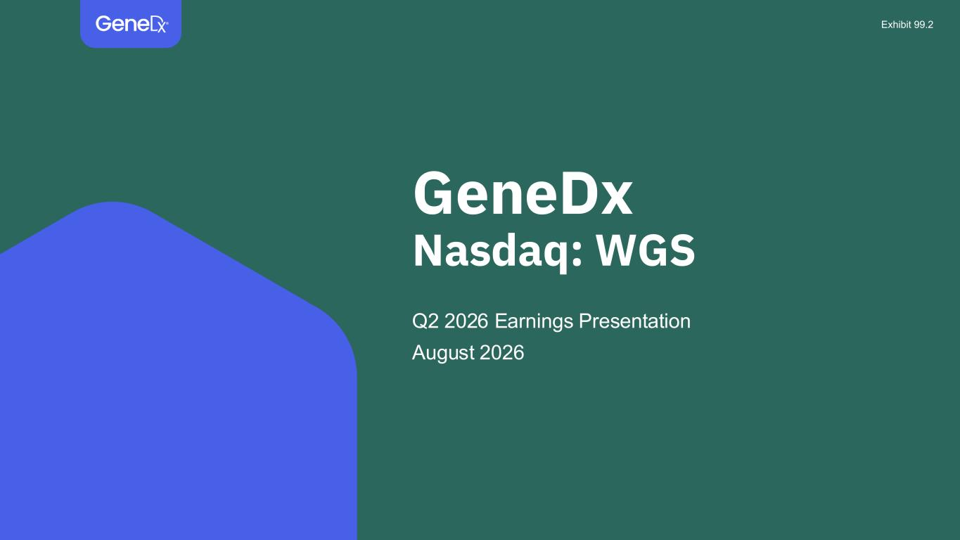

GeneDx Nasdaq: WGS Q2 2026 Earnings Presentation August 2026 Exhibit 99.2

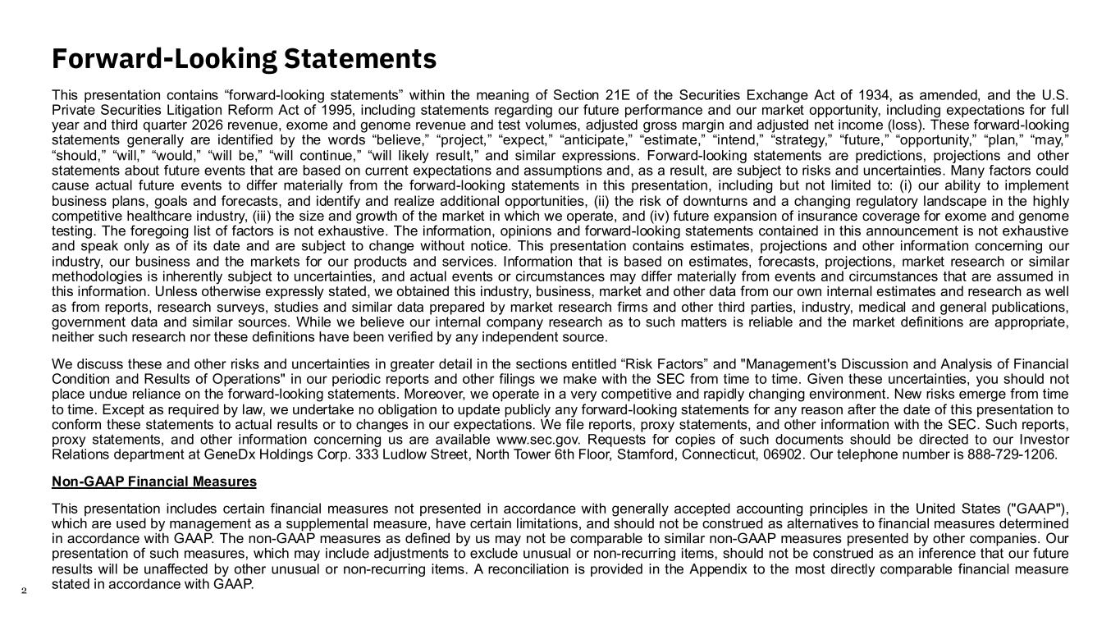
2 Forward-Looking Statements This presentation contains “forward-looking statements” within the meaning of Section 21E of the Securities Exchange Act of 1934, as amended, and the U.S. Private Securities Litigation Reform Act of 1995, including statements regarding our future performance and our market opportunity, including expectations for full year and third quarter 2026 revenue, exome and genome revenue and test volumes, adjusted gross margin and adjusted net income (loss). These forward-looking statements generally are identified by the words “believe,” “project,” “expect,” “anticipate,” “estimate,” “intend,” “strategy,” “future,” “opportunity,” “plan,” “may,” “should,” “will,” “would,” “will be,” “will continue,” “will likely result,” and similar expressions. Forward-looking statements are predictions, projections and other statements about future events that are based on current expectations and assumptions and, as a result, are subject to risks and uncertainties. Many factors could cause actual future events to differ materially from the forward-looking statements in this presentation, including but not limited to: (i) our ability to implement business plans, goals and forecasts, and identify and realize additional opportunities, (ii) the risk of downturns and a changing regulatory landscape in the highly competitive healthcare industry, (iii) the size and growth of the market in which we operate, and (iv) future expansion of insurance coverage for exome and genome testing. The foregoing list of factors is not exhaustive. The information, opinions and forward-looking statements contained in this announcement is not exhaustive and speak only as of its date and are subject to change without notice. This presentation contains estimates, projections and other information concerning our industry, our business and the markets for our products and services. Information that is based on estimates, forecasts, projections, market research or similar methodologies is inherently subject to uncertainties, and actual events or circumstances may differ materially from events and circumstances that are assumed in this information. Unless otherwise expressly stated, we obtained this industry, business, market and other data from our own internal estimates and research as well as from reports, research surveys, studies and similar data prepared by market research firms and other third parties, industry, medical and general publications, government data and similar sources. While we believe our internal company research as to such matters is reliable and the market definitions are appropriate, neither such research nor these definitions have been verified by any independent source. We discuss these and other risks and uncertainties in greater detail in the sections entitled “Risk Factors” and "Management's Discussion and Analysis of Financial Condition and Results of Operations" in our periodic reports and other filings we make with the SEC from time to time. Given these uncertainties, you should not place undue reliance on the forward-looking statements. Moreover, we operate in a very competitive and rapidly changing environment. New risks emerge from time to time. Except as required by law, we undertake no obligation to update publicly any forward-looking statements for any reason after the date of this presentation to conform these statements to actual results or to changes in our expectations. We file reports, proxy statements, and other information with the SEC. Such reports, proxy statements, and other information concerning us are available www.sec.gov. Requests for copies of such documents should be directed to our Investor Relations department at GeneDx Holdings Corp. 333 Ludlow Street, North Tower 6th Floor, Stamford, Connecticut, 06902. Our telephone number is 888-729-1206. Non-GAAP Financial Measures This presentation includes certain financial measures not presented in accordance with generally accepted accounting principles in the United States ("GAAP"), which are used by management as a supplemental measure, have certain limitations, and should not be construed as alternatives to financial measures determined in accordance with GAAP. The non-GAAP measures as defined by us may not be comparable to similar non-GAAP measures presented by other companies. Our presentation of such measures, which may include adjustments to exclude unusual or non-recurring items, should not be construed as an inference that our future results will be unaffected by other unusual or non-recurring items. A reconciliation is provided in the Appendix to the most directly comparable financial measure stated in accordance with GAAP.

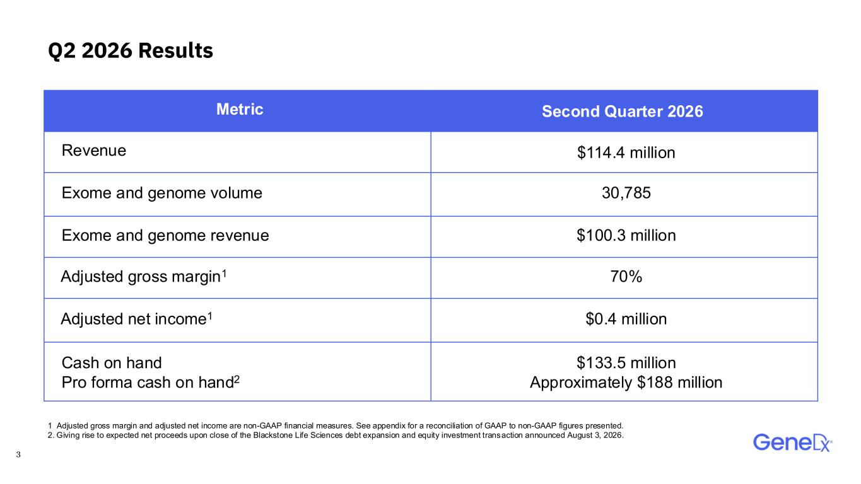
3 Q2 2026 Results Metric Second Quarter 2026 Revenue $114.4 million Exome and genome volume 30,785 Exome and genome revenue $100.3 million Adjusted gross margin1 70% Adjusted net income1 $0.4 million Cash on hand Pro forma cash on hand2 $133.5 million Approximately $188 million 1 Adjusted gross margin and adjusted net income are non-GAAP financial measures. See appendix for a reconciliation of GAAP to non-GAAP figures presented. 2. Giving rise to expected net proceeds upon close of the Blackstone Life Sciences debt expansion and equity investment transaction announced August 3, 2026.

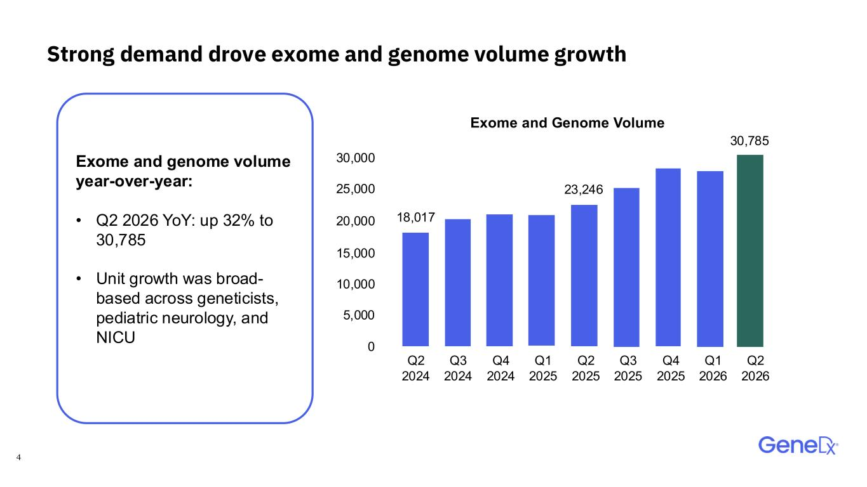
4 Strong demand drove exome and genome volume growth Exome and genome volume year-over-year: • Q2 2026 YoY: up 32% to 30,785 • Unit growth was broad- based across geneticists, pediatric neurology, and NICU 30,785 Q1 2025 Exome and Genome Volume Q2 2025 Q3 2025 Q4 2025 Q1 2026 0 5,000 10,000 15,000 20,000 25,000 30,000 Q2 2024 Q3 2024 Q4 2024 18,017 Q2 2026 23,246

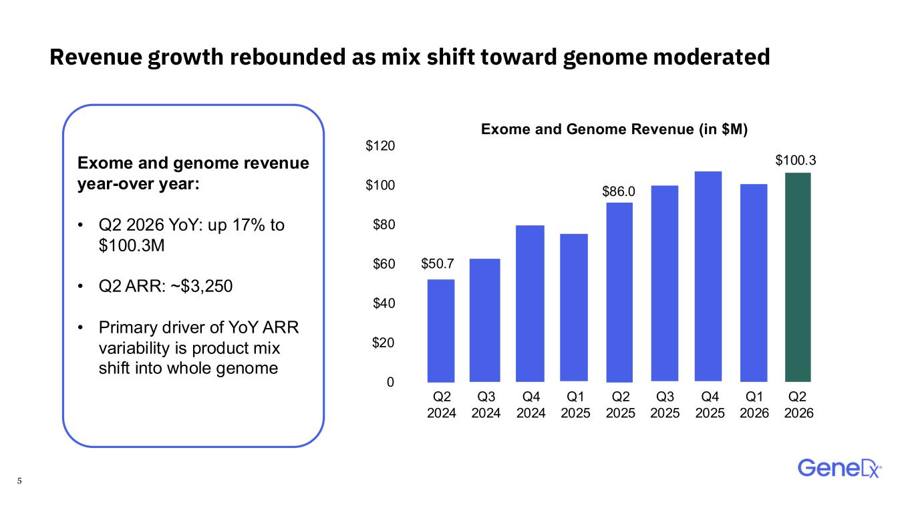
5 Revenue growth rebounded as mix shift toward genome moderated $100.3 Q1 2025 Exome and Genome Revenue (in $M) Q2 2025 Q3 2025 Q4 2025 Q1 2026 0 $20 $86.0 Q2 2024 Q3 2024 Q4 2024 $50.7 Exome and genome revenue year-over year: • Q2 2026 YoY: up 17% to $100.3M • Q2 ARR: ~$3,250 • Primary driver of YoY ARR variability is product mix shift into whole genome $40 $60 $80 $100 $120 Q2 2026

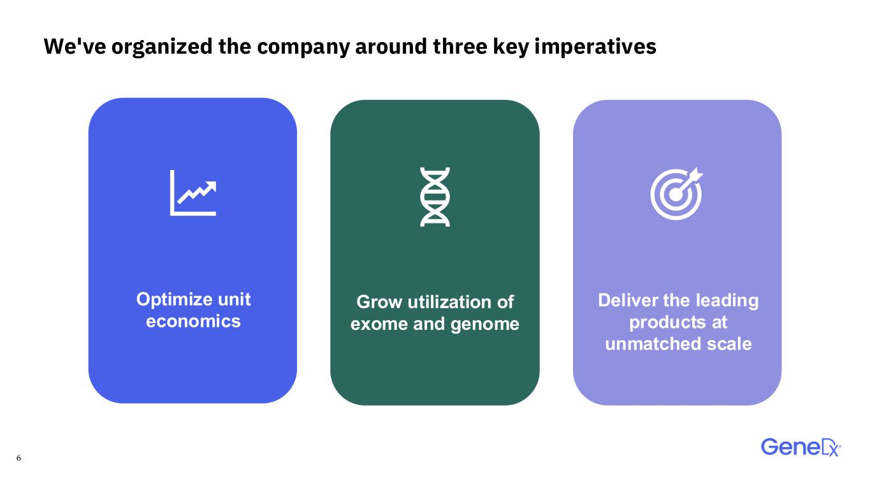
6 We've organized the company around three key imperatives Optimize unit economics Deliver the leading products at unmatched scale Grow utilization of exome and genome

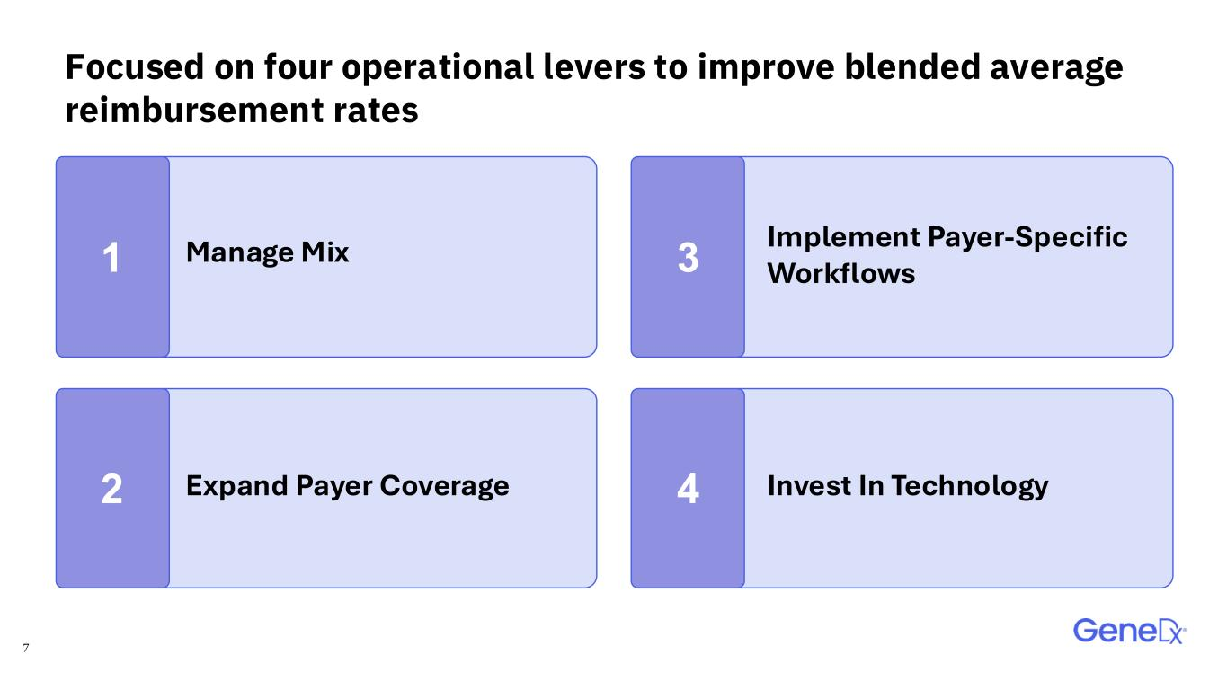
7 Focused on four operational levers to improve blended average reimbursement rates Manage Mix Expand Payer Coverage Invest In Technology Implement Payer-Specific Workflows1 3 2 4

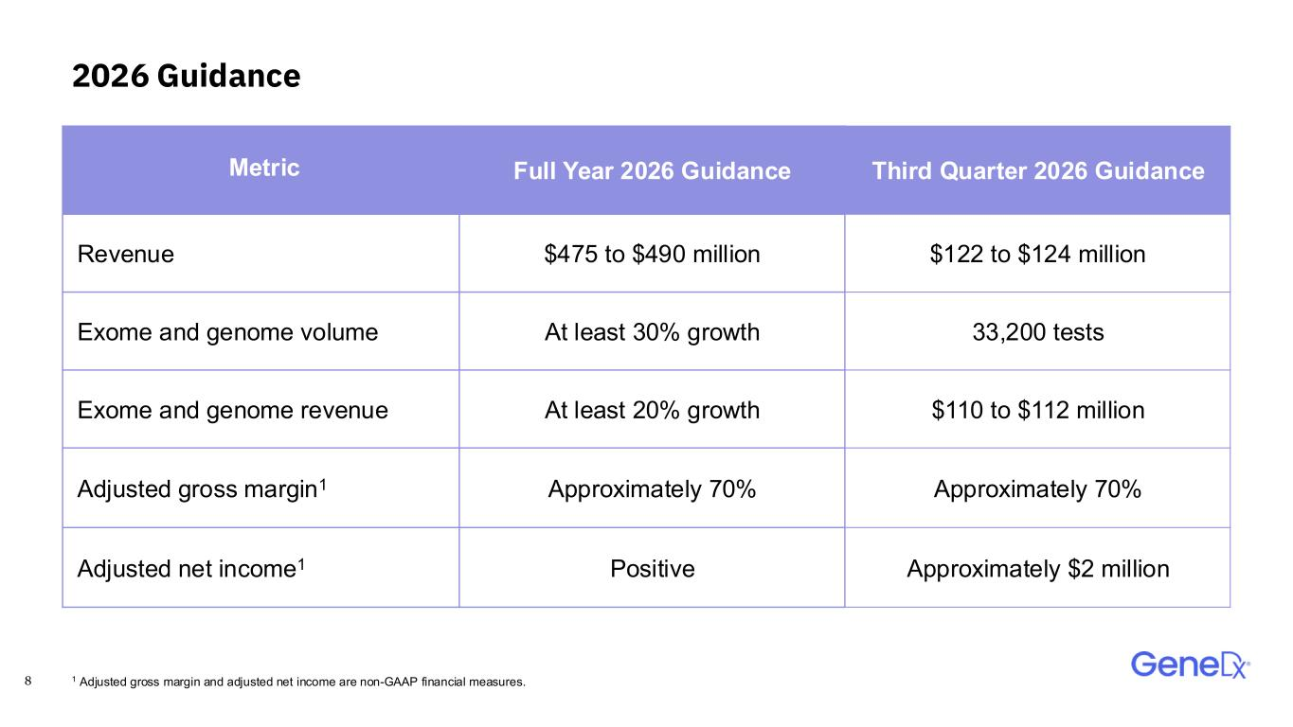
8 2026 Guidance Metric Full Year 2026 Guidance Third Quarter 2026 Guidance Revenue $475 to $490 million $122 to $124 million Exome and genome volume At least 30% growth 33,200 tests Exome and genome revenue At least 20% growth $110 to $112 million Adjusted gross margin1 Approximately 70% Approximately 70% Adjusted net income1 Positive Approximately $2 million 1 Adjusted gross margin and adjusted net income are non-GAAP financial measures.


9 Confidential & Proprietary. Do Not Distribute. Appendix


10 Empowering everyone to live their healthiest life through genomics

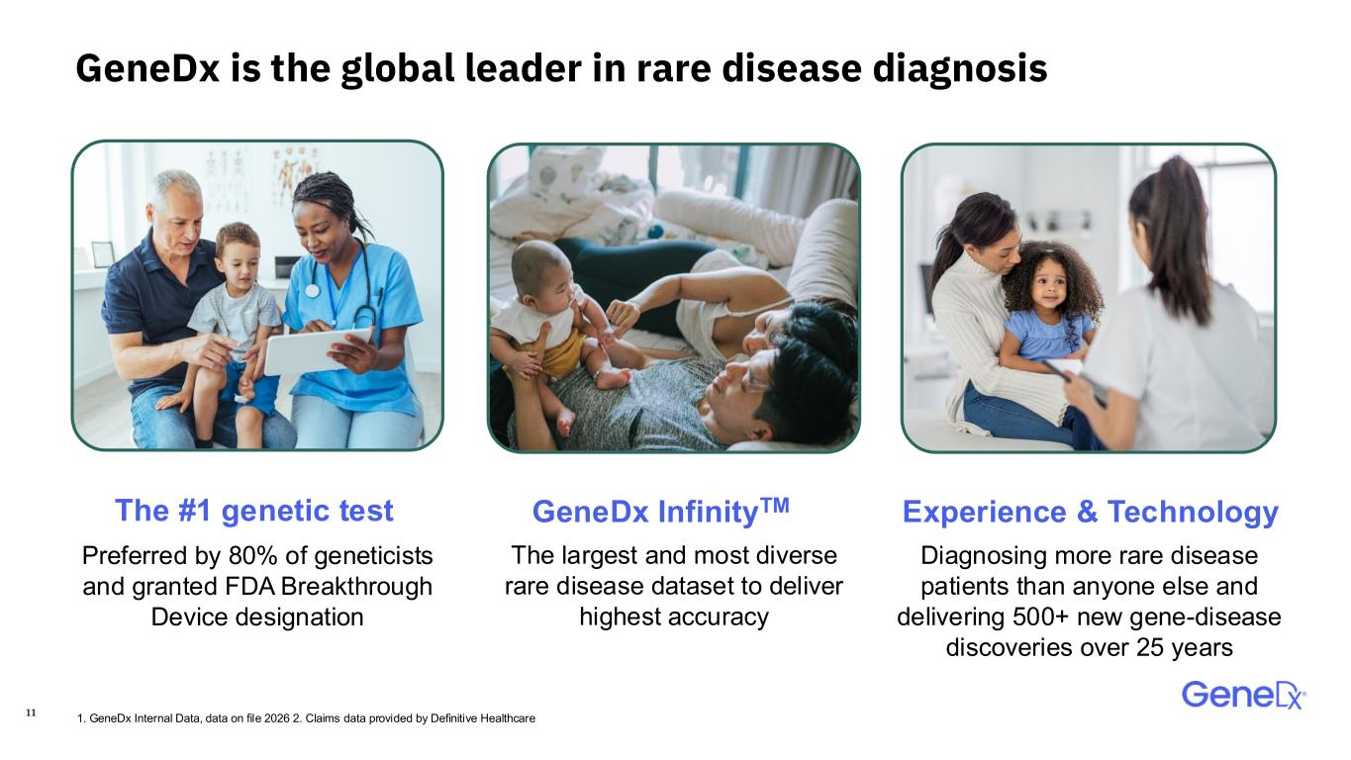
11 GeneDx is the global leader in rare disease diagnosis The largest and most diverse rare disease dataset to deliver highest accuracy Diagnosing more rare disease patients than anyone else and delivering 500+ new gene-disease discoveries over 25 years Preferred by 80% of geneticists and granted FDA Breakthrough Device designation The #1 genetic test Experience & TechnologyGeneDx InfinityTM 1. GeneDx Internal Data, data on file 2026 2. Claims data provided by Definitive Healthcare

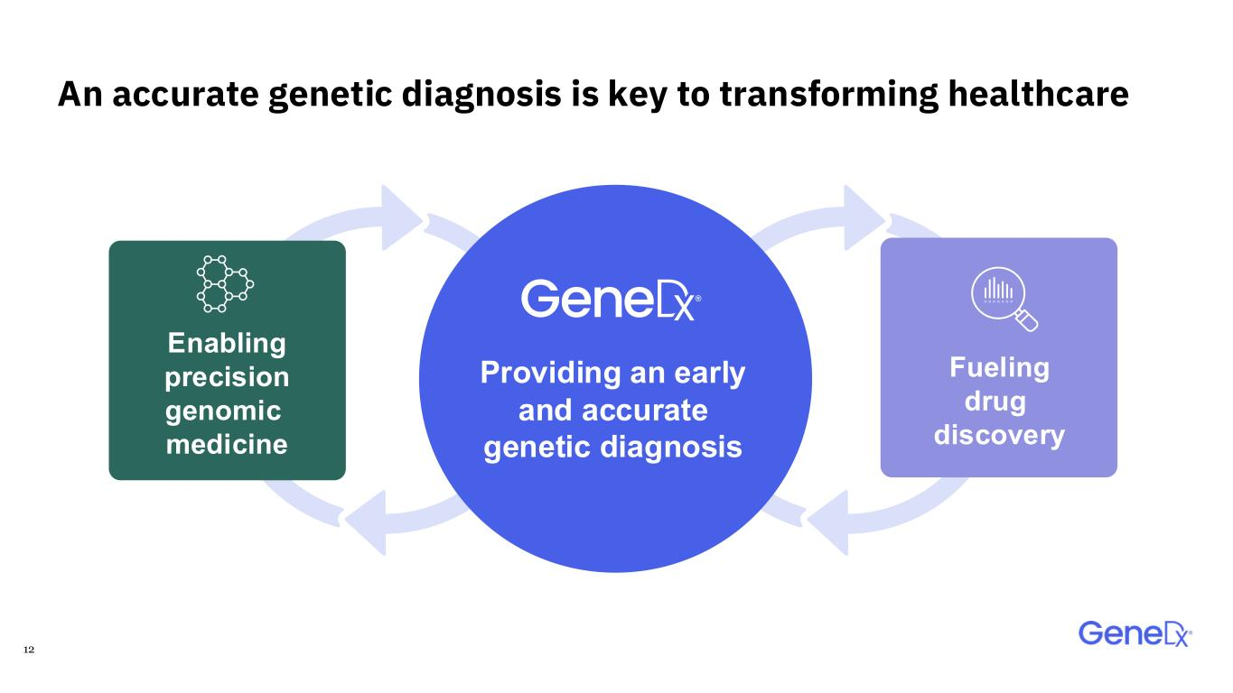
12 An accurate genetic diagnosis is key to transforming healthcare Enabling precision genomic medicine Providing an early and accurate genetic diagnosis Fueling drug discovery

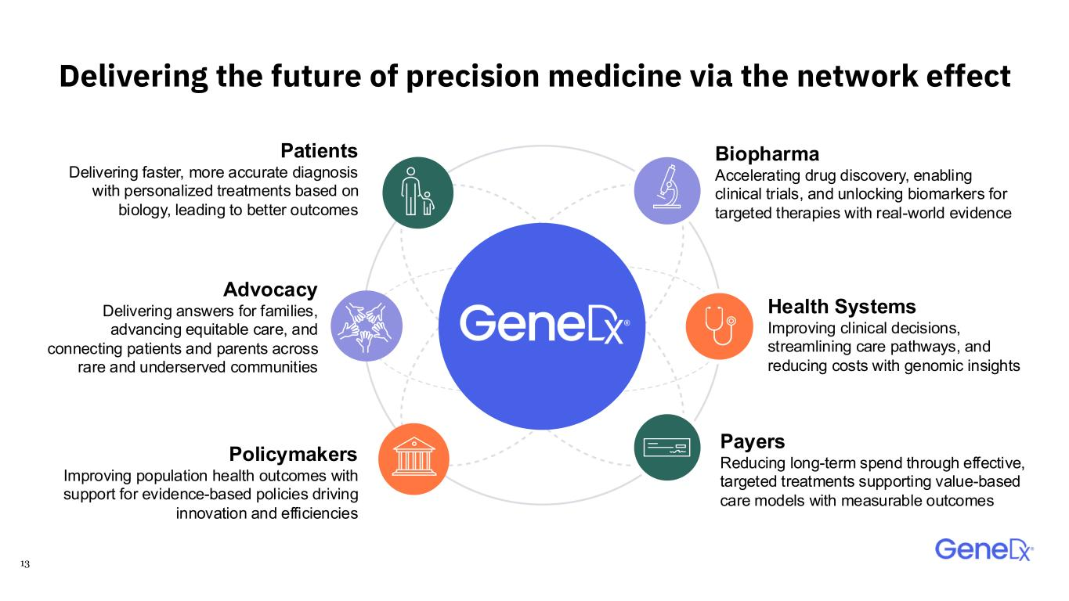
13 Delivering the future of precision medicine via the network effect Biopharma Accelerating drug discovery, enabling clinical trials, and unlocking biomarkers for targeted therapies with real-world evidence Policymakers Improving population health outcomes with support for evidence-based policies driving innovation and efficiencies Patients Delivering faster, more accurate diagnosis with personalized treatments based on biology, leading to better outcomes Health Systems Improving clinical decisions, streamlining care pathways, and reducing costs with genomic insights Payers Reducing long-term spend through effective, targeted treatments supporting value-based care models with measurable outcomes Advocacy Delivering answers for families, advancing equitable care, and connecting patients and parents across rare and underserved communities

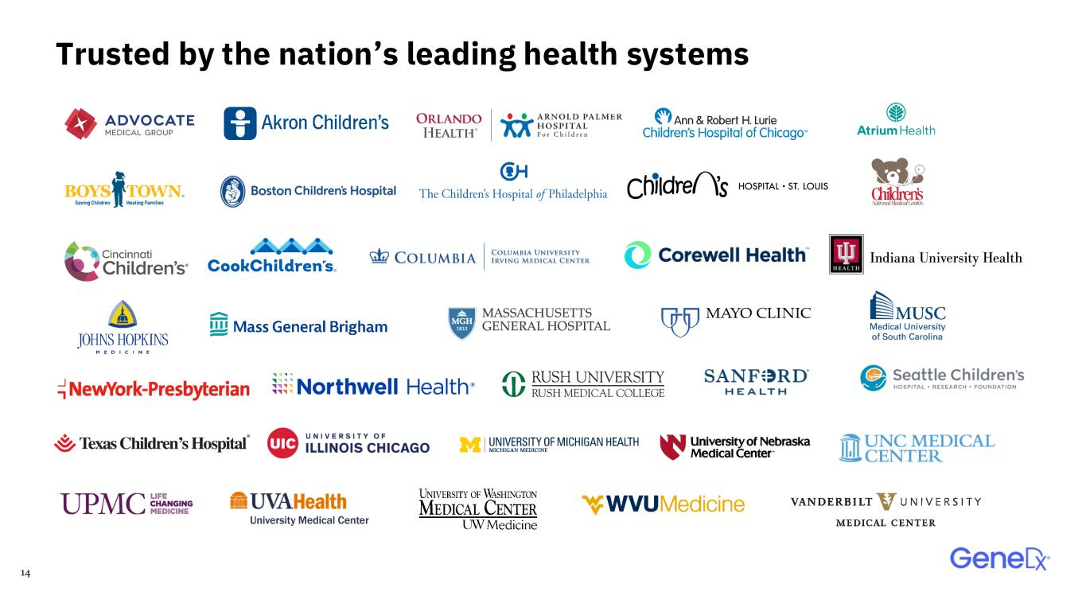
14 Trusted by the nation’s leading health systems

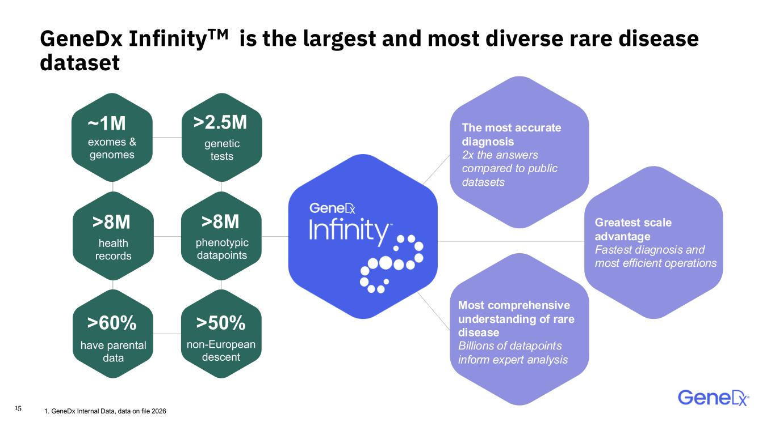
15 >2.5M >50% >8M ~1M >8M >60% genetic tests non-European descent health records exomes & genomes phenotypic datapoints have parental data GeneDx InfinityTM is the largest and most diverse rare disease dataset Greatest scale advantage Fastest diagnosis and most efficient operations Most comprehensive understanding of rare disease Billions of datapoints inform expert analysis The most accurate diagnosis 2x the answers compared to public datasets 1. GeneDx Internal Data, data on file 2026

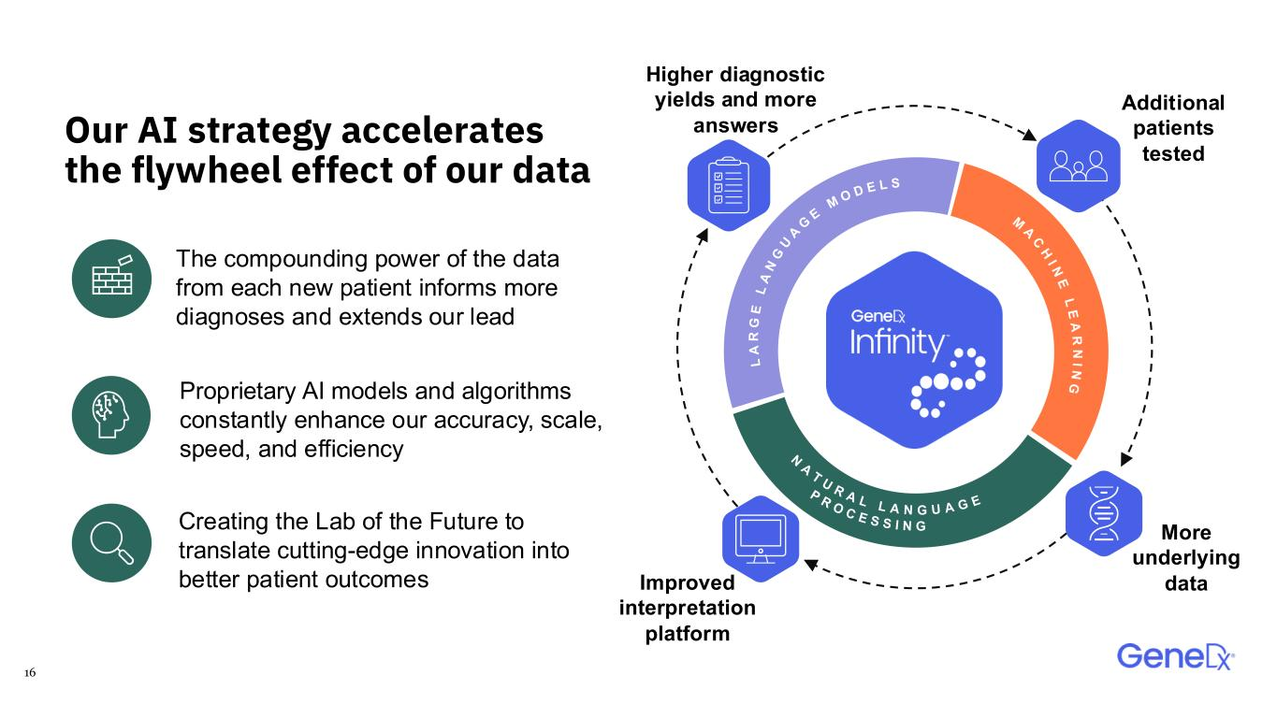
16 Our AI strategy accelerates the flywheel effect of our data Additional patients tested Improved interpretation platform Higher diagnostic yields and more answers More underlying data N A T U R A L L A N G U A G E P R O C E S S I N G M A C H I N E L E A R N I N G L A R G E L A N G U A G E M O D E L S Creating the Lab of the Future to translate cutting-edge innovation into better patient outcomes The compounding power of the data from each new patient informs more diagnoses and extends our lead Proprietary AI models and algorithms constantly enhance our accuracy, scale, speed, and efficiency

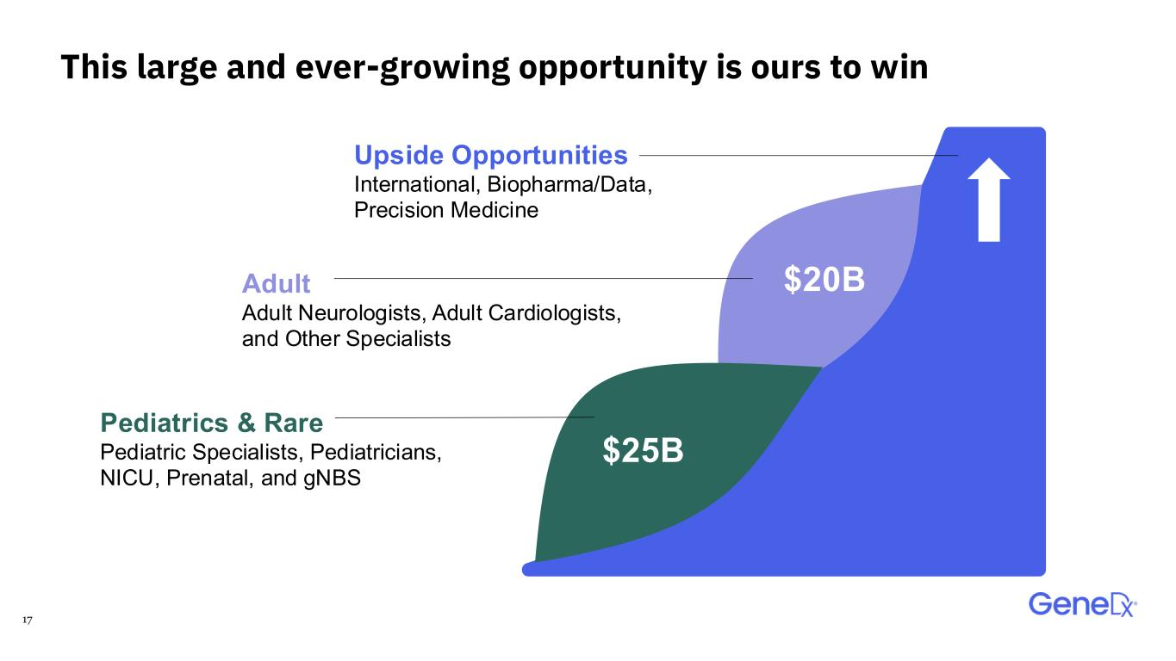
17 Upside Opportunities International, Biopharma/Data, Precision Medicine Pediatrics & Rare Pediatric Specialists, Pediatricians, NICU, Prenatal, and gNBS Adult​ Adult Neurologists, Adult Cardiologists, and Other Specialists $25B $20B This large and ever-growing opportunity is ours to win

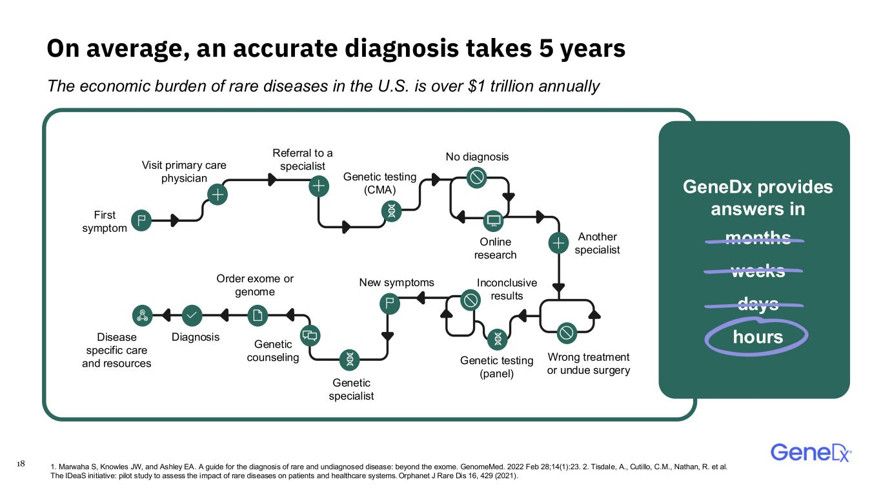
18 On average, an accurate diagnosis takes 5 years GeneDx provides answers in months weeks days hours First symptom Visit primary care physician Referral to a specialist Genetic testing (CMA) No diagnosis Online research Another specialist Wrong treatment or undue surgery Genetic testing (panel) Inconclusive results New symptoms Genetic specialist Genetic counseling Order exome or genome DiagnosisDisease specific care and resources The economic burden of rare diseases in the U.S. is over $1 trillion annually 1. Marwaha S, Knowles JW, and Ashley EA. A guide for the diagnosis of rare and undiagnosed disease: beyond the exome. Genome Med. 2022 Feb 28;14(1):23. 2. Tisdale, A., Cutillo, C.M., Nathan, R. et al. The IDeaS initiative: pilot study to assess the impact of rare diseases on patients and healthcare systems. Orphanet J Rare Dis 16, 429 (2021).

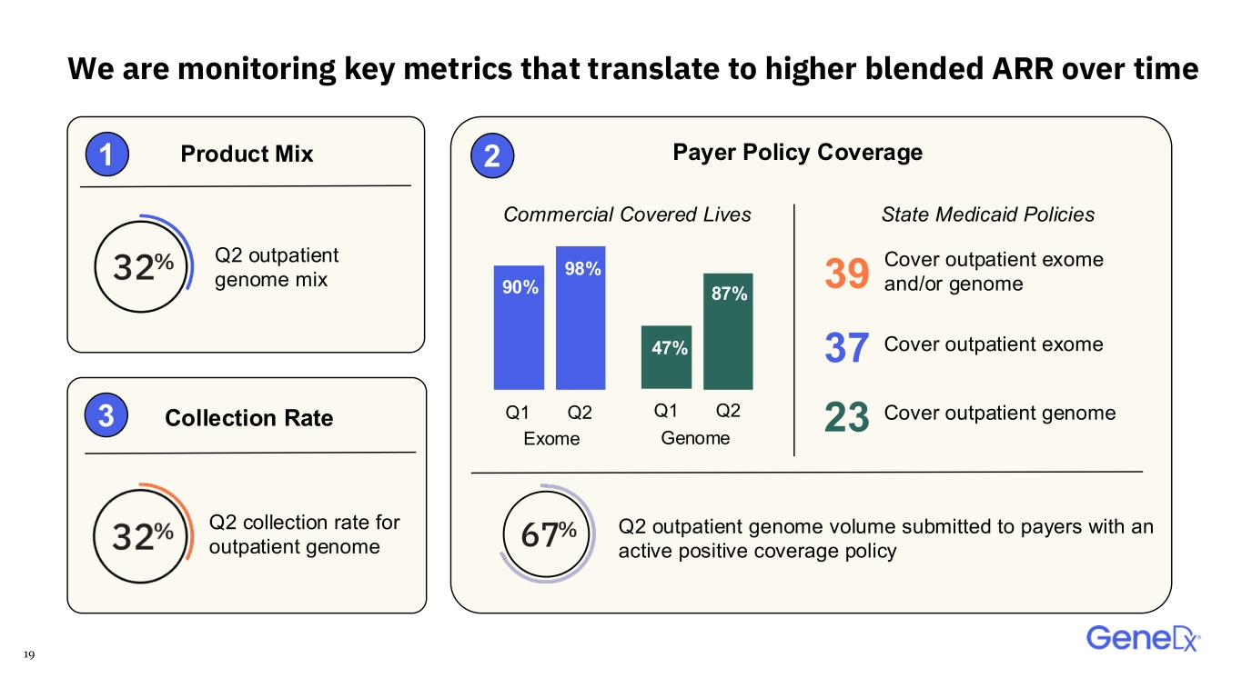
19 We are monitoring key metrics that translate to higher blended ARR over time Payer Policy CoverageProduct Mix Commercial Covered Lives Genome Q2 outpatient genome mix 98% 90% 87% 47% Exome Q1 Q2 Q1 Q2 Q2 outpatient genome volume submitted to payers with an active positive coverage policy Collection Rate Q2 collection rate for outpatient genome 1 3 2 39 23 37 State Medicaid Policies Cover outpatient exome and/or genome Cover outpatient exome Cover outpatient genome

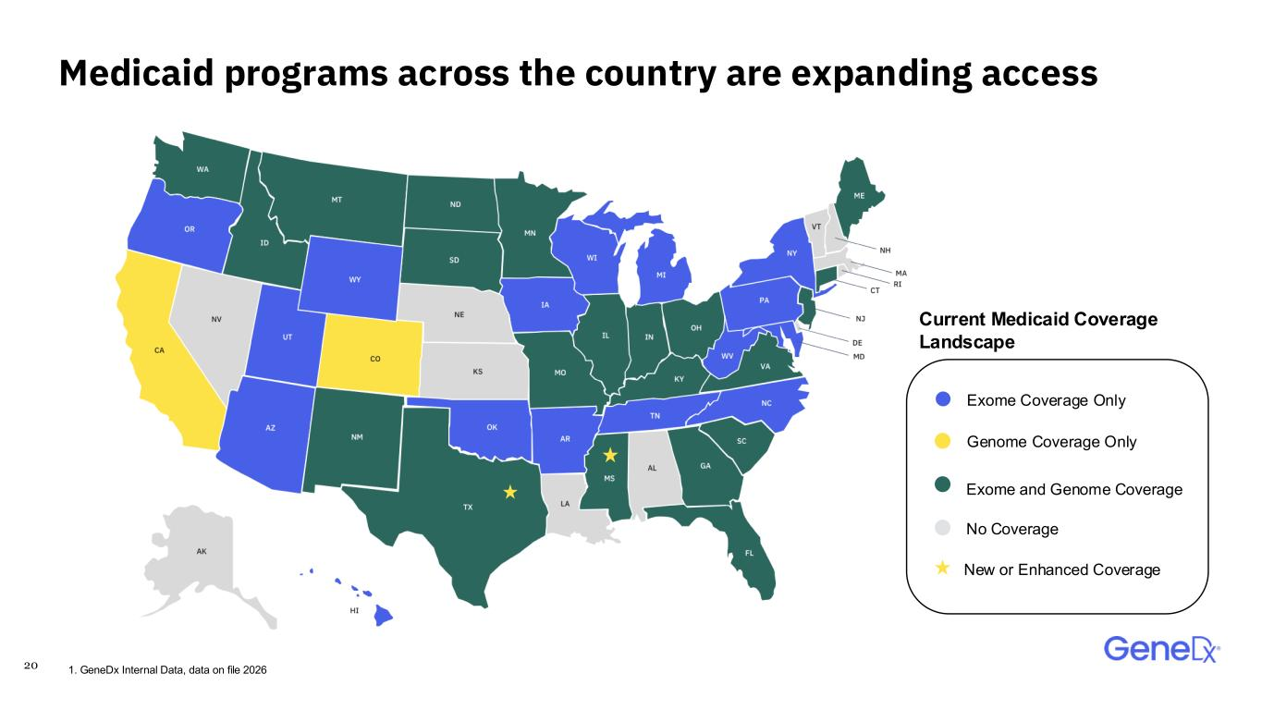
20 Medicaid programs across the country are expanding access 1. GeneDx Internal Data, data on file 2026 Exome Coverage Only Genome Coverage Only Exome and Genome Coverage No Coverage Current Medicaid Coverage Landscape New or Enhanced Coverage


21 Our north star is to diagnose as many people as fast as possible

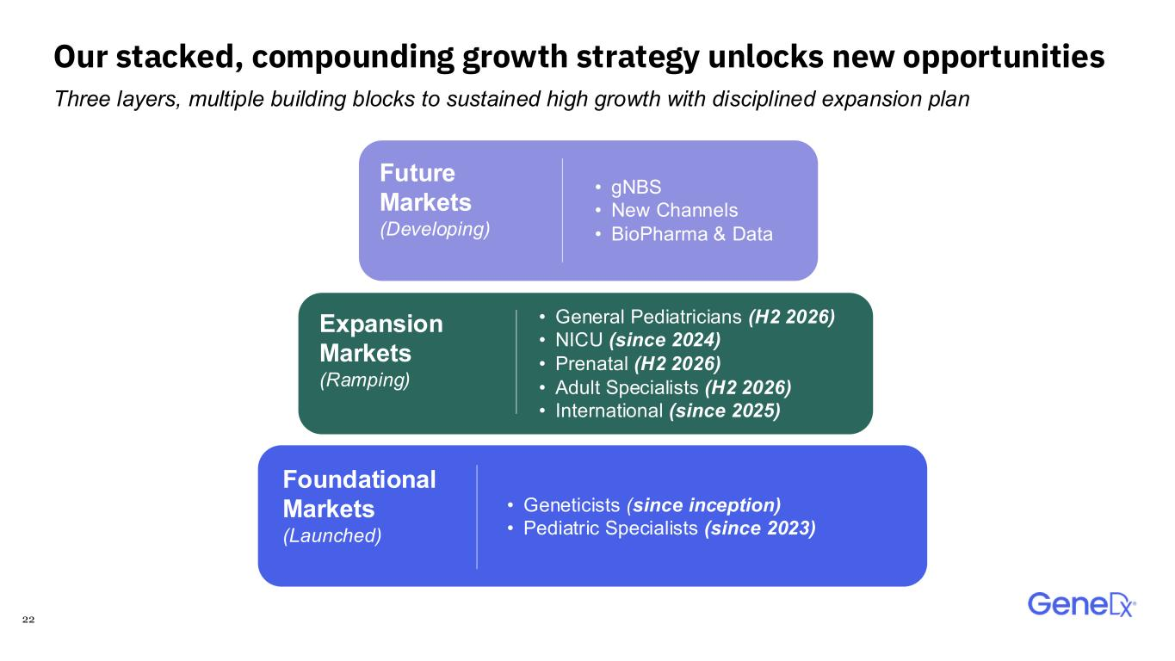
22 Our stacked, compounding growth strategy unlocks new opportunities Foundational Markets (Launched) Expansion Markets (Ramping) Future Markets (Developing) • Geneticists (since inception) • Pediatric Specialists (since 2023) • General Pediatricians (H2 2026) • NICU (since 2024) • Prenatal (H2 2026) • Adult Specialists (H2 2026) • International (since 2025) • gNBS • New Channels • BioPharma & Data Three layers, multiple building blocks to sustained high growth with disciplined expansion plan

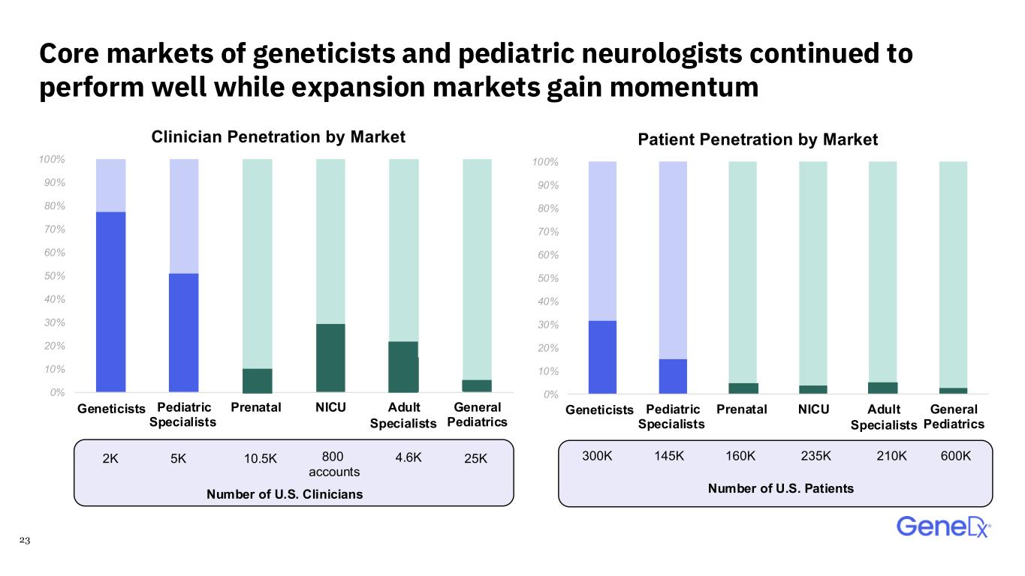
23 Core markets of geneticists and pediatric neurologists continued to perform well while expansion markets gain momentum 0% 10% 20% 30% 40% 50% 60% 70% 80% 90% 100% Geneticsits Pediatric Specialists Prenatal NICU Adult specialists General Pediatrics Clinician Penetration by Market 0% 10% 20% 30% 40% 50% 60% 70% 80% 90% 100% Geneticsits Pediatric Specialists Prenatal NICU Adult specialists General Pediatrics Patient Penetration by Market 5K2K 800 accounts 10.5K 25K4.6K ti ist enetici ts S i li t S 145K300K 235K160K 600K210K Number of U.S. PatientsNumber of U.S. Clinicians

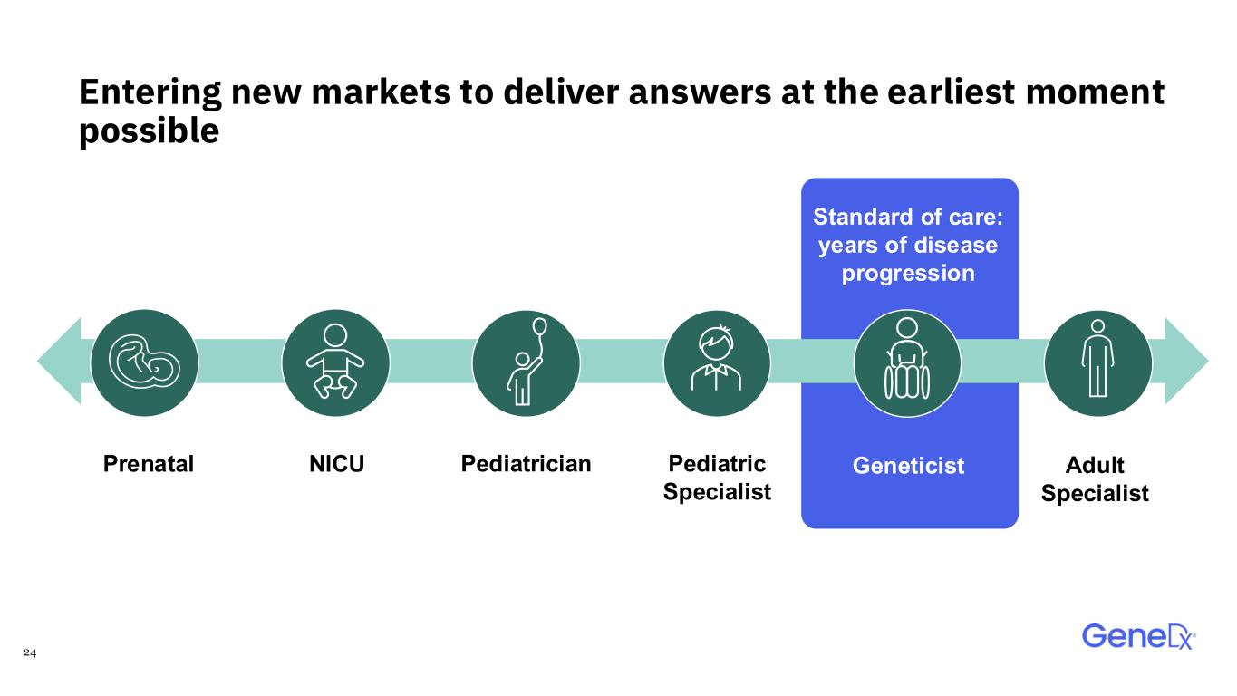
24 GeneticistPrenatal Standard of care: years of disease progression Pediatrician Entering new markets to deliver answers at the earliest moment possible NICU Adult Specialist Pediatric Specialist

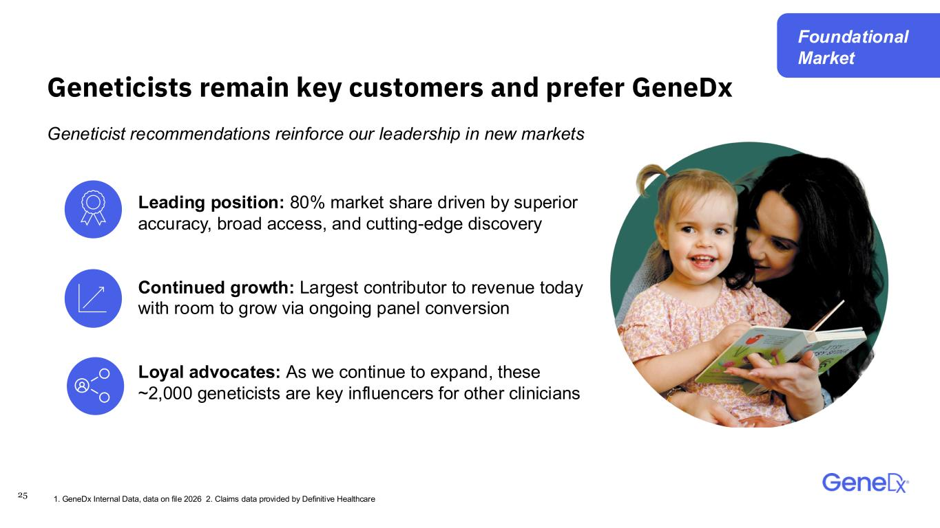
25 Geneticists remain key customers and prefer GeneDx Geneticist recommendations reinforce our leadership in new markets Leading position: 80% market share driven by superior accuracy, broad access, and cutting-edge discovery Continued growth: Largest contributor to revenue today with room to grow via ongoing panel conversion Loyal advocates: As we continue to expand, these ~2,000 geneticists are key influencers for other clinicians 1. GeneDx Internal Data, data on file 2026 2. Claims data provided by Definitive Healthcare Foundational Market

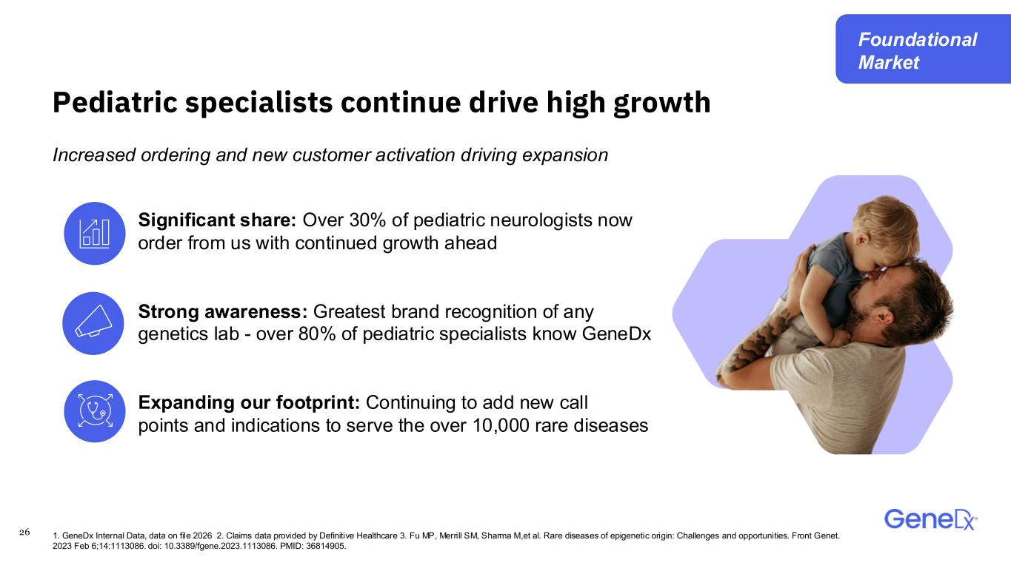
26 Pediatric specialists continue drive high growth Significant share: Over 30% of pediatric neurologists now order from us with continued growth ahead Strong awareness: Greatest brand recognition of any genetics lab - over 80% of pediatric specialists know GeneDx Expanding our footprint: Continuing to add new call points and indications to serve the over 10,000 rare diseases Increased ordering and new customer activation driving expansion 1. GeneDx Internal Data, data on file 2026 2. Claims data provided by Definitive Healthcare 3. Fu MP, Merrill SM, Sharma M,et al. Rare diseases of epigenetic origin: Challenges and opportunities. Front Genet. 2023 Feb 6;14:1113086. doi: 10.3389/fgene.2023.1113086. PMID: 36814905. Foundational Market

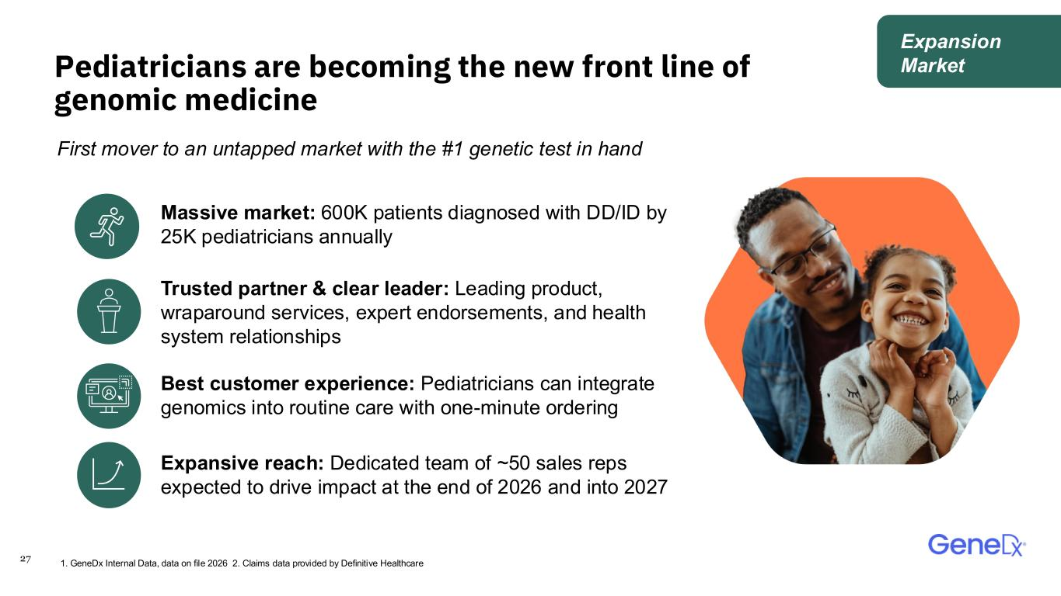
27 Pediatricians are becoming the new front line of genomic medicine Massive market: 600K patients diagnosed with DD/ID by 25K pediatricians annually First mover to an untapped market with the #1 genetic test in hand Trusted partner & clear leader: Leading product, wraparound services, expert endorsements, and health system relationships Best customer experience: Pediatricians can integrate genomics into routine care with one-minute ordering Expansive reach: Dedicated team of ~50 sales reps expected to drive impact at the end of 2026 and into 2027 1. GeneDx Internal Data, data on file 2026 2. Claims data provided by Definitive Healthcare Expansion Market

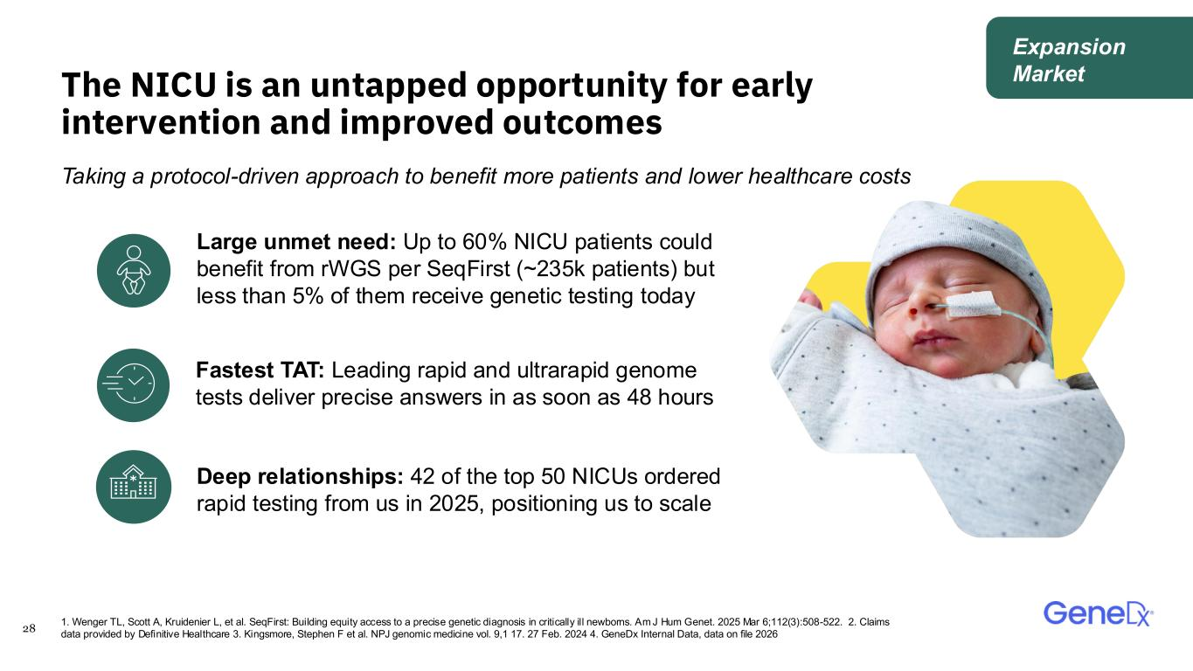
28 The NICU is an untapped opportunity for early intervention and improved outcomes Taking a protocol-driven approach to benefit more patients and lower healthcare costs Large unmet need: Up to 60% NICU patients could benefit from rWGS per SeqFirst (~235k patients) but less than 5% of them receive genetic testing today 1. Wenger TL, Scott A, Kruidenier L, et al. SeqFirst: Building equity access to a precise genetic diagnosis in critically ill newborns. Am J Hum Genet. 2025 Mar 6;112(3):508-522. 2. Claims data provided by Definitive Healthcare 3. Kingsmore, Stephen F et al. NPJ genomic medicine vol. 9,1 17. 27 Feb. 2024 4. GeneDx Internal Data, data on file 2026 Deep relationships: 42 of the top 50 NICUs ordered rapid testing from us in 2025, positioning us to scale Fastest TAT: Leading rapid and ultrarapid genome tests deliver precise answers in as soon as 48 hours Expansion Market

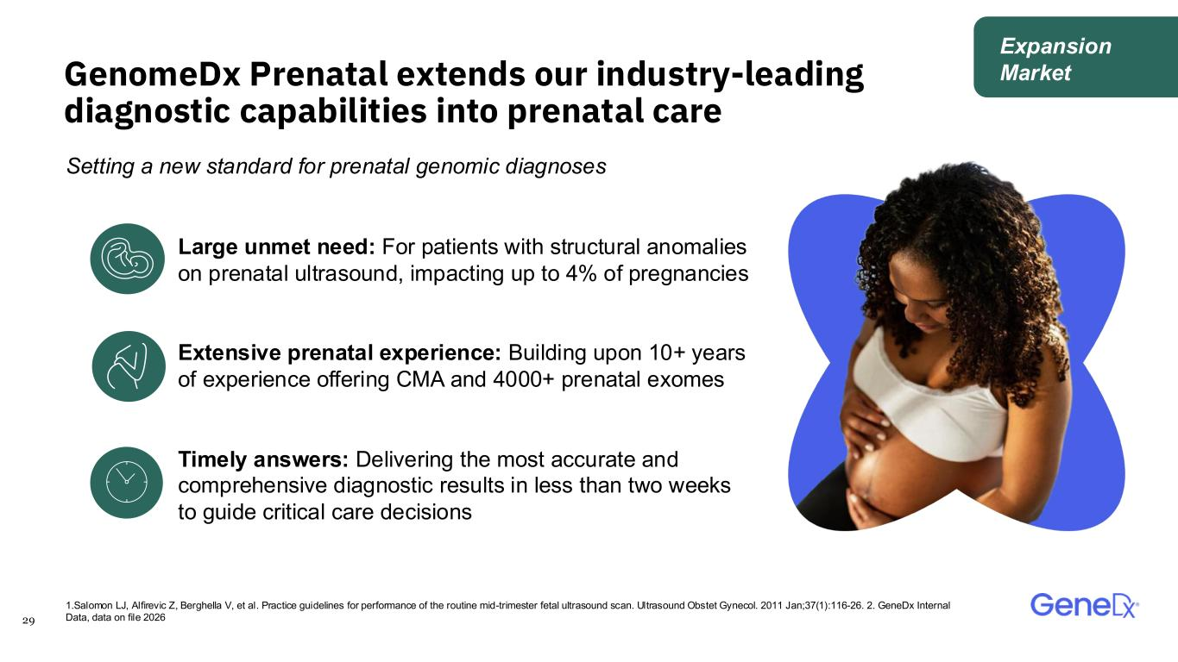
29 GenomeDx Prenatal extends our industry-leading diagnostic capabilities into prenatal care Setting a new standard for prenatal genomic diagnoses Large unmet need: For patients with structural anomalies on prenatal ultrasound, impacting up to 4% of pregnancies Extensive prenatal experience: Building upon 10+ years of experience offering CMA and 4000+ prenatal exomes Timely answers: Delivering the most accurate and comprehensive diagnostic results in less than two weeks to guide critical care decisions 1.Salomon LJ, Alfirevic Z, Berghella V, et al. Practice guidelines for performance of the routine mid-trimester fetal ultrasound scan. Ultrasound Obstet Gynecol. 2011 Jan;37(1):116-26.​ 2. GeneDx Internal Data, data on file 2026 Expansion Market

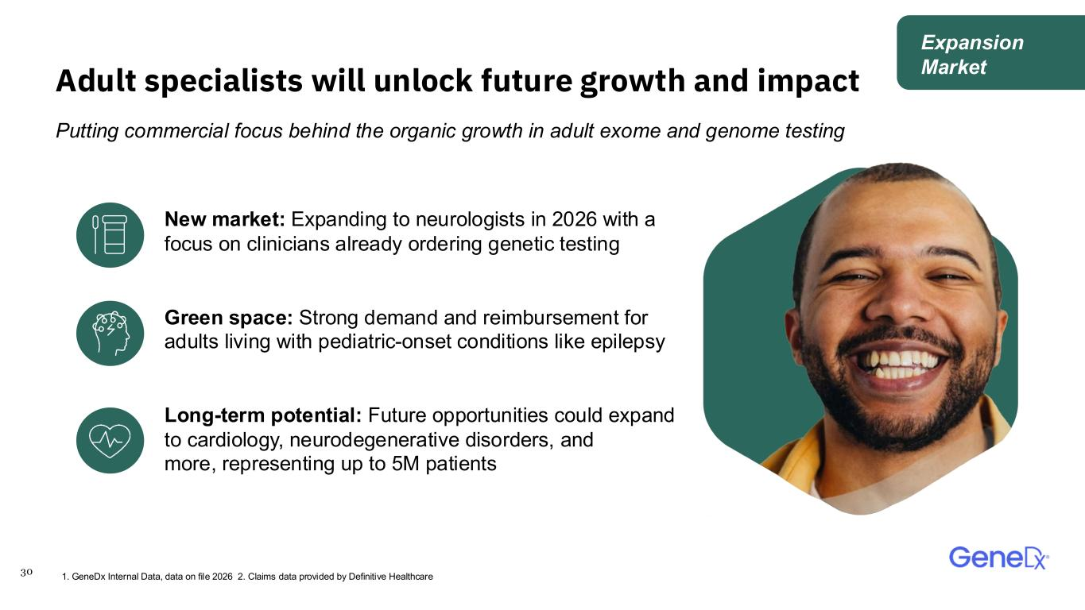
30 Adult specialists will unlock future growth and impact Putting commercial focus behind the organic growth in adult exome and genome testing New market: Expanding to neurologists in 2026 with a focus on clinicians already ordering genetic testing Green space: Strong demand and reimbursement for adults living with pediatric-onset conditions like epilepsy Long-term potential: Future opportunities could expand to cardiology, neurodegenerative disorders, and more, representing up to 5M patients 1. GeneDx Internal Data, data on file 2026 2. Claims data provided by Definitive Healthcare Expansion Market

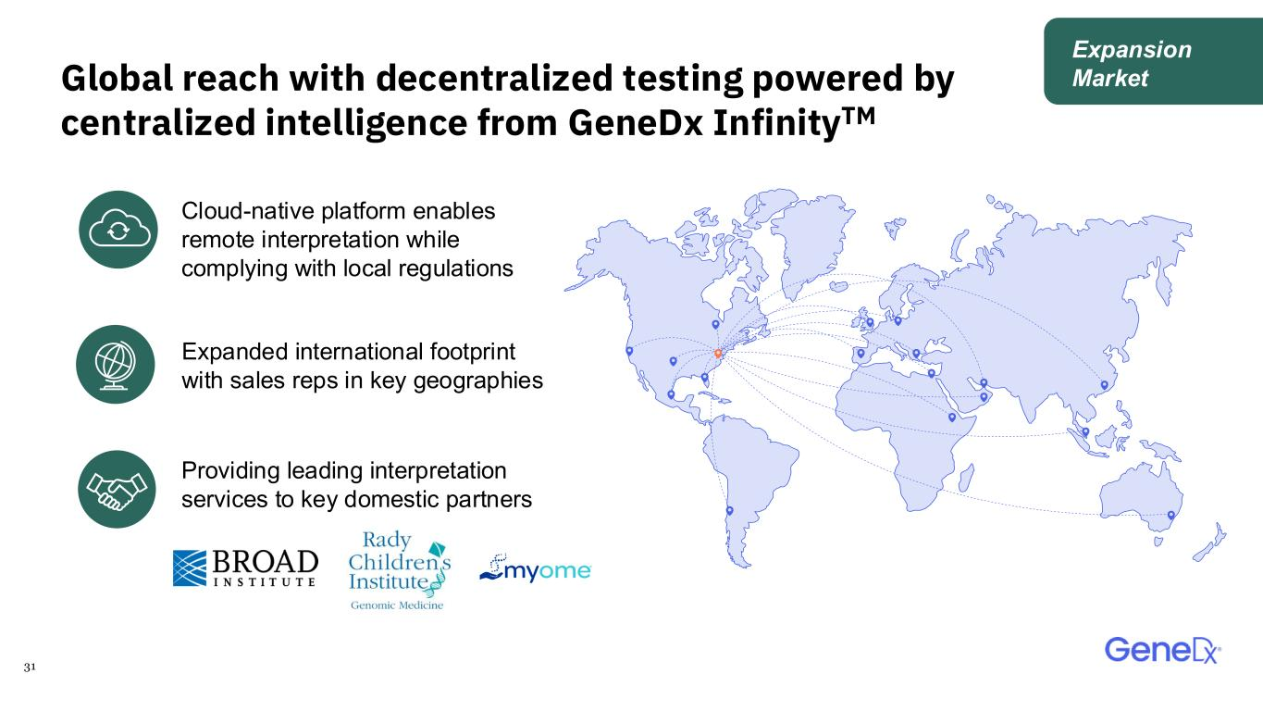
31 Global reach with decentralized testing powered by centralized intelligence from GeneDx InfinityTM Cloud-native platform enables remote interpretation while complying with local regulations Providing leading interpretation services to key domestic partners Expanded international footprint with sales reps in key geographies Expansion Market

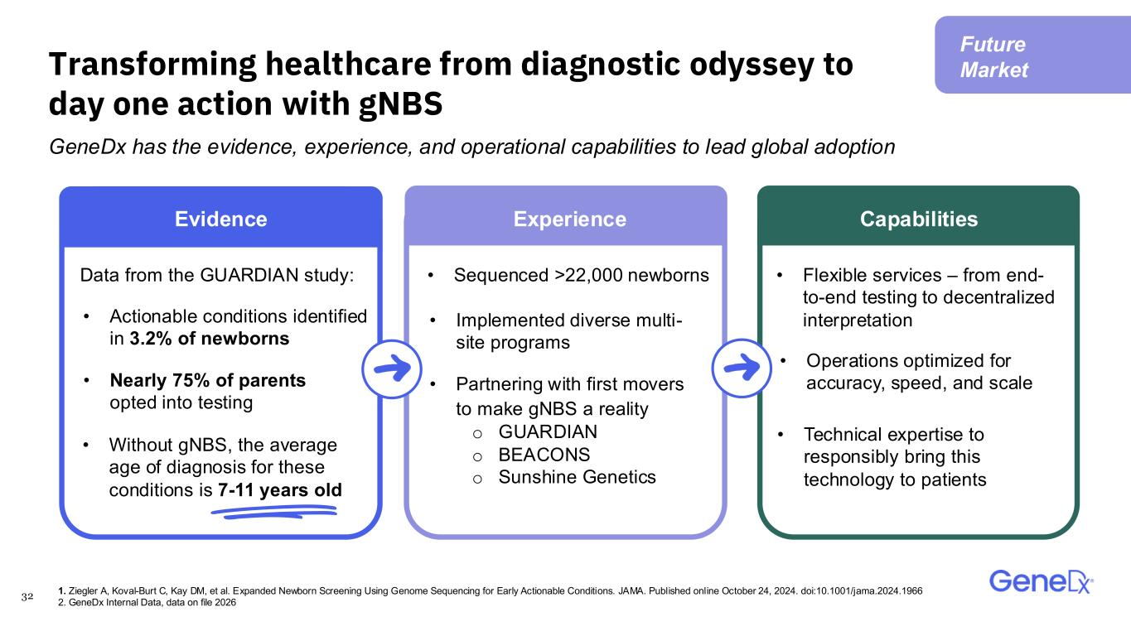
32 Transforming healthcare from diagnostic odyssey to day one action with gNBS GeneDx has the evidence, experience, and operational capabilities to lead global adoption • Partnering with first movers to make gNBS a reality o GUARDIAN o BEACONS o Sunshine Genetics • Without gNBS, the average age of diagnosis for these conditions is 7-11 years old Data from the GUARDIAN study: • Nearly 75% of parents opted into testing • Implemented diverse multi- site programs Evidence Experience Capabilities • Actionable conditions identified in 3.2% of newborns • Sequenced >22,000 newborns • Operations optimized for accuracy, speed, and scale • Flexible services – from end- to-end testing to decentralized interpretation • Technical expertise to responsibly bring this technology to patients 1. Ziegler A, Koval-Burt C, Kay DM, et al. Expanded Newborn Screening Using Genome Sequencing for Early Actionable Conditions. JAMA. Published online October 24, 2024. doi:10.1001/jama.2024.1966 2. GeneDx Internal Data, data on file 2026 Future Market


33 Pioneering new channels and partnerships to deliver on the promise of precision genomic medicine Future Market

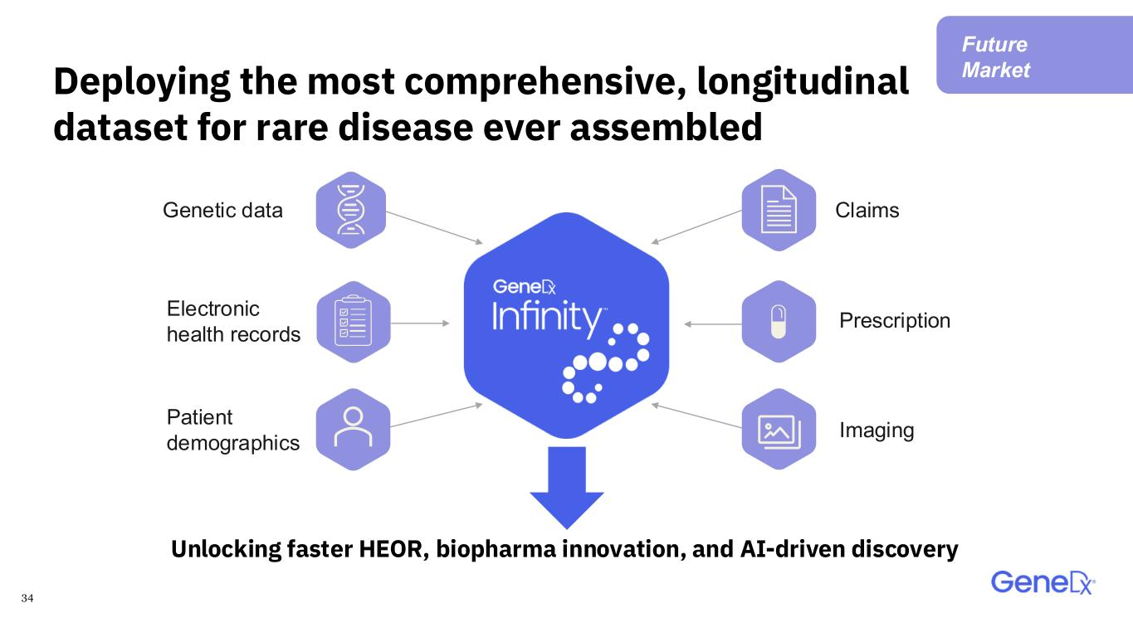
34 Unlocking faster HEOR, biopharma innovation, and AI-driven discovery Genetic data Electronic health records Patient demographics Claims Prescription Imaging Deploying the most comprehensive, longitudinal dataset for rare disease ever assembled Future Market

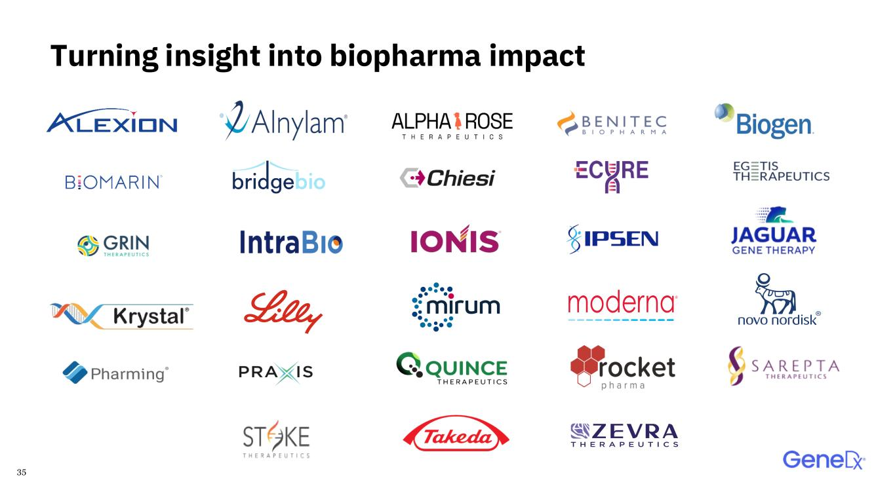
35 Turning insight into biopharma impact

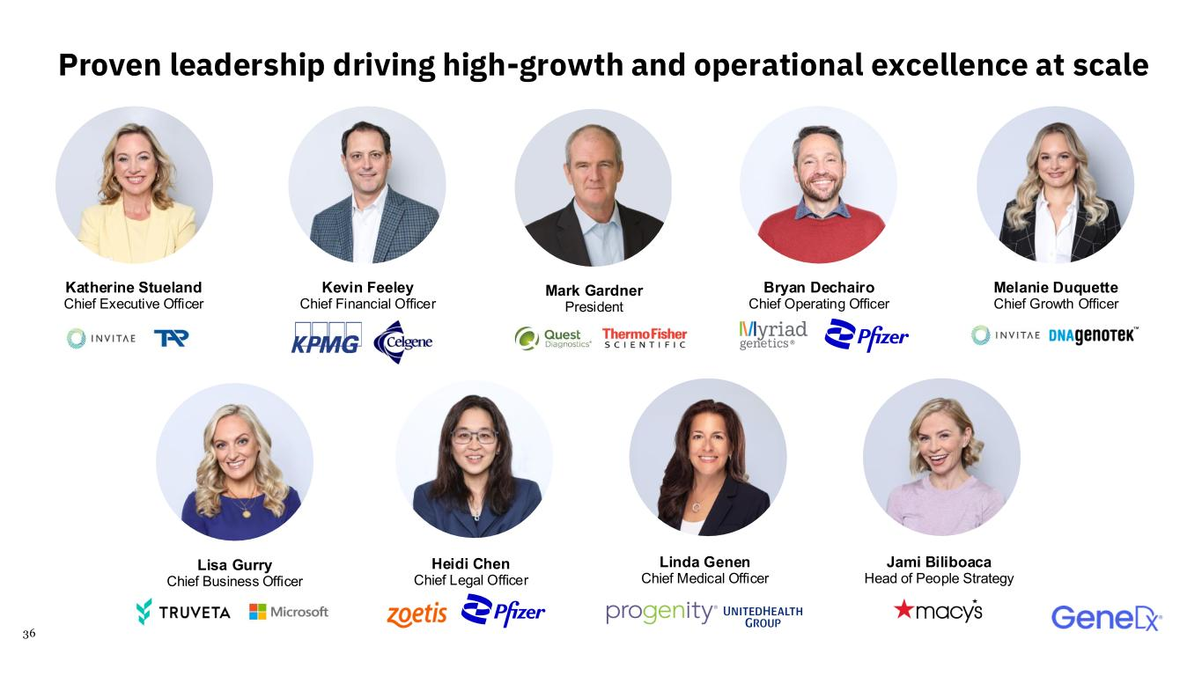
36 Proven leadership driving high-growth and operational excellence at scale Heidi Chen Chief Legal Officer Linda Genen Chief Medical Officer Jami Biliboaca Head of People Strategy Katherine Stueland Chief Executive Officer Kevin Feeley Chief Financial Officer Melanie Duquette Chief Growth Officer Mark Gardner President Lisa Gurry Chief Business Officer Bryan Dechairo Chief Operating Officer

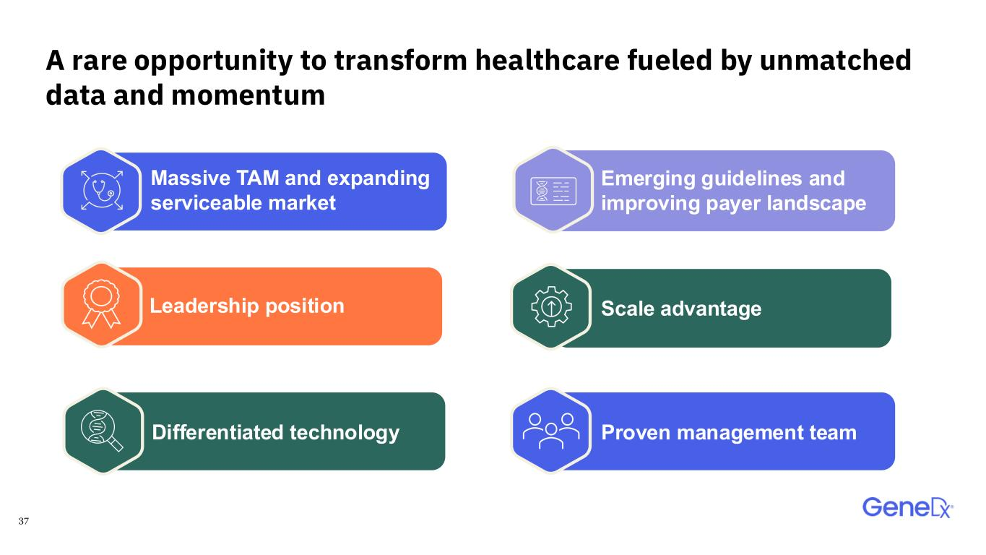
37 Massive TAM and expanding serviceable market Leadership position Differentiated technology A rare opportunity to transform healthcare fueled by unmatched data and momentum Emerging guidelines and improving payer landscape Scale advantage Proven management team

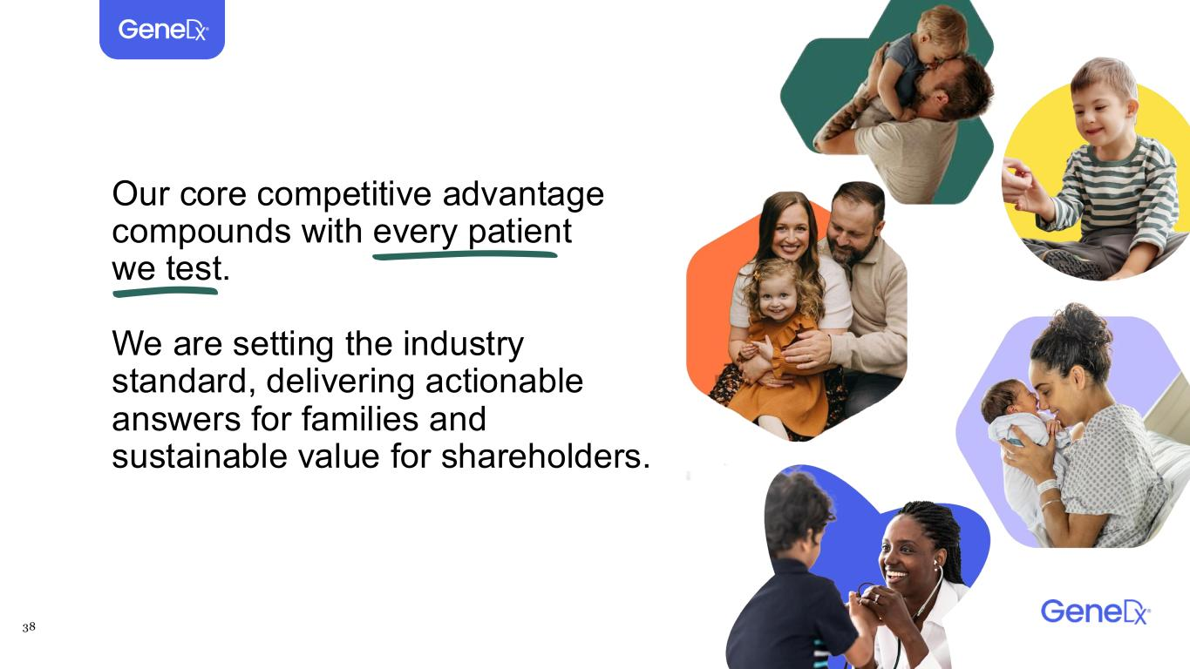
38 Our core competitive advantage compounds with every patient we test. We are setting the industry standard, delivering actionable answers for families and sustainable value for shareholders.

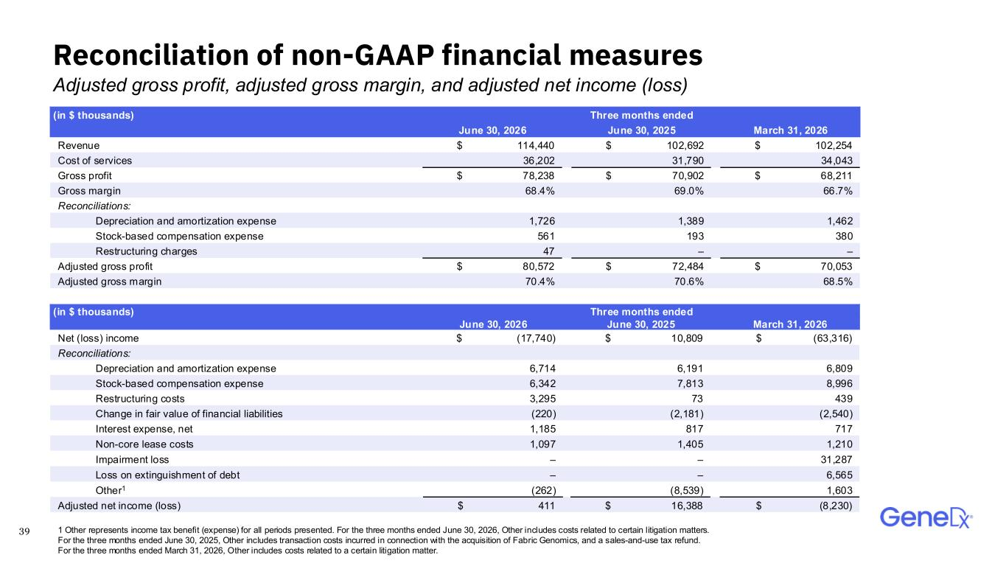
39 Reconciliation of non-GAAP financial measures Adjusted gross profit, adjusted gross margin, and adjusted net income (loss) (in $ thousands) Three months ended June 30, 2026 June 30, 2025 March 31, 2026 Revenue $ 114,440 $ 102,692 $ 102,254 Cost of services 36,202 31,790 34,043 Gross profit $ 78,238 $ 70,902 $ 68,211 Gross margin 68.4% 69.0% 66.7% Reconciliations: Depreciation and amortization expense 1,726 1,389 1,462 Stock-based compensation expense 561 193 380 Restructuring charges 47 – – Adjusted gross profit $ 80,572 $ 72,484 $ 70,053 Adjusted gross margin 70.4% 70.6% 68.5% (in $ thousands) Three months ended June 30, 2026 June 30, 2025 March 31, 2026 Net (loss) income $ (17,740) $ 10,809 $ (63,316) Reconciliations: Depreciation and amortization expense 6,714 6,191 6,809 Stock-based compensation expense 6,342 7,813 8,996 Restructuring costs 3,295 73 439 Change in fair value of financial liabilities (220) (2,181) (2,540) Interest expense, net 1,185 817 717 Non-core lease costs 1,097 1,405 1,210 Impairment loss – – 31,287 Loss on extinguishment of debt – – 6,565 Other1 (262) (8,539) 1,603 Adjusted net income (loss) $ 411 $ 16,388 $ (8,230) 1 Other represents income tax benefit (expense) for all periods presented. For the three months ended June 30, 2026, Other includes costs related to certain litigation matters. For the three months ended June 30, 2025, Other includes transaction costs incurred in connection with the acquisition of Fabric Genomics, and a sales-and-use tax refund. For the three months ended March 31, 2026, Other includes costs related to a certain litigation matter.

