UNITED STATES
SECURITIES AND EXCHANGE COMMISSION
Washington, D.C. 20549
FORM 8-K
CURRENT REPORT
Pursuant to Section 13 OR 15(d) of The Securities Exchange Act of 1934
Date of Report (date of earliest event reported): April 29, 2024
Commission file number 001-39482

GeneDx Holdings Corp.
(Exact name of registrant as specified in its charter)

Delaware |  |  | 85-1966622
(State or other jurisdiction of incorporation or organization) |  |  | (I.R.S. Employer Identification No.)
333 Ludlow Street, North Tower; 6th Floor
Stamford, Connecticut 06902
(Address of Principal Executive Offices) (Zip Code)
Registrant's telephone number, including area code: (888) 729-1206
Check the appropriate box below if the Form 8-K filing is intended to simultaneously satisfy the filing obligation of the registrant under any of the following provisions (see General Instruction A.2. below):
☐ Written communications pursuant to Rule 425 under the Securities Act (17 CFR 230.425)
☐ Soliciting material pursuant to Rule 14a-12 under the Exchange Act (17 CFR 240.14a-12)
☐ Pre-commencement communications pursuant to Rule 14d-2(b) under the Exchange Act (17 CFR 240.14d-2(b))
☐ Pre-commencement communications pursuant to Rule 13e-4(c) under the Exchange Act (17 CFR 240.13e-4(c))
Securities registered pursuant to Section 12(b) of the Act:
Title of each class |  |  |  |  |  | Trading Symbol |  |  |  |  |  | Name of each exchange on which registered
Class A common stock, par value $0.0001 per share |  |  |  |  |  | WGS |  |  |  |  |  | The Nasdaq Stock Market LLC
Warrants to purchase one share of Class A common stock, each at an exercise price of $379.50 per share |  |  |  |  |  | WGSWW |  |  |  |  |  | The Nasdaq Stock Market LLC
Indicate by check mark whether the registrant is an emerging growth company as defined in Rule 405 of the Securities Act of 1933 (§230.405 of this chapter) or Rule 12b-2 of the Securities Exchange Act of 1934 (§240.12b-2 of this chapter).
Emerging growth company ☒
If an emerging growth company, indicate by check mark if the registrant has elected not to use the extended transition period for complying with any new or revised financial accounting standards provided pursuant to Section 13(a) of the Exchange Act. ☐

Item 2.02 Results of Operations and Financial Condition.
On April 29, 2024, GeneDx Holdings Corp. (the “Company”) issued a press release (the “Press Release”) and will hold a conference call announcing the Company's financial results for the quarter ended March 31, 2024. Copies of the Press Release and Earnings Presentation are furnished as Exhibits 99.1 and 99.2, respectively, to this Current Report on Form 8-K.
The information furnished with this Item 2.02, including Exhibits 99.1 and 99.2 hereto, shall not be deemed “filed” for purposes of Section 18 of the Securities Exchange Act of 1934, as amended (the “Exchange Act”), or otherwise subject to the liabilities of that section, nor shall it be deemed incorporated by reference into any other filing under the Securities Act of 1933, as amended, or the Exchange Act, except as expressly set forth by specific reference in such a filing.

Item 9.01 Financial Statements and Exhibits.
(d) Exhibits
Exhibit No |  |  | Description
99.1 |  |  | Press Release, dated April 29, 2024, regarding the registrant’s results for the quarter ended March 31, 2024
99.2 |  |  | Earnings Presentation, dated April 29, 2024

SIGNATURES
Pursuant to the requirements of the Securities Exchange Act of 1934, the registrant has duly caused this report to be signed on its behalf by the undersigned hereunto duly authorized.
 |  |  |  |  |  | GENEDX HOLDINGS CORP.
Date: |  |  | April 29, 2024 |  |  | By: |  |  | /s/ Katherine Stueland
 |  |  |  |  |  | Name: |  |  | Katherine Stueland
 |  |  |  |  |  | Title: |  |  | Chief Executive Officer

Exhibit 99.1

GeneDx Reports First Quarter 2024 Financial Results and Business Highlights
Reported first quarter 2024 revenue from continuing operations1 of $61.5M with 96% year-over-year growth of exome and genome test revenue
Expanded first quarter 2024 adjusted gross margins2 from continuing operations to 61%
Narrowed first quarter 2024 adjusted net loss2 to $8.5M and delivered 71% year-over-year cash burn reduction
Raised guidance to deliver between $235M and $245M in FY 2024 revenue and reiterate path to profitability in 2025
GeneDx to host conference call today at 4:30 p.m. ET

STAMFORD, Conn., April 29, 2024 — GeneDx Holdings Corp. (Nasdaq: WGS), a leader in delivering improved health outcomes through genomic insights, today reported its financial results for the first quarter of 2024.
“Our strong first quarter results reflect our continued dedication to our three key organizational focuses: growing exome and genome revenue, increasing our average reimbursement rates while expanding access to testing, and meaningfully reducing our cash burn,” said Katherine Stueland, Chief Executive Officer of GeneDx. “Our team’s successful execution in the first quarter gives us the confidence to raise full year 2024 revenue guidance to between $235-$245 million and reiterate our expectation to reach profitability in 2025.”

First Quarter 2024 Financial Results (Unaudited)1,2
Revenues
•Revenues from continuing operations grew to $61.5 million, an increase of 51% year-over-year and 6% sequentially.
◦Total company revenues were $62.4 million.
•Exome and genome test revenue grew to $44.0 million, an increase of 96% year-over-year and 12% sequentially.
Exome and genome volume
•Exome and genome test results volume grew to 16,592, an increase of 91% year-over-year and 6% sequentially.
•Exome and genome represented 30% of all test results, up from 16% in the first quarter of 2023 and up from 27% in the fourth quarter of 2023.
Gross margin
•Adjusted gross margin from continuing operations expanded to 61%, up from 34% in the first quarter of 2023 and up from 56% in the fourth quarter of 2023.
◦Total company gross margin was 60%.
•Exome and genome adjusted gross margin operated in excess of 65%.
Operating expenses
•Adjusted total operating expenses reduced to $45.4 million, a decrease of 26% year-over-year and 6% sequentially.
◦Total GAAP operating expenses were $50.1 million.
Net loss
•Adjusted net loss narrowed to $8.5 million, an improvement of 83% year-over-year and 52% sequentially.
◦GAAP net loss was $20.2 million.

Cash burn and cash position
•Total net use of cash was $17.2 million in the first quarter of 2024, an improvement of 71% year-over-year and 48% sequentially.
•Cash, cash equivalents, marketable securities and restricted cash was $113.9 million as of March 31, 2024.
1Revenue and gross margin results from continuing operations, which we believe are representative of our ongoing business strategy exclude any revenue and cost of goods sold of the exited Legacy Sema4 diagnostic testing business for the current and all comparative periods. Total company results include GeneDx’s continuing operations and the financial impacts of exited Legacy Sema4 business activities for the current and all comparative periods.
2Adjusted gross margin, adjusted total operating expenses and adjusted net loss are non-GAAP financial measures. See appendix for a reconciliation of GAAP to Non-GAAP figures presented.

Updated GeneDx Full Year 2024 Guidance
GeneDx has updated its full year 2024 guidance. Management expects GeneDx to:
•Drive full year 2024 revenues between $235 and $245 million (previous guidance was $220 to $230 million);
•Expand full year 2024 adjusted gross margin profile to at least 60% (previous guidance was at least 50%);
•Use $70 to $80 million of net cash for full year 2024 (previous guidance was $75 to $80 million);
•Turn profitable in 2025 (no change).

First Quarter 2024 Business Highlights
Driving sustainable growth and market leadership
•Reached new milestone of sequencing 600k clinical exomes and genomes since inception, with over half sequenced since July 2021 and 100k sequenced since the fall. This continued acceleration of exome and genome sequencing and interpretation further solidifies GeneDx’s industry leadership, enhances the robustness of its proprietary dataset, and enables more definitive diagnoses for more patients.
•Presented new data at the American College of Medical Genetics and Genomics Annual Meeting further demonstrating the clinical superiority of exome compared to chromosomal microarray (“CMA”), supporting our efforts to eliminate the need for CMA to be ordered when exome is ordered first.
•State Medicaid programs continue to expand coverage of rapid genetic testing in the neonatal intensive care unit (“NICU”), bringing total states covering rapid whole genome in the acute care setting to 11, including new coverage announced in:
◦Georgia (January 2024)
◦South Dakota (March 2024)
•New York added outpatient whole exome sequencing (“WES”) coverage to their Medicaid plan, effective April 1, 2024, bringing total states covering WES to 28.
•Grew biopharma partner programs to 21, predominantly with biotech companies who are relying on us to find patients with a specific variant for clinical trial purposes.
•Launched a strategic partnership with Komodo Health, a premier healthcare technology company for the pharmaceutical industry, enabling improved access to genetic insights that can help inform drug pipelines and accelerate clinical trial enrollment for biopharma partners.

Webcast and Conference Call Details
GeneDx will host a conference call today, April 29, 2024, at 4:30 p.m. Eastern Time. Investors interested in listening to the conference call are required to register online. A live and archived webcast of the event will be available on the “Events” section of the GeneDx investor relations website at https://ir.genedx.com/.
Forward-Looking Statements
This press release contains certain forward-looking statements within the meaning of the federal securities laws, including statements regarding our future performance and our market opportunity, including our expected full year 2024 reported revenue guidance, our expectations regarding our adjusted gross margin profile in 2024, our use of net cash in 2024 and our turning profitable in 2025. These forward-looking statements generally are identified by the words “believe,” “project,” “expect,” “anticipate,” “estimate,” “intend,” “strategy,” “future,” “opportunity,” “plan,” “may,” “should,” “will,” “would,” “will be,” “will continue,” “will likely result,” and similar expressions. Forward-looking statements are predictions, projections and other statements about future events that are based on current expectations and assumptions and, as a result, are subject to risks and uncertainties. Many factors could cause actual future events to differ materially from the forward-looking statements in this press release, including but not limited to: (i) our ability to implement business plans, goals and forecasts, and identify and realize additional opportunities, (ii) the risk of downturns and a changing regulatory landscape in the highly competitive healthcare industry, (iii) the size and growth of the market in which we operate, (iv) our ability to pursue our new strategic direction, and (vi) our ability to enhance our artificial intelligence tools that we use in our clinical interpretation platform. The foregoing list of factors is not exhaustive. You should carefully consider the foregoing factors and the other risks and uncertainties described in the “Risk Factors” section of our Annual Report on Form 10-K for the fiscal year ended December 31, 2023, filed with the U.S. Securities and Exchange Commission (the “SEC”) on February 23, 2024 and other documents filed by us from time to time with the SEC. These filings identify and address other important risks and uncertainties that could cause actual events and results to differ materially from those contained in the forward-looking statements. Forward-looking statements speak only as of the date they are made. Readers are cautioned not to put undue reliance on forward-looking statements, and we assume no obligation and do not intend to update or revise these forward-looking statements, whether as a result of new information, future events, or otherwise. We do not give any assurance that we will achieve our expectations.
About GeneDx
At GeneDx (Nasdaq: WGS), we believe that everyone deserves personalized, targeted medical care—and that it all begins with a genetic diagnosis. Fueled by one of the world’s largest rare disease data sets, our industry-leading exome and genome tests translate complex genomic data into clinical answers that unlock personalized health plans, accelerate drug discovery, and improve health system efficiencies. It all starts with a single test. For more information, please visit genedx.com and connect with us on LinkedIn, X, Facebook, and Instagram.

Investor Relations Contact:
Investors@GeneDx.com
Media Contact:
Press@GeneDx.com

Volume and revenue in the table below include the combination of the Legacy GeneDx diagnostic business with the data and information business of Legacy Sema4.
Volume & Revenue
 |  |  | 1Q24 |  |  |  |  |  | 4Q23 |  |  |  |  |  | 3Q23 |  |  |  |  |  | 2Q23 |  |  |  |  |  | 1Q23
Volumes
Whole exome, whole genome |  |  | 16,592 |  |  |  |  |  | 15,663 |  |  |  |  |  | 13,216 |  |  |  |  |  | 11,855 |  |  |  |  |  | 8,705
Hereditary cancer |  |  | 6,868 |  |  |  |  |  | 8,240 |  |  |  |  |  | 8,556 |  |  |  |  |  | 7,142 |  |  |  |  |  | 7,120
Other panels |  |  | 31,763 |  |  |  |  |  | 33,692 |  |  |  |  |  | 35,861 |  |  |  |  |  | 35,931 |  |  |  |  |  | 36,953
Total |  |  | 55,223 |  |  |  |  |  | 57,595 |  |  |  |  |  | 57,633 |  |  |  |  |  | 54,928 |  |  |  |  |  | 52,778
Revenue ($ millions)
Whole exome, whole genome |  |  | $ | 44.0 |  |  |  |  | $ | 39.2 |  |  |  |  | $ | 34.0 |  |  |  |  | $ | 28.7 |  |  |  |  | $ | 22.4
Hereditary cancer |  |  | 5.5 |  |  |  |  |  | 5.5 |  |  |  |  |  | 4.5 |  |  |  |  |  | 3.8 |  |  |  |  |  | 4.3
Other panels |  |  | 10.7 |  |  |  |  |  | 11.2 |  |  |  |  |  | 10.6 |  |  |  |  |  | 10.6 |  |  |  |  |  | 12.7
Data information |  |  | 1.3 |  |  |  |  |  | 2.2 |  |  |  |  |  | 1.3 |  |  |  |  |  | 2.1 |  |  |  |  |  | 1.3
Total |  |  | $ | 61.5 |  |  |  |  | $ | 58.1 |  |  |  |  | $ | 50.4 |  |  |  |  | $ | 45.2 |  |  |  |  | $ | 40.7
Unaudited Select Financial Information (in thousands)
 |  |  | Three months ended March 31, 2024 |  |  |  |  |  |  |  |  |  |  |  |  |  |  |  |  |  | Three months ended December 31, 2023
 |  |  | GeneDx |  |  |  |  |  | Legacy Sema4 |  |  |  |  |  | Total |  |  |  |  |  | GeneDx |  |  |  |  |  | Legacy Sema4 |  |  |  |  |  | Total
Revenue |  |  | $61,461 |  |  |  |  |  | $961 |  |  |  |  |  | $62,422 |  |  |  |  |  | $58,107 |  |  |  |  |  | $(689) |  |  |  |  |  | $57,418
Adjusted cost of services |  |  | 24,099 |  |  |  |  |  | — |  |  |  |  |  | 24,099 |  |  |  |  |  | 25,626 |  |  |  |  |  | — |  |  |  |  |  | 25,626
Adjusted gross profit (loss) |  |  | $37,362 |  |  |  |  |  | $961 |  |  |  |  |  | $38,323 |  |  |  |  |  | $32,481 |  |  |  |  |  | $(689) |  |  |  |  |  | $31,792
Adjusted gross margin % |  |  | 60.8% |  |  |  |  |  | (100.0)% |  |  |  |  |  | 61.4% |  |  |  |  |  | 55.9% |  |  |  |  |  | 100.0% |  |  |  |  |  | 55.4%
 |  |  | Three months ended March 31, 2023
 |  |  | GeneDx |  |  |  |  |  | Legacy Sema4 |  |  |  |  |  | Total
Revenue |  |  | $40,693 |  |  |  |  |  | $2,446 |  |  |  |  |  | $43,139
Adjusted cost of services |  |  | 26,826 |  |  |  |  |  | 2,080 |  |  |  |  |  | 28,906
Adjusted gross profit (loss) |  |  | $13,867 |  |  |  |  |  | $366 |  |  |  |  |  | $14,233
Adjusted gross margin % |  |  | 34.1% |  |  |  |  |  | 15.0% |  |  |  |  |  | 33.0%

 |  |  | Three months ended March 31, 2024
 |  |  | Reported |  |  |  |  |  | Depreciation and amortization |  |  |  |  |  | Stock-based compensation expense |  |  |  |  |  | Restructuring costs |  |  |  |  |  | Change in FV of financial liabilities |  |  |  |  |  | Charges related to business exit |  |  |  |  |  | Other |  |  |  |  |  | Adjusted
Diagnostic test revenue |  |  | $ | 61,104 |  |  |  |  | $ | — |  |  |  |  | $ | — |  |  |  |  | $ | — |  |  |  |  | $ | — |  |  |  |  | $ | — |  |  |  |  | $ | — |  |  |  |  | $ | 61,104
Other revenue |  |  | 1,318 |  |  |  |  |  | — |  |  |  |  |  | — |  |  |  |  |  | — |  |  |  |  |  | — |  |  |  |  |  | — |  |  |  |  |  | — |  |  |  |  |  | 1,318
Total revenue |  |  | 62,422 |  |  |  |  |  | — |  |  |  |  |  | — |  |  |  |  |  | — |  |  |  |  |  | — |  |  |  |  |  | — |  |  |  |  |  | — |  |  |  |  |  | 62,422
Cost of services |  |  | 25,011 |  |  |  |  |  | (816) |  |  |  |  |  | (48) |  |  |  |  |  | (48) |  |  |  |  |  | — |  |  |  |  |  | — |  |  |  |  |  | — |  |  |  |  |  | 24,099
Gross profit (loss) |  |  | 37,411 |  |  |  |  |  | 816 |  |  |  |  |  | 48 |  |  |  |  |  | 48 |  |  |  |  |  | — |  |  |  |  |  | — |  |  |  |  |  | — |  |  |  |  |  | 38,323
Gross margin |  |  | 59.9 |  | % |  |  |  |  |  |  |  |  |  |  |  |  |  |  |  |  |  |  |  |  |  |  |  |  |  |  |  |  |  |  |  |  |  |  |  |  |  |  |  | 61.4 |  | %
Research and development |  |  | 11,567 |  |  |  |  |  | (196) |  |  |  |  |  | 187 |  |  |  |  |  | (103) |  |  |  |  |  | — |  |  |  |  |  | — |  |  |  |  |  | — |  |  |  |  |  | 11,455
Selling and marketing |  |  | 16,085 |  |  |  |  |  | (1,225) |  |  |  |  |  | 20 |  |  |  |  |  | (400) |  |  |  |  |  | — |  |  |  |  |  | — |  |  |  |  |  | — |  |  |  |  |  | 14,480
General and administrative |  |  | 22,445 |  |  |  |  |  | (3,011) |  |  |  |  |  | 292 |  |  |  |  |  | (292) |  |  |  |  |  | — |  |  |  |  |  | — |  |  |  |  |  | — |  |  |  |  |  | 19,434
Impairment loss |  |  | — |  |  |  |  |  | — |  |  |  |  |  | — |  |  |  |  |  | — |  |  |  |  |  | — |  |  |  |  |  | — |  |  |  |  |  | — |  |  |  |  |  | —
Other, net |  |  | 974 |  |  |  |  |  | — |  |  |  |  |  | — |  |  |  |  |  | — |  |  |  |  |  | — |  |  |  |  |  | — |  |  |  |  |  | — |  |  |  |  |  | 974
Loss from operations |  |  | (13,660) |  |  |  |  |  | 5,248 |  |  |  |  |  | (451) |  |  |  |  |  | 843 |  |  |  |  |  | — |  |  |  |  |  | — |  |  |  |  |  | — |  |  |  |  |  | (8,020)
Interest income (expense), net |  |  | (597) |  |  |  |  |  | — |  |  |  |  |  | — |  |  |  |  |  | — |  |  |  |  |  | — |  |  |  |  |  | — |  |  |  |  |  | — |  |  |  |  |  | (597)
Other income (expense), net |  |  | (6,064) |  |  |  |  |  | — |  |  |  |  |  | — |  |  |  |  |  | — |  |  |  |  |  | 6,101 |  |  |  |  |  | — |  |  |  |  |  | — |  |  |  |  |  | 37
Income tax benefit |  |  | 82 |  |  |  |  |  | — |  |  |  |  |  | — |  |  |  |  |  | — |  |  |  |  |  | — |  |  |  |  |  | — |  |  |  |  |  | — |  |  |  |  |  | 82
Net loss |  |  | $ | (20,239) |  |  |  |  | $ | 5,248 |  |  |  |  | $ | (451) |  |  |  |  | $ | 843 |  |  |  |  | $ | 6,101 |  |  |  |  | $ | — |  |  |  |  | $ | — |  |  |  |  | $ | (8,498)
 |  |  | Three months ended March 31, 2023
 |  |  | Reported |  |  |  |  |  | Depreciation and amortization |  |  |  |  |  | Stock-based compensation expense |  |  |  |  |  | Restructuring costs |  |  |  |  |  | Change in FV of financial liabilities |  |  |  |  |  | Charges related to business exit |  |  |  |  |  | Other |  |  |  |  |  | Adjusted
Diagnostic test revenue |  |  | $ | 41,850 |  |  |  |  | $ | — |  |  |  |  | $ | — |  |  |  |  | $ | — |  |  |  |  | $ | — |  |  |  |  | $ | — |  |  |  |  |  |  |  |  |  |  | $ | 41,850
Other revenue |  |  | 1,289 |  |  |  |  |  | — |  |  |  |  |  | — |  |  |  |  |  | — |  |  |  |  |  | — |  |  |  |  |  | — |  |  |  |  |  | — |  |  |  |  |  | 1,289
Total revenue |  |  | 43,139 |  |  |  |  |  | — |  |  |  |  |  | — |  |  |  |  |  | — |  |  |  |  |  | — |  |  |  |  |  | — |  |  |  |  |  | — |  |  |  |  |  | 43,139
Cost of services |  |  | 27,903 |  |  |  |  |  | (589) |  |  |  |  |  | 1,666 |  |  |  |  |  | (74) |  |  |  |  |  | — |  |  |  |  |  | — |  |  |  |  |  | — |  |  |  |  |  | 28,906
Gross profit (loss) |  |  | 15,236 |  |  |  |  |  | 589 |  |  |  |  |  | (1,666) |  |  |  |  |  | 74 |  |  |  |  |  | — |  |  |  |  |  | — |  |  |  |  |  | — |  |  |  |  |  | 14,233
Gross margin |  |  | 35.3 |  | % |  |  |  |  |  |  |  |  |  |  |  |  |  |  |  |  |  |  |  |  |  |  |  |  |  |  |  |  |  |  |  |  |  |  |  |  |  |  |  | 33.0 |  | %
Research and development |  |  | 14,592 |  |  |  |  |  | (852) |  |  |  |  |  | (943) |  |  |  |  |  | (91) |  |  |  |  |  | — |  |  |  |  |  | — |  |  |  |  |  | — |  |  |  |  |  | 12,706
Selling and marketing |  |  | 13,452 |  |  |  |  |  | (1,227) |  |  |  |  |  | (63) |  |  |  |  |  | (142) |  |  |  |  |  | — |  |  |  |  |  | — |  |  |  |  |  | — |  |  |  |  |  | 12,020
General and administrative |  |  | 43,689 |  |  |  |  |  | (5,968) |  |  |  |  |  | (708) |  |  |  |  |  | (395) |  |  |  |  |  | — |  |  |  |  |  | — |  |  |  |  |  | — |  |  |  |  |  | 36,618
Impairment loss |  |  | 2,120 |  |  |  |  |  | — |  |  |  |  |  | — |  |  |  |  |  | — |  |  |  |  |  | — |  |  |  |  |  | (2,120) |  |  |  |  |  | — |  |  |  |  |  | —
Other, net |  |  | 1,747 |  |  |  |  |  | — |  |  |  |  |  | — |  |  |  |  |  | — |  |  |  |  |  | — |  |  |  |  |  | — |  |  |  |  |  | — |  |  |  |  |  | 1,747
Loss from operations |  |  | (60,364) |  |  |  |  |  | 8,636 |  |  |  |  |  | 48 |  |  |  |  |  | 702 |  |  |  |  |  | — |  |  |  |  |  | 2,120 |  |  |  |  |  | — |  |  |  |  |  | (48,858)
Interest income (expense), net |  |  | (35) |  |  |  |  |  | — |  |  |  |  |  | — |  |  |  |  |  | — |  |  |  |  |  | — |  |  |  |  |  | — |  |  |  |  |  | — |  |  |  |  |  | (35)
Other income (expense), net |  |  | (737) |  |  |  |  |  | — |  |  |  |  |  | — |  |  |  |  |  | — |  |  |  |  |  | 3,453 |  |  |  |  |  | — |  |  |  |  |  | (2,750) |  |  |  |  |  | (34)
Income tax benefit |  |  | 147 |  |  |  |  |  | — |  |  |  |  |  | — |  |  |  |  |  | — |  |  |  |  |  | — |  |  |  |  |  | — |  |  |  |  |  | — |  |  |  |  |  | 147
Net loss |  |  | $ | (60,989) |  |  |  |  | $ | 8,636 |  |  |  |  | $ | 48 |  |  |  |  | $ | 702 |  |  |  |  | $ | 3,453 |  |  |  |  | $ | 2,120 |  |  |  |  | $ | (2,750) |  |  |  |  | $ | (48,780)

 |  |  | Three months ended December 31, 2023
 |  |  | Reported |  |  |  |  |  | Depreciation and amortization |  |  |  |  |  | Stock-based compensation expense |  |  |  |  |  | Restructuring costs |  |  |  |  |  | Change in FV of financial liabilities |  |  |  |  |  | Charges related to business exit |  |  |  |  |  | Other |  |  |  |  |  | Adjusted
Diagnostic test revenue |  |  | $ | 55,214 |  |  |  |  | $ | — |  |  |  |  | $ | — |  |  |  |  | $ | — |  |  |  |  | $ | — |  |  |  |  | $ | — |  |  |  |  | $ | — |  |  |  |  | $ | 55,214
Other revenue |  |  | 2,204 |  |  |  |  |  | — |  |  |  |  |  | — |  |  |  |  |  | — |  |  |  |  |  | — |  |  |  |  |  | — |  |  |  |  |  | — |  |  |  |  |  | 2,204
Total revenue |  |  | 57,418 |  |  |  |  |  | — |  |  |  |  |  | — |  |  |  |  |  | — |  |  |  |  |  | — |  |  |  |  |  | — |  |  |  |  |  | — |  |  |  |  |  | 57,418
Cost of services |  |  | 26,664 |  |  |  |  |  | (915) |  |  |  |  |  | (123) |  |  |  |  |  | — |  |  |  |  |  | — |  |  |  |  |  | — |  |  |  |  |  | — |  |  |  |  |  | 25,626
Gross profit (loss) |  |  | 30,754 |  |  |  |  |  | 915 |  |  |  |  |  | 123 |  |  |  |  |  | — |  |  |  |  |  | — |  |  |  |  |  | — |  |  |  |  |  | — |  |  |  |  |  | 31,792
Gross margin |  |  | 53.6 |  | % |  |  |  |  |  |  |  |  |  |  |  |  |  |  |  |  |  |  |  |  |  |  |  |  |  |  |  |  |  |  |  |  |  |  |  |  |  |  |  | 55.4 |  | %
Research and development |  |  | 12,248 |  |  |  |  |  | (919) |  |  |  |  |  | 2,320 |  |  |  |  |  | (1,300) |  |  |  |  |  | — |  |  |  |  |  | — |  |  |  |  |  | — |  |  |  |  |  | 12,349
Selling and marketing |  |  | 15,559 |  |  |  |  |  | (1,225) |  |  |  |  |  | 1,071 |  |  |  |  |  | (487) |  |  |  |  |  | — |  |  |  |  |  | — |  |  |  |  |  | — |  |  |  |  |  | 14,918
General and administrative |  |  | 26,626 |  |  |  |  |  | (3,035) |  |  |  |  |  | (2,356) |  |  |  |  |  | (197) |  |  |  |  |  | — |  |  |  |  |  | — |  |  |  |  |  | — |  |  |  |  |  | 21,038
Impairment loss |  |  | — |  |  |  |  |  | — |  |  |  |  |  | — |  |  |  |  |  | — |  |  |  |  |  | — |  |  |  |  |  | — |  |  |  |  |  | — |  |  |  |  |  | —
Other, net |  |  | 1,964 |  |  |  |  |  | — |  |  |  |  |  | — |  |  |  |  |  | — |  |  |  |  |  | — |  |  |  |  |  | (1,277) |  |  |  |  |  | — |  |  |  |  |  | 687
Loss from operations |  |  | (25,643) |  |  |  |  |  | 6,094 |  |  |  |  |  | (912) |  |  |  |  |  | 1,984 |  |  |  |  |  | — |  |  |  |  |  | 1,277 |  |  |  |  |  | — |  |  |  |  |  | (17,200)
Interest income (expense), net |  |  | (978) |  |  |  |  |  | — |  |  |  |  |  | — |  |  |  |  |  | — |  |  |  |  |  | — |  |  |  |  |  | — |  |  |  |  |  | — |  |  |  |  |  | (978)
Other income (expense), net |  |  | 437 |  |  |  |  |  | — |  |  |  |  |  | — |  |  |  |  |  | — |  |  |  |  |  | (485) |  |  |  |  |  | — |  |  |  |  |  | 48 |  |  |  |  |  | —
Income tax benefit |  |  | 411 |  |  |  |  |  | — |  |  |  |  |  | — |  |  |  |  |  | — |  |  |  |  |  | — |  |  |  |  |  | — |  |  |  |  |  | — |  |  |  |  |  | 411
Net loss |  |  | $ | (25,773) |  |  |  |  | $ | 6,094 |  |  |  |  | $ | (912) |  |  |  |  | $ | 1,984 |  |  |  |  | $ | (485) |  |  |  |  | $ | 1,277 |  |  |  |  | $ | 48 |  |  |  |  | $ | (17,767)

GeneDx Holdings Corp.
Condensed Consolidated Balance Sheets
(in thousands, except share and per share amounts)
 |  |  | March 31, 2024 (Unaudited) |  |  |  |  |  | December 31, 2023
Assets:
Current assets:
Cash and cash equivalents |  |  | $ | 83,673 |  |  |  |  | $ | 99,681
Marketable securities |  |  | 29,239 |  |  |  |  |  | 30,467
Accounts receivable |  |  | 28,151 |  |  |  |  |  | 32,371
Due from related parties |  |  | 772 |  |  |  |  |  | 445
Inventory, net |  |  | 11,615 |  |  |  |  |  | 8,777
Prepaid expenses and other current assets |  |  | 9,974 |  |  |  |  |  | 10,598
Total current assets |  |  | 163,424 |  |  |  |  |  | 182,339
Operating lease right-of-use assets |  |  | 26,304 |  |  |  |  |  | 26,900
Property and equipment, net |  |  | 31,301 |  |  |  |  |  | 32,479
Intangible assets, net |  |  | 169,119 |  |  |  |  |  | 172,625
Other assets (1) |  |  | 4,380 |  |  |  |  |  | 4,413
Total assets |  |  | $ | 394,528 |  |  |  |  | $ | 418,756
Liabilities and Stockholders’ Equity:
Current liabilities:
Accounts payable and accrued expenses |  |  | $ | 32,410 |  |  |  |  | $ | 37,456
Due to related parties |  |  | 1,041 |  |  |  |  |  | 1,379
Short-term lease liabilities |  |  | 4,043 |  |  |  |  |  | 3,647
Other current liabilities |  |  | 13,240 |  |  |  |  |  | 16,336
Total current liabilities |  |  | 50,734 |  |  |  |  |  | 58,818
Long-term debt, net of current portion |  |  | 52,293 |  |  |  |  |  | 52,688
Long-term lease liabilities |  |  | 62,030 |  |  |  |  |  | 62,938
Other liabilities |  |  | 20,836 |  |  |  |  |  | 14,735
Deferred taxes |  |  | 1,418 |  |  |  |  |  | 1,560
Total liabilities |  |  | 187,311 |  |  |  |  |  | 190,739
Stockholders’ Equity:
Preferred stock |  |  | — |  |  |  |  |  | —
Class A common stock |  |  | 2 |  |  |  |  |  | 2
Additional paid-in capital |  |  | 1,527,351 |  |  |  |  |  | 1,527,778
Accumulated deficit |  |  | (1,320,427) |  |  |  |  |  | (1,300,188)
Accumulated other comprehensive income |  |  | 291 |  |  |  |  |  | 425
Total stockholders’ equity |  |  | 207,217 |  |  |  |  |  | 228,017
Total liabilities and stockholders’ equity |  |  | $ | 394,528 |  |  |  |  | $ | 418,756
(1)Other assets includes $987 thousand of restricted cash as of both March 31, 2024 and December 31, 2023.

GeneDx Holdings Corp.
Condensed Consolidated Statements of Operations (Unaudited)
(in thousands, except share and per share amounts)
 |  |  |  |  | Three months ended March 31,
 |  |  |  |  |  |  | 2024 |  |  |  |  |  | 2023
Revenue
Diagnostic test revenue |  |  |  |  |  |  | $ | 61,104 |  |  |  |  | $ | 41,850
Other revenue |  |  |  |  |  |  | 1,318 |  |  |  |  |  | 1,289
Total revenue |  |  |  |  |  |  | 62,422 |  |  |  |  |  | 43,139
Cost of services |  |  |  |  |  |  | 25,011 |  |  |  |  |  | 27,903
Gross profit |  |  |  |  |  |  | 37,411 |  |  |  |  |  | 15,236
Research and development |  |  |  |  |  |  | 11,567 |  |  |  |  |  | 14,592
Selling and marketing |  |  |  |  |  |  | 16,085 |  |  |  |  |  | 13,452
General and administrative |  |  |  |  |  |  | 22,445 |  |  |  |  |  | 43,689
Impairment loss |  |  |  |  |  |  | — |  |  |  |  |  | 2,120
Other operating expenses, net |  |  |  |  |  |  | 974 |  |  |  |  |  | 1,747
Loss from operations |  |  |  |  |  |  | (13,660) |  |  |  |  |  | (60,364)
Non-operating income (expenses), net
Change in fair value of warrants and earn-out contingent liabilities |  |  |  |  |  |  | (6,101) |  |  |  |  |  | (3,453)
Interest expense, net |  |  |  |  |  |  | (597) |  |  |  |  |  | (35)
Other income, net |  |  |  |  |  |  | 37 |  |  |  |  |  | 2,716
Total non-operating loss, net |  |  |  |  |  |  | (6,661) |  |  |  |  |  | (772)
Loss before income taxes |  |  |  |  |  |  | $ | (20,321) |  |  |  |  | $ | (61,136)
Income tax benefit |  |  |  |  |  |  | 82 |  |  |  |  |  | 147
Net loss |  |  |  |  |  |  | $ | (20,239) |  |  |  |  | $ | (60,989)
Weighted average shares outstanding of Class A common stock |  |  |  |  |  |  | 26,062,170 |  |  |  |  |  | 20,061,945
Basic and diluted net loss per share, Class A common stock |  |  |  |  |  |  | $ | (0.78) |  |  |  |  | $ | (3.04)

GeneDx Holdings Corp.
Condensed Consolidated Statements of Cash Flows (Unaudited)
(in thousands)
 |  |  | Three months ended March 31,
 |  |  | 2024 |  |  |  |  |  | 2023
Operating activities
Net loss |  |  | $ | (20,239) |  |  |  |  | $ | (60,989)
Adjustments to reconcile net loss to net cash used in operating activities:
Depreciation and amortization expense |  |  | 5,248 |  |  |  |  |  | 8,636
Stock-based compensation expense |  |  | (451) |  |  |  |  |  | 48
Change in fair value of warrants and contingent liabilities |  |  | 6,101 |  |  |  |  |  | 3,453
Deferred tax benefit |  |  | (82) |  |  |  |  |  | (147)
Provision for excess and obsolete inventory |  |  | 40 |  |  |  |  |  | —
Change in third party payor reserves |  |  | (193) |  |  |  |  |  | (1,070)
Gain on debt forgiveness |  |  | — |  |  |  |  |  | (2,750)
Impairment loss |  |  | — |  |  |  |  |  | 2,120
Other |  |  | 846 |  |  |  |  |  | 274
Change in operating assets and liabilities:
Accounts receivable |  |  | 4,220 |  |  |  |  |  | 9,723
Inventory |  |  | (2,877) |  |  |  |  |  | 1,331
Accounts payable and accrued expenses |  |  | (4,733) |  |  |  |  |  | (13,400)
Other assets and liabilities |  |  | (4,293) |  |  |  |  |  | (2,789)
Net cash used in operating activities |  |  | (16,413) |  |  |  |  |  | (55,560)
Investing activities
Purchases of property and equipment |  |  | (443) |  |  |  |  |  | —
Purchases of marketable securities |  |  | (5,167) |  |  |  |  |  | —
Proceeds from sales of marketable securities |  |  | 598 |  |  |  |  |  | —
Proceeds from maturities of marketable securities |  |  | 5,855 |  |  |  |  |  | —
Development of internal-use software assets |  |  | — |  |  |  |  |  | (462)
Net cash provided by (used in) investing activities |  |  | 843 |  |  |  |  |  | (462)
Financing activities
Proceeds from offerings, net of issuance costs |  |  | — |  |  |  |  |  | 135,439
Exercise of stock options |  |  | 24 |  |  |  |  |  | 266
Long-term debt principal payments |  |  | — |  |  |  |  |  | (2,000)
Finance lease payoff and principal payments |  |  | (462) |  |  |  |  |  | (1,047)
Net cash (used in) provided by financing activities |  |  | (438) |  |  |  |  |  | 132,658
Net (decrease) increase in cash, cash equivalents and restricted cash |  |  | (16,008) |  |  |  |  |  | 76,636
Cash, cash equivalents and restricted cash, at beginning of period |  |  | 100,668 |  |  |  |  |  | 138,303
Cash, cash equivalents and restricted cash, at end of period (1) |  |  | $ | 84,660 |  |  |  |  | $ | 214,939
Supplemental disclosures of cash flow information
Cash paid for interest |  |  | $ | 2,019 |  |  |  |  | $ | 583
Cash paid for taxes |  |  | $ | 300 |  |  |  |  | $ | 104
Purchases of property and equipment in accounts payable and accrued expenses |  |  | $ | 36 |  |  |  |  | $ | 1,073
Software development costs in accounts payable and accrued expenses |  |  | $ | — |  |  |  |  | $ | 157
(1)Cash, cash equivalents and restricted cash at March 31, 2024 excludes marketable securities of $29.2 million.
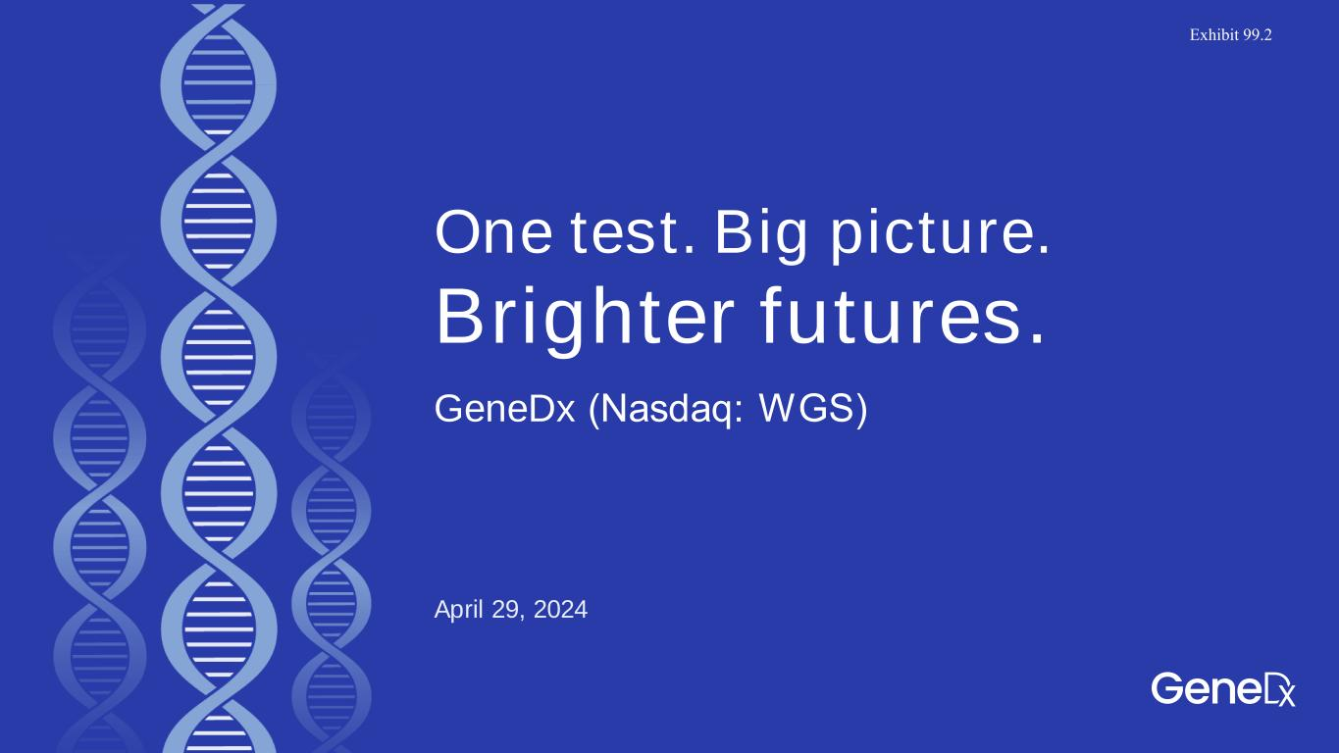

One test. Big picture. Brighter futures. April 29, 2024 GeneDx (Nasdaq: WGS)​ Exhibit 99.2

2 Disclaimer This presentation contains forward-looking statements under the meaning of the Private Securities Litigation Reform Act of 1995. Forward-looking statements are statements that do not relate to historical facts and events and such statements and opinions pertaining to the future that, for example, contain wording such as “may,” “might,” “will,” “could,” “would,” “should,” “expect,” “intend,” “plan,” “objective,” “anticipate,” “believe,” “estimate,” “predict,” “potential,” “continue,” “ongoing,” or the negative of these terms, or other comparable terminology intended to identify statements about the future. Forward-looking statements contained in this presentation may include, but are not limited to, statements about: our future performance and our market opportunity, and our expectations regarding full year 2024 revenue, adjusted gross margin profile and cash burn and our expectation of turning profitable in 2025. We cannot assure that the forward-looking statements in this presentation will prove to be accurate. Furthermore, if our forward-looking statements prove to be inaccurate, the inaccuracy may be material. These statements involve known and unknown risks, uncertainties and other important factors that may cause our actual results, levels of activity, performance or achievements to be materially different from the information expressed or implied by these forward-looking statements. The forward-looking statements and opinions contained in this presentation are based on our management’s beliefs and assumptions and are based upon information currently available to our management as of the date of this presentation and, while we believe such information forms a reasonable basis for such statements, such information may be limited or incomplete, and our statements should not be read to indicate that we have conducted an exhaustive inquiry into, or review of, all potentially available relevant information. Many factors could cause actual future events to differ materially from the forward-looking statements in this presentation, including but not limited to: (i) the ability to implement business plans, goals and forecasts, and identify and realize additional opportunities, (ii) the risk of downturns and a changing regulatory landscape in the highly competitive healthcare industry, and (iii) the size and growth of the market in which we operate. The information, opinions and forward- looking statements contained in this announcement speak only as of its date and are subject to change without notice. This presentation contains estimates, projections and other information concerning our industry, our business, and the markets for our products and services. Information that is based on estimates, forecasts, projections, market research or similar methodologies is inherently subject to uncertainties, and actual events or circumstances may differ materially from events and circumstances that are assumed in this information. Unless otherwise expressly stated, we obtained this industry, business, market and other data from our own internal estimates and research as well as from reports, research surveys, studies and similar data prepared by market research firms and other third parties, industry, medical and general publications, government data and similar sources. While we believe our internal company research as to such matters is reliable and the market definitions are appropriate, neither such research nor these definitions have been verified by any independent source. We discuss these and other risks and uncertainties in greater detail in the sections entitled “Risk Factors” and "Management's Discussion and Analysis of Financial Condition and Results of Operations" in our periodic reports and other filings we make with the SEC from time to time. Given these uncertainties, you should not place undue reliance on the forward-looking statements. Moreover, we operate in a very competitive and rapidly changing environment. New risks emerge from time to time. Except as required by law, we undertake no obligation to update publicly any forward-looking statements for any reason after the date of this presentation to conform these statements to actual results or to changes in our expectations. We file reports, proxy statements, and other information with the SEC. Such reports, proxy statements, and other information concerning us are available www.sec.gov. Requests for copies of such documents should be directed to our Investor Relations department at GeneDx Holdings Corp. 333 Ludlow Street, North Tower, Stamford, Connecticut, 06902. Our telephone number is 800-298-6470.

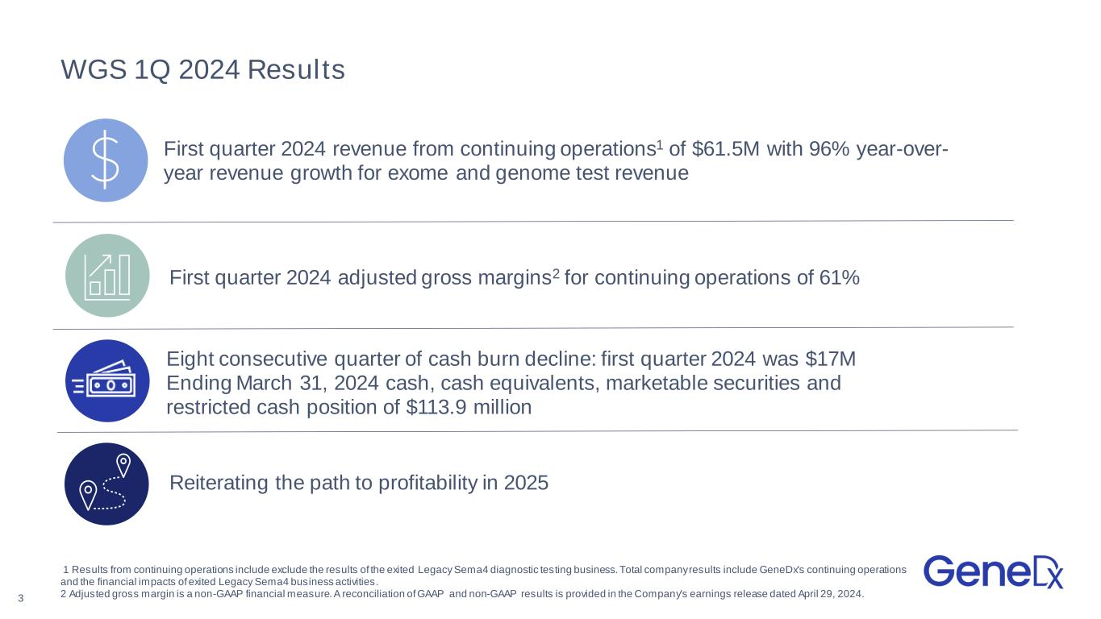
WGS 1Q 2024 Results First quarter 2024 revenue from continuing operations1 of $61.5M with 96% year-over- year revenue growth for exome and genome test revenue Reiterating the path to profitability in 2025 First quarter 2024 adjusted gross margins2 for continuing operations of 61% Eight consecutive quarter of cash burn decline: first quarter 2024 was $17M Ending March 31, 2024 cash, cash equivalents, marketable securities and restricted cash position of $113.9 million 1 Results from continuing operations include exclude the results of the exited Legacy Sema4 diagnostic testing business. Total company results include GeneDx's continuing operations and the financial impacts of exited Legacy Sema4 business activities. 2 Adjusted gross margin is a non-GAAP financial measure. A reconciliation of GAAP and non-GAAP results is provided in the Company's earnings release dated April 29, 2024.3

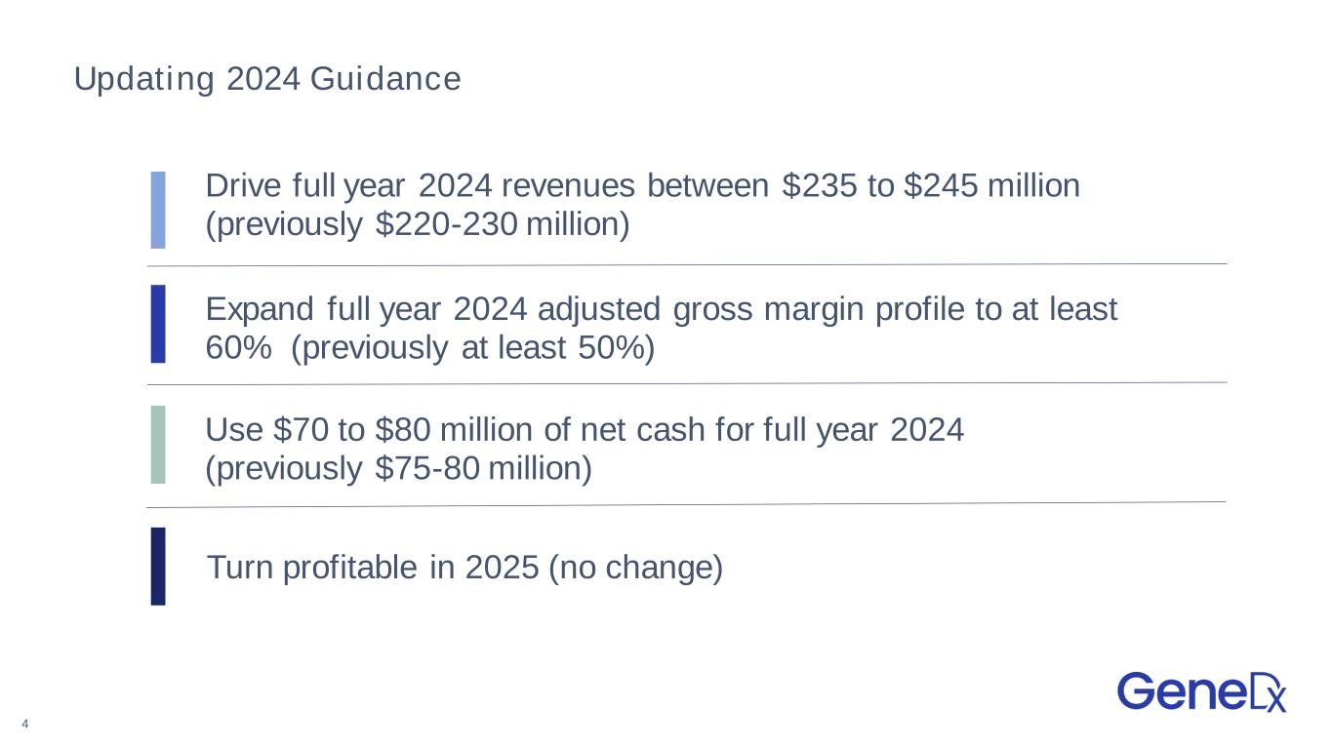
Updating 2024 Guidance Drive full year 2024 revenues between $235 to $245 million (previously $220-230 million) Expand full year 2024 adjusted gross margin profile to at least 60% (previously at least 50%) Use $70 to $80 million of net cash for full year 2024 (previously $75-80 million) Turn profitable in 2025 (no change) 4

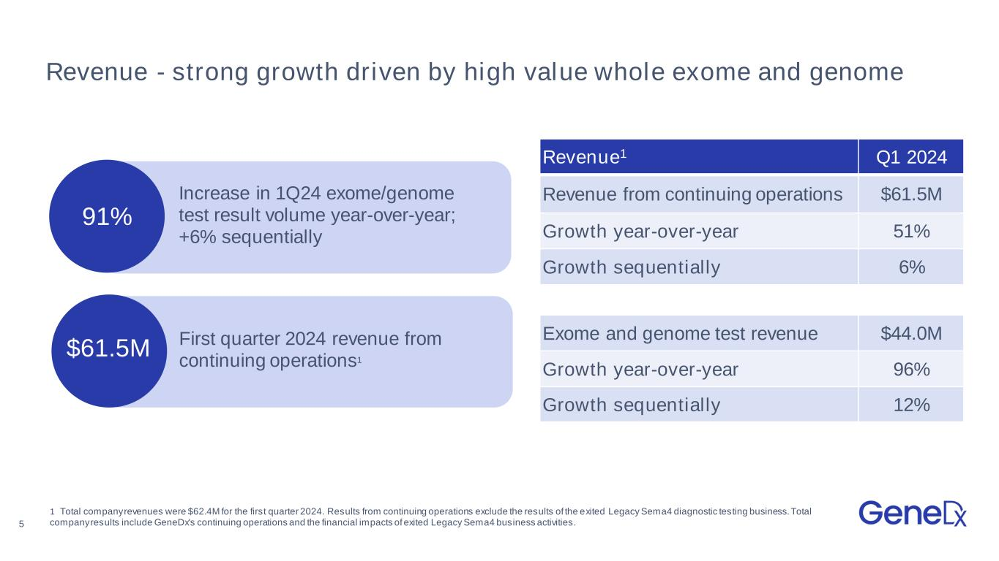
5 91% Revenue - strong growth driven by high value whole exome and genome Revenue1 Q1 2024 Revenue from continuing operations $61.5M Growth year-over-year 51% Growth sequentially 6% Exome and genome test revenue $44.0M Growth year-over-year 96% Growth sequentially 12% Increase in 1Q24 exome/genome test result volume year-over-year; +6% sequentially 1 Total company revenues were $62.4M for the first quarter 2024. Results from continuing operations exclude the results of the exited Legacy Sema4 diagnostic testing business. Total company results include GeneDx's continuing operations and the financial impacts of exited Legacy Sema4 business activities. First quarter 2024 revenue from continuing operations1 $61.5M

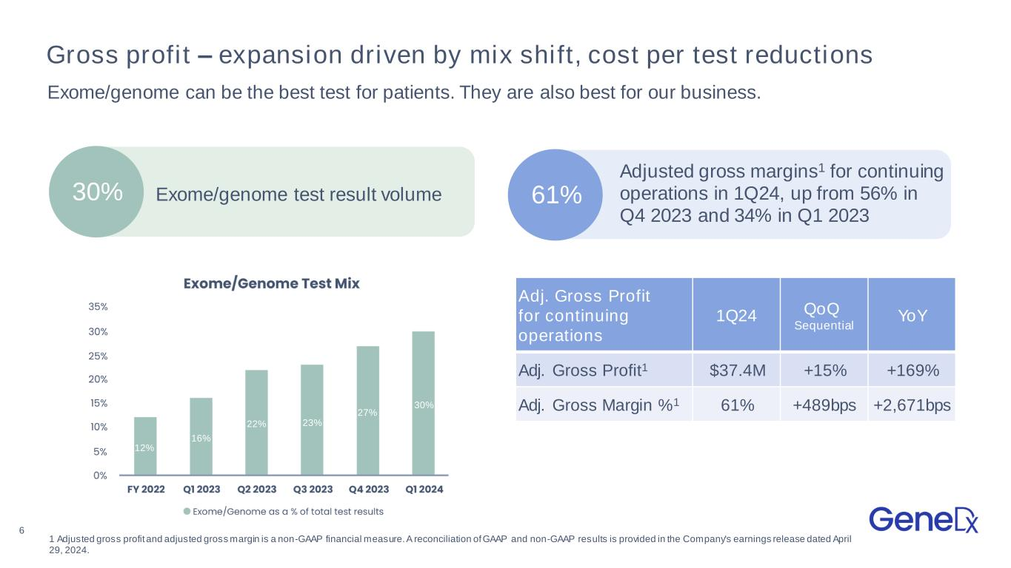
6 Gross profit – expansion driven by mix shift, cost per test reductions Adj. Gross Profit for continuing operations 1Q24 QoQ Sequential YoY Adj. Gross Profit1 $37.4M +15% +169% Adj. Gross Margin %1 61% +489bps +2,671bps Exome/genome can be the best test for patients. They are also best for our business. 30% Exome/genome test result volume Adjusted gross margins1 for continuing operations in 1Q24, up from 56% in Q4 2023 and 34% in Q1 2023 61% 12% 16% 22% 23% 27% 30% 1 Adjusted gross profit and adjusted gross margin is a non-GAAP financial measure. A reconciliation of GAAP and non-GAAP results is provided in the Company's earnings release dated April 29, 2024.

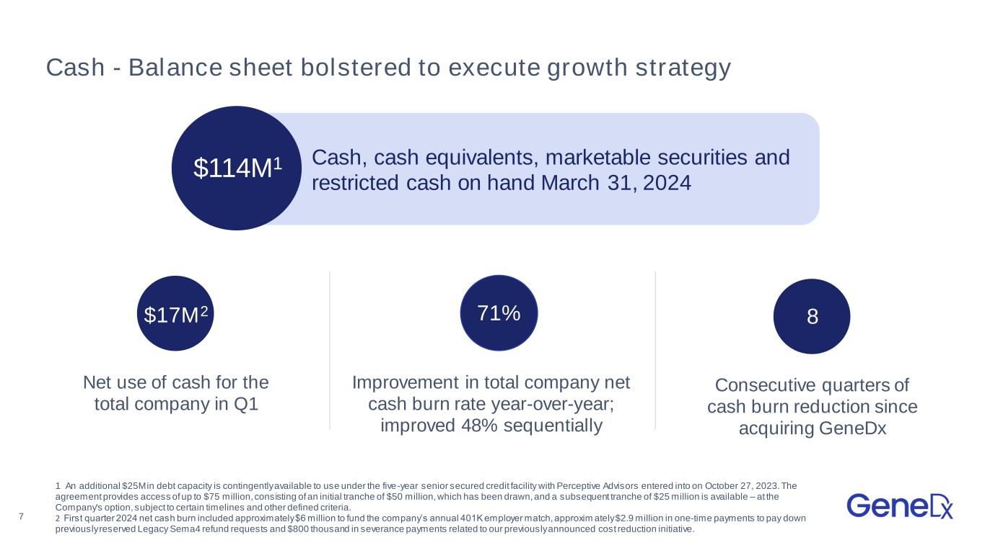
7 Cash - Balance sheet bolstered to execute growth strategy 1 An additional $25M in debt capacity is contingently available to use under the five-year senior secured credit facility with Perceptive Advisors entered into on October 27, 2023. The agreement provides access of up to $75 million, consisting of an initial tranche of $50 million, which has been drawn, and a subsequent tranche of $25 million is available – at the Company's option, subject to certain timelines and other defined criteria. 2 First quarter 2024 net cash burn included approximately $6 million to fund the company’s annual 401K employer match, approxim ately $2.9 million in one-time payments to pay down previously reserved Legacy Sema4 refund requests and $800 thousand in severance payments related to our previously announced cost reduction initiative. 1 $114M1 Cash, cash equivalents, marketable securities and restricted cash on hand March 31, 2024 8 Consecutive quarters of cash burn reduction since acquiring GeneDx Net use of cash for the total company in Q1 Improvement in total company net cash burn rate year-over-year; improved 48% sequentially $17M2 71%

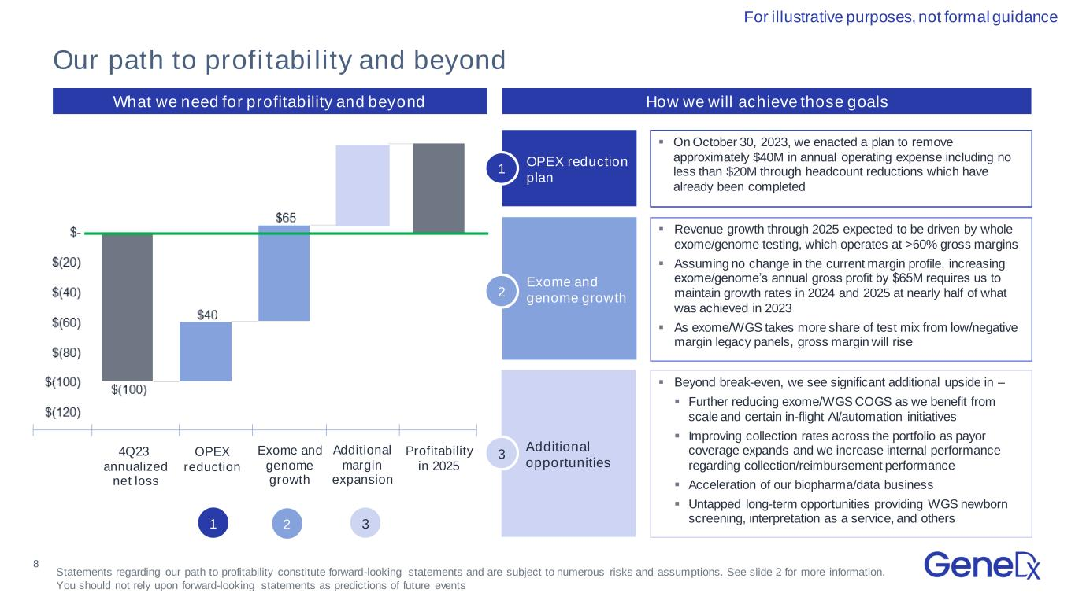
8 Confidential and Proprietary; Do Not Distribute OPEX reduction plan What we need for profitability and beyond ▪ On October 30, 2023, we enacted a plan to remove approximately $40M in annual operating expense including no less than $20M through headcount reductions which have already been completed ▪ Revenue growth through 2025 expected to be driven by whole exome/genome testing, which operates at >60% gross margins ▪ Assuming no change in the current margin profile, increasing exome/genome’s annual gross profit by $65M requires us to maintain growth rates in 2024 and 2025 at nearly half of what was achieved in 2023 ▪ As exome/WGS takes more share of test mix from low/negative margin legacy panels, gross margin will rise ▪ Beyond break-even, we see significant additional upside in – ▪ Further reducing exome/WGS COGS as we benefit from scale and certain in-flight AI/automation initiatives ▪ Improving collection rates across the portfolio as payor coverage expands and we increase internal performance regarding collection/reimbursement performance ▪ Acceleration of our biopharma/data business ▪ Untapped long-term opportunities providing WGS newborn screening, interpretation as a service, and others Exome and genome growth Additional opportunities 4Q23 annualized net loss OPEX reduction Additional margin expansion Exome and genome growth Profitability in 2025 Our path to profitability and beyond For illustrative purposes, not formal guidance How we will achieve those goals 1 2 3 1 2 3 Statements regarding our path to profitability constitute forward-looking statements and are subject to numerous risks and assumptions. See slide 2 for more information. You should not rely upon forward-looking statements as predictions of future events


9 One test. Big picture. Brighter futures.


10 Appendix

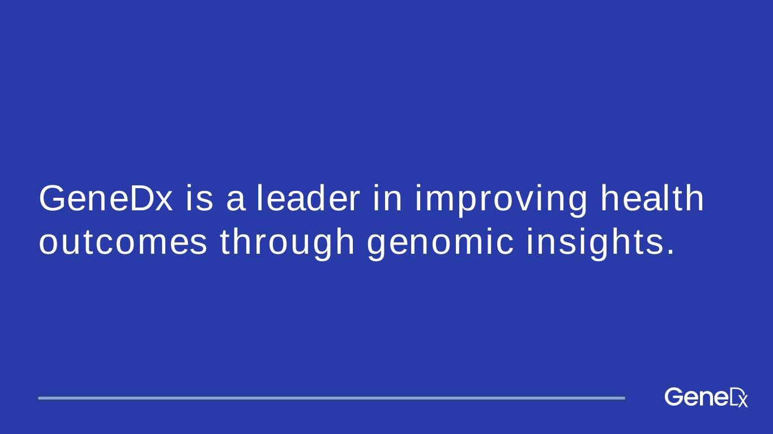
GeneDx is a leader in improving health outcomes through genomic insights.

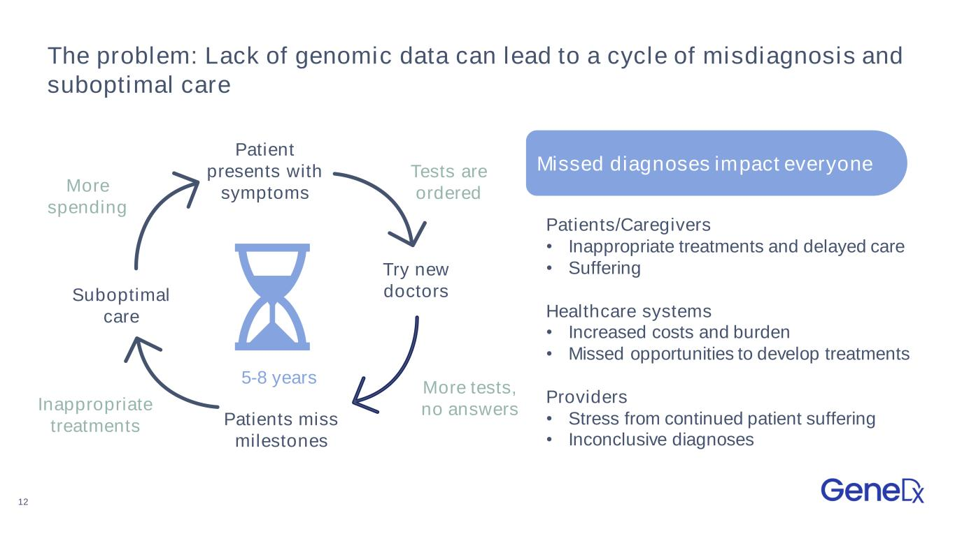
12 The problem: Lack of genomic data can lead to a cycle of misdiagnosis and suboptimal care Missed diagnoses impact everyone 5-8 years Patients/Caregivers • Inappropriate treatments and delayed care • Suffering Healthcare systems • Increased costs and burden • Missed opportunities to develop treatments Providers • Stress from continued patient suffering • Inconclusive diagnoses Try new doctors Patients miss milestones Patient presents with symptoms Suboptimal care More tests, no answersInappropriate treatments Tests are orderedMore spending

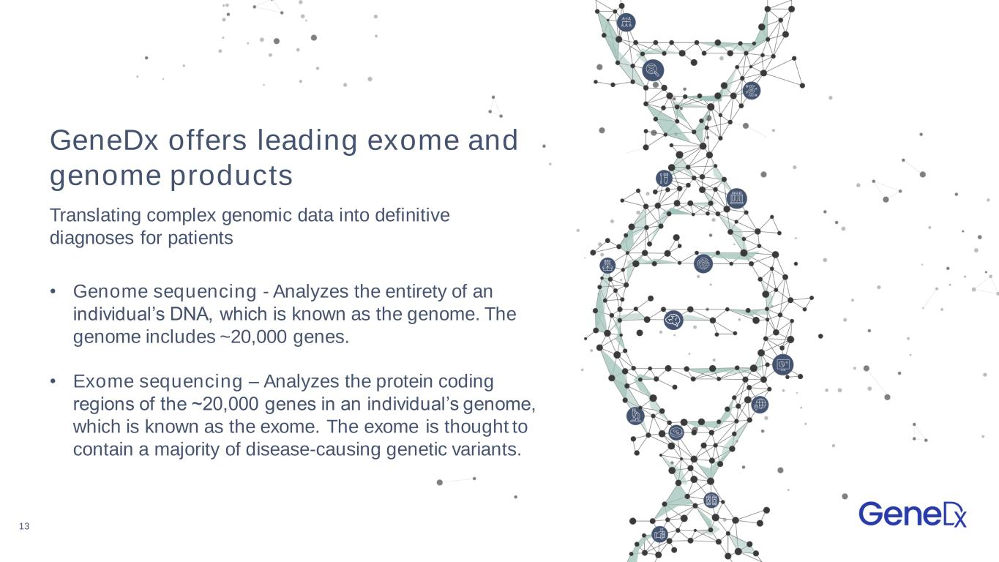
13 GeneDx offers leading exome and genome products • Genome sequencing - Analyzes the entirety of an individual’s DNA, which is known as the genome. The genome includes ~20,000 genes. • Exome sequencing – Analyzes the protein coding regions of the ~20,000 genes in an individual’s genome, which is known as the exome. The exome is thought to contain a majority of disease-causing genetic variants. Translating complex genomic data into definitive diagnoses for patients

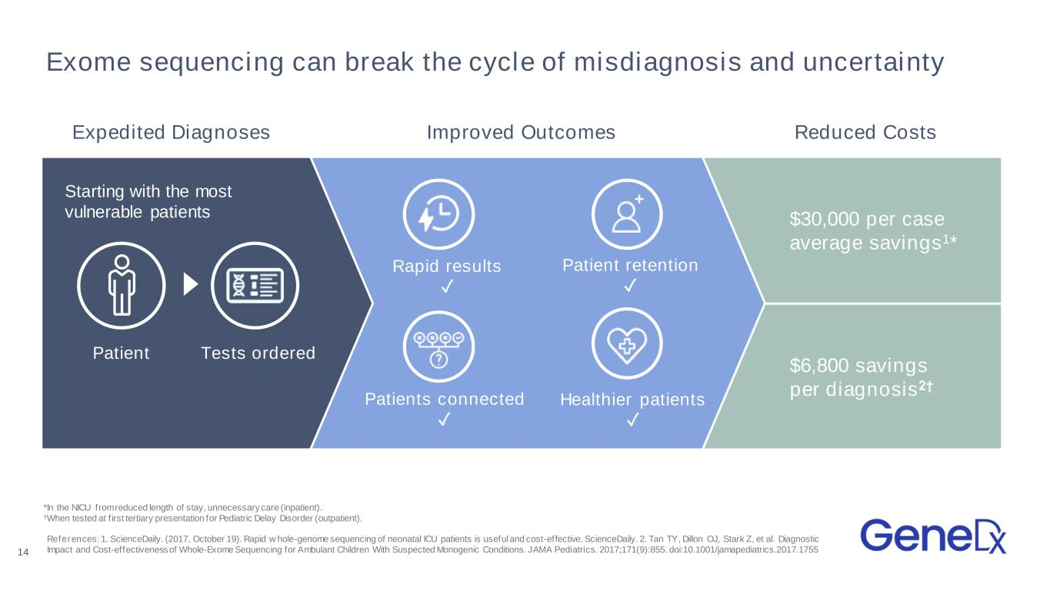
Exome sequencing can break the cycle of misdiagnosis and uncertainty $6,800 savings per diagnosis2† $30,000 per case average savings1* Rapid results ✓ Patient retention ✓ Patients connected ✓ Healthier patients ✓ Tests ordered Starting with the most vulnerable patients References: 1. ScienceDaily. (2017, October 19). Rapid w hole-genome sequencing of neonatal ICU patients is useful and cost-effective. ScienceDaily. 2. Tan TY, Dillon OJ, Stark Z, et al. Diagnostic Impact and Cost-effectiveness of Whole-Exome Sequencing for Ambulant Children With Suspected Monogenic Conditions. JAMA Pediatrics. 2017;171(9):855. doi:10.1001/jamapediatrics.2017.1755 *In the NICU from reduced length of stay, unnecessary care (inpatient). †When tested at f irst tertiary presentation for Pediatric Delay Disorder (outpatient). 14 Patient Expedited Diagnoses Improved Outcomes Reduced Costs

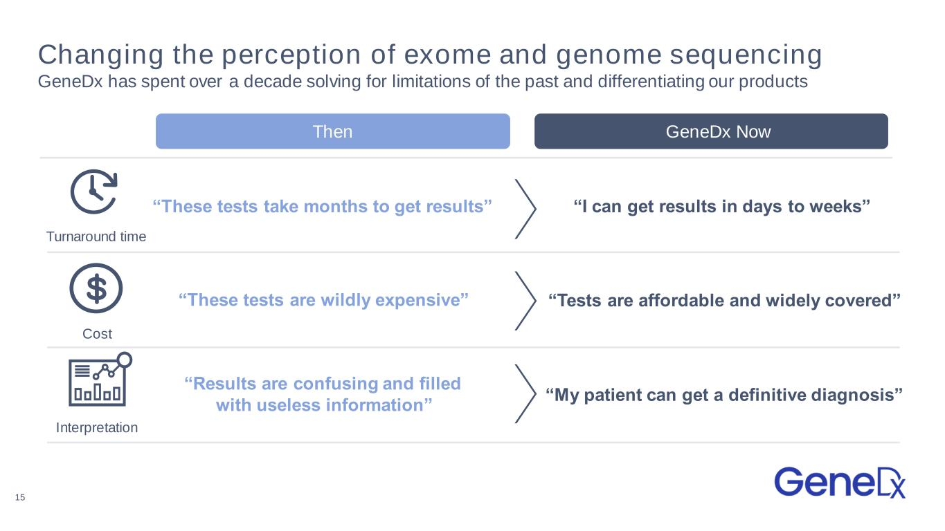
Changing the perception of exome and genome sequencing GeneDx has spent over a decade solving for limitations of the past and differentiating our products Then GeneDx Now “I can get results in days to weeks”“These tests take months to get results” “These tests are wildly expensive” “Tests are affordable and widely covered” “Results are confusing and filled with useless information” “My patient can get a definitive diagnosis” Turnaround time Cost Interpretation 15

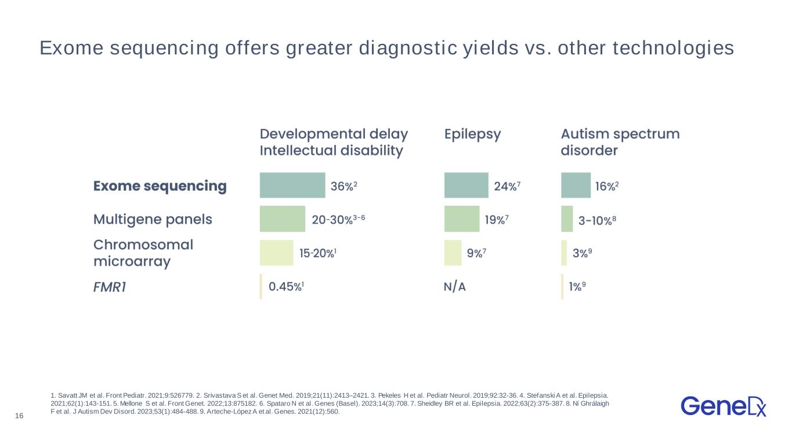
16 1. Savatt JM et al. Front Pediatr. 2021;9:526779. 2. Srivastava S et al. Genet Med. 2019;21(11):2413–2421. 3. Pekeles H et al. Pediatr Neurol. 2019;92:32-36. 4. Stefanski A et al. Epilepsia. 2021;62(1):143-151. 5. Mellone S et al. Front Genet. 2022;13:875182. 6. Spataro N et al. Genes (Basel). 2023;14(3):708. 7. Sheidley BR et al. Epilepsia. 2022;63(2):375-387. 8. Ní Ghrálaigh F et al. J Autism Dev Disord. 2023;53(1):484-488. 9. Arteche-López A et al. Genes. 2021(12):560. Exome sequencing offers greater diagnostic yields vs. other technologies

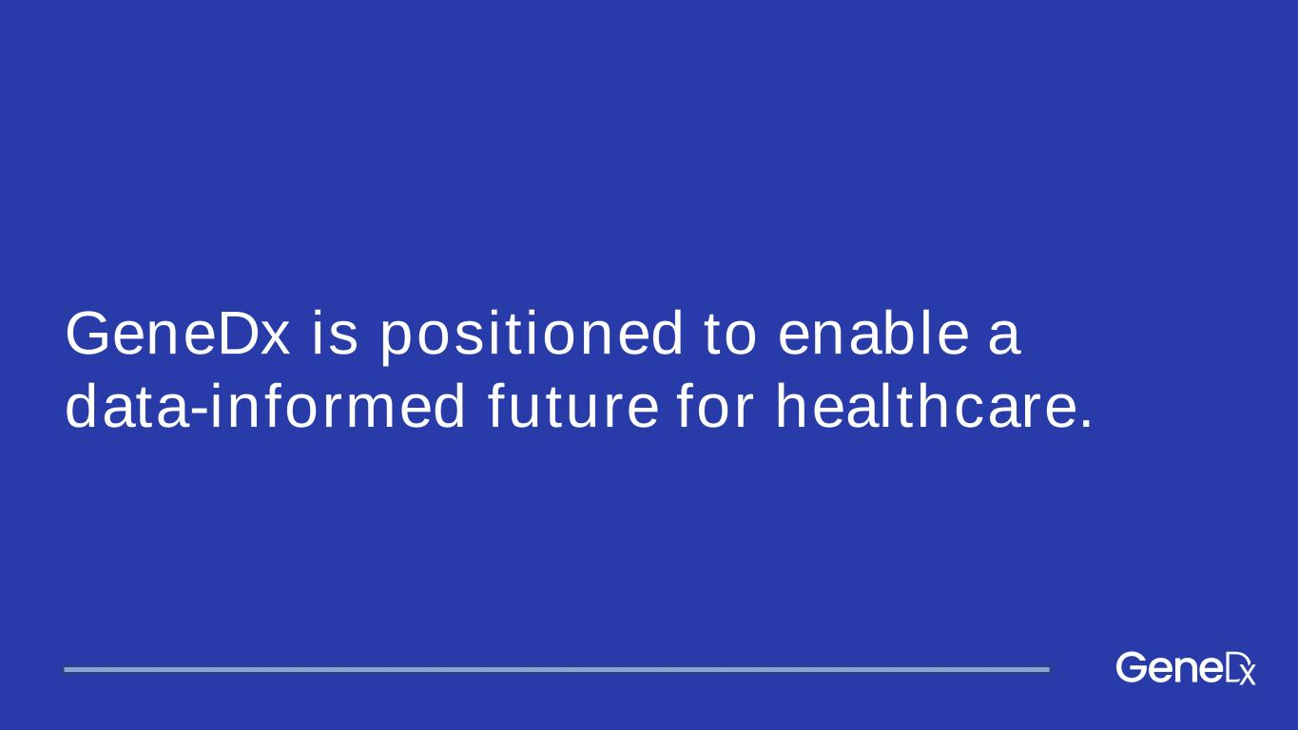
GeneDx is positioned to enable a data-informed future for healthcare.

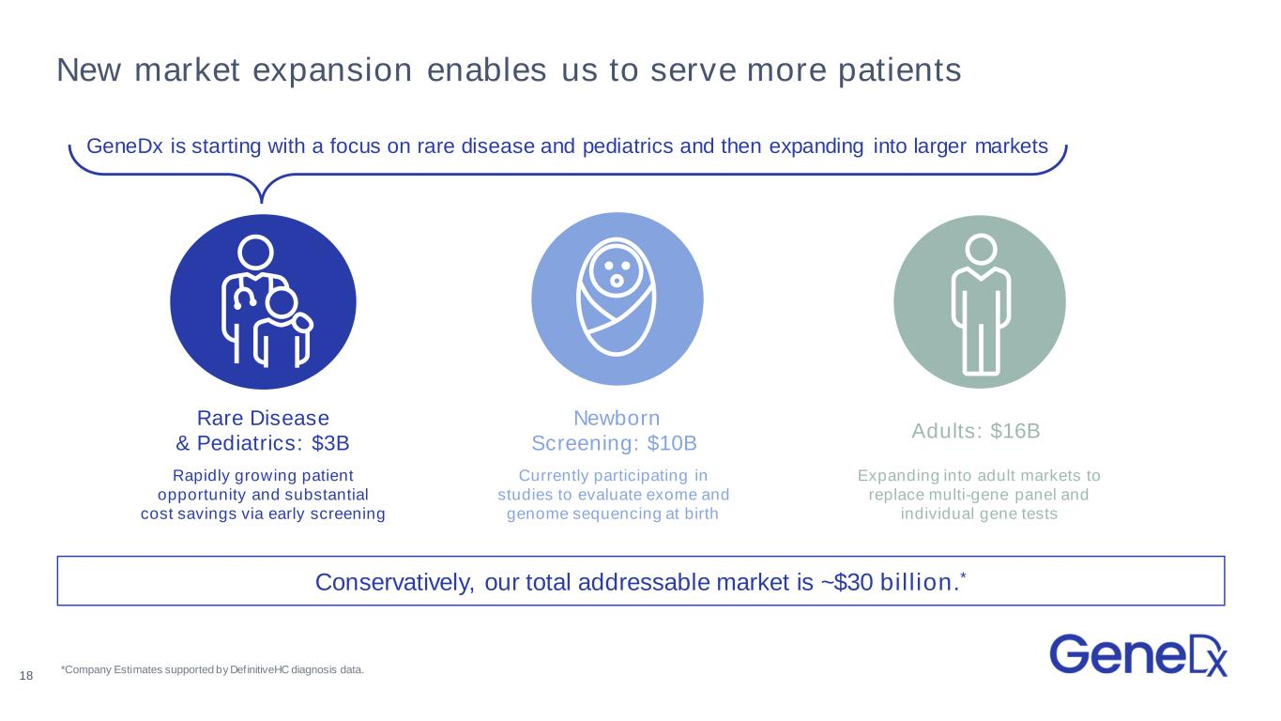
Adults: $16B Expanding into adult markets to replace multi-gene panel and individual gene tests New market expansion enables us to serve more patients Rapidly growing patient opportunity and substantial cost savings via early screening Rare Disease & Pediatrics: $3B *Company Estimates supported by DefinitiveHC diagnosis data. Conservatively, our total addressable market is ~$30 billion.* Newborn Screening: $10B Currently participating in studies to evaluate exome and genome sequencing at birth 18 GeneDx is starting with a focus on rare disease and pediatrics and then expanding into larger markets

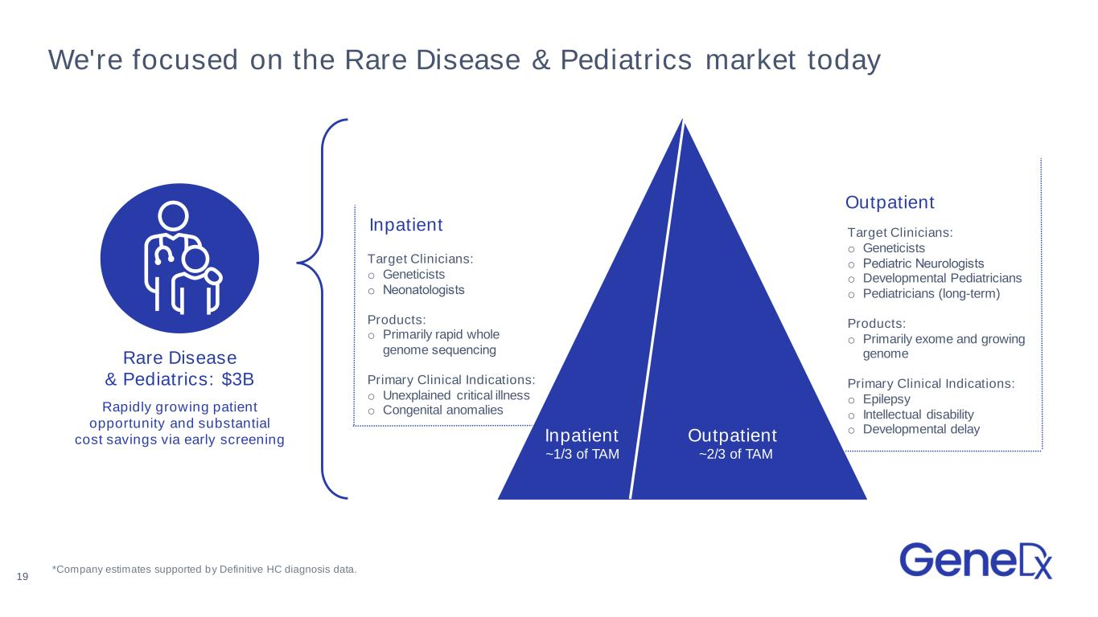
We're focused on the Rare Disease & Pediatrics market today Rapidly growing patient opportunity and substantial cost savings via early screening Rare Disease & Pediatrics: $3B 19 Inpatient ~1/3 of TAM Outpatient ~2/3 of TAM Target Clinicians: o Geneticists o Pediatric Neurologists​ o Developmental Pediatricians o Pediatricians (long-term) Products: o Primarily exome and growing genome Primary Clinical Indications: o Epilepsy o Intellectual disability o Developmental delay Target Clinicians: o Geneticists o Neonatologists​ Products: o Primarily rapid whole genome sequencing​ Primary Clinical Indications: o Unexplained critical illness o Congenital anomalies Inpatient Outpatient *Company estimates supported by Definitive HC diagnosis data.

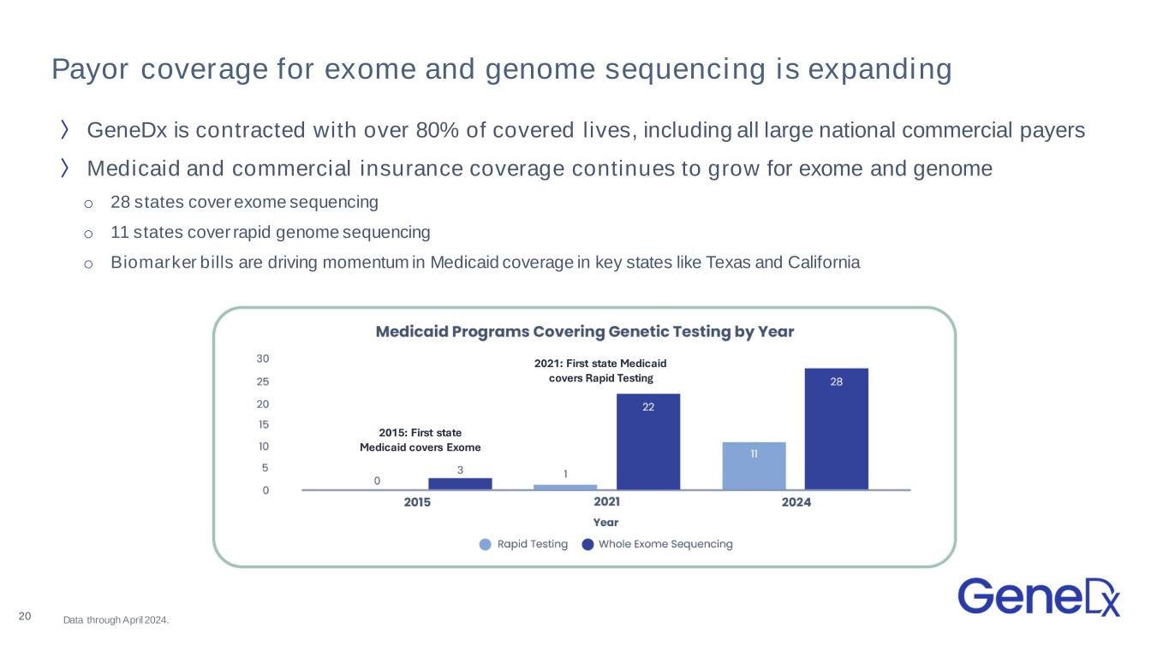
Payor coverage for exome and genome sequencing is expanding Data through April 2024.20 〉 GeneDx is contracted with over 80% of covered lives, including all large national commercial payers 〉Medicaid and commercial insurance coverage continues to grow for exome and genome o 28 states cover exome sequencing o 11 states cover rapid genome sequencing o Biomarker bills are driving momentum in Medicaid coverage in key states like Texas and California 2021: First state Medicaid covers Rapid Testing 2015: First state Medicaid covers Exome

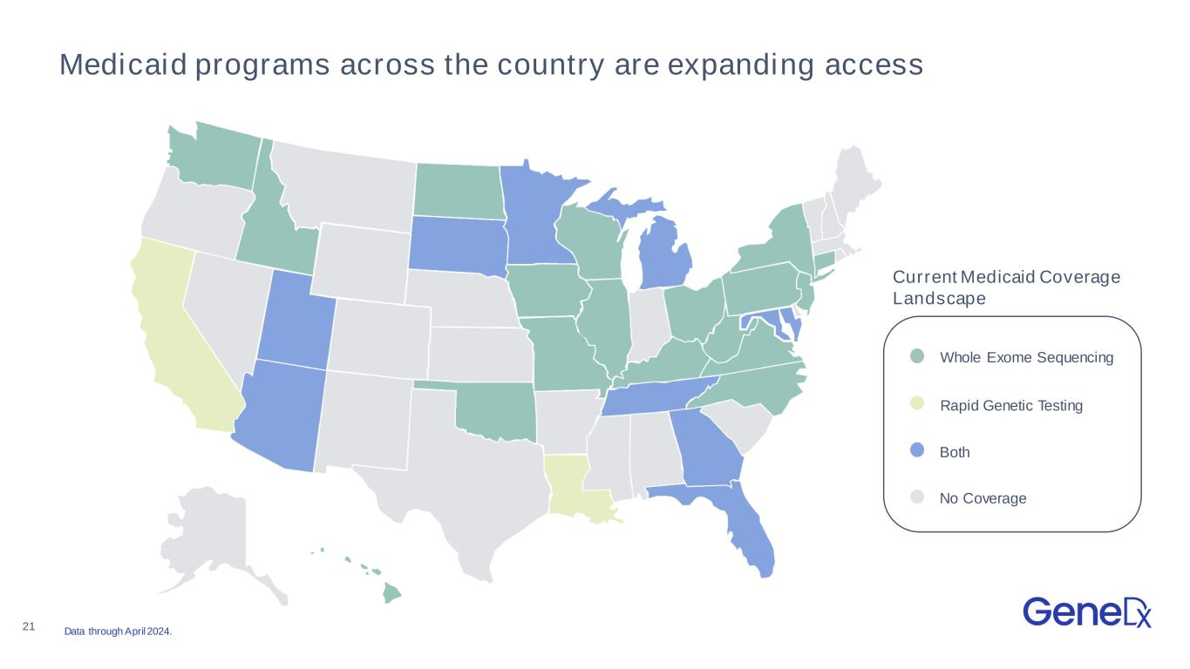
21 Medicaid programs across the country are expanding access Whole Exome Sequencing Rapid Genetic Testing Both No Coverage Current Medicaid Coverage Landscape Data through April 2024.

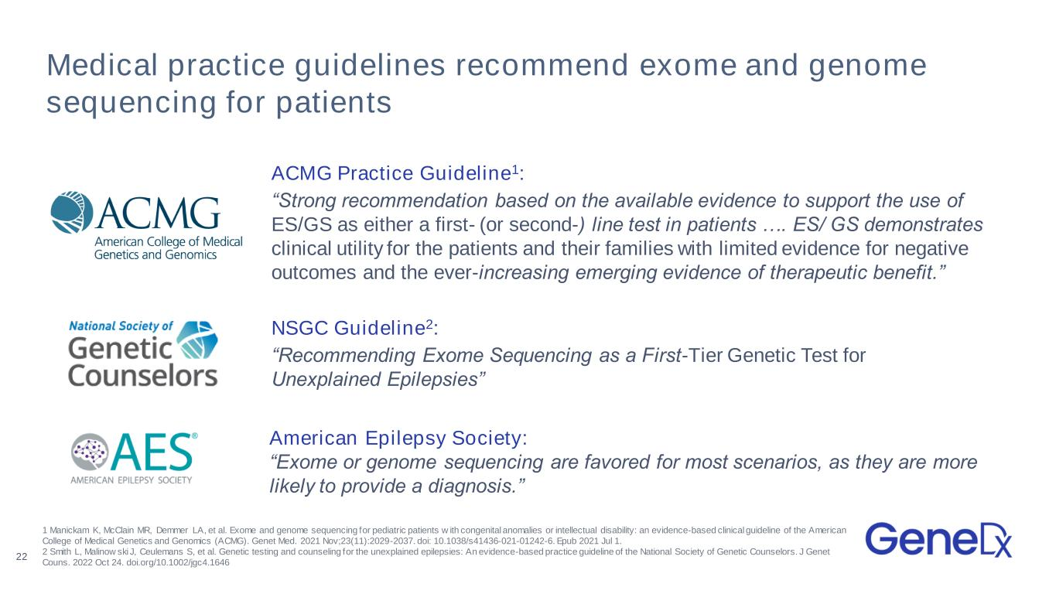
Medical practice guidelines recommend exome and genome sequencing for patients ACMG Practice Guideline1: “Strong recommendation based on the available evidence to support the use of ES/GS as either a first- (or second-) line test in patients …. ES/ GS demonstrates clinical utility for the patients and their families with limited evidence for negative outcomes and the ever-increasing emerging evidence of therapeutic benefit.” NSGC Guideline2: “Recommending Exome Sequencing as a First-Tier Genetic Test for Unexplained Epilepsies” 22 American Epilepsy Society: “Exome or genome sequencing are favored for most scenarios, as they are more likely to provide a diagnosis.” 1 Manickam K, McClain MR, Demmer LA, et al. Exome and genome sequencing for pediatric patients w ith congenital anomalies or intellectual disability: an evidence-based clinical guideline of the American College of Medical Genetics and Genomics (ACMG). Genet Med. 2021 Nov;23(11):2029-2037. doi: 10.1038/s41436-021-01242-6. Epub 2021 Jul 1. 2 Smith L, Malinow ski J, Ceulemans S, et al. Genetic testing and counseling for the unexplained epilepsies: An evidence-based practice guideline of the National Society of Genetic Counselors. J Genet Couns. 2022 Oct 24. doi.org/10.1002/jgc4.1646

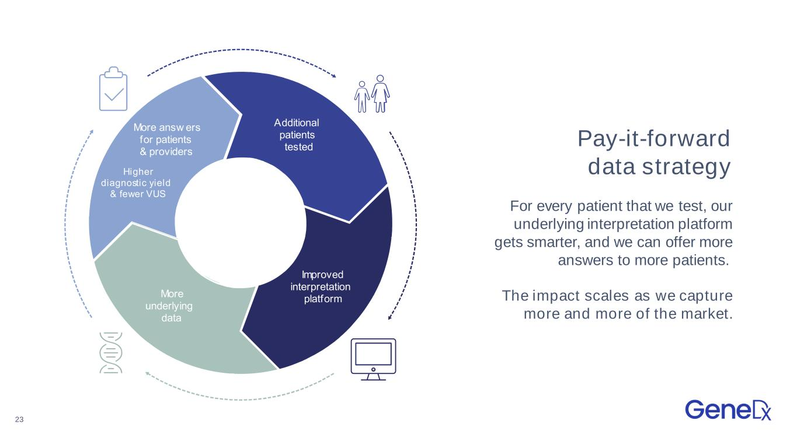
23 Pay-it-forward data strategy For every patient that we test, our underlying interpretation platform gets smarter, and we can offer more answers to more patients. The impact scales as we capture more and more of the market. Additional patients tested mproved interpretation platform More underlying data More answ ers for patients providers igher diagnostic y ield f ewer S Additional patients tested mproved interpretation platform More underlying data More answ ers for patients providers igher diagnostic yield fewer S

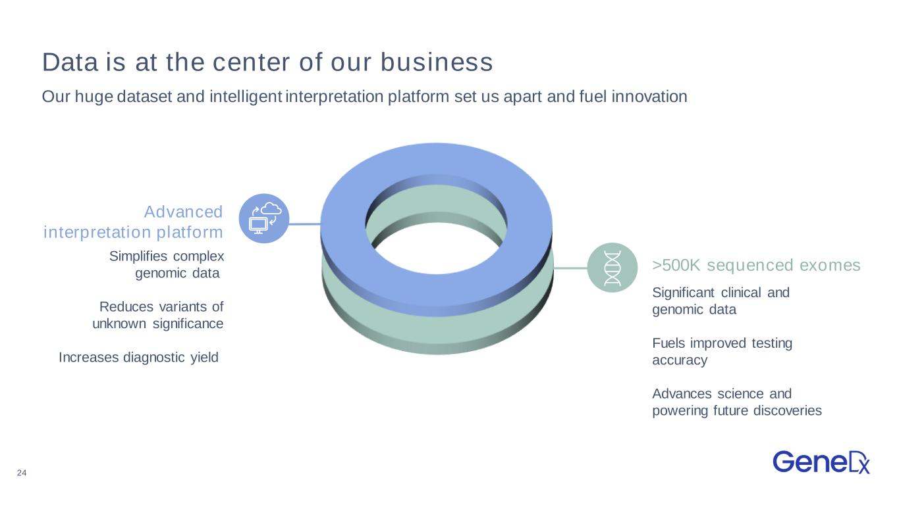
24 >500K sequenced exomes Data is at the center of our business Our huge dataset and intelligent interpretation platform set us apart and fuel innovation Simplifies complex genomic data Reduces variants of unknown significance Increases diagnostic yield Significant clinical and genomic data Fuels improved testing accuracy Advances science and powering future discoveries Advanced interpretation platform

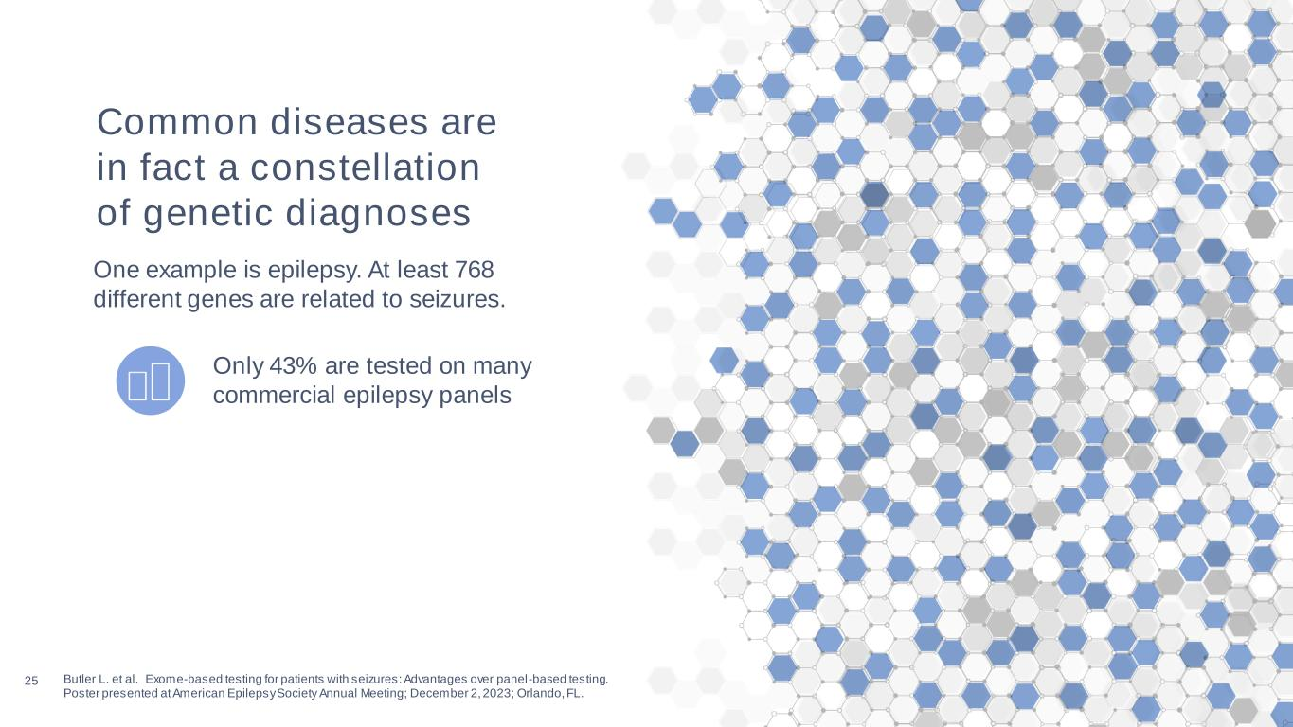
25 Butler L. et al. Exome-based testing for patients with seizures: Advantages over panel-based testing. Poster presented at American Epilepsy Society Annual Meeting; December 2, 2023; Orlando, FL. Only 43% are tested on many commercial epilepsy panels Common diseases are in fact a constellation of genetic diagnoses One example is epilepsy. At least 768 different genes are related to seizures.

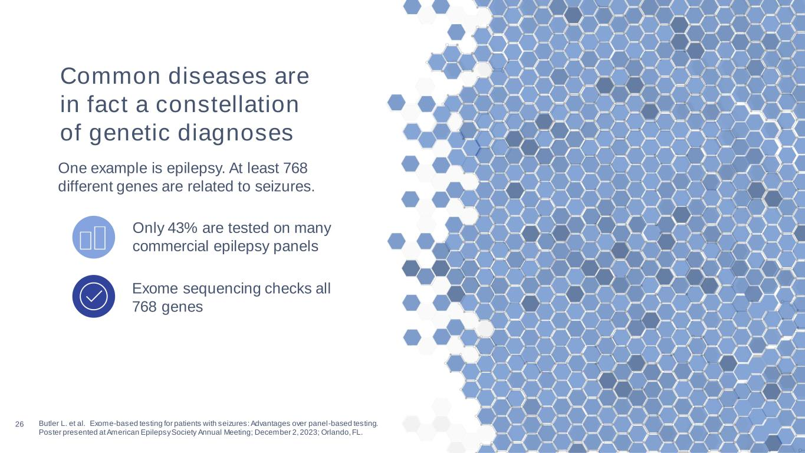
26 Butler L. et al. Exome-based testing for patients with seizures: Advantages over panel-based testing. Poster presented at American Epilepsy Society Annual Meeting; December 2, 2023; Orlando, FL. Exome sequencing checks all 768 genes Only 43% are tested on many commercial epilepsy panels Common diseases are in fact a constellation of genetic diagnoses One example is epilepsy. At least 768 different genes are related to seizures.

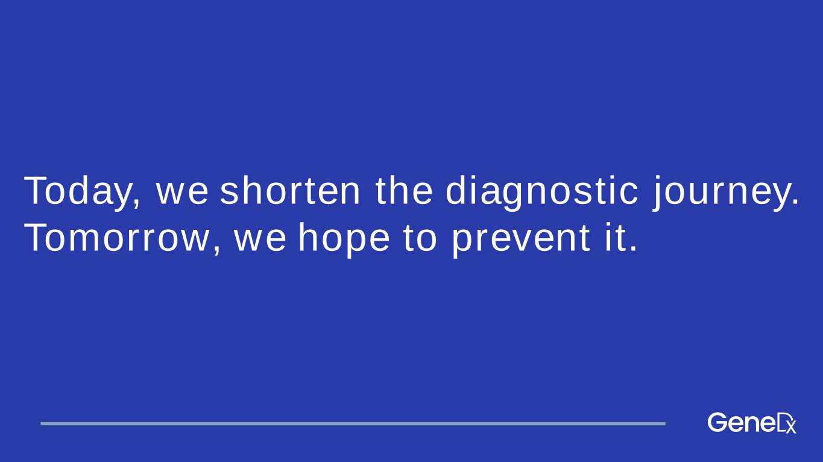
Today, we shorten the diagnostic journey. Tomorrow, we hope to prevent it.

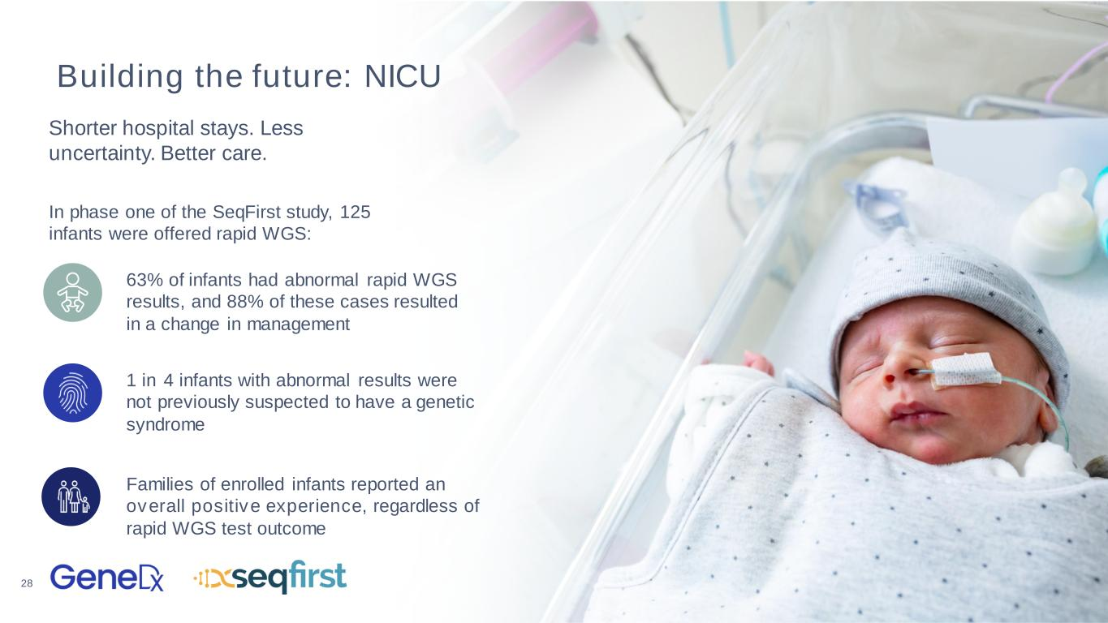
28 Building the future: NICU Shorter hospital stays. Less uncertainty. Better care. 63% of infants had abnormal rapid WGS results, and 88% of these cases resulted in a change in management In phase one of the SeqFirst study, 125 infants were offered rapid WGS: 1 in 4 infants with abnormal results were not previously suspected to have a genetic syndrome Families of enrolled infants reported an overall positive experience, regardless of rapid WGS test outcome

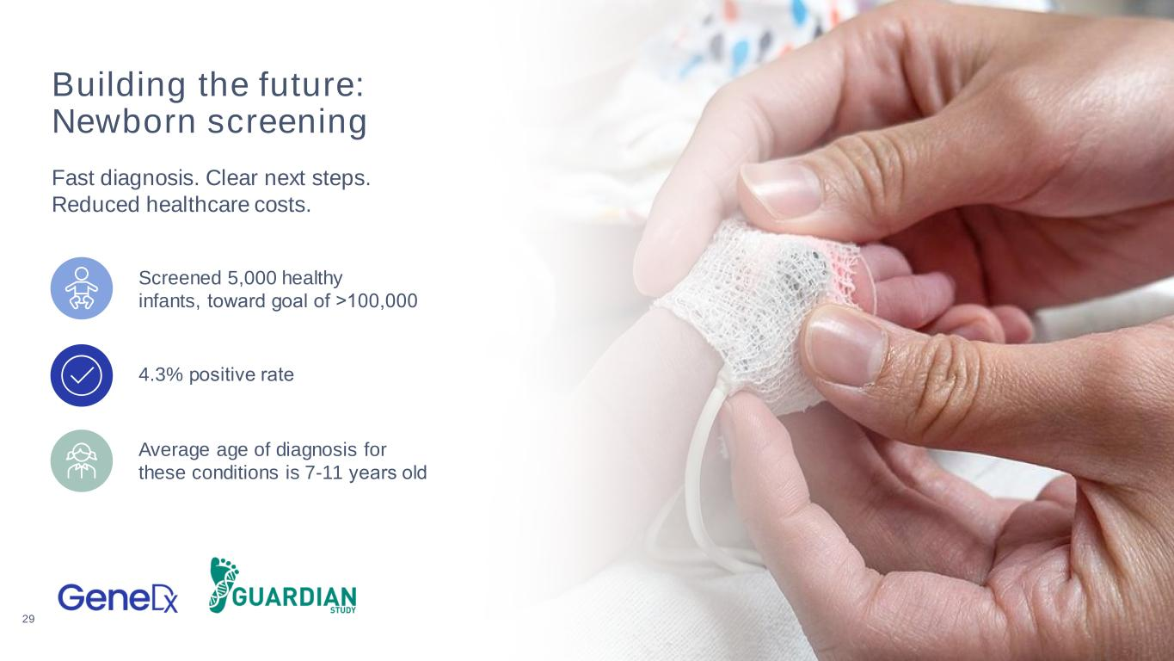
29 Building the future: Newborn screening Fast diagnosis. Clear next steps. Reduced healthcare costs. Screened 5,000 healthy infants, toward goal of >100,000​ 4.3% positive rate​ Average age of diagnosis for these conditions is 7-11 years old​


30 Building the future: Partnerships Enriched data. Empowered drug discovery. mproved outcomes.​ GeneDx offers solutions across the pharma drug development pipeline​ Find Connect Understand

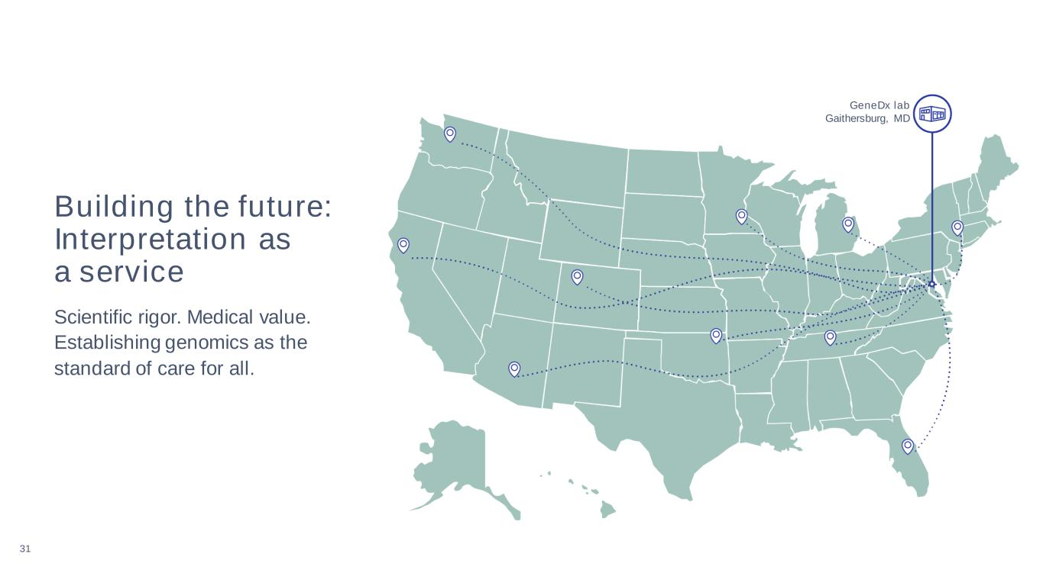
31 Building the future: Interpretation as a service Scientific rigor. Medical value. Establishing genomics as the standard of care for all. GeneDx lab Gaithersburg, MD

