UNITED STATES
SECURITIES AND EXCHANGE COMMISSION
Washington, D.C. 20549
FORM 8-K
CURRENT REPORT
Pursuant to Section 13 OR 15(d) of The Securities Exchange Act of 1934
Date of Report (date of earliest event reported): May 12, 2022
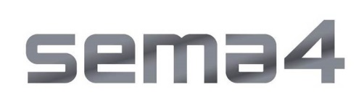
Sema4 Holdings Corp.
(Exact name of registrant as specified in its charter)
Delaware |  |  |  |  |  |  |  |  | 001-39482 |  |  |  |  |  |  |  |  | 85-1966622
(State or other jurisdiction of incorporation or organization) |  |  |  |  |  |  |  |  | (Commission File Number) |  |  |  |  |  |  |  |  | (I.R.S. Employer Identification No.)
333 Ludlow Street, North Tower, 8th Floor |  |  |  |  |  |  |  |  |  |  |  |  |  |  |  |  |  | 06902
Stamford, |  |  | Connecticut
(Address of Principal Executive Offices) |  |  |  |  |  |  |  |  |  |  |  |  |  |  |  |  |  | (Zip Code)
(800) 298-6470
Registrant's telephone number, including area code
(Former name or former address, if changed since last report.)
Check the appropriate box below if the Form 8-K filing is intended to simultaneously satisfy the filing obligation of the registrant under any of the following provisions (see General Instruction A.2. below):
☐ Written communications pursuant to Rule 425 under the Securities Act (17 CFR 230.425)
☐ Soliciting material pursuant to Rule 14a-12 under the Exchange Act (17 CFR 240.14a-12)
☐ Pre-commencement communications pursuant to Rule 14d-2(b) under the Exchange Act (17 CFR 240.14d-2(b))
☐ Pre-commencement communications pursuant to Rule 13e-4(c) under the Exchange Act (17 CFR 240.13e-4(c))
Securities registered pursuant to Section 12(b) of the Act:
Title of each class |  |  |  |  |  | Trading Symbol(s) |  |  |  |  |  | Name of each exchange on which registered
Class A common stock, par value $0.0001 per share |  |  |  |  |  | SMFR |  |  |  |  |  | The Nasdaq Global Select Market
Warrants to purchase one share of Class A common stock, each at an exercise price of $11.50 per share |  |  |  |  |  | SMFRW |  |  |  |  |  | The Nasdaq Global Select Market
Indicate by check mark whether the registrant is an emerging growth company as defined in Rule 405 of the Securities Act of 1933 (§230.405 of this chapter) or Rule 12b-2 of the Securities Exchange Act of 1934 (§240.12b-2 of this chapter).
Emerging growth company ☒
If an emerging growth company, indicate by check mark if the registrant has elected not to use the extended transition period for complying with any new or revised financial accounting standards provided pursuant to Section 13(a) of the Exchange Act.☐

Item 2.02 Results of Operations and Financial Condition.
On May 12, 2022, Sema4 Holdings Corp. (“Sema4 Holdings” or the “Company”) issued a press release (the “Press Release”) and will hold a conference call announcing the Company's financial results for the three months ended March 31, 2022. Copies of the Press Release and Earnings Presentation are furnished as Exhibits 99.1 and 99.2, respectively, to this Current Report on Form 8-K.
The information furnished with this Item 2.02, including Exhibits 99.1 and 99.2, shall not be deemed “filed” for purposes of Section 18 of the Securities Exchange Act of 1934, as amended (the “Exchange Act”), or otherwise subject to the liabilities of that section, nor shall it be deemed incorporated by reference into any other filing under the Securities Act of 1933, as amended, or the Exchange Act, except as expressly set forth by specific reference in such a filing.

Item 9.01 Financial Statement and Exhibits.
(d) Exhibits.
Exhibit  Number |  |  | Description
99.1 |  |  | Press Release, dated May 12, 2022, regarding the Registrant’s results for the quarter ended March 31, 2022
99.2 |  |  | Earnings Presentation, dated May 12, 2022

SIGNATURES
Pursuant to the requirements of the Securities Exchange Act of 1934, the registrant has duly caused this report to be signed on its behalf by the undersigned hereunto duly authorized.
 |  |  |  |  |  | Sema4 Holdings Corp.
Date: |  |  | May 12, 2022 |  |  | By: |  |  | /s/ Katherine Stueland
 |  |  |  |  |  | Name: |  |  | Katherine Stueland
 |  |  |  |  |  | Title: |  |  | Chief Executive Officer

Exhibit 99.1

Sema4 Reports First Quarter 2022 Financial Results and Business Highlights
Total revenue of $53.9 million
1,300 basis points of sequential adjusted gross margin improvement
Reaffirming full year 2022 pro forma revenue target
New operating model and focus on efficiencies to reduce 2022 cash burn by an estimated $50 million, extending cash runway into 2024
Sema4 to host conference call today at 4:30 p.m. ET
STAMFORD, CT — May 12, 2022 — Sema4 Holdings Corp. (Nasdaq: SMFR) (“Sema4”), an AI-driven genomic and clinical data intelligence platform company, today reported its financial results for the first quarter ended March 31, 2022 and provided an update on key strategic and operational initiatives.
“I am very pleased by our start to the year, which shows fundamental improvements from a financial perspective, as well as significant progress across our strategic objectives. We delivered record test volume and expanded engagement across our health system partnerships,” said Eric Schadt, PhD, President and Chief Research & Development Officer of Sema4. “We were also delighted to complete the acquisition of GeneDx and welcome Katherine Stueland as our new CEO to further scale, operationalize, and strengthen Sema4.”
“With the strength of Sema4’s platform, the addition of GeneDx will accelerate the delivery of precision medicine and enable even broader data capabilities than before. We have strong momentum that puts us on a path to deliver on our 2022 pro forma revenue target of $350 million. In addition, we are focused on operating efficiencies that will reduce 2022 cash burn by an estimated $50 million compared to our original plan, extending our cash runway into 2024,” said Katherine Stueland, Chief Executive Officer of Sema4. “Since closing the GeneDx acquisition, we have streamlined our leadership team and established a new, agile operating model to drive growth, operating efficiency, and the delivery of transformational partnerships, all of which put us on a scalable path to profitability. With this focus, we can realize our vision of applying the use of genomics and large-scale clinical data to set a new standard of care, enabling comprehensive family health, from planning a pregnancy through every stage of life.”
First Quarter & Recent Highlights
•Testing volumes were up 27% in the first quarter of 2022 compared to the same period of 2021, with 84,925 tests resulted (excluding COVID-19 tests)
•Total revenue in the first quarter of 2022, excluding COVID-19 testing revenue, was $50.1 million compared to $48.3 million in the same period of 2021. Total revenue in the first quarter of 2022, including COVID-19 testing revenue, was $53.9 million compared to $64.2 million in the same period of 2021
•Completed the acquisition of GeneDx, Inc. (“GeneDx”) at the end of April, accelerating the Company’s path to improving gross margins and ultimately towards profitability
•Streamlined the leadership team to enable focused execution across key growth priorities, operating efficiency, and transformational health system and biopharma partnerships
•Closed $200 million in financing via private placement from leading growth and life sciences investors, including Pfizer, in conjunction with the completion of the GeneDx acquisition
•Expanded REPRESENT study in March to run nationally in partnership with community oncologists caring for patients with advanced cancer in diverse and traditionally underserved populations

First Quarter 2022 Financial Results
Total revenue for the first quarter of 2022 was $53.9 million compared to $64.2 million in the first quarter of 2021. The decline in year over year revenue was primarily attributable to a decrease in COVID-19 test volumes as a result of the decision to discontinue testing services at the end of the first quarter of 2022. This was partially offset by an increase in testing volumes of both our Women’s Health and Oncology product lines. First quarter revenue growth was 4% year-over-year and 6% sequentially (excluding COVID-19 testing revenue) vs. the fourth quarter of 2021.
Gross margin for the first quarter of 2022 was 10%. Adjusted gross margin for the first quarter of 2022 was 13%, as compared to adjusted gross margin of 22% for the same period in the prior year. Adjusted gross margin was up roughly 1,300 basis points sequentially vs. the fourth quarter of 2021.
Operating expenses for the first quarter of 2022 were $94.9 million. Adjusted operating expenses for the first quarter of 2022, which excludes stock-based compensation, restructuring, and transaction expenses, were $71.8 million compared to $43.9 million in the same period of 2021.
Net loss for the first quarter of 2022 was ($76.9) million. Adjusted net loss for the first quarter of 2022 was ($65.5) million compared to ($24.9) million in the same period of 2021.
Total cash and cash equivalents were $315.0 million as of March 31, 2022 and the Company’s $125 million revolving credit facility remains undrawn, bringing total liquidity to $440.0 million. As of April 29, 2022, Sema4 had 377,249,186 outstanding shares of Class A common stock.
Fiscal Year 2022 Guidance
Sema4 is reaffirming its previously issued full year 2022 pro forma revenue target of $350 million. The company now expects fiscal year 2022 total revenue to be $305-315 million, reflecting the inclusion of GeneDx for the eight months of ownership in 2022. Sema4 is raising its full year 2022 adjusted gross margin target and now expects full year 2022 gross margin to exceed 20%. The Company expects to end 2022 with more than $200 million of cash and cash equivalents and total liquidity of over $325 million. The 2022 revenue guidance is on a combined basis for the portion of the year which Sema4 owns GeneDx, following completion of the GeneDx acquisition.
Webcast and Conference Call Details
Sema4 will host a conference call today, May 12, 2022, at 4:30 p.m. Eastern Time. Interested parties may access the live teleconference by dialing (844) 631-4065 for domestic callers or (929) 517-0920 for international callers, followed by conference ID: 6568437. A live and archived webcast of the event will be available on the “Events” section of the Sema4 investor relations website at https://ir.sema4.com/.
Forward-Looking Statements
This press release contains certain forward-looking statements within the meaning of the federal securities laws, including statements regarding our future performance and our market opportunity, including our expected full year 2022 revenue, volume and gross margin guidance, our expectations for our growth and future investment in our business, and our expectations of the anticipated benefits and synergies of the recently completed GeneDx acquisition. These forward-looking statements generally are identified by the words “believe,” “project,” “expect,” “anticipate,” “estimate,” “intend,” “strategy,” “future,” “opportunity,” “plan,” “may,” “should,” “will,” “would,” “will be,” “will continue,” “will likely result,” and similar expressions. Forward-looking statements are predictions, projections and other statements about future events that are based on current expectations and assumptions and, as a result, are subject to risks and uncertainties. Many factors could cause actual future events to differ materially from the forward-looking statements in this press release,

including but not limited to: (i) the ability to implement business plans, goals and forecasts, and identify and realize additional opportunities, (ii) the risk of downturns and a changing regulatory landscape in the highly competitive healthcare industry, (iii) the size and growth of the market in which we operate, and (iv) the risk that the anticipated benefits of the GeneDx acquisition may not be fully realized, if at all. The foregoing list of factors is not exhaustive. You should carefully consider the foregoing factors and the other risks and uncertainties described in the “Risk Factors” section of our Annual Report on Form 10-K for the fiscal year ended December 31, 2021, filed with the U.S. Securities and Exchange Commission (the “SEC”) on March 14, 2022 and other documents filed by us from time to time with the SEC. These filings identify and address other important risks and uncertainties that could cause actual events and results to differ materially from those contained in the forward-looking statements. Forward-looking statements speak only as of the date they are made. Readers are cautioned not to put undue reliance on forward-looking statements, and we assume no obligation and do not intend to update or revise these forward-looking statements, whether as a result of new information, future events, or otherwise. We do not give any assurance that we will achieve our expectations.
About Sema4
Sema4 is a patient-centered health intelligence company dedicated to advancing healthcare through data-driven insights. Sema4 is transforming healthcare by applying AI and machine learning to multidimensional, longitudinal clinical and genomic data to build dynamic models of human health and defining optimal, individualized health trajectories. Centrellis®, our innovative health intelligence platform, is enabling us to generate a more complete understanding of disease and wellness and to provide science-driven solutions to the most pressing medical needs. Sema4 believes that patients should be treated as partners, and that data should be shared for the benefit of all.

For more information, please visit sema4.com and connect with Sema4 on Twitter, LinkedIn, Facebook and YouTube.
Investor Relations Contact:
Joel Kaufman
investors@sema4.com
Media Contact:
Radley Moss
radley.moss@sema4.com

Sema4 Holdings Corp.
Condensed Statements of Operations and Comprehensive Loss
(In thousands, except share amounts)
(unaudited)

 |  |  | Three months ended March 31,
 |  |  | 2022 |  |  |  |  |  | 2021 (1)
Revenue:
Diagnostic test revenue |  |  | $ 52,495 |  |  |  |  |  | $ 62,760
Other revenue |  |  | 1,446 |  |  |  |  |  | 1,441
Total revenue |  |  | 53,941 |  |  |  |  |  | 64,201
Cost of services |  |  | 48,316 |  |  |  |  |  | 68,524
Gross profit (loss) |  |  | 5,625 |  |  |  |  |  | (4,323)
Research and development |  |  | 21,315 |  |  |  |  |  | 53,133
Selling and marketing |  |  | 29,547 |  |  |  |  |  | 35,366
General and administrative |  |  | 42,784 |  |  |  |  |  | 102,038
Related party expenses |  |  | 1,284 |  |  |  |  |  | 1,797
Loss from operations |  |  | (89,305) |  |  |  |  |  | (196,657)
Other income (expense), net:
Change in fair market value of warrant and earn-out contingent liabilities |  |  | 13,190 |  |  |  |  |  | —
Interest income |  |  | 27 |  |  |  |  |  | 21
Interest expense |  |  | (808) |  |  |  |  |  | (723)
Other income |  |  | — |  |  |  |  |  | 5,584
Total other income (expense), net |  |  | 12,409 |  |  |  |  |  | 4,882
Loss before income taxes |  |  | $ (76,896) |  |  |  |  |  | $ (191,775)
Income tax provision |  |  | — |  |  |  |  |  | —
Net loss and comprehensive loss |  |  | $ (76,896) |  |  |  |  |  | $ (191,775)
Weighted average shares outstanding of Class A common stock |  |  | 244,368,743 |  |  |  |  |  | 549,778
Basic and diluted net loss per share, Class A common stock |  |  | $ (0.31) |  |  |  |  |  | $ (348.82)

Sema4 Holdings Corp.
Consolidated Balance Sheets
(unaudited, in thousands, except share and per share amounts)
 |  |  | March 31, 2022 (unaudited) |  |  |  |  |  | December 31, 2021
Assets
Current assets:
Cash and cash equivalents |  |  | $ 315,002 |  |  |  |  |  | $ 400,569
Accounts receivable, net |  |  | 37,642 |  |  |  |  |  | 26,509
Due from related parties |  |  | 125 |  |  |  |  |  | 54
Inventory, net |  |  | 36,318 |  |  |  |  |  | 33,456
Prepaid expenses |  |  | 17,241 |  |  |  |  |  | 19,154
Other current assets |  |  | 4,096 |  |  |  |  |  | 3,802
Total current assets |  |  | $ 410,424 |  |  |  |  |  | $ 483,544
Operating lease right-of-use assets |  |  | 38,417 |  |  |  |  |  | —
Property and equipment, net |  |  | 60,976 |  |  |  |  |  | 62,719
Restricted cash |  |  | 900 |  |  |  |  |  | 900
Other assets |  |  | 6,953 |  |  |  |  |  | 6,930
Total assets |  |  | $ 517,670 |  |  |  |  |  | $ 554,093
Liabilities and Stockholders’ Equity
Current liabilities:
Accounts payable and accrued expenses |  |  | $ 68,880 |  |  |  |  |  | $ 64,801
Due to related parties |  |  | 3,237 |  |  |  |  |  | 2,623
Contract liabilities |  |  | 66 |  |  |  |  |  | 473
Short-term lease liabilities |  |  | 5,072 |  |  |  |  |  | —
Other current liabilities |  |  | 23,384 |  |  |  |  |  | 33,387
Total current liabilities |  |  | $ 100,639 |  |  |  |  |  | $ 101,284
Long-term debt, net of current portion |  |  | 11,000 |  |  |  |  |  | 11,000
Long-term lease liabilities |  |  | 57,478 |  |  |  |  |  | —
Other liabilities |  |  | 500 |  |  |  |  |  | 21,907
Warrant liability |  |  | 15,177 |  |  |  |  |  | 21,555
Earn-out contingent liability |  |  | 3,432 |  |  |  |  |  | 10,244
Total liabilities |  |  | $ 188,226 |  |  |  |  |  | $ 165,990
Commitments and contingencies (Note 10)
Stockholders’ equity:
Preferred Stock, $0.0001 par value: 1,000,000 and 0 shares authorized at March 31, 2022 and December 31, 2021, respectively; 0 shares issued and outstanding at March 31, 2022 and December 31, 2021, respectively |  |  | — |  |  |  |  |  | —
Class A common stock, $0.0001 par value, 380,000,000 shares authorized, 245,154,475 shares issued and outstanding at March 31, 2022 and $0.0001 par value: 380,000,000 shares authorized, 242,647,604 shares issued and outstanding at December 31, 2021 |  |  | 24 |  |  |  |  |  | 24
Additional paid-in capital |  |  | 981,757 |  |  |  |  |  | $ 963,520
Accumulated deficit |  |  | (652,337) |  |  |  |  |  | (575,441)
Total stockholders’ equity |  |  | 329,444 |  |  |  |  |  | 388,103
Total liabilities and stockholders’ equity |  |  | $ 517,670 |  |  |  |  |  | $ 554,093

Sema4 Holdings Corp
Consolidated Statements of Cash Flows
(in thousands, unaudited)
 |  |  | Three months ended March 31,
 |  |  | 2022 |  |  |  |  |  | 2021 (1)
Operating activities
Net loss |  |  | $ (76,896) |  |  |  |  |  | $ (191,775)
Adjustments to reconcile net loss to net cash used in operating activities:
Depreciation and amortization expense |  |  | 5,803 |  |  |  |  |  | 4,902
Stock-based compensation expense |  |  | 17,559 |  |  |  |  |  | 164,962
Change in fair value of warrant and earn-out contingent liabilities |  |  | (13,190) |  |  |  |  |  | —
Provision for excess and obsolete inventory |  |  | 43 |  |  |  |  |  | 1,821
Non-cash lease expense |  |  | 167 |  |  |  |  |  | 191
Amortization of deferred debt issuance costs |  |  | 128 |  |  |  |  |  | —
Change in operating assets and liabilities:
Accounts receivable |  |  | (11,132) |  |  |  |  |  | (1,296)
Inventory |  |  | (2,904) |  |  |  |  |  | (9,828)
Prepaid expenses and other current assets |  |  | 1,596 |  |  |  |  |  | (6,327)
Due to/from related parties |  |  | 543 |  |  |  |  |  | (688)
Other assets |  |  | (151) |  |  |  |  |  | —
Accounts payable and accrued expenses |  |  | 3,932 |  |  |  |  |  | 3,951
Contract liabilities |  |  | (408) |  |  |  |  |  | 1,027
Other current liabilities |  |  | (6,584) |  |  |  |  |  | (9,148)
Net cash used in operating activities |  |  | (81,494) |  |  |  |  |  | (42,208)
Investing activities
Purchases of property and equipment |  |  | (1,378) |  |  |  |  |  | (2,075)
Development of internal-use software assets |  |  | (2,535) |  |  |  |  |  | (2,919)
Net cash used in investing activities |  |  | (3,913) |  |  |  |  |  | (4,994)
Financing activities
Payment of deferred transaction costs |  |  | — |  |  |  |  |  | (1,254)
Finance lease principal payments |  |  | (862) |  |  |  |  |  | (1,052)
Long-term debt principal payments |  |  | — |  |  |  |  |  | (394)
Exercise of stock options |  |  | 702 |  |  |  |  |  | 422
Net cash used in financing activities |  |  | (160) |  |  |  |  |  | (2,278)
Net decrease in cash, cash equivalents and restricted cash |  |  | (85,567) |  |  |  |  |  | (49,480)
Cash, cash equivalents and restricted cash, at beginning of period |  |  | 401,469 |  |  |  |  |  | 118,960
Cash, cash equivalents and restricted cash, at end of period |  |  | $ 315,902 |  |  |  |  |  | $ 69,480
Supplemental disclosures of cash flow information
Cash paid for interest |  |  | $ 607 |  |  |  |  |  | $ 723
Cash paid for taxes |  |  | $ 168 |  |  |  |  |  | $ —
Purchases of property and equipment in accounts payable and accrued expenses |  |  | $ 1,325 |  |  |  |  |  | $ 1,164
Software development costs in accounts payable and accrued expenses |  |  | $ 717 |  |  |  |  |  | $ 1,570
Unpaid deferred transaction costs included in accounts payable and accrued expenses |  |  | $ 227 |  |  |  |  |  | $ 4,228

Sema4 Holdings Corp.
Reconciliation of Revenue to our Adjusted Gross Profit & Adjusted EBITDA
(unaudited, in thousands)
The following is a reconciliation of revenue to our Adjusted Gross Profit, Adjusted Gross Margin, Adjusted Research & Development, Adjusted Selling & Marketing, Adjusted General & Administrative and Related Party Expense, Adjusted Loss from Operations, and Adjusted Net Income for the three months ended March 31, 2022 and 2021. Please see the footnotes in the reconciliation to Adjusted EBITDA for additional detail on the following adjustments:

 |  |  | Three months ended March 31,
 |  |  | 2022 |  |  |  |  |  | 2021
 |  |  | (in thousands)
Revenue |  |  | 53,941 |  |  |  |  |  | 64,201
Cost of services |  |  | 48,316 |  |  |  |  |  | 68,524
Gross (Loss) Profit |  |  | 5,625 |  |  |  |  |  | (4,323)
Gross Margin |  |  | 10% |  |  |  |  |  | (7)%
Stock-based compensation |  |  | (1,381) |  |  |  |  |  | (18,475)
Transaction, acquisition, and restructuring costs |  |  | (106) |  |  |  |  |  | —
Adjusted Gross Profit |  |  | 7,112 |  |  |  |  |  | 14,152
Adjusted Gross Margin |  |  | 13% |  |  |  |  |  | 22%
Research & Development |  |  | 21,315 |  |  |  |  |  | 53,133
Stock-based compensation |  |  | (4,341) |  |  |  |  |  | (38,187)
Transaction, acquisition, and restructuring costs |  |  | (1) |  |  |  |  |  | —
Adjusted Research & Development |  |  | 16,973 |  |  |  |  |  | 14,946
Selling & Marketing |  |  | 29,547 |  |  |  |  |  | 35,366
Stock-based compensation |  |  | (2,825) |  |  |  |  |  | (18,688)
Transaction, acquisition, and restructuring costs |  |  | (347) |  |  |  |  |  | —
Adjusted Selling & Marketing |  |  | 26,375 |  |  |  |  |  | 16,678
General & Administrative & Related Party Expense |  |  | 44,068 |  |  |  |  |  | 103,835
Stock-based compensation |  |  | (9,012) |  |  |  |  |  | (89,612)
Transaction, acquisition, and restructuring costs |  |  | (6,612) |  |  |  |  |  | (1,954)
Adjusted General & Administrative & Related Party |  |  | 28,444 |  |  |  |  |  | 12,269
Loss from Operations |  |  | (89,305) |  |  |  |  |  | (196,657)
Stock-based compensation |  |  | (17,559) |  |  |  |  |  | (164,962)
Transaction, acquisition, and restructuring costs |  |  | (7,066) |  |  |  |  |  | (1,954)
Adjusted loss from operations |  |  | (64,680) |  |  |  |  |  | (29,741)

 |  |  | Three months ended March 31,
 |  |  | 2022 |  |  |  |  |  | 2021
 |  |  | (in thousands)
Net loss |  |  | (76,896) |  |  |  |  |  | (191,775)
Stock-based compensation expense |  |  | 17,559 |  |  |  |  |  | 164,962
Change in fair market value of warrant and earn-out contingent liabilities |  |  | (13,190) |  |  |  |  |  | —
Transaction, acquisition, and restructuring costs |  |  | 7,066 |  |  |  |  |  | 1,954
Adjusted net loss |  |  | (65,461) |  |  |  |  |  | (24,859)

 |  |  | Three months ended March 31,
 |  |  | 2022 |  |  |  |  |  | 2021
 |  |  | (in thousands)
Net loss |  |  | $ (76,896) |  |  |  |  |  | $ (191,775)
Interest expense, net (1) |  |  | 781 |  |  |  |  |  | 702
Depreciation and amortization |  |  | 5,803 |  |  |  |  |  | 4,902
Stock-based compensation expense |  |  | 17,559 |  |  |  |  |  | 164,962
Transaction and acquisition costs (2) |  |  | 4,337 |  |  |  |  |  | 1,954
Restructuring costs (3) |  |  | 2,729 |  |  |  |  |  | —
Change in fair market value of warrant and earn-out contingent liabilities (4) |  |  | (13,190) |  |  |  |  |  | —
Other income (5) |  |  | — |  |  |  |  |  | (5,584)
Adjusted EBITDA |  |  | $ (58,877) |  |  |  |  |  | $ (24,839)
__________________
(1)Represents the total of interest expense related to our finance leases and interest-bearing loans and interest income on money market funds. This also includes the unused line fee and amortization of deferred transaction costs related to the loan and security agreement entered into with Silicon Valley Bank.
(2)Represents professional service costs incurred in connection with pursuing the business combination transaction that did not meet the requirement for capitalization in 2021. In the first quarter of 2022, this represents professional service costs incurred in connection with the Acquisition transaction, which include due diligence and legal costs.
(3)Represents costs incurred for restructuring activities, which include severance packages offered to impacted employees and third party consulting costs incurred in the first quarter of 2022.
(4)Represents the change in fair market value of the liabilities associated with our public warrants and private placement warrants and the earn-out shares issuable under the terms of the merger agreement related to our business combination with CMLS.
(5)For the three months ended March 31, 2021, primarily consists of funding received under the CARES Act Provider Relief Fund.

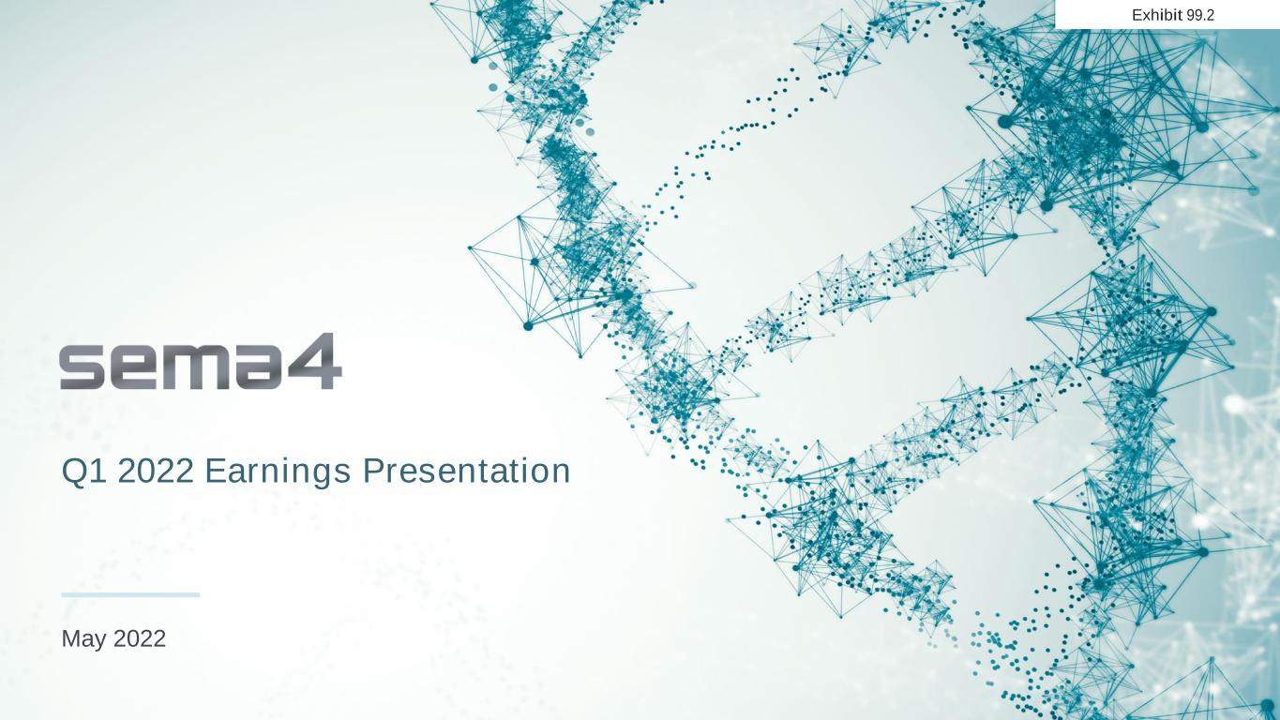

Q1 2022 Earnings Presentation May 2022 Exhibit 99.2

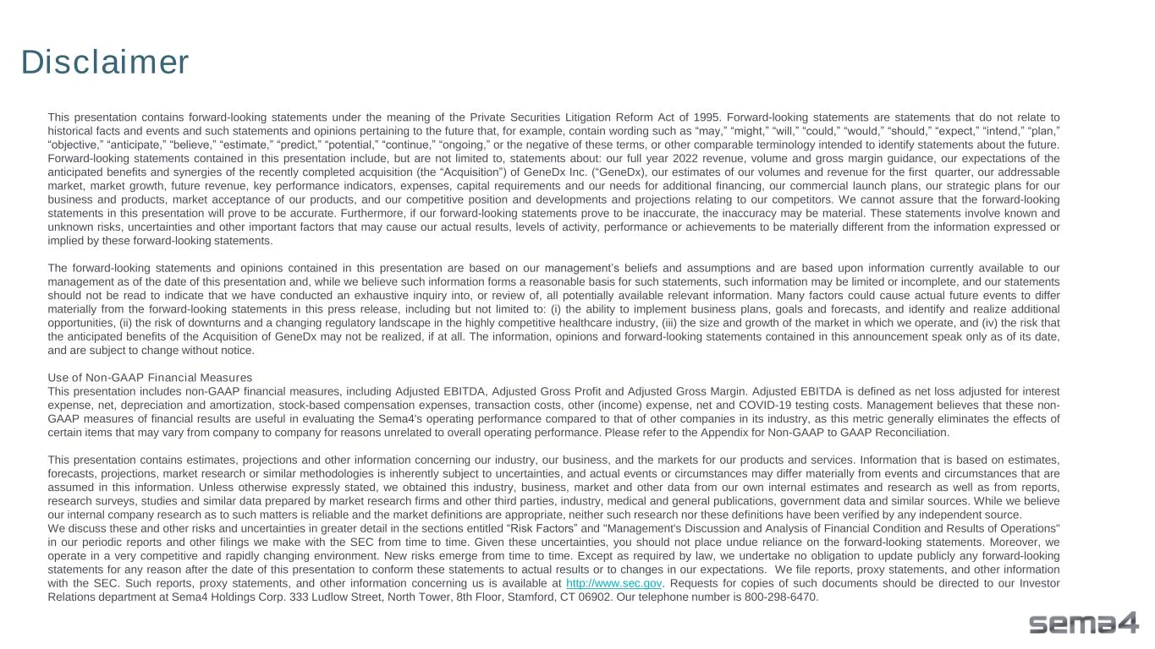
This presentation contains forward-looking statements under the meaning of the Private Securities Litigation Reform Act of 1995. Forward-looking statements are statements that do not relate to historical facts and events and such statements and opinions pertaining to the future that, for example, contain wording such as “may,” “might,” “will,” “could,” “would,” “should,” “expect,” “intend,” “plan,” “objective,” “anticipate,” “believe,” “estimate,” “predict,” “potential,” “continue,” “ongoing,” or the negative of these terms, or other comparable terminology intended to identify statements about the future. Forward-looking statements contained in this presentation include, but are not limited to, statements about: our full year 2022 revenue, volume and gross margin guidance, our expectations of the anticipated benefits and synergies of the recently completed acquisition (the “Acquisition”) of GeneDx Inc. (“GeneDx), our estimates of our volumes and revenue for the first quarter, our addressable market, market growth, future revenue, key performance indicators, expenses, capital requirements and our needs for additional financing, our commercial launch plans, our strategic plans for our business and products, market acceptance of our products, and our competitive position and developments and projections relating to our competitors. We cannot assure that the forward-looking statements in this presentation will prove to be accurate. Furthermore, if our forward-looking statements prove to be inaccurate, the inaccuracy may be material. These statements involve known and unknown risks, uncertainties and other important factors that may cause our actual results, levels of activity, performance or achievements to be materially different from the information expressed or implied by these forward-looking statements. The forward-looking statements and opinions contained in this presentation are based on our management’s beliefs and assumptions and are based upon information currently available to our management as of the date of this presentation and, while we believe such information forms a reasonable basis for such statements, such information may be limited or incomplete, and our statements should not be read to indicate that we have conducted an exhaustive inquiry into, or review of, all potentially available relevant information. Many factors could cause actual future events to differ materially from the forward-looking statements in this press release, including but not limited to: (i) the ability to implement business plans, goals and forecasts, and identify and realize additional opportunities, (ii) the risk of downturns and a changing regulatory landscape in the highly competitive healthcare industry, (iii) the size and growth of the market in which we operate, and (iv) the risk that the anticipated benefits of the Acquisition of GeneDx may not be realized, if at all. The information, opinions and forward-looking statements contained in this announcement speak only as of its date, and are subject to change without notice. Use of Non-GAAP Financial Measures This presentation includes non-GAAP financial measures, including Adjusted EBITDA, Adjusted Gross Profit and Adjusted Gross Margin. Adjusted EBITDA is defined as net loss adjusted for interest expense, net, depreciation and amortization, stock-based compensation expenses, transaction costs, other (income) expense, net and COVID-19 testing costs. Management believes that these non- GAAP measures of financial results are useful in evaluating the Sema4's operating performance compared to that of other companies in its industry, as this metric generally eliminates the effects of certain items that may vary from company to company for reasons unrelated to overall operating performance. Please refer to the Appendix for Non-GAAP to GAAP Reconciliation. This presentation contains estimates, projections and other information concerning our industry, our business, and the markets for our products and services. Information that is based on estimates, forecasts, projections, market research or similar methodologies is inherently subject to uncertainties, and actual events or circumstances may differ materially from events and circumstances that are assumed in this information. Unless otherwise expressly stated, we obtained this industry, business, market and other data from our own internal estimates and research as well as from reports, research surveys, studies and similar data prepared by market research firms and other third parties, industry, medical and general publications, government data and similar sources. While we believe our internal company research as to such matters is reliable and the market definitions are appropriate, neither such research nor these definitions have been verified by any independent source. We discuss these and other risks and uncertainties in greater detail in the sections entitled “Risk Factors” and "Management's Discussion and Analysis of Financial Condition and Results of Operations" in our periodic reports and other filings we make with the SEC from time to time. Given these uncertainties, you should not place undue reliance on the forward-looking statements. Moreover, we operate in a very competitive and rapidly changing environment. New risks emerge from time to time. Except as required by law, we undertake no obligation to update publicly any forward-looking statements for any reason after the date of this presentation to conform these statements to actual results or to changes in our expectations. We file reports, proxy statements, and other information with the SEC. Such reports, proxy statements, and other information concerning us is available at http://www.sec.gov. Requests for copies of such documents should be directed to our Investor Relations department at Sema4 Holdings Corp. 333 Ludlow Street, North Tower, 8th Floor, Stamford, CT 06902. Our telephone number is 800-298-6470. Disclaimer

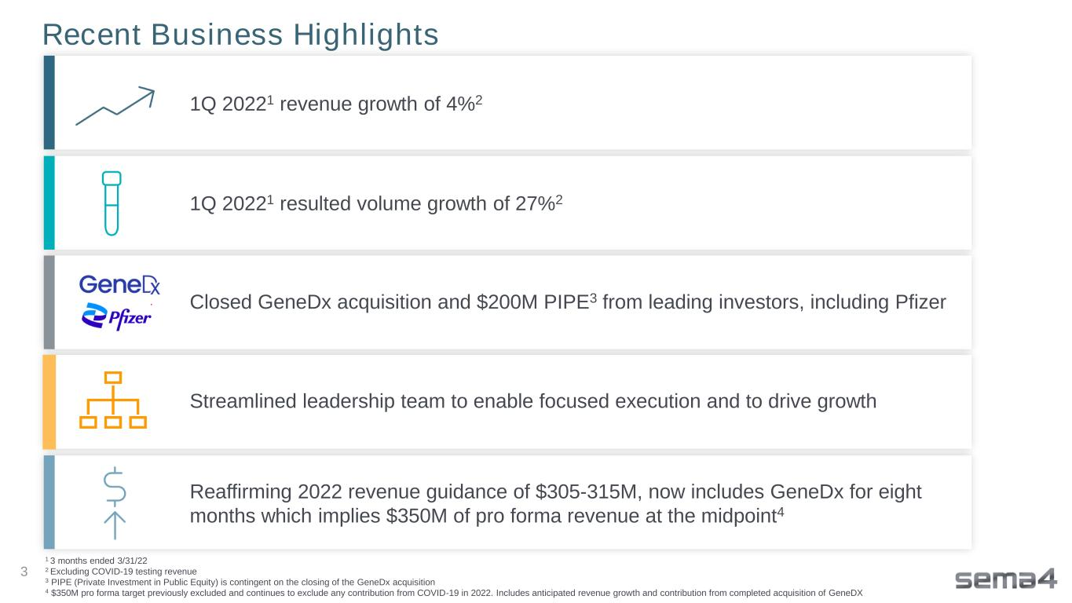
Recent Business Highlights 1Q 20221 revenue growth of 4%2 1Q 20221 resulted volume growth of 27%2 Closed GeneDx acquisition and $200M PIPE3 from leading investors, including Pfizer Streamlined leadership team to enable focused execution and to drive growth Reaffirming 2022 revenue guidance of $305-315M, now includes GeneDx for eight months which implies $350M of pro forma revenue at the midpoint4 1 3 months ended 3/31/22 2 Excluding COVID-19 testing revenue 3 PIPE (Private Investment in Public Equity) is contingent on the closing of the GeneDx acquisition 4 $350M pro forma target previously excluded and continues to exclude any contribution from COVID-19 in 2022. Includes anticipated revenue growth and contribution from completed acquisition of GeneDX 3

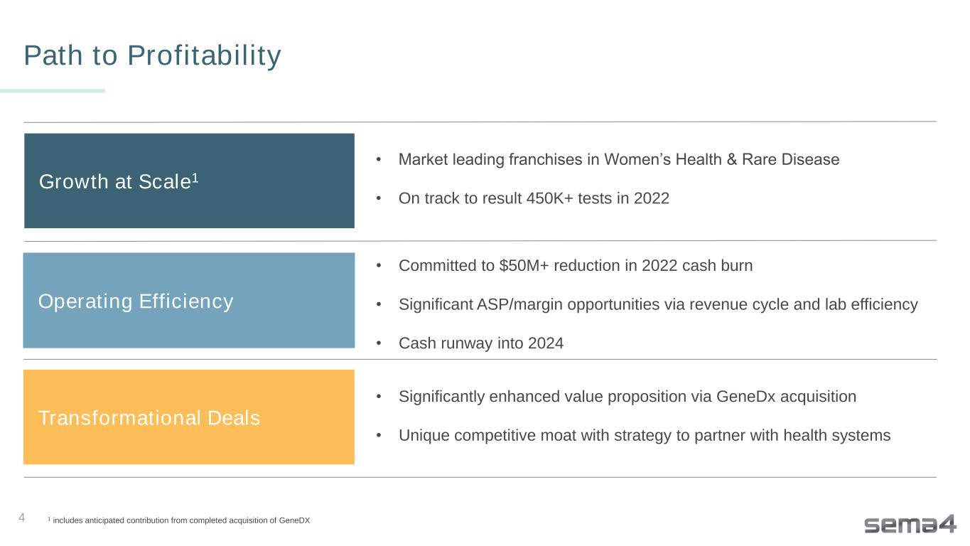
4 Path to Profitability Growth at Scale1 Operating Efficiency Transformational Deals • Market leading franchises in Women’s Health & Rare Disease • On track to result 450K+ tests in 2022 • Committed to $50M+ reduction in 2022 cash burn • Significant ASP/margin opportunities via revenue cycle and lab efficiency • Cash runway into 2024 • Significantly enhanced value proposition via GeneDx acquisition • Unique competitive moat with strategy to partner with health systems 1 includes anticipated contribution from completed acquisition of GeneDX

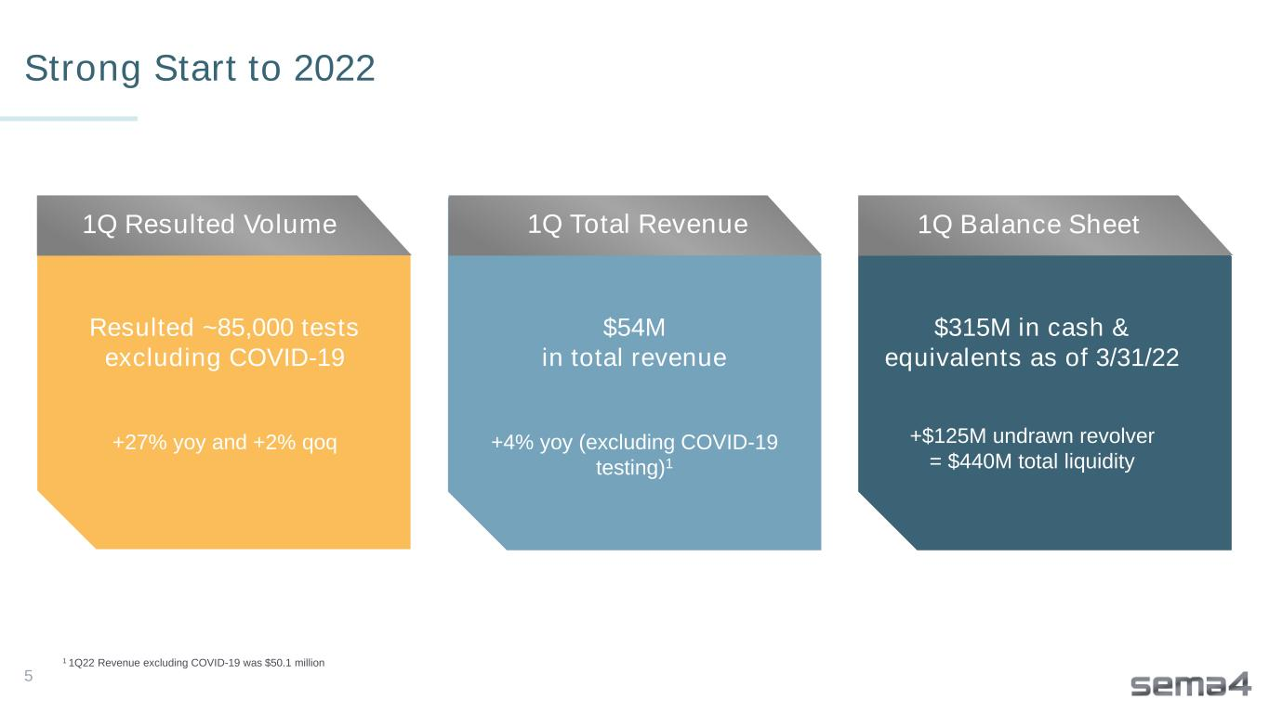
Strong Start to 2022 5 Resulted ~85,000 tests excluding COVID-19 +27% yoy and +2% qoq $54M in total revenue +4% yoy (excluding COVID-19 testing)1 $315M in cash & equivalents as of 3/31/22 +$125M undrawn revolver = $440M total liquidity 1Q Resulted Volume 1Q Total Revenue 1Q Balance Sheet 1 1Q22 Revenue excluding COVID-19 was $50.1 million

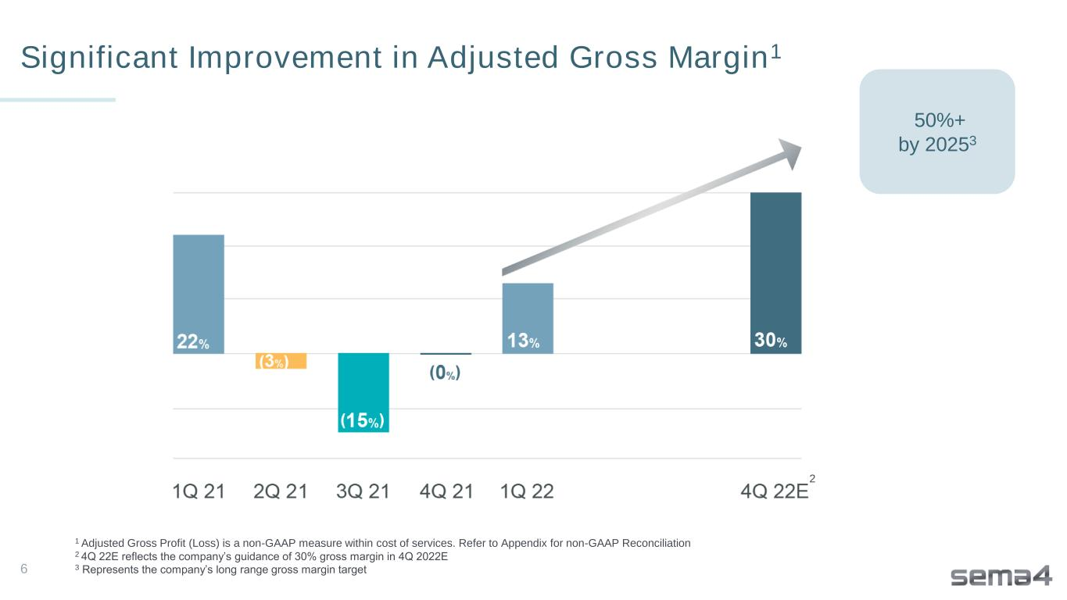
Significant Improvement in Adjusted Gross Margin1 6 2 1 Adjusted Gross Profit (Loss) is a non-GAAP measure within cost of services. Refer to Appendix for non-GAAP Reconciliation 2 4Q 22E reflects the company’s guidance of 30% gross margin in 4Q 2022E 3 Represents the company’s long range gross margin target 50%+ by 20253

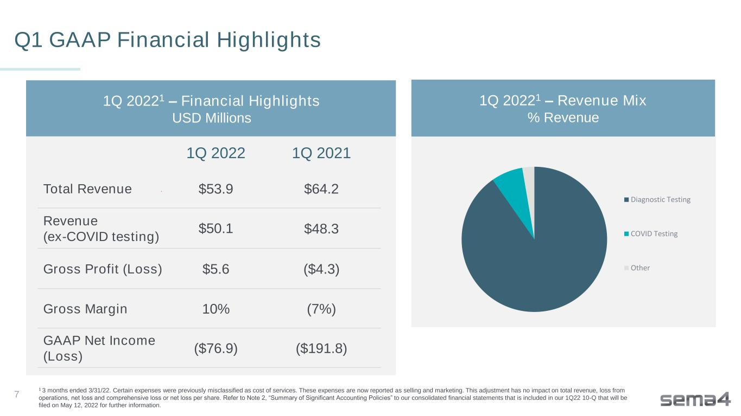
Q1 GAAP Financial Highlights 1Q 2022 1Q 2021 Total Revenue $53.9 $64.2 Revenue (ex-COVID testing) $50.1 $48.3 Gross Profit (Loss) $5.6 ($4.3) Gross Margin 10% (7%) GAAP Net Income (Loss) ($76.9) ($191.8) 1 3 months ended 3/31/22. Certain expenses were previously misclassified as cost of services. These expenses are now reported as selling and marketing. This adjustment has no impact on total revenue, loss from operations, net loss and comprehensive loss or net loss per share. Refer to Note 2, “Summary of Significant Accounting Policies” to our consolidated financial statements that is included in our 1Q22 10-Q that will be filed on May 12, 2022 for further information. 1Q 20221 – Financial Highlights USD Millions 1Q 20221 – Revenue Mix % Revenue 7 Diagnostic Testing COVID Testing Other

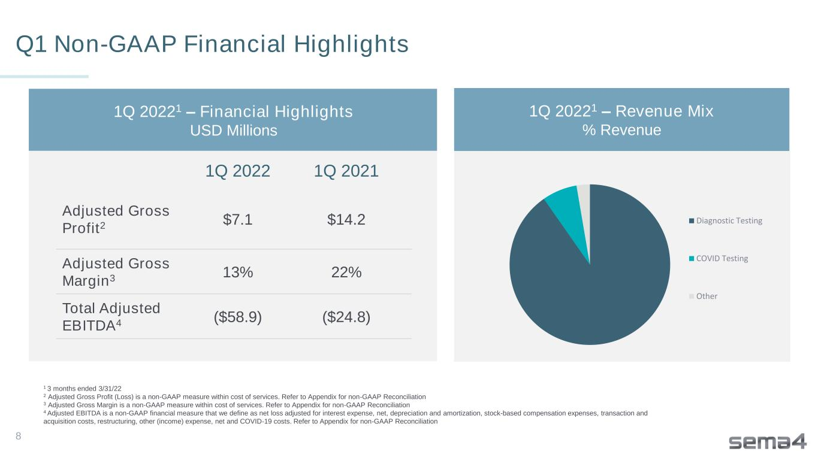
Q1 Non-GAAP Financial Highlights 1Q 2022 1Q 2021 Adjusted Gross Profit2 $7.1 $14.2 Adjusted Gross Margin3 13% 22% Total Adjusted EBITDA4 ($58.9) ($24.8) 1Q 20221 – Financial Highlights USD Millions 1 3 months ended 3/31/22 2 Adjusted Gross Profit (Loss) is a non-GAAP measure within cost of services. Refer to Appendix for non-GAAP Reconciliation 3 Adjusted Gross Margin is a non-GAAP measure within cost of services. Refer to Appendix for non-GAAP Reconciliation 4 Adjusted EBITDA is a non-GAAP financial measure that we define as net loss adjusted for interest expense, net, depreciation and amortization, stock-based compensation expenses, transaction and acquisition costs, restructuring, other (income) expense, net and COVID-19 costs. Refer to Appendix for non-GAAP Reconciliation 8 1Q 20221 – Revenue Mix % Revenue Diagnostic Testing COVID Testing Other

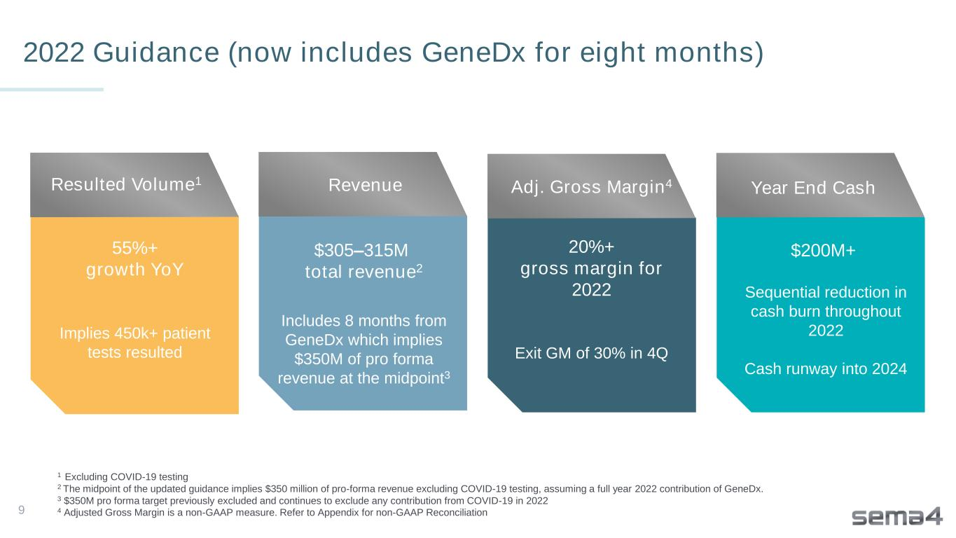
9 55%+ growth YoY Implies 450k+ patient tests resulted Adjusted gross margin to exceed 10% Resulted Volume1 2022 Guidance (now includes GeneDx for eight months) Revenue $305–315M total revenue2 Includes 8 months from GeneDx which implies $350M of pro forma revenue at the midpoint3 Adj. Gross Margin4 20%+ gross margin for 2022 Exit GM of 30% in 4Q $200M+ Sequential reduction in cash burn throughout 2022 Cash runway into 2024 1 Excluding COVID-19 testing 2 The midpoint of the updated guidance implies $350 million of pro-forma revenue excluding COVID-19 testing, assuming a full year 2022 contribution of GeneDx. 3 $350M pro forma target previously excluded and continues to exclude any contribution from COVID-19 in 2022 4 Adjusted Gross Margin is a non-GAAP measure. Refer to Appendix for non-GAAP Reconciliation Year End Cash

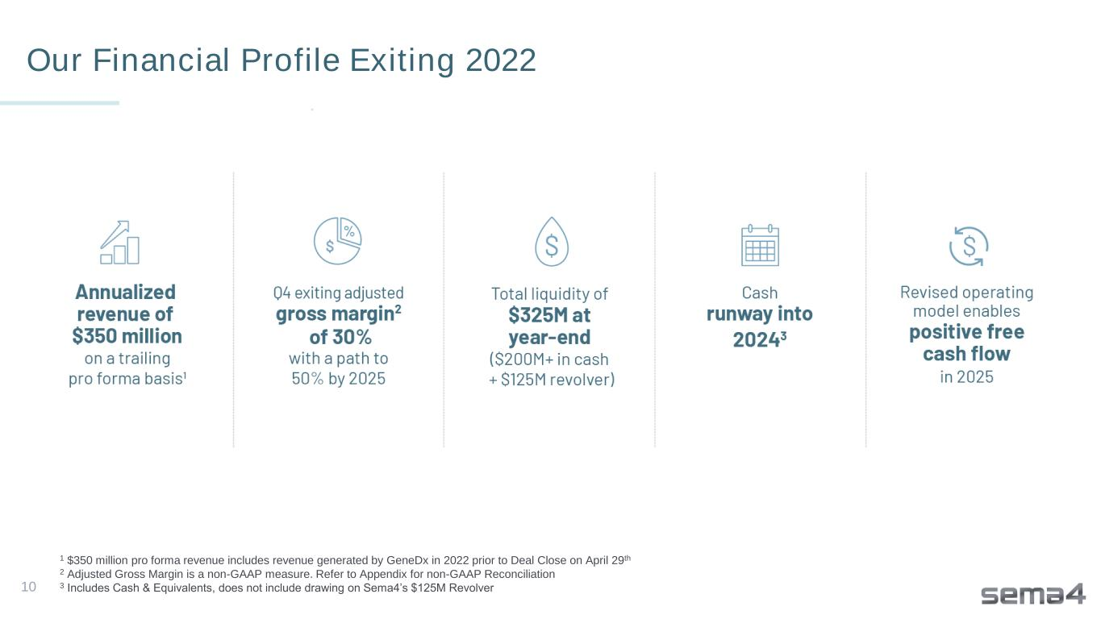
10 Our Financial Profile Exiting 2022 1 $350 million pro forma revenue includes revenue generated by GeneDx in 2022 prior to Deal Close on April 29th 2 Adjusted Gross Margin is a non-GAAP measure. Refer to Appendix for non-GAAP Reconciliation 3 Includes Cash & Equivalents, does not include drawing on Sema4’s $125M Revolver


Thank you


Appendix

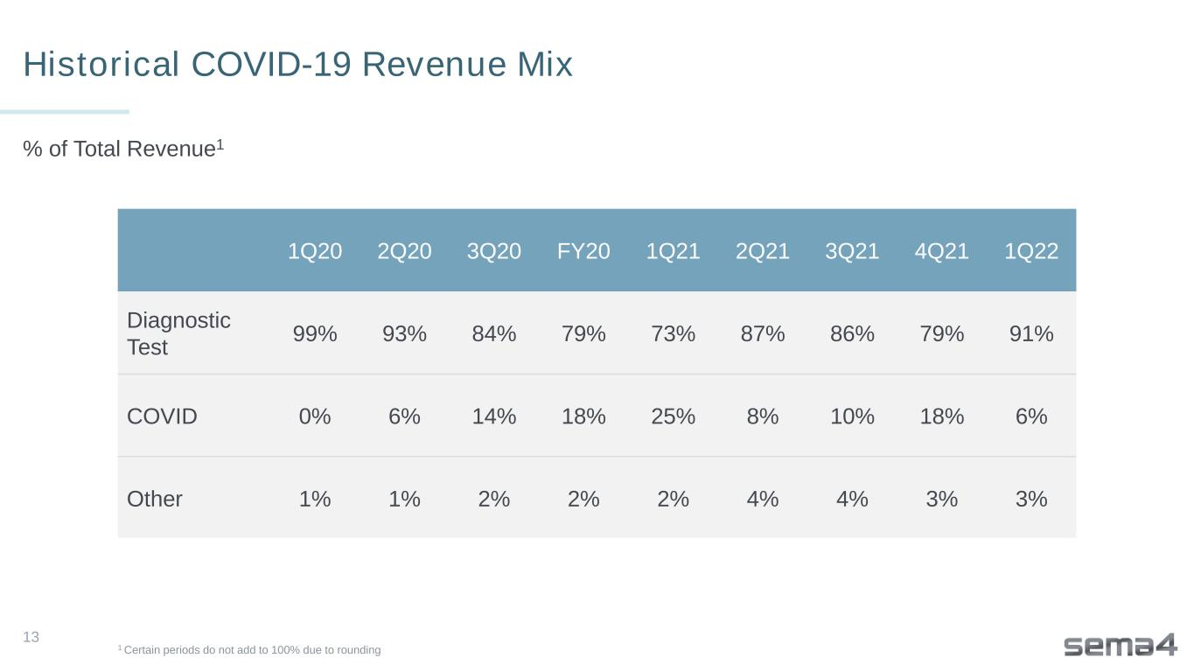
1Q20 2Q20 3Q20 FY20 1Q21 2Q21 3Q21 4Q21 1Q22 Diagnostic Test 99% 93% 84% 79% 73% 87% 86% 79% 91% COVID 0% 6% 14% 18% 25% 8% 10% 18% 6% Other 1% 1% 2% 2% 2% 4% 4% 3% 3% 1 Certain periods do not add to 100% due to rounding Historical COVID-19 Revenue Mix % of Total Revenue1 13

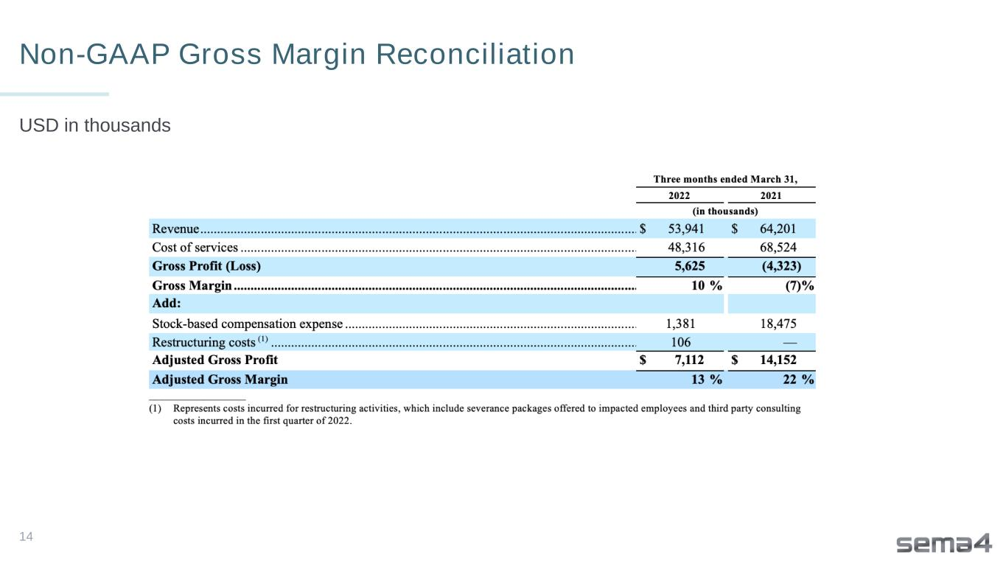
Non-GAAP Gross Margin Reconciliation USD in thousands 14

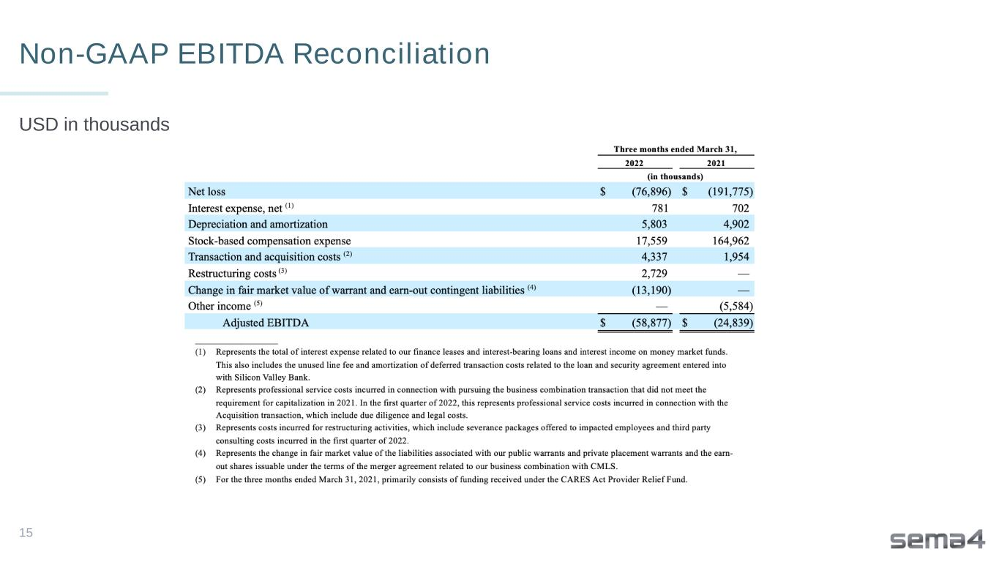
Non-GAAP EBITDA Reconciliation USD in thousands 15



