UNITED STATES
SECURITIES AND EXCHANGE COMMISSION
Washington, D.C. 20549
FORM 8-K
CURRENT REPORT
Pursuant to Section 13 OR 15(d) of The Securities Exchange Act of 1934

Date of Report (date of earliest event reported): August 8, 2023

GeneDx Holdings Corp.
(Exact name of registrant as specified in its charter)
Delaware |  |  |  |  |  |  |  |  | 001-39482 |  |  |  |  |  |  |  |  | 85-1966622
(State or other jurisdiction of incorporation or organization) |  |  |  |  |  |  |  |  | (Commission File Number) |  |  |  |  |  |  |  |  | (I.R.S. Employer Identification No.)
333 Ludlow Street, North Tower |  |  |  |  |  |  |  |  |  |  |  |  |  |  |  |  |  | 06902
Stamford, |  |  | Connecticut
(Address of Principal Executive Offices) |  |  |  |  |  |  |  |  |  |  |  |  |  |  |  |  |  | (Zip Code)
(800) 298-6470
Registrant's telephone number, including area code
(Former name or former address, if changed since last report.)

Check the appropriate box below if the Form 8-K filing is intended to simultaneously satisfy the filing obligation of the registrant under any of the following provisions (see General Instruction A.2. below):

☐ Written communications pursuant to Rule 425 under the Securities Act (17 CFR 230.425)

☐ Soliciting material pursuant to Rule 14a-12 under the Exchange Act (17 CFR 240.14a-12)

☐ Pre-commencement communications pursuant to Rule 14d-2(b) under the Exchange Act (17 CFR 240.14d-2(b))

☐ Pre-commencement communications pursuant to Rule 13e-4(c) under the Exchange Act (17 CFR 240.13e-4(c))

Securities registered pursuant to Section 12(b) of the Act:
Title of each class |  |  |  |  |  | Trading Symbol(s) |  |  |  |  |  | Name of each exchange on which registered
Class A common stock, par value $0.0001 per share |  |  |  |  |  | WGS |  |  |  |  |  | The Nasdaq Global Select Market
Warrants to purchase one share of Class A common stock, each at an exercise price of $379.50 per share |  |  |  |  |  | WGSWW |  |  |  |  |  | The Nasdaq Global Select Market
Indicate by check mark whether the registrant is an emerging growth company as defined in Rule 405 of the Securities Act of 1933 (§230.405 of this chapter) or Rule 12b-2 of the Securities Exchange Act of 1934 (§240.12b-2 of this chapter).

Emerging growth company ☒
If an emerging growth company, indicate by check mark if the registrant has elected not to use the extended transition period for complying with any new or revised financial accounting standards provided pursuant to Section 13(a) of the Exchange Act.☐

Item 2.02 Results of Operations and Financial Condition.

On August 8, 2023, GeneDx Holdings Corp. (the “Company”) issued a press release (the “Press Release”) and will hold a conference call announcing the Company's financial results for the six months ended June 30, 2023. Copies of the Press Release and Earnings Presentation are furnished as Exhibits 99.1 and 99.2, respectively, to this Current Report on Form 8-K.

The information furnished with this Item 2.02, including Exhibits 99.1 and 99.2 hereto, shall not be deemed “filed” for purposes of Section 18 of the Securities Exchange Act of 1934, as amended (the “Exchange Act”), or otherwise subject to the liabilities of that section, nor shall it be deemed incorporated by reference into any other filing under the Securities Act of 1933, as amended, or the Exchange Act, except as expressly set forth by specific reference in such a filing.

Item 9.01 Financial Statements and Exhibits

(d) Exhibits

Exhibit No |  |  | Description
99.1 |  |  | Press Release, dated August 8, 2023, regarding the registrant’s results for the quarter ended June 30, 2023
99.2 |  |  | Earning Presentation, dated August 8, 2023

SIGNATURES
Pursuant to the requirements of the Securities Exchange Act of 1934, the registrant has duly caused this report to be signed on its behalf by the undersigned hereunto duly authorized.
 |  |  |  |  |  | GeneDx Holdings Corp.
Date: |  |  | August 8, 2023 |  |  | By: |  |  | /s/ Katherine Stueland
 |  |  |  |  |  | Name: |  |  | Katherine Stueland
 |  |  |  |  |  | Title: |  |  | Chief Executive Officer

Exhibit 99.1

GeneDx Reports Second Quarter 2023 Financial Results and Business Highlights

Accelerated whole exome and genome test volume growth by 56% year-over-year

Total revenue of $48M in Q2 is inclusive of 36% year-over-year growth of exome and genome test revenue

Expanded gross margins and operating expense rationalization resulting in continued cash burn reduction of 36% year-over-year

Broadened network of strategic partners, including breakthrough research collaboration with PacBio and University of Washington

GeneDx to host conference call today at 4:30 p.m. ET

STAMFORD, Conn., August 8, 2023 — GeneDx Holdings Corp. (Nasdaq: WGS), a leader in delivering improved health outcomes through genomic and clinical insights, today reported its financial results for the second quarter of 2023.
“Our goal at GeneDx is to end the diagnostic odyssey for patients and their families, and with the growth in exome volume and revenue this quarter, I’m pleased to say that we’re increasingly realizing that mission,” said Katherine Stueland, President and Chief Executive Officer of GeneDx. “We are accelerating physician conversion to whole exome and genome tests, which is not only better for patient care, but also better for the business. We expect this growth to continue through the second half of the year, which gives us confidence to meet our full year revenue guidance. In addition, we are continuing to rationalize our operating expenses and reduce our cash burn as we move forward to gain efficiency.”

Pro Forma Second Quarter Financial Results from Continuing Operations1

Pro forma results for GeneDx reported today include the combination of Legacy GeneDx and only the data and information business of Legacy Sema4, and assume Legacy GeneDx was owned for the entirety of 2022. Continuing operations exclude revenues and costs from the now discontinued Legacy Sema4 diagnostics testing business.
•Revenue: Pro forma revenue for the second quarter of 2023 was $45.2 million, compared to $40.1 million in the second quarter of 2022, representing an increase of 13% year-over-year. Revenues from whole exome and genome tests were $28.7 million compared to $21.1 million in the second quarter of 2022, representing an increase of 36% year-over-year, and an increase of 28% quarter-over-quarter.
•Test Volume: Total pro forma tests resulted in the second quarter of 2023 were nearly 55,000, compared to over 45,000 for the second quarter of 2022. Total whole exome and whole genome tests resulted were approximately 11,900, an increase of 56% year-over-year, and an increase of 36% quarter-over-quarter.
•Gross Margin: Pro forma adjusted gross margin expanded to 37% in the second quarter of 2023 up sequentially from 34% in the first quarter of 2023

Total Company Second Quarter Financial Results1

Total Company results reported today for the second quarter of 2023 include the combination of continuing operations and the now discontinued Legacy Sema4 diagnostic testing business. All comparable 2022 information presented below excludes any Legacy GeneDx revenues and associated costs prior to the second quarter of 2022 acquisition of GeneDx which closed April 29, 2022.

·Cash Position: Cash and cash equivalents and restricted cash were $157.6 million as of June 30, 2023. Excluding financing proceeds, total Company burn for the second quarter of 2023 was $53 million, an improvement of 36% year-over-year and 10% sequentially.
·Net Loss1: Total Company net loss for the second quarter of 2023 was $46.7 million. Total Company adjusted net loss for the second quarter of 2023 was $41.8 million2, an improvement of 37% year-over-year and 17% sequentially.
·Revenue1: Revenue for the second quarter of 2023 was $48.7 million, compared to $36.2 million in the second quarter of 2022.
·Gross Margin1: Gross margin for the second quarter of 2023 was 39%. Adjusted gross margin for the second quarter of 2023 was 42%.

Recent Business Highlights
Commercial Updates
•Continued to expand access to services, including state rapid whole genome sequencing (rWGS) in Medicaid populations in Florida and Arizona
oEight state Medicaid programs now cover rWGS in the pediatric inpatient setting, and additional bills are pending in three states, including Massachusetts
•Announced strategic partnership with Prognos Health to help rare disease patients rapidly gain access to potential treatment options, allowing commercial biopharma companies to leverage real-time data within Prognos Marketplace
•Signed agreements with biotechnology companies to leverage GeneDx’s clinical and genomic data to advance drug development.
•Increased the number of ordering clinicians by 39% in pediatrics and 55% in neurology through the second quarter of 2023

Scientific Updates
•PacBio and GeneDx in collaboration with the University of Washington to study the capabilities of HiFi long-read whole genome sequencing (WGS) to increase diagnostic rates in pediatric patients with genetic conditions.
oComparing long-read with short-read sequencing will help researchers explore whether novel variants, previously undiscovered by short-read technologies, may explain specific genetic conditions.
•Published research using PanGenome Research-Tool Kit (PGR-TK), a computational tool for scalable analysis of clinically relevant genes within the human pangenome
•Presented new data at the 2023 United Mitochondrial Disease Foundation’s (UMDF) Mitochondrial Medicine Symposium demonstrating urine mitochondrial DNA testing as a clinically impactful and non-invasive option for analysis of the m.3243A>G variant
•Recently hired team of engineers with decades of experience in building genomic analysis tools to accelerate clinical interpretation artificial intelligence (AI) platform

Financial & Corporate Growth
•Completed 1-for-33 reverse stock split effective on May 4, 2023
•Appointed Devin K. Schaffer, JD, MBA as general counsel and secretary, responsible for all legal, compliance, and regulatory activities

GeneDx Pro Forma Full Year 2023 Guidance

GeneDx is reiterating certain previously issued full year 2023 guidance. The continuing operations of GeneDx, excluding revenues and direct costs from the now discontinued Legacy Sema4 diagnostic testing business, are expected to:
•Generate revenues between $205 to $220 million for full year 2023;
•Expand gross margin profile in 2023 and beyond; and
•Turn profitable in 2025.

GeneDx is updating its previously issued cash use guidance and now expects to use $70 to $85 million of net cash for the second half of 2023, inclusive of servicing obligations of the previously exited business activities. The Company’s total cash burn in the fourth quarter of 2023 is expected to be nearly half of second quarter burn.

1 The pro forma unadjusted and adjusted results from continuing operations for the second quarter of 2023 and the comparable results for the second quarter of 2022 are presented on a pro forma basis assuming Legacy GeneDx and the Company were combined for the entirety of 2022 and exclude the revenues and costs from the now discontinued Legacy Sema4 diagnostic testing business, and include the combination of the Legacy GeneDx diagnostic business revenues and costs with the data and information revenues and associated costs derived from the Legacy Sema4 business. Actual results include the Legacy GeneDx business from the date of the Company’s acquisition of Legacy GeneDx on April 29, 2022, the purchase accounting associated with the acquisition of Legacy GeneDx, and also include the financial impacts of exited Legacy Sema4 business activities for the full quarter.
2 Adjusted gross margin and adjusted net loss are non-GAAP financial measures. See appendix for a reconciliation of GAAP to Non-GAAP figures presented.

Webcast and Conference Call Details
GeneDx will host a conference call today, August 8, 2023, at 4:30 p.m. Eastern Time. Investors interested in listening to the conference call are required to register online. A live and archived webcast of the event will be available on the “Events” section of the GeneDx investor relations website at https://ir.genedx.com/.

Forward-Looking Statements
This press release contains certain forward-looking statements within the meaning of the federal securities laws, including statements regarding our future performance and our market opportunity, including our expected full year 2023 reported revenue guidance, our expectations regarding our gross margin profile in 2023 and beyond, our use of cash and our cash burn in 2023 and our turning profitable in 2025, our expectations for our growth and future investment in our business, our expectations regarding our plans to pursue new strategic direction, improve our operational efficiency and reduce our cash burn and our ability to scale to profitability, the associated cost savings of our business exits and impact on our gross margins. These forward-looking statements generally are identified by the words “believe,” “project,” “expect,” “anticipate,” “estimate,” “intend,” “strategy,” “future,” “opportunity,” “plan,” “may,” “should,” “will,” “would,” “will be,” “will continue,” “will likely result,” and similar expressions. Forward-looking statements are predictions, projections and other statements about future events that are based on current expectations and assumptions and, as a result, are subject to risks and uncertainties. Many factors could cause actual future events to differ materially from the forward-looking statements in this press release, including but not limited to: (i) our ability to implement business plans, goals and forecasts, and identify and realize additional opportunities, (ii) the risk of downturns and a changing regulatory landscape in the highly competitive healthcare industry, (iii) the size and growth of the market in which we operate, (iv) our ability to pursue our new strategic direction, and (vi) our ability to enhance our artificial intelligence tools that we use in our clinical interpretation platform. The foregoing list of factors is not exhaustive. You should carefully consider the foregoing factors and the other risks and uncertainties described in the “Risk Factors” section of our Annual Report on Form 10-K for the fiscal year ended December 31, 2022, filed with the U.S. Securities and Exchange Commission (the “SEC”) on March 16, 2023, and other documents filed by us from time to time with the SEC. These filings identify and address other important risks and uncertainties that could cause actual events and results to differ materially from those contained in the forward-looking statements. Forward-looking statements speak only as of the date they are made. Readers are cautioned not to put undue reliance on forward-looking statements, and we assume no obligation and do not intend to update or revise these forward-looking statements, whether as a result of new information, future events, or otherwise. We do not give any assurance that we will achieve our expectations.

About GeneDx
GeneDx (Nasdaq: WGS) delivers personalized and actionable health insights to inform diagnosis, direct treatment and improve drug discovery. The company is uniquely positioned to accelerate the use of genomic and large-scale clinical information to enable precision medicine as the standard of care. GeneDx is at the forefront of transforming healthcare through its industry-leading exome and genome testing and interpretation, fueled by one of the world’s largest rare disease data sets. For more information, please visit genedx.com and connect with us on LinkedIn, Facebook, Twitter and Instagram.

Investor Relations Contact:
Tricia Truehart
Investors@GeneDx.com

Media Contact:
Maurissa Messier
Press@GeneDx.com

Pro forma select volume and revenue from Continuing Operations in the table below assume Legacy GeneDx was owned for the entirety of the applicable quarter(s) and are calculated based on the construct of our continuing operations inclusive of Legacy GeneDx combined with data revenues and associated costs from Legacy Sema4. Pro forma select metrics are presented for illustrative purposes only and are not necessarily indicative of the results that would have occurred had the GeneDx acquisition been completed on such dates or that may occur in the future.

Pro Forma Select Volume & Revenue from Continuing Operations
 |  |  | 2Q22 |  |  | 3Q22 |  |  | 4Q22 |  |  | 1Q23 |  |  | 2Q23
Volumes
Whole Exome, Whole Genome |  |  | 7,579 |  |  | 7,722 |  |  | 7,862 |  |  | 8,705 |  |  | 11,855
Exome based Panels |  |  | 3,141 |  |  | 2,983 |  |  | 3,013 |  |  | 3,136 |  |  | 3,472
Hereditary Cancer |  |  | 7,391 |  |  | 5,445 |  |  | 6,069 |  |  | 7,120 |  |  | 7,142
Other individual gene tests and multi-gene disease panels |  |  | 27,446 |  |  | 28,764 |  |  | 31,891 |  |  | 33,817 |  |  | 32,459
Total |  |  | 45,557 |  |  | 44,914 |  |  | 48,835 |  |  | 52,778 |  |  | 54,928
Revenue
Whole Exome, Whole Genome |  |  | $21.1 |  |  | $24.0 |  |  | $23.3 |  |  | $22.4 |  |  | $28.7
Exome based Panels |  |  | $2.4 |  |  | $2.3 |  |  | $2.0 |  |  | $2.0 |  |  | $2.0
Hereditary Cancer |  |  | $3.8 |  |  | $3.5 |  |  | $4.4 |  |  | $4.3 |  |  | $3.8
Other individual gene tests and multi-gene disease panels |  |  | $10.5 |  |  | $15.6 |  |  | $14.3 |  |  | $10.6 |  |  | $8.6
Data Information |  |  | $2.3 |  |  | $1.8 |  |  | $1.9 |  |  | $1.3 |  |  | $2.1
Total |  |  | $40.1 |  |  | $47.2 |  |  | $45.8 |  |  | $40.7 |  |  | $45.2
Unaudited Pro forma select financial information assume Legacy GeneDx was owned for the entirety of 2022 and is calculated based on the construct of our continuing operations inclusive of Legacy GeneDx combined with data revenues and associated costs from Legacy Sema4. Unaudited Pro forma select financial information is presented for illustrative purposes only and is not necessarily indicative of the results that would have occurred had the Legacy GeneDx acquisition been completed on such dates or that may occur in the future.

UNAUDITED PRO FORMA SELECT FINANCIAL INFORMATION
FOR THE THREE MONTHS ENDED JUNE 30, 2023
(in thousands)
 |  |  | GeneDx Continuing Operations |  |  | Legacy Sema4 Discontinued Business |  |  | Combined GeneDx and Sema4
Revenue |  |  | $45,226 |  |  | $3,480 |  |  | $48,706
Adjusted Cost of Services |  |  | 28,452 |  |  | - |  |  | 28,452
Adjusted Gross Margin |  |  | $16,774 |  |  | $3,480 |  |  | $20,254
Adjusted Gross Margin % |  |  | 37.1% |  |  | -% |  |  | 41.6%
UNAUDITED PRO FORMA SELECT FINANCIAL INFORMATION
FOR THE THREE MONTHS ENDED MARCH 31, 2023
(in thousands)
 |  |  | GeneDx Continuing Operations |  |  | Legacy Sema4 Discontinued Business |  |  | Combined GeneDx and Sema4
Revenue |  |  | $40,693 |  |  | $2,446 |  |  | $43,139
Adjusted Cost of Services |  |  | 26,826 |  |  | 2,080 |  |  | 28,906
Adjusted Gross Margin |  |  | $13,867 |  |  | $366 |  |  | $14,233
Adjusted Gross Margin % |  |  | 34.1% |  |  | 14.9% |  |  | 33.0%

 |  |  | Three months ended June 30,
 |  |  | 2023 |  |  |  |  |  | 2022
 |  |  | (in thousands)
Revenue
Diagnostic test revenue |  |  | $46,635 |  |  |  |  |  | $34,004
Other Revenue |  |  | 2,071 |  |  |  |  |  | 2,165
Total Revenue |  |  | 48,706 |  |  |  |  |  | 36,169
Cost of Service |  |  | 29,949 |  |  |  |  |  | 65,767
Gross (Loss) Profit |  |  | $18,757 |  |  |  |  |  | $(29,598)
Gross Margin |  |  | 39% |  |  |  |  |  | (82)%
Depreciation and amortization |  |  | 1,233 |  |  |  |  |  | 3,316
Stock-based compensation |  |  | 251 |  |  |  |  |  | 1,810
Restructuring costs |  |  | 13 |  |  |  |  |  | 205
Adjusted Gross (Loss) Profit |  |  | $20,254 |  |  |  |  |  | $(24,267)
Adjusted Gross Margin |  |  | 42% |  |  |  |  |  | (67)%

 |  |  | Three months ended March 31,
 |  |  | 2023
 |  |  | (in thousands)
Revenue
Diagnostic test revenue |  |  | $41,850
Other Revenue |  |  | 1,289
Total Revenue |  |  | 43,139
Cost of Service |  |  | 27,903
Gross (Loss) Profit |  |  | $15,236
Gross Margin |  |  | 35.3%
Depreciation and amortization |  |  | 589
Stock-based compensation |  |  | (1,666)
Restructuring costs |  |  | 74
Adjusted Gross (Loss) Profit |  |  | $14,233
Adjusted Gross Margin |  |  | 33.0%

 |  |  | Three months ended June 30,
 |  |  | 2023 |  |  |  |  |  |  |  |  | 2022
 |  |  | (in thousands)
Net (loss) income |  |  | $(46,719) |  |  |  |  |  |  |  |  | $(85,742)
Interest expense, net |  |  | (1,074) |  |  |  |  |  |  |  |  | 408
Income tax benefit |  |  | (196) |  |  |  |  |  |  |  |  | (49,077)
Depreciation and amortization |  |  | 10,332 |  |  |  |  |  |  |  |  | 8,964
Stock-based compensation expense |  |  | 108 |  |  |  |  |  |  |  |  | 22,721
Transaction and acquisition costs |  |  | — |  |  |  |  |  |  |  |  | 9,099
Restructuring |  |  | 1,637 |  |  |  |  |  |  |  |  | 6,832
Change in fair market value of financial liabilities |  |  | (3,547) |  |  |  |  |  |  |  |  | (28,182)
Gain on sale of assets |  |  | (2,954) |  |  |  |  |  |  |  |  | —
Third party payor reserve release |  |  | (3,238) |  |  |  |  |  |  |  |  | —
Provision for excess and obsolete inventory associated with Legacy Sema4 |  |  | 2,620 |  |  |  |  |  |  |  |  | —
Other income, net |  |  | (86) |  |  |  |  |  |  |  |  | (56)
Adjusted EBITDA |  |  | $(43,117) |  |  |  |  |  |  |  |  | $(115,033)
Net (loss) income |  |  | (46,719) |  |  |  |  |  |  |  |  | (85,742)
Stock-based compensation expense |  |  | 108 |  |  |  |  |  |  |  |  | 22,721
Depreciation and amortization |  |  | 10,332 |  |  |  |  |  |  |  |  | 8,964
Change in fair market value of warrant and earn-out contingent liabilities |  |  | (3,547) |  |  |  |  |  |  |  |  | (28,182)
Transaction and acquisition costs |  |  | — |  |  |  |  |  |  |  |  | 9,099
Restructuring |  |  | 1,637 |  |  |  |  |  |  |  |  | 6,832
Gain on sale of assets |  |  | (2,954) |  |  |  |  |  |  |  |  | —
Third party payor reserve release |  |  | (3,238) |  |  |  |  |  |  |  |  | —
Provision for excess and obsolete inventory associated with Legacy Sema4 |  |  | 2,620 |  |  |  |  |  |  |  |  | —
Other income, net |  |  | (86) |  |  |  |  |  |  |  |  | (56)
Adjusted Net loss |  |  | $(41,847) |  |  |  |  |  |  |  |  | $(66,364)

 |  |  | Three months ended March 31,
 |  |  | 2023
 |  |  | (in thousands)
Net (loss) income |  |  | $(60,989)
Interest expense, net |  |  | 35
Income tax benefit |  |  | (147)
Depreciation and amortization |  |  | 8,636
Stock-based compensation expense |  |  | 48
Impairment loss |  |  | 2,120
Transaction and acquisition costs |  |  | —
Restructuring |  |  | 702
Change in fair market value of financial liabilities |  |  | 3,453
Gain on debt forgiveness |  |  | (2,750)
Adjusted EBITDA |  |  | $(48,892)
Net (loss) income |  |  | (60,989)
Stock-based compensation expense |  |  | 48
Depreciation and amortization |  |  | 8,636
Impairment loss |  |  | 2,120
Change in fair market value of warrant and earn-out contingent liabilities |  |  | 3,453
Transaction and acquisition costs |  |  | —
Restructuring |  |  | 702
Other, net |  |  | (2,750)
Adjusted Net loss |  |  | $(48,780)

 |  |  | Three months ended,
 |  |  | Q2 2023 |  |  |  |  |  | Q1 2023 |  |  |  |  |  | Q2 2022 |  |  |  |  |  | Q4 2022
 |  |  | (in thousands)
Operating expenses |  |  | $70,379 |  |  |  |  |  | $75,600 |  |  |  |  |  | $133,051 |  |  |  |  |  | $308,557
Depreciation and amortization |  |  | (9,099) |  |  |  |  |  | (8,046) |  |  |  |  |  | (5,648) |  |  |  |  |  | (14,046)
Stock-based compensation |  |  | 143 |  |  |  |  |  | (1,715) |  |  |  |  |  | (20,911) |  |  |  |  |  | (10)
Restructuring costs |  |  | (1,624) |  |  |  |  |  | (628) |  |  |  |  |  | (15,726) |  |  |  |  |  | (7,358)
Impairment loss |  |  | — |  |  |  |  |  | (2,120) |  |  |  |  |  | — |  |  |  |  |  | (210,145)
Other, net |  |  | 334 |  |  |  |  |  | — |  |  |  |  |  | — |  |  |  |  |  | —
Adjusted operating expenses |  |  | $ 60,133 |  |  |  |  |  | $ 63,091 |  |  |  |  |  | $ 90,766 |  |  |  |  |  | $ 76,998

GeneDx Holdings Corp.

Condensed Consolidated Balance Sheets
(in thousands, except share and per share amounts)

 |  |  | June 30, 2023  (unaudited) |  |  |  |  |  | December 31, 2022
Assets
Current assets:
Cash and cash equivalents |  |  | $ 156,655 |  |  |  |  |  | $ 123,933
Restricted cash |  |  | — |  |  |  |  |  | 13,470
Accounts receivable, net |  |  | 32,710 |  |  |  |  |  | 42,634
Due from related parties |  |  | 1,196 |  |  |  |  |  | 708
Inventory, net |  |  | 11,531 |  |  |  |  |  | 13,665
Prepaid expenses and other current assets |  |  | 11,185 |  |  |  |  |  | 18,212
Total current assets |  |  | 213,277 |  |  |  |  |  | 212,622
Operating lease right-of-use assets |  |  | 33,684 |  |  |  |  |  | 32,758
Property and equipment, net |  |  | 43,332 |  |  |  |  |  | 51,527
Intangible assets, net |  |  | 179,638 |  |  |  |  |  | 186,650
Long-term restricted cash |  |  | 900 |  |  |  |  |  | 900
Other assets |  |  | 5,559 |  |  |  |  |  | 6,485
Total assets |  |  | $ 476,390 |  |  |  |  |  | $ 490,942
Liabilities and Stockholders’ Equity
Current liabilities:
Accounts payable and accrued expenses |  |  | $ 54,767 |  |  |  |  |  | $ 84,878
Due to related parties |  |  | 4,338 |  |  |  |  |  | 3,593
Short-term lease liabilities |  |  | 5,346 |  |  |  |  |  | 6,121
Other current liabilities |  |  | 19,917 |  |  |  |  |  | 49,705
Total current liabilities |  |  | 84,368 |  |  |  |  |  | 144,297
Long-term debt, net of current portion |  |  | 6,250 |  |  |  |  |  | 6,250
Long-term lease liabilities |  |  | 63,748 |  |  |  |  |  | 60,013
Other liabilities |  |  | 22,411 |  |  |  |  |  | 22,000
Deferred taxes |  |  | 2,250 |  |  |  |  |  | 2,659
Warrant liability |  |  | 220 |  |  |  |  |  | 418
Earn-out contingent liability |  |  | 1,030 |  |  |  |  |  | 1,600
Total liabilities |  |  | 180,277 |  |  |  |  |  | 237,237
Commitments and contingencies (Note 10)
Stockholders’ equity:
Preferred Stock, $0.0001 par value: 1,000,000 and 1,000,000 shares authorized at June 30, 2023 and December 31, 2022, respectively; 0 shares issued and outstanding at June 30, 2023 and December 31, 2022, respectively |  |  | — |  |  |  |  |  | —
Class A common stock, $0.0001 par value: 1,000,000,000 and 1,000,000,000 shares authorized at June 30, 2023 and December 31, 2022, respectively; 25,761,147 and 11,773,065 shares issued and outstanding at June 30, 2023 and December 31, 2022, respectively |  |  | 2 |  |  |  |  |  | 1
Additional paid-in capital |  |  | 1,528,240 |  |  |  |  |  | 1,378,125
Accumulated deficit |  |  | (1,232,129) |  |  |  |  |  | (1,124,421)
Total stockholders’ equity |  |  | 296,113 |  |  |  |  |  | 253,705
Total liabilities and stockholders’ equity |  |  | $ 476,390 |  |  |  |  |  | $ 490,942

GeneDx Holdings Corp.

Condensed Consolidated Statements of Operations and Comprehensive Loss
(in thousands, except share and per share amounts)
(unaudited)

 |  |  | Three months ended June 30, |  |  |  |  |  |  |  |  |  |  |  | Six months ended June 30,
 |  |  | 2023 |  |  |  |  |  | 2022 |  |  |  |  |  | 2023 |  |  |  |  |  | 2022
Revenue:
Diagnostic test revenue |  |  | $ 46,635 |  |  |  |  |  | $ 34,004 |  |  |  |  |  | $ 88,485 |  |  |  |  |  | $ 86,499
Other revenue |  |  | 2,071 |  |  |  |  |  | 2,165 |  |  |  |  |  | 3,360 |  |  |  |  |  | 3,611
Total revenue |  |  | 48,706 |  |  |  |  |  | 36,169 |  |  |  |  |  | 91,845 |  |  |  |  |  | 90,110
Cost of services |  |  | 29,949 |  |  |  |  |  | 65,767 |  |  |  |  |  | 57,852 |  |  |  |  |  | 114,083
Gross profit (loss) |  |  | 18,757 |  |  |  |  |  | (29,598) |  |  |  |  |  | 33,993 |  |  |  |  |  | (23,973)
Research and development |  |  | 17,138 |  |  |  |  |  | 27,168 |  |  |  |  |  | 31,730 |  |  |  |  |  | 48,483
Selling and marketing |  |  | 15,182 |  |  |  |  |  | 32,827 |  |  |  |  |  | 28,634 |  |  |  |  |  | 58,456
General and administrative |  |  | 37,341 |  |  |  |  |  | 71,325 |  |  |  |  |  | 81,030 |  |  |  |  |  | 118,027
Related party expenses |  |  | 1,052 |  |  |  |  |  | 1,731 |  |  |  |  |  | 2,799 |  |  |  |  |  | 3,015
Impairment loss |  |  | — |  |  |  |  |  | — |  |  |  |  |  | 2,120 |  |  |  |  |  | —
Other, net |  |  | (334) |  |  |  |  |  | — |  |  |  |  |  | (334) |  |  |  |  |  | —
Loss from operations |  |  | (51,622) |  |  |  |  |  | (162,649) |  |  |  |  |  | (111,986) |  |  |  |  |  | (251,954)
Other income (expense), net:
Change in fair market value of warrant and earn-out contingent liabilities |  |  | 3,547 |  |  |  |  |  | 28,182 |  |  |  |  |  | 94 |  |  |  |  |  | 41,372
Interest income |  |  | 1,700 |  |  |  |  |  | 382 |  |  |  |  |  | 2,432 |  |  |  |  |  | 409
Interest expense |  |  | (626) |  |  |  |  |  | (790) |  |  |  |  |  | (1,393) |  |  |  |  |  | (1,598)
Other income, net |  |  | 86 |  |  |  |  |  | 56 |  |  |  |  |  | 2,802 |  |  |  |  |  | 56
Total other (expense) income, net |  |  | 4,707 |  |  |  |  |  | 27,830 |  |  |  |  |  | 3,935 |  |  |  |  |  | 40,239
Loss before income taxes |  |  | $ (46,915) |  |  |  |  |  | $ (134,819) |  |  |  |  |  | $ (108,051) |  |  |  |  |  | $ (211,715)
Income tax benefit |  |  | 196 |  |  |  |  |  | 49,077 |  |  |  |  |  | 343 |  |  |  |  |  | 49,077
Net loss and comprehensive loss |  |  | $ (46,719) |  |  |  |  |  | $ (85,742) |  |  |  |  |  | $ (107,708) |  |  |  |  |  | $ (162,638)
Weighted average shares outstanding of Class A common stock |  |  | 25,418,358 |  |  |  |  |  | 10,234,910 |  |  |  |  |  | 22,754,948 |  |  |  |  |  | 8,827,829
Basic and diluted net loss per share, Class A common stock |  |  | $ (1.84) |  |  |  |  |  | $ (8.38) |  |  |  |  |  | $ (4.73) |  |  |  |  |  | $ (18.42)

GeneDx Holdings Corp.

Condensed Consolidated Statements of Cash Flows
(in thousands)
(unaudited)

 |  |  | Six months ended June 30,
 |  |  | 2023 |  |  |  |  |  | 2022
Operating activities
Net loss |  |  | $ (107,708) |  |  |  |  |  | $ (162,638)
Adjustments to reconcile net loss to net cash used in operating activities:
Depreciation and amortization expense |  |  | 18,968 |  |  |  |  |  | 14,767
Impairment loss |  |  | 2,120 |  |  |  |  |  | —
Gain on sale of assets |  |  | (2,954) |  |  |  |  |  | —
Stock-based compensation expense |  |  | 156 |  |  |  |  |  | 40,280
Gain on debt forgiveness |  |  | (2,750) |  |  |  |  |  | —
Change in fair value of warrant and earn-out contingent liabilities |  |  | (94) |  |  |  |  |  | (41,372)
Deferred tax benefit |  |  | (343) |  |  |  |  |  | (49,077)
Provision for excess and obsolete inventory |  |  | 2,620 |  |  |  |  |  | 347
Third party payor reserve release |  |  | (4,308) |  |  |  |  |  | —
Non-cash lease expense |  |  | 155 |  |  |  |  |  | 331
Amortization of deferred debt issuance costs |  |  | 257 |  |  |  |  |  | 257
Change in operating assets and liabilities:
Accounts receivable |  |  | 10,174 |  |  |  |  |  | 2,357
Inventory |  |  | (486) |  |  |  |  |  | (2,282)
Prepaid expenses and other current assets |  |  | 5,476 |  |  |  |  |  | 2,910
Due to/from related parties |  |  | 256 |  |  |  |  |  | (1,325)
Other assets |  |  | 416 |  |  |  |  |  | (1,126)
Accounts payable and accrued expenses |  |  | (25,399) |  |  |  |  |  | 35,712
Contract liabilities |  |  | — |  |  |  |  |  | (473)
Other current liabilities |  |  | (5,617) |  |  |  |  |  | (4,807)
Net cash used in operating activities |  |  | (109,061) |  |  |  |  |  | (166,139)
Investing activities
Consideration on escrow paid for GeneDx acquisition |  |  | (12,144) |  |  |  |  |  | (127,004)
Purchases of property and equipment |  |  | (2,762) |  |  |  |  |  | (2,748)
Proceeds from sale of assets |  |  | 3,634 |  |  |  |  |  | —
Development of internal-use software assets |  |  | (461) |  |  |  |  |  | (4,458)
Net cash used in investing activities |  |  | (11,733) |  |  |  |  |  | (134,210)
Financing activities
Proceeds from PIPE issuance, net of issuance costs |  |  | — |  |  |  |  |  | 197,712
Proceeds from offerings, net of issuance costs |  |  | 143,002 |  |  |  |  |  | —
Long-term debt principal payment |  |  | (2,000) |  |  |  |  |  | —
Finance lease principal payments |  |  | (784) |  |  |  |  |  | (1,634)
Finance lease payoff |  |  | (438) |  |  |  |  |  | —
Exercise of stock options |  |  | 266 |  |  |  |  |  | 1,819
Net cash provided by financing activities |  |  | 140,046 |  |  |  |  |  | 197,897
Net increase (decrease) in cash, cash equivalents and restricted cash |  |  | 19,252 |  |  |  |  |  | (102,452)
Cash, cash equivalents and restricted cash, at beginning of period |  |  | 138,303 |  |  |  |  |  | 401,469
Cash, cash equivalents and restricted cash, at end of period |  |  | $ 157,555 |  |  |  |  |  | $ 299,017

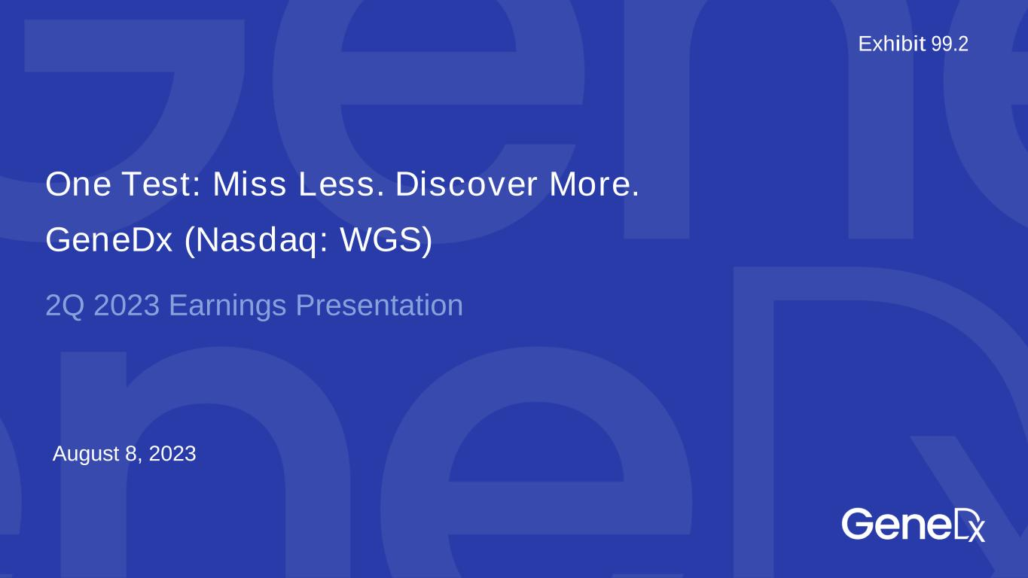

August 8, 2023 One Test: Miss Less. Discover More. GeneDx (Nasdaq: WGS) 2Q 2023 Earnings Presentation Exhibit 99.2

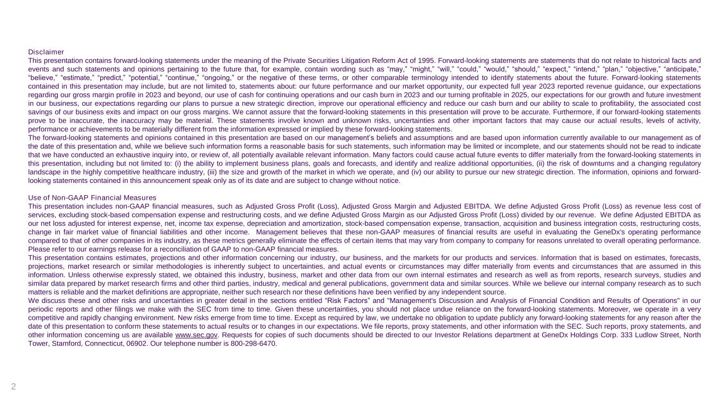
2 Disclaimer This presentation contains forward-looking statements under the meaning of the Private Securities Litigation Reform Act of 1995. Forward-looking statements are statements that do not relate to historical facts and events and such statements and opinions pertaining to the future that, for example, contain wording such as “may,” “might,” “will,” “could,” “would,” “should,” “expect,” “intend,” “plan,” “objective,” “anticipate,” “believe,” “estimate,” “predict,” “potential,” “continue,” “ongoing,” or the negative of these terms, or other comparable terminology intended to identify statements about the future. Forward-looking statements contained in this presentation may include, but are not limited to, statements about: our future performance and our market opportunity, our expected full year 2023 reported revenue guidance, our expectations regarding our gross margin profile in 2023 and beyond, our use of cash for continuing operations and our cash burn in 2023 and our turning profitable in 2025, our expectations for our growth and future investment in our business, our expectations regarding our plans to pursue a new strategic direction, improve our operational efficiency and reduce our cash burn and our ability to scale to profitability, the associated cost savings of our business exits and impact on our gross margins. We cannot assure that the forward-looking statements in this presentation will prove to be accurate. Furthermore, if our forward-looking statements prove to be inaccurate, the inaccuracy may be material. These statements involve known and unknown risks, uncertainties and other important factors that may cause our actual results, levels of activity, performance or achievements to be materially different from the information expressed or implied by these forward-looking statements. The forward-looking statements and opinions contained in this presentation are based on our management’s beliefs and assumptions and are based upon information currently available to our management as of the date of this presentation and, while we believe such information forms a reasonable basis for such statements, such information may be limited or incomplete, and our statements should not be read to indicate that we have conducted an exhaustive inquiry into, or review of, all potentially available relevant information. Many factors could cause actual future events to differ materially from the forward-looking statements in this presentation, including but not limited to: (i) the ability to implement business plans, goals and forecasts, and identify and realize additional opportunities, (ii) the risk of downturns and a changing regulatory landscape in the highly competitive healthcare industry, (iii) the size and growth of the market in which we operate, and (iv) our ability to pursue our new strategic direction. The information, opinions and forward- looking statements contained in this announcement speak only as of its date and are subject to change without notice. Use of Non-GAAP Financial Measures This presentation includes non-GAAP financial measures, such as Adjusted Gross Profit (Loss), Adjusted Gross Margin and Adjusted EBITDA. We define Adjusted Gross Profit (Loss) as revenue less cost of services, excluding stock-based compensation expense and restructuring costs, and we define Adjusted Gross Margin as our Adjusted Gross Profit (Loss) divided by our revenue. We define Adjusted EBITDA as our net loss adjusted for interest expense, net, income tax expense, depreciation and amortization, stock-based compensation expense, transaction, acquisition and business integration costs, restructuring costs, change in fair market value of financial liabilities and other income. Management believes that these non-GAAP measures of financial results are useful in evaluating the GeneDx's operating performance compared to that of other companies in its industry, as these metrics generally eliminate the effects of certain items that may vary from company to company for reasons unrelated to overall operating performance. Please refer to our earnings release for a reconciliation of GAAP to non-GAAP financial measures. This presentation contains estimates, projections and other information concerning our industry, our business, and the markets for our products and services. Information that is based on estimates, forecasts, projections, market research or similar methodologies is inherently subject to uncertainties, and actual events or circumstances may differ materially from events and circumstances that are assumed in this information. Unless otherwise expressly stated, we obtained this industry, business, market and other data from our own internal estimates and research as well as from reports, research surveys, studies and similar data prepared by market research firms and other third parties, industry, medical and general publications, government data and similar sources. While we believe our internal company research as to such matters is reliable and the market definitions are appropriate, neither such research nor these definitions have been verified by any independent source. We discuss these and other risks and uncertainties in greater detail in the sections entitled “Risk Factors” and "Management's Discussion and Analysis of Financial Condition and Results of Operations" in our periodic reports and other filings we make with the SEC from time to time. Given these uncertainties, you should not place undue reliance on the forward-looking statements. Moreover, we operate in a very competitive and rapidly changing environment. New risks emerge from time to time. Except as required by law, we undertake no obligation to update publicly any forward-looking statements for any reason after the date of this presentation to conform these statements to actual results or to changes in our expectations. We file reports, proxy statements, and other information with the SEC. Such reports, proxy statements, and other information concerning us are available www.sec.gov. Requests for copies of such documents should be directed to our Investor Relations department at GeneDx Holdings Corp. 333 Ludlow Street, North Tower, Stamford, Connecticut, 06902. Our telephone number is 800-298-6470.


Our mission: deliver personalized and actionable health insights to inform diagnosis, direct treatment and improve drug discovery.

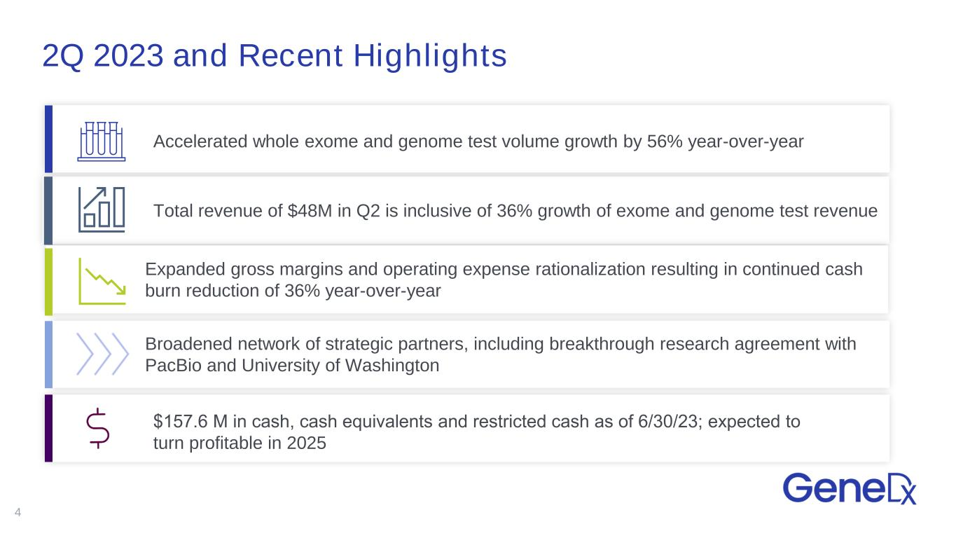
2Q 2023 and Recent Highlights 4 Accelerated whole exome and genome test volume growth by 56% year-over-year $157.6 M in cash, cash​ equivalents and restricted cash as of 6/30/23; expected to turn profitable in 2025 Expanded gross margins and operating expense rationalization resulting in continued cash burn reduction of 36% year-over-year Total revenue of $48M in Q2 is inclusive of 36% growth of exome and genome test revenue Broadened network of strategic partners, including breakthrough research agreement with PacBio and University of Washington

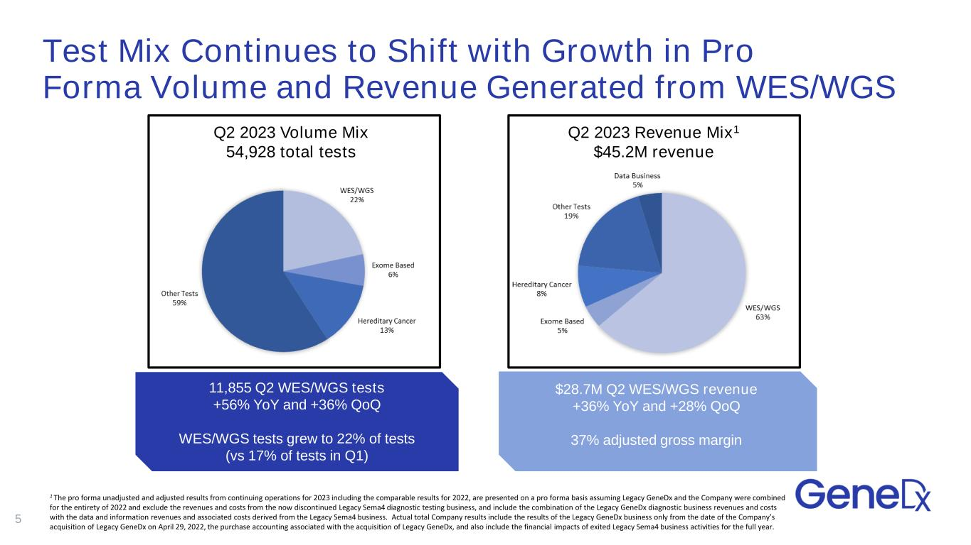
Test Mix Continues to Shift with Growth in Pro Forma Volume and Revenue Generated from WES/WGS 5 Q2 2023 Volume Mix 54,928 total tests Q2 2023 Revenue Mix1 $45.2M revenue 11,855 Q2 WES/WGS tests +56% YoY and +36% QoQ WES/WGS tests grew to 22% of tests (vs 17% of tests in Q1) $171.0M 2022 total revenue 39% adj gross margin 1 The pro forma unadjusted and adjusted results from continuing operations for 2023 including the comparable results for 2022, are presented on a pro forma basis assuming Legacy GeneDx and the Company were combined for the entirety of 2022 and exclude the revenues and costs from the now discontinued Legacy Sema4 diagnostic testing business, and include the combination of the Legacy GeneDx diagnostic business revenues and costs with the data and information revenues and associated costs derived from the Legacy Sema4 business. Actual total Company results include the results of the Legacy GeneDx business only from the date of the Company’s acquisition of Legacy GeneDx on April 29, 2022, the purchase accounting associated with the acquisition of Legacy GeneDx, and also include the financial impacts of exited Legacy Sema4 business activities for the full year. $28.7M Q2 WES/WGS revenue +36% YoY and +28% QoQ 37% adjusted gross margin

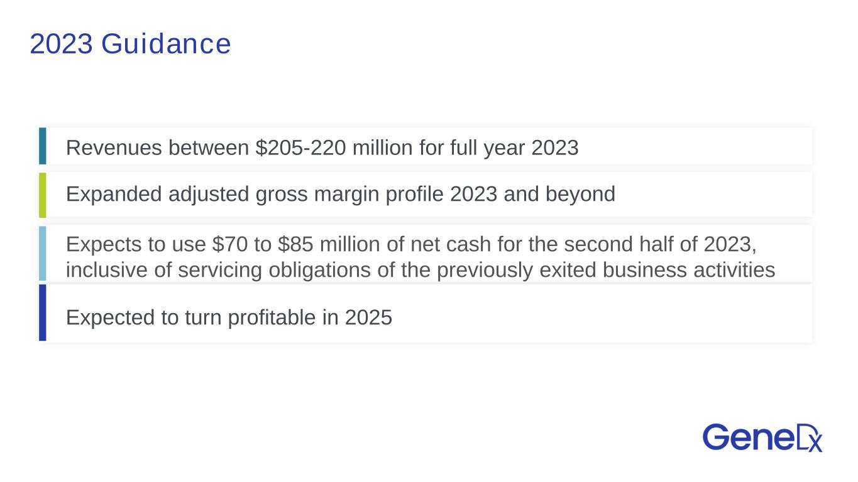
Revenues between $205-220 million for full year 2023 Expanded adjusted gross margin profile 2023 and beyond Expects to use $70 to $85 million of net cash for the second half of 2023, inclusive of servicing obligations of the previously exited business activities Expected to turn profitable in 2025 2023 Guidance

