UNITED STATES

SECURITIES AND EXCHANGE COMMISSION

Washington, D.C. 20549

FORM 8-K

CURRENT REPORT

Pursuant to Section 13 OR 15(d) of The Securities Exchange Act of 1934

Date of Report (date of earliest event reported): August 15, 2022
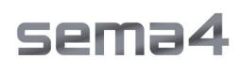

Sema4 Holdings Corp.

(Exact name of registrant as specified in its charter)

Delaware | 001-39482 |  |  | 85-1966622
(State or other jurisdiction of incorporation or organization) |  | (Commission File Number) |  | (I.R.S. Employer Identification No.)
333 Ludlow Street, North Tower, 8th Floor
Stamford, Connecticut |  |  |  | 06902
(Address of Principal Executive Offices) |  |  |  | (Zip Code)

(800) 298-6470

Registrant's telephone number, including area code

(Former name or former address, if changed since last report.)

Check the appropriate box below if the Form 8-K filing is intended to simultaneously satisfy the filing obligation of the registrant under any of the following provisions (see General Instruction A.2. below):

- Written communications pursuant to Rule 425 under the Securities Act (17 CFR 230.425)

- Soliciting material pursuant to Rule 14a-12 under the Exchange Act (17 CFR 240.14a-12)

- Pre-commencement communications pursuant to Rule 14d-2(b) under the Exchange Act (17 CFR 240.14d-2(b))

- Pre-commencement communications pursuant to Rule 13e-4(c) under the Exchange Act (17 CFR 240.13e-4(c)) Securities registered pursuant to Section 12(b) of the Act:

Title of each class |  | Trading Symbol(s) |  | Name of each exchange on which registered
Class A common stock, par value $0.0001 per share |  | SMFR |  | The Nasdaq Global Select Market
Warrants to purchase one share of Class A common stock, each at an exercise price of $11.50
per share |  | SMFRW |  | The Nasdaq Global Select Market

Indicate by check mark whether the registrant is an emerging growth company as defined in Rule 405 of the Securities Act of 1933 (§230.405 of this chapter) or Rule 12b-2 of the Securities Exchange Act of 1934 (§240.12b-2 of this chapter).

Emerging growth company ☒

If an emerging growth company, indicate by check mark if the registrant has elected not to use the extended transition period for complying with any new or revised financial accounting standards provided pursuant to Section 13(a) of the Exchange Act.☐

Item 2.02 Results of Operations and Financial Condition.

On August 15, 2022, Sema4 Holdings Corp. (“Sema4 Holdings” or the “Company”) issued a press release (the “Press Release”) and will hold a conference call announcing the Company's financial results for the three and six months ended June 30, 2022. Copies of the Press Release and Earnings Presentation are furnished as Exhibits 99.1 and 99.2, respectively, to this Current Report on Form 8-K.

Item 7.01 Regulation FD Disclosure.

On August 15, 2022, the Company also issued a press release announcing certain changes to its research & development leadership team. A copy of this press release is furnished as Exhibits 99.3 to this Current Report on Form 8-K.

The information furnished under Items 2.02 and 7.01 of this Current Report on Form 8-K, including Exhibits 99.1, 99.2 and 99.3, respectively, shall not be deemed “filed” for purposes of Section 18 of the Securities Exchange Act of 1934, as amended (the “Exchange Act”), or otherwise subject to the liabilities of that section, nor shall it be deemed incorporated by reference into any other filing under the Securities Act of 1933, as amended, or the Exchange Act, except as expressly set forth by specific reference in such a filing.

Item 9.01 Financial Statement and Exhibits.

(d) Exhibits.
 |  | Exhibit
 | Number |  |  |  |  | Description
99.1 |  |  |  |  | Press Release, dated August 15, 2022, regarding the Registrant’s results for the quarter ended June 30, 2022
99.2 |  |  |  |  | Earnings Presentation, dated August 15, 2022
 |  |  |  |  | Press Release, dated August 15, 2022, regarding Changes to the Registrant’s Research & Development Leadership
99.3
 |  |  |  |  | Cover Page Interactive Data File (embedded within the Inline XBRL document).
104

SIGNATURES

Pursuant to the requirements of the Securities Exchange Act of 1934, the registrant has duly caused this report to be signed on its behalf by the undersigned hereunto duly authorized.

 | Sema4 Holdings Corp.
Date: August 15, 2022 | By: | /s/ Katherine Stueland
 | Name: | Katherine Stueland
 | Title: | Chief Executive Officer

Exhibit 99.1

Sema4 Announces Continued Restructuring, Business Highlights, and Reports Second Quarter

2022 Financial Results

New management team implements significant restructuring to focus on profitable growth, efficiency, and scale

19% pro forma¹ volume growth vs. 2Q 2021

Sema4 to host a conference call today at 4:30 p.m. ET

STAMFORD, CT — August 15, 2022 — Sema4 Holdings Corp. (Nasdaq: SMFR) (“Sema4”), a health insights company, today announced a series of corporate realignments, business highlights, and financial results for the second quarter ended June 30, 2022.

"We saw strong volume growth in both our reproductive health and recently acquired pediatrics and rare disease businesses, which delivered on record volumes. The underlying performance of the legacy GeneDx business is meeting our internal expectations

and tracking ahead of our previously issued guidance. In order to drive Sema4 toward profitable growth, we have made strategic decisions since last updating the market during our first quarter 2022 conference call in May,” said Katherine Stueland, Chief Executive Officer of Sema4.

The company is on track to deliver against its previously announced cost savings target of approximately $50 million in 2022. With additional initiatives underway, the company will be on target to achieve more than $150 million in annualized savings and approximately $200 million in cumulative savings by the end of 2023.

Led by Sema4’s new Transformation Management Office, the actions taken by the company include:

- Exiting the somatic tumor testing business, including the planned closure of the clinical laboratory in Branford, CT, effective December 31, 2022. This business line represents less than 1% of the company’s revenue and approximately $35 million in annual expense.
- Eliminating approximately 250 positions, representing approximately 13% of its workforce. Combined with the prior reductions in force in the first half of 2022, the company has eliminated approximately 30% of roles from the legacy Sema4 business.

- Moving hereditary cancer testing operations from Stamford, CT to Gaithersburg, MD at the end of the third quarter of 2022. The company believes this effort will improve gross margins by leveraging superior automation capabilities in the clinical laboratory in Gaithersburg.
- Reorganizing the commercial team to deploy a more productive and data-driven strategy in support of profitable growth.

Moving forward, Sema4 will focus on building the company’s health insights business by delivering a portfolio of genomic and data solutions to guide patients through their family health journey. With new leadership and strategy, Sema4 will also work with its founding health system partners to develop scalable plans for data generation and broad utilization of testing services, as well as productize offerings for biopharma partnerships.

“Our mission is to unlock insights from data, leading to healthier lives. To do that, we’re making pivotal decisions to strengthen our foundation and finances. Since May, our new management team has been assessing the overall operating model, looking at the profitability profile of each line of business. We are clear-eyed about the opportunities we have today to make a positive impact on more patients by focusing on our strengths and in areas where we have operational scale, competitive advantage, and scientific leadership,” said Ms. Stueland. “As we look forward, Sema4 will have a dramatically improved cost structure and a more targeted commercial effort supported by an optimized product development strategy. This will enable us to continue to accelerate the use of genomics and leverage clinical data to enhance the standard of care through the more extensive use of precision medicine.”

Second Quarter & Recent Highlights

“During the second quarter, we experienced strong underlying demand for our core testing services, including carrier screening, non-invasive prenatal screening, and our pediatric and rare disease franchises, with pro forma volume growth of 19%,” said Rich Miao, Interim Chief Financial Officer of Sema4.

1

Highlights include:

- Testing volumes on a pro forma basis were up 19% in the second quarter of 2022 compared to the same period of 2021, with 132,622 tests resulted (excluding COVID-19 tests)¹.

- Testing volumes on a reported basis were up 63% in the second quarter of 2022 compared to the same period of 2021, with 117,838 tests resulted (excluding COVID-19 tests)¹.
- Workforce reduced to approximately 1,600 employees and exiting the somatic testing business to help achieve the targeted $50 million of cost savings in 2022.

- Published the first data-driven study to predict preeclampsia events throughout the pregnancy journey with models developed from large-scale electronic medical record data.

Second Quarter 2022 Financial Results

Total revenue for the second quarter of 2022 was $36.2 million compared to $47.0 million in the second quarter of 2021. Excluding the $30.1 million of prior period revenue adjustments recorded in the second quarter of 2022 due to our change in estimates, total revenue would have been $66.3 million for the quarter.

Pro forma revenue in the second quarter of 2022, assuming GeneDx’s results were included for the full applicable quarter, excluding COVID-19 related revenue and the $30.1 million of prior period revenue adjustment would have been $78.1 million compared to $72.8 million in the second quarter of 2021.

Net loss in the second quarter of 2022 was ($85.7) million. Adjusted net loss for the second quarter of 2022 was ($72.9) million compared to ($43.5) million in the same period of 2021.

Total cash and cash equivalents were $285 million as of June 30, 2022 and the company’s $125 million revolving credit facility remains undrawn, bringing total liquidity to $410 million. As of August 9, 2022, Sema4 had 380,641,510 outstanding shares of Class A common stock.

Fiscal Year 2022 Guidance

The company now expects fiscal year 2022 reported revenue to be $245-255 million, reflecting the inclusion of GeneDx’s results for the eight months of ownership in 2022. Embedded in this revenue guidance is a $24 million reduction in revenue due to our estimated change of Sema4’s revenue related to periods prior to 2022 and a more conservative outlook on volumes and pricing trends within our reproductive health product lines for the remainder of the year.

Sema4 is updating its 2022 adjusted gross margin target and now expects full year 2022 adjusted gross margin to be in the range of 4-9%, inclusive of the $24 million reduction in revenue due to our estimated change in revenue related to periods prior to 2022.

Excluding this revision would imply an adjusted gross margin in the range of 11-16%.

The company expects second half 2022 revenue in the range of $154-164 million, and second half 2022 adjusted gross margin in the range of 15-20%. The company expects to end 2022 with more than $165 million of cash and cash equivalents and total liquidity of over $290 million.

Leadership Change

- Sema4 also announced changes to its management team and governance:

  - Founder Eric Schadt is resigning from his roles as President and Chief Research & Development Officer, as well as his position as a Director of the company, effective today.

  - Matthew Davis, former Head of AI & Data at Invitae Corp., is joining the company as Chief Technology & Product Officer. Mr. Davis will work in close partnership with Chief Science Officer Gustavo Stolovitzky to drive scientific and product innovation to deliver on the company’s data strategy for health systems and biopharma partners.

“We would not be where we are today without Eric’s vision. He conceived Sema4 and led its rapid growth from a spin out of Mount Sinai to a publicly held company,” said Ms. Stueland. “As we move into this new phase of commercial scale fueled by customer-centric

2

scientific innovation, I’m excited about the essential role that Matt and Gustavo will play in helping us shape a truly pioneering future of healthcare.”

Webcast and Conference Call Details

Sema4 will host a conference call today, August 15, 2022, at 4:30 p.m. Eastern Time. Investors interested in listening to the conference call are required to register online. A live and archived webcast of the event will be available on the “Events” section of the Sema4 investor relations website at https://ir.sema4.com/.

- Pro forma metrics consolidate GeneDx operating results for the entirety of the compared periods. Pro forma metrics are presented for illustrative purposes only and are not necessarily indicative of the results that would have occurred had the GeneDx acquisition been completed on such dates or that may occur in the future. See Appendix for Historical Sema4 & GeneDx Resulted Volumes & Revenue.

Forward-Looking Statements

This press release contains certain forward-looking statements within the meaning of the federal securities laws, including statements regarding our future performance and our market opportunity, including our expected full year and second half 2022 reported revenue and adjusted gross margin guidance, our expectations regarding our year end cash and cash equivalents and total liquidity, our expectations for our growth and future investment in our business, our expectations regarding our restructuring plans and the associated cost savings and impact on our gross margins, and our expectations of the anticipated benefits and synergies of the recently completed GeneDx acquisition. These forward-looking statements generally are identified by the words “believe,” “project,” “expect,” “anticipate,” “estimate,” “intend,” “strategy,” “future,” “opportunity,” “plan,” “may,” “should,” “will,” “would,” “will be,” “will continue,” “will likely result,” and similar expressions. Forward-looking statements are predictions, projections and other statements about future events that are based on current expectations and assumptions and, as a result, are subject to risks and uncertainties. Many factors could cause actual future events to differ materially from the forward-looking statements in this press release, including but not limited to: (i) the ability to implement business plans, goals and forecasts, and identify and realize additional opportunities, (ii) the risk of downturns and a changing regulatory landscape in the highly competitive healthcare industry,

- the size and growth of the market in which we operate, and (iv) our expectations regarding our restructuring plans and the associated cost savings and impact on our gross margins, (v) the risk that the anticipated benefits of the GeneDx acquisition may not be fully realized, if at all. The foregoing list of factors is not exhaustive. You should carefully consider the foregoing factors and the other risks and uncertainties described in the “Risk Factors” section of our Annual Report on Form 10-K for the fiscal year ended December 31, 2021, filed with the U.S. Securities and Exchange Commission (the “SEC”) on March 14, 2022 and other documents filed by us from time to time with the SEC. These filings identify and address other important risks and uncertainties that could cause actual events and results to differ materially from those contained in the forward-looking statements. Forward-looking statements speak only as of the date they are made. Readers are cautioned not to put undue reliance on forward-looking statements, and we assume no obligation and do not intend to update or revise these forward-looking statements, whether as a result of new information, future events, or otherwise. We do not give any assurance that we will achieve our expectations.

About Sema4

Sema4 is a patient-centered health intelligence company dedicated to advancing healthcare through data-driven insights. Sema4 is transforming healthcare by applying AI and machine learning to multidimensional, longitudinal clinical and genomic data to build dynamic models of human health and defining optimal, individualized health trajectories. Centrellis®, our innovative health intelligence platform, is enabling us to generate a more complete understanding of disease and wellness and to provide science-driven solutions to the most pressing medical needs. Sema4 believes that patients should be treated as partners, and that data should be shared for the benefit of all.

For more information, please visit sema4.com and connect with Sema4 on Twitter, LinkedIn, Facebook and YouTube.

Investor Relations Contact:

Joel Kaufman

investors@sema4.com

Media Contact:

Radley Moss

radley.moss@sema4.com

3

Historical Pro Forma Resulted Volume and Revenue¹

 | 1Q21 | 2Q21 | 3Q21 | 4Q21 | 1Q22 | 2Q22⁴
Pro Forma Resulted Volumes²
Complex Reproductive Health | 46,052 | 50,155 | 49,475 | 61,741 | 67,907 | 73,288
Whole Exome, Whole Genome & NICU | 3,344 | 6,698 | 6,162 | 6,619 | 7,395 | 7,572
Other Diagnostic Testing (Excluding COVID) | 49,230 | 54,412 | 51,780 | 53,387 | 51,057 | 51,802
Total Excluding COVID¹ | 98,626 | 111,265 | 107,417 | 121,747 | 126,359 | 132,662
Sema4 (Excluding COVID) | 66,945 | 72,083 | 69,895 | 82,966 | 84,925 | 87,094
GeneDx | 31,681 | 39,182 | 37,522 | 38,781 | 41,434 | 45,568
Total Excluding COVID¹ | 98,626 | 111,265 | 107,417 | 121,747 | 126,359 | 132,662
Pro Forma Revenue²
Complex Reproductive Health | $46.5 | $41.3 | $37.6 | $46.2 | $48.3 | $8.2
Whole Exome, Whole Genome & NICU | $8.4 | $13.5 | $14.2 | $15.3 | $18.4 | $21.1
Other Diagnostic Testing (Excluding COVID) | $14.8 | $15.7 | $15.2 | $15.7 | $17.9 | $16.5
COVID | $15.9 | $3.8 | $4.2 | $10.5 | $3.8 | $0.3
Pharma | $1.4 | $2.2 | $1.8 | $2.4 | $1.6 | $2.3
Total² | $87.0 | $76.7 | $73.0 | $90.1 | $90.1 | $48.3
2Q 2022 Prior Period Revenue Adjustment³ | - | - | - | - | - | ($30.1)
Adjusted Total | $87.0 | $76.7 | $73.0 | $90.1 | $90.1 | $78.4
Adjusted Total Excluding COVID | $71.1 | $72.8 | $68.8 | $79.6 | $86.3 | $78.1
Sema4 | $64.2 | $47.0 | $43.2 | $57.8 | $53.9 | $10.0
Sema4 Diagnostic Testing (Excluding COVID) | $48.3 | $43.2 | $39.0 | $47.3 | $50.1 | $9.8
Sema4 COVID Testing | $15.9 | $3.8 | $4.2 | $10.5 | $3.8 | $0.3
Sema4 Pharma | $1.4 | $2.2 | $1.7 | $1.4 | $1.4 | $1.7
GeneDx | $22.8 | $29.6 | $29.8 | $32.3 | $36.1 | $38.3
Total² | $87.0 | $76.7 | $73.0 | $90.1 | $90.1 | $48.3
2Q 2022 Prior Period Revenue Adjustment³ | - | - | - | - | - | ($30.1)
Adjusted Total | $87.0 | $76.7 | $73.0 | $90.1 | $90.1 | $78.4
Adjusted Total Excluding COVID | $71.1 | $72.8 | $68.8 | $79.6 | $86.3 | $78.1

- Pro forma volume and revenue metrics assume GeneDx was owned for the entirety of the applicable quarter and are calculated based on the sum of each of Sema4’s and GeneDx’s historical volumes or revenues, as applicable. Pro forma metrics are presented for illustrative purposes only and are not necessarily indicative of the results that would have occurred had the GeneDx acquisition been completed on such dates or that may occur in the future.
2 Represents aggregated Resulted Volume and Revenue from GeneDx and Sema4.
³ 30.1 million of revenue adjustments recorded related to prior periods due to our change in estimate. ⁴ 2Q22 results include GeneDx for the entirety of the second quarter

4

Sema4 Holdings Corp.

Condensed Consolidated Balance Sheets

(in thousands, except share amounts)

 |  | June 30, 2022 (unaudited) |  |  | December 31, 2021
Assets
Current assets:
Cash and cash equivalents | $ |  | 284,647 |  | $ | 400,569
Accounts receivable, net |  |  | 45,803 |  |  | 26,509
Due from related parties |  |  | 1,110 |  |  | 54
Inventory, net |  |  | 41,601 |  |  | 33,456
Prepaid expenses |  |  | 21,547 |  |  | 19,154
Other current assets |  |  | 7,993 |  |  | 3,802
Total current assets |  | $ | 402,701 |  | $ | 483,544
Operating lease right-of-use assets |  |  | 44,038 |  |  | —
Property and equipment, net |  |  | 89,455 |  |  | 62,719
Intangible assets, net |  |  | 193,663 |  |  | —
Goodwill |  |  | 181,184 |  |  | —
Restricted cash |  |  | 14,370 |  |  | 900
Other assets |  |  | 7,869 |  |  | 6,930
Total assets |  | $ | 933,280 |  | $ | 554,093
Liabilities and Stockholders’ Equity
Current liabilities:
Accounts payable and accrued expenses | $ |  | 115,878 |  |  | $ 64,801
Due to related parties |  |  | 2,354 |  |  | 2,623
Contract liabilities |  |  | — |  |  | 473
Short-term lease liabilities |  |  | 4,755 |  |  | —
Other current liabilities |  |  | 81,619 |  |  | 33,387
Total current liabilities |  | $ | 204,606 |  | $ | 101,284
Long-term debt, net of current portion |  |  | 11,000 |  |  | 11,000
Long-term lease liabilities |  |  | 62,806 |  |  | —
Other liabilities |  |  | 500 |  |  | 21,907
Deferred taxes |  |  | 2,668 |  |  | —
Warrant liability |  |  | 7,258 |  |  | 21,555
Earn-out contingent liabilities |  |  | 7,168 |  |  | 10,244
Total liabilities |  | $ | 296,006 |  | $ | 165,990
Commitments and contingencies
Stockholders’ equity:
Preferred Stock |  |  | — |  |  | —
Class A common stock |  |  | 38 |  |  | 24
Additional paid-in capital |  |  | 1,375,315 |  | $ | 963,520
Accumulated deficit |  |  | (738,079) |  |  | (575,441)
Total stockholders’ equity |  |  | 637,274 |  |  | 388,103
Total liabilities and stockholders’ equity | $ |  | 933,280 |  | $ | 554,093
 | 5

Sema4 Holdings Corp.

Condensed Consolidated Statements of Operations and Comprehensive Loss

(in thousands, except share and per share amounts)

(unaudited)

 | Three months ended June 30, |  |  |  |  |  |  |  |  | Six months ended June 30,
 | 2022 |  |  |  | 2021 (1) |  |  | 2022 |  |  |  |  | 2021 (1)
Revenue:
Diagnostic test revenue | $ | 34,004 |  |  | $ | 44,803 |  |  | $ | 86,499 |  |  | $ | 107,563
Other revenue |  | 2,165 |  |  |  | 2,212 |  |  |  | 3,611 |  |  |  | 3,653
Total revenue |  | 36,169 |  |  |  | 47,015 |  |  |  | 90,110 |  |  |  | 111,216
Cost of services |  | 65,767 |  |  |  | 48,179 |  |  |  | 114,083 |  |  |  | 116,703
Gross profit (loss) |  | (29,598) |  |  |  | (1,164) |  |  |  | (23,973) |  |  |  | (5,487)
Research and development |  | 27,168 |  |  |  | 11,952 |  |  |  | 48,483 |  |  |  | 65,085
Selling and marketing |  | 36,118 |  |  |  | 18,574 |  |  |  | 65,665 |  |  |  | 53,940
General and administrative |  | 68,034 |  |  |  | 12,870 |  |  |  | 110,818 |  |  |  | 114,908
Related party expenses |  | 1,731 |  |  |  | 888 |  |  |  | 3,015 |  |  |  | 2,685
Loss from operations | (162,649) |  |  |  |  | (45,448) |  |  | (251,954) |  |  |  |  | (242,105)
Other income (expense), net:
Change in fair market value of warrant and earn-out contingent liabilities |  | 28,182 |  |  |  | — |  |  |  | 41,372 |  |  |  | —
Interest income |  | 382 |  |  |  | 9 |  |  |  | 409 |  |  |  | 30
Interest expense |  | (790) |  |  |  | (722) |  |  |  | (1,598) |  |  |  | (1,445)
Other income |  | 56 |  |  |  | — |  |  |  | 56 |  |  |  | 5,584
Total other income (expense), net |  | 27,830 |  |  |  | (713) |  |  |  | 40,239 |  |  |  | 4,169
Loss before income taxes | $ (134,819) |  |  |  | $ | (46,161) |  | $ | (211,715) |  |  |  | $ | (237,936)
Income tax benefit |  | 49,077 |  |  |  | — |  |  |  | 49,077 |  |  |  | —
Net loss and comprehensive loss | $ | (85,742) |  |  | $ | (46,161) |  | $ | (162,638) |  |  |  | $ | (237,936)
Weighted average shares outstanding of Class A common stock | 337,752,029 |  |  |  | 1,100,734 |  |  | 291,318,351 |  |  |  |  |  | 826,778
Basic and diluted net loss per share, Class A common stock | $ | (0.25) |  |  | $ | (41.94) |  |  | $ | (0.56) |  |  | $ | (287.79)

- As previously disclosed in Note 2, “Summary of Significant Accounting Policies” to our consolidated financial statements included in our Annual Report on Form 10-K for the year ended December 31, 2021, certain adjustments were made to reclassify certain expenses between cost of services and operating expenses. The adjustments are reflected as disclosed.

6

Sema4 Holdings Corp.

Condensed Consolidated Statements of Cash Flows

(in thousands)

(unaudited)

Six months ended June 30,

 | 2022 |  |  | 2021 (1)
Operating activities
Net loss |  | $ (162,638) |  | $ (237,936)
Adjustments to reconcile net loss to net cash used in operating activities:
Depreciation and amortization expense |  | 14,767 |  | 10,521
Stock-based compensation expense |  | 40,280 |  | 164,443
Change in fair value of warrant and earn-out contingent liabilities |  | (41,372) |  | —
Income tax benefit |  | (49,077) |  | —
Provision for excess and obsolete inventory |  | 347 |  | 2,466
Non-cash lease expense |  | 331 |  | 383
Amortization of deferred debt issuance costs |  | 257 |  | —
Change in operating assets and liabilities, net of effects from purchase of
business:
Accounts receivable |  | 2,357 |  | 7,476
Inventory |  | (2,282) |  | (6,632)
Prepaid expenses and other current assets |  | 2,910 |  | (9,697)
Due to/from related parties |  | (1,325) |  | (295)
Other assets |  | (1,126) |  | —
Accounts payable and accrued expenses |  | 35,712 |  | 10,028
Contract liabilities |  | (473) |  | (442)
Other current liabilities |  | (4,807) |  | (7,824)
Net cash used in operating activities |  | (166,139) |  | (67,509)
Investing activities
Purchase of business, net of cash acquired |  | (127,004) |  | —
Purchases of property and equipment |  | (2,748) |  | (3,320)
Development of internal-use software assets |  | (4,458) |  | (6,155)
Net cash used in investing activities |  | (134,210) |  | (9,475)
Financing activities
Proceeds from PIPE issuance, net of issuance costs |  | 197,712 |  | —
Payment of deferred transaction costs |  | — |  | (2,779)
Finance lease principal payments |  | (1,634) |  | (1,994)
Long-term debt principal payments |  | — |  | (848)
Exercise of stock options |  | 1,819 |  | 974
Net cash provided by (used) in financing activities |  | 197,897 |  | (4,647)

Net decrease in cash, cash equivalents and restricted cash
Cash, cash equivalents and restricted cash, at beginning of period

Cash, cash equivalents and restricted cash, at end of period

(102,452)

401,469

- 299,017

(81,631)

118,960

- 37,329

Supplemental disclosures of cash flow information
Cash paid for interest | $ | 1,193 | $ 1,445
Cash paid for taxes | $ | 365 | $ —
 | 7

Stock consideration paid for purchase of business | $ | 172,000 |  |  |  | $ | —
Purchases of property and equipment in accounts payable and accrued expenses |  | $ | 3,243 |  |  | $ | 87
Software development costs in accounts payable and accrued expenses |  | $ | 1,118 |  | $ | 1,225
Unpaid deferred transaction costs included in accounts payable and accrued expenses |  |  | $ | 53 | $ | 5,799
Non-cash impact of shares reclass into APIC |  |  | $ | — | $ | 1,483

- As previously disclosed in Note 2, “Summary of Significant Accounting Policies” to our consolidated financial statements included in our Annual Report on Form 10-K for the year ended December 31, 2021, certain adjustments were made to certain liability accounts previously reported in the condensed balance sheets as of June 30, 2021. The adjustments are reflected accordingly as disclosed.

8

Sema4 Holdings Corp.
Reconciliation of Revenue to our Adjusted Gross Profit, Adjusted EBITDA, & Adjusted Net Loss
(unaudited, in thousands)

The following is a reconciliation of revenue to our Adjusted Gross Profit, Adjusted Gross Margin, Adjusted Research & Development, Adjusted Selling & Marketing, Adjusted General & Administrative and
Related Party Expense, Adjusted Loss from Operations, and Adjusted Net Income (Loss) for the three and six months ended June 30, 2022 and 2021. Please see the footnotes in the reconciliation to Adjusted
EBITDA for additional detail on the following adjustments:

 |  |  | Three months ended June 30,
 |  | 2022 |  |  |  |  |  | 2021
 |  |  |  |  | (in thousands)
Revenue
Diagnostic test revenue |  |  | $ | 34,004 |  |  |  | $ | 44,803
Other Revenue |  |  |  | 2,165 |  |  |  |  | 2,212
Total Revenue |  |  |  | 36,169 |  |  |  |  | 47,015
Cost of Service |  |  |  | 65,767 |  |  |  |  | 48,179
Gross (Loss) Profit |  |  | $ | (29,598) |  |  |  | $ | (1,164)
Gross Margin |  |  |  | (82) | % |  |  |  | (2) | %
Stock-based compensation |  |  |  | 1,810 |  |  |  |  | (306)
Restructuring costs |  |  |  |  | 205 |  |  |  |  | —
Adjusted Gross (Loss) Profit |  |  |  | (27,583) |  |  |  |  | (1,470)
Adjusted Gross Margin |  |  |  | (76) | % |  |  |  | (3) | %
Research & Development |  |  |  | 27,168 |  |  |  |  | 11,952
Stock-based compensation |  |  |  | (6,515) |  |  |  |  |  | 370
Restructuring costs |  |  |  | (1,005) |  |  |  |  |  | —
Adjusted Research & Development |  |  | $ | 19,648 |  |  |  | $ | 12,322
Selling & Marketing |  |  |  | 36,118 |  |  |  |  | 18,574
Stock-based compensation |  |  |  | (1,485) |  |  |  |  | (1,065)
Amortization of acquired intangibles |  |  |  | (817) |  |  |  |  |  | —
Restructuring costs |  |  |  | (2,293) |  |  |  |  |  | —
Adjusted Selling & Marketing |  |  | $ | 31,523 |  |  |  | $ | 17,509
General & Administrative & Related Party Expense |  |  |  | 69,765 |  |  |  |  | 13,758
Stock-based compensation |  |  |  | (12,911) |  |  |  |  |  | 908
Amortization of acquired intangibles |  |  |  | (1,520) |  |  |  |  |  | —
Transaction, acquisition, business integration and restructuring costs |  |  |  | (12,428) |  |  |  | —
Adjusted General & Administrative & Related Party |  |  | $ | 42,906 |  |  |  | $ | 14,666
Total Adjusted Operating Expenses |  |  |  | 94,077 |  |  |  |  | 44,497
Loss from Operations |  |  | (162,649) |  |  |  |  |  | (45,448)
Stock-based compensation |  |  |  | 22,721 |  |  |  |  | (519)
Amortization of acquired intangibles |  |  |  | 2,337 |  |  |  |  |  | —
Transaction, acquisition, business integration and restructuring costs |  |  |  | 15,931 |  |  |  |  | 3,151
Adjusted loss from operations |  | $ | (121,660) |  |  |  |  | $ | (42,816)
 | 9

 |  | Three months ended June 30,
 | 2022 |  |  |  | 2021
 |  | (in thousands)
Net loss | $ | (85,742) |  |  | $ | (46,161)
Interest expense, net ⁽¹⁾ |  | 408 |  |  |  | 713
Income tax benefit |  | (49,077) |  |  |  | —
Depreciation and amortization |  | 8,964 |  |  |  | 5,619
Stock-based compensation expense |  | 22,721 |  |  |  | (519)
Transaction, acquisition and business integration costs ⁽²⁾ |  | 9,099 |  |  |  | 3,151
Restructuring costs ⁽³⁾ |  | 6,832 |  |  |  | —
Change in fair market value of warrant and earn-out contingent liabilities ⁽⁴⁾ |  | (28,182) |  |  |  | —
Other income |  | (56) |  |  |  | —
Adjusted EBITDA | $ | (115,033) |  |  | $ | (37,197)

__________________

- Represents the total of interest expense related to our finance leases and interest-bearing loans and interest income on money market funds. This also includes the unused line fee and amortization of deferred transaction costs related to the loan and security agreement entered into with Silicon Valley Bank.
- Represents professional service costs incurred in connection with pursuing the business combination transaction that did not meet the requirement for capitalization in 2021. For the second quarter of 2022, this represents professional service costs incurred in connection with the Acquisition transaction, which include due diligence, legal and business integration costs.
- Represents costs incurred for restructuring activities, which include severance packages offered to impacted employees and third party consulting costs incurred in the second quarter of 2022.

- Represents the change in fair market value of the liabilities associated with our public warrants and private placement warrants and the earn-out shares issuable under the terms of the merger agreement related to our business combination with CMLS.

 |  | Three months ended June 30,
 | 2022 | 2021
 |  | (in thousands)
Net loss | (85,742) | (46,161)
Stock-based compensation expense | 22,721 | (519)
Amortization of acquisition intangibles | 2,337 | —
Change in fair market value of warrant and earn-out contingent liabilities | (28,182) | —
Transaction, acquisition, business integration and restructuring costs | 15,931 | 3,151
Adjusted Net loss | (72,935) | (43,529)

10

 |  | Six months ended June 30,
 | 2022 |  |  |  |  |  | 2021
 |  |  |  | (in thousands)
Revenue
Diagnostic test revenue |  | $ | 86,499 |  |  |  |  | $ | 107,563
Other Revenue |  |  | 3,611 |  |  |  |  |  | 3,653
Total Revenue |  |  | 90,110 |  |  |  |  |  | 111,216
Cost of Service |  |  | 114,083 |  |  |  |  |  | 116,703
Gross (Loss) Profit |  | $ | (23,973) |  |  |  |  | $ | (5,487)
Gross Margin |  |  | (27) | % |  |  |  |  | (5) | %
Stock-based compensation |  |  | 3,191 |  |  |  |  |  | 18,169
Restructuring costs |  |  |  | 311 |  |  |  |  |  | —
Adjusted Gross (Loss) Profit |  |  | (20,471) |  |  |  |  |  | 12,682
Adjusted Gross Margin |  |  | (23) | % |  |  |  |  | 11 | %
Research & Development |  |  | 48,483 |  |  |  |  |  | 65,085
Stock-based compensation |  |  | (10,856) |  |  |  |  |  | (37,817)
Restructuring costs |  |  | (1,006) |  |  |  |  |  |  | —
Adjusted Research & Development |  | $ | 36,621 |  |  |  |  | $ | 27,268
Selling & Marketing |  | $ | 65,665 |  |  |  |  | $ | 53,940
Stock-based compensation |  |  | (4,310) |  |  |  |  |  | (19,753)
Amortization of acquisition intangibles |  |  | (817) |  |  |  |  |  |  | —
Restructuring costs |  |  | (2,640) |  |  |  |  |  |  | —
Adjusted Selling & Marketing |  | $ | 57,898 |  |  |  |  | $ | 34,187
General & Administrative & Related Party Expense |  |  | 113,833 |  |  |  |  |  | 117,593
Stock-based compensation |  |  | (21,923) |  |  |  |  |  | (88,704)
Amortization of acquisition intangibles |  |  | (1,520) |  |  |  |  |  |  | —
Transaction, acquisition, business integration and restructuring costs |  |  | (19,040) |  |  |  |  |  | (5,105)
Adjusted General & Administrative & Related Party |  | $ | 71,350 |  |  |  |  | $ | 23,784
Total Adjusted Operating Expenses |  | $ | 165,869 |  |  |  |  | $ | 85,239
Loss from Operations | $ | (251,954) |  |  |  |  | $ | (242,105)
Stock-based compensation |  |  | 40,280 |  |  |  |  |  | 164,443
Amortization of acquisition intangibles |  |  | 2,337 |  |  |  |  |  |  | —
Transaction, acquisition, business integration and restructuring costs |  |  | 22,997 |  |  |  |  |  | 5,105
Adjusted loss from operations | $ | (186,340) |  |  |  |  |  | $ | (72,557)

11

 |  | Six months ended June 30,
 | 2022 |  |  |  | 2021
 |  | (in thousands)
Net loss | $ | (162,638) |  |  | $ | (237,936)
Interest expense, net ⁽¹⁾ |  | 1,189 |  |  |  | 1,415
Income tax benefit |  | (49,077) |  |  |  | —
Depreciation and amortization |  | 14,767 |  |  |  | 10,521
Stock-based compensation expense |  | 40,280 |  |  |  | 164,443
Transaction, acquisition and business integration costs ⁽²⁾ |  | 13,436 |  |  |  | 5,105
Restructuring costs ⁽³⁾ |  | 9,561 |  |  |  | —
Change in fair market value of warrant and earn-out contingent liabilities ⁽⁴⁾ |  | (41,372) |  |  |  | —
Other income ⁽⁵⁾ |  | (56) |  |  |  | (5,584)
Adjusted EBITDA | $ | (173,910) |  |  | $ | (62,036)

__________________

- Represents the total of interest expense related to our finance leases and interest-bearing loans and interest income on money market funds. This also includes the unused line fee and amortization of deferred transaction costs related to the loan and security agreement entered into with Silicon Valley Bank.
- Represents professional service costs incurred in connection with pursuing the business combination transaction that did not meet the requirement for capitalization in 2021. For the first half of 2022, this represents professional service costs incurred in connection with the Acquisition transaction, which include due diligence, legal and business integration costs.
- Represents costs incurred for restructuring activities, which include severance packages offered to impacted employees and third party consulting costs incurred in the first half of 2022.

- Represents the change in fair market value of the liabilities associated with our public warrants and private placement warrants and the earn-out shares issuable under the terms of the merger agreement related to our business combination with CMLS.

- For the six months ended June 30, 2021, the amount represents funding received under the CARES Act Provider Relief Fund in the first quarter of 2021.

 |  | Six months ended June 31,
 | 2022 | 2021
 |  | (in thousands)
Net loss | (162,638) | (237,936)
Stock-based compensation expense | 40,280 | 164,443
Amortization of acquisition intangibles | 2,337 | —
Change in fair market value of warrant and earn-out contingent liabilities | (41,372) | —
Transaction, acquisition, business integration and restructuring costs | 22,997 | 5,105
Adjusted Net loss | (138,396) | (68,388)

12

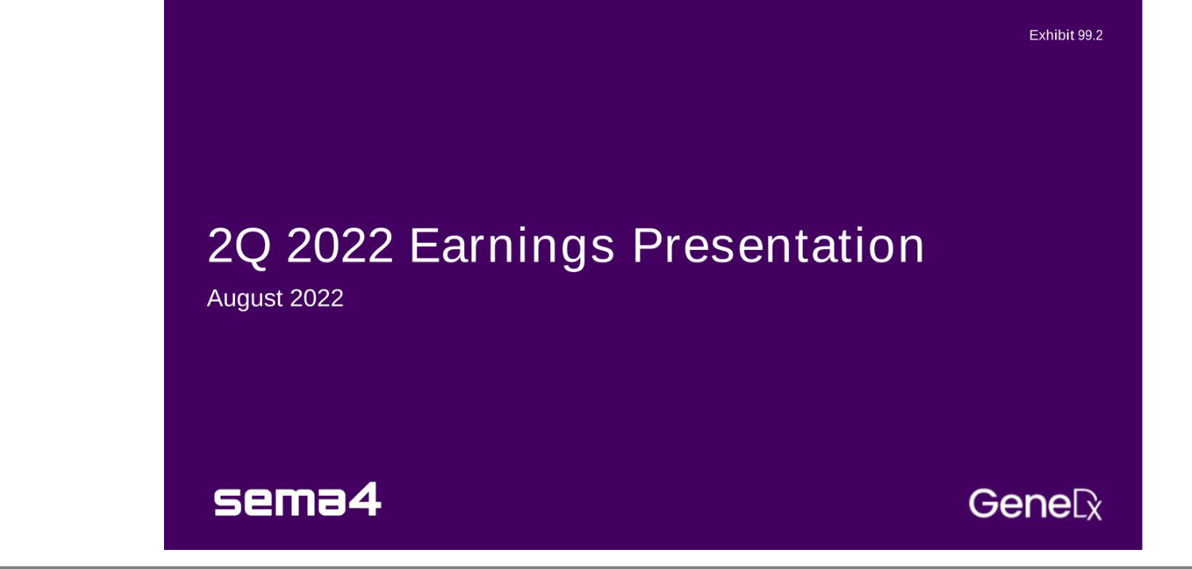

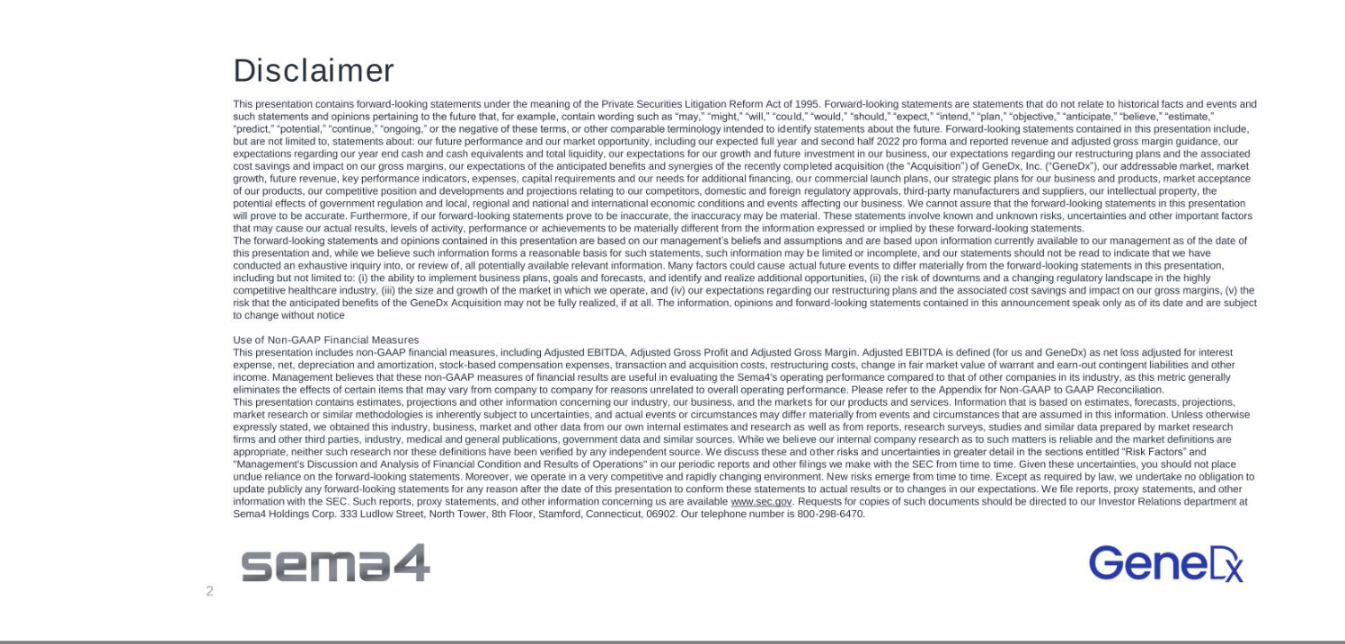







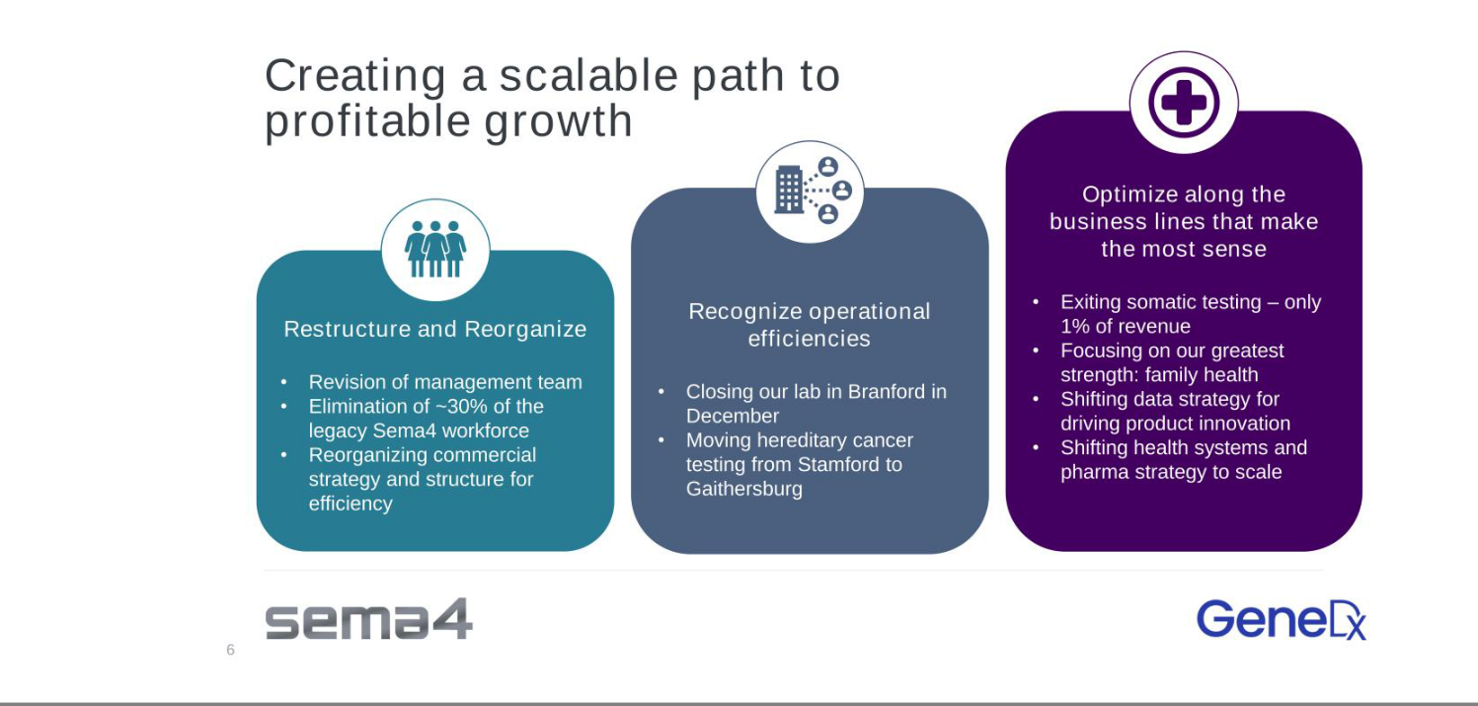

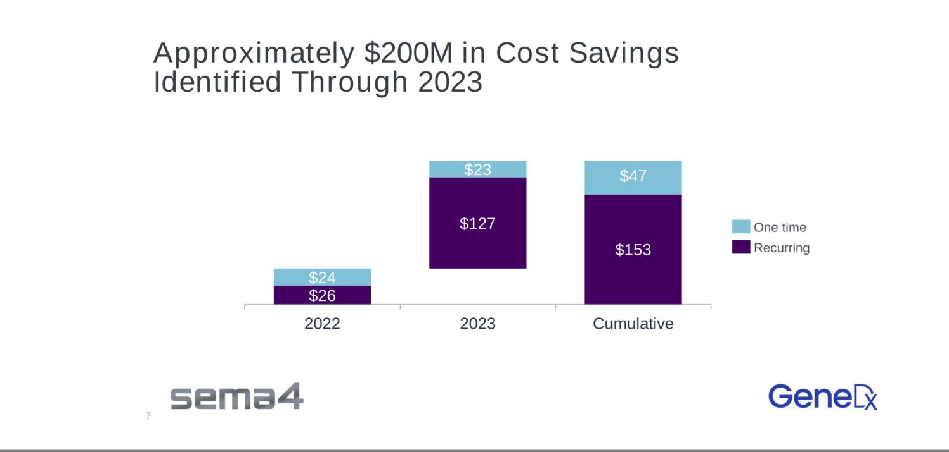

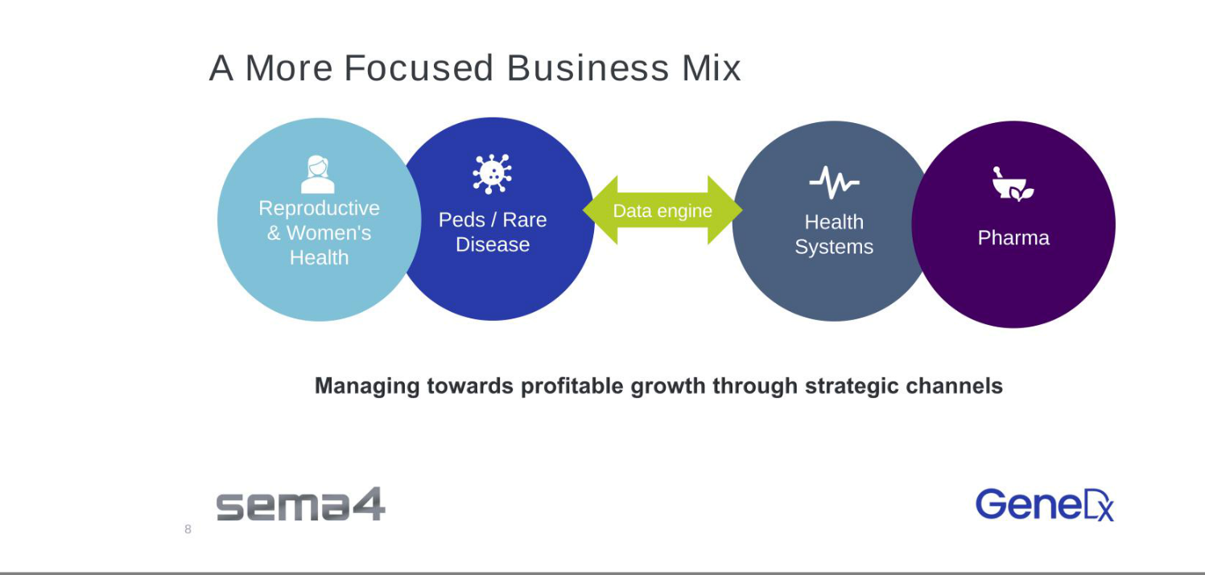



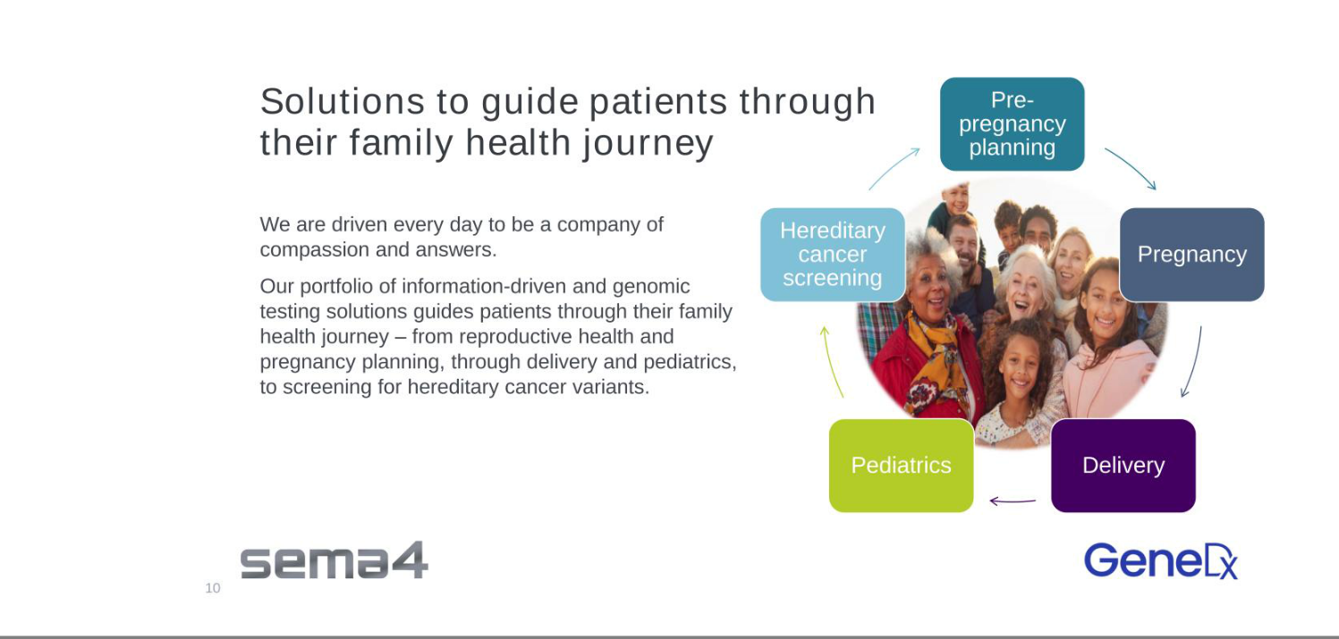

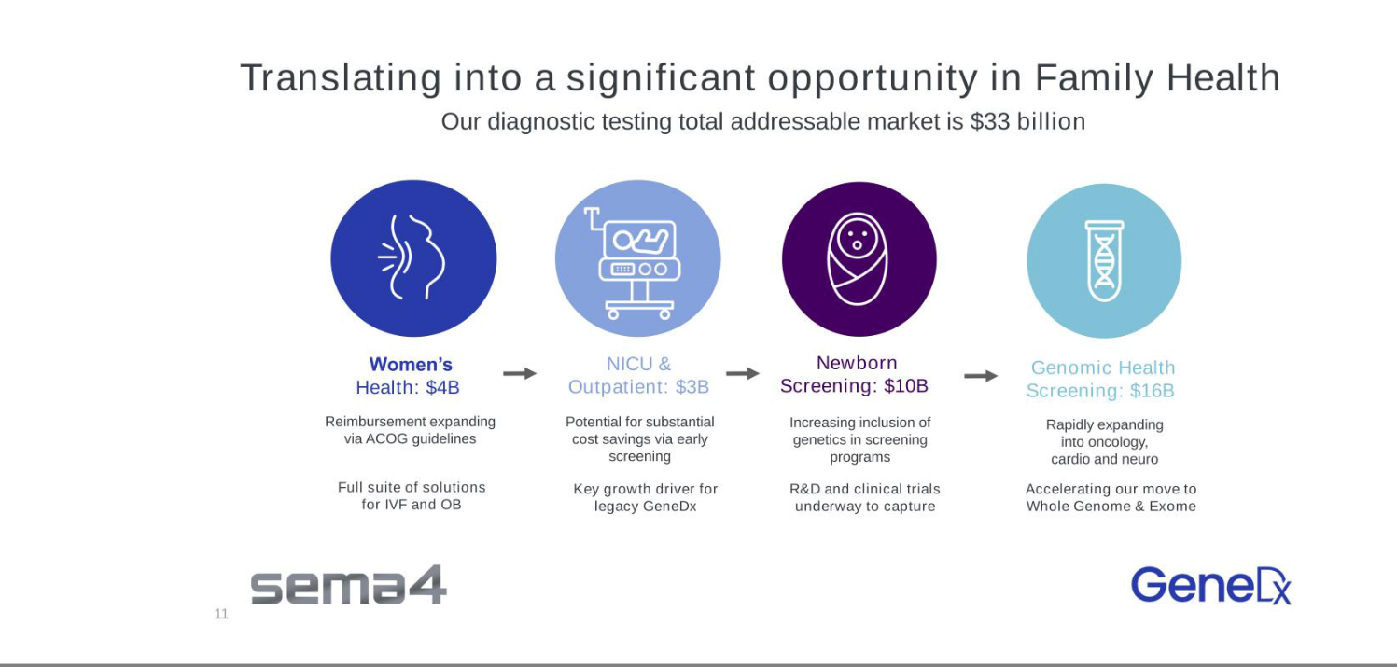

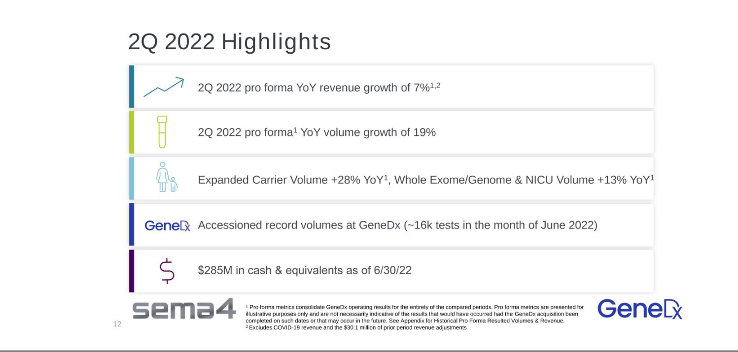

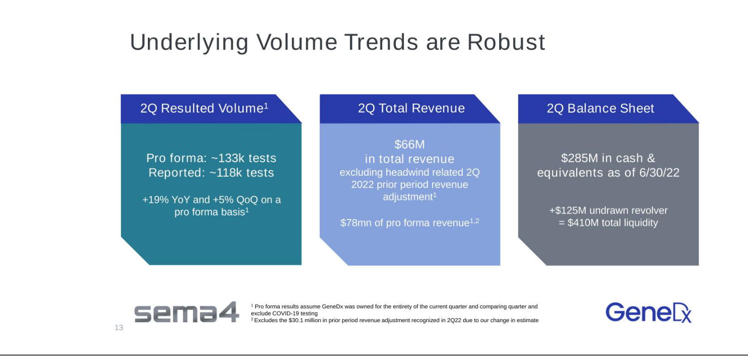

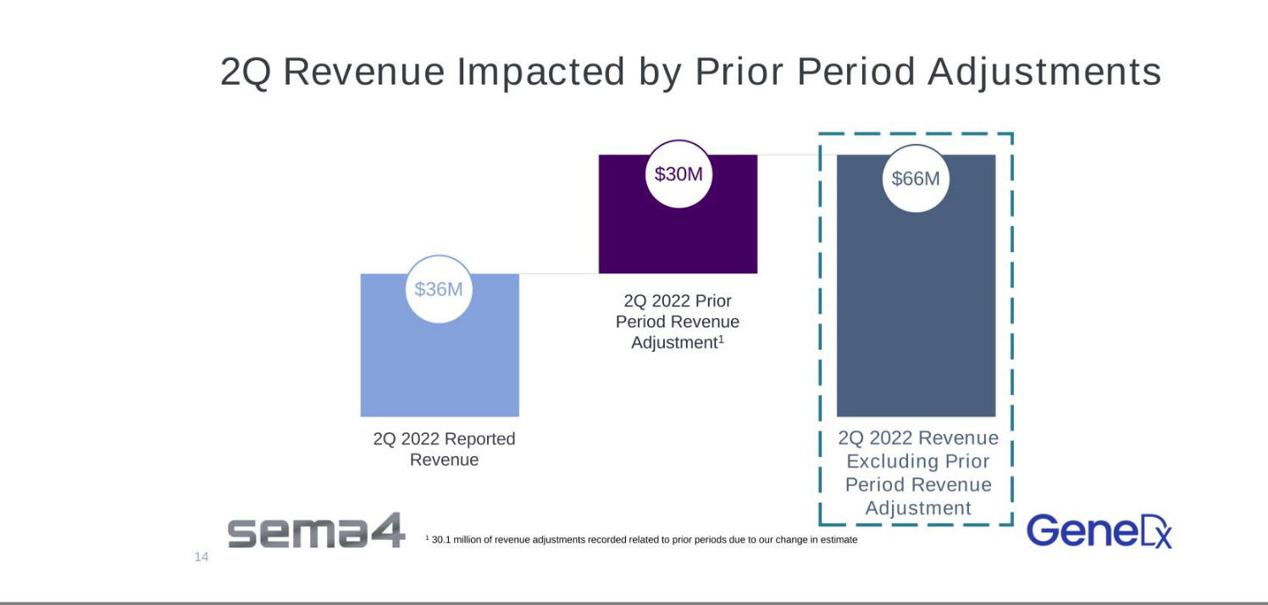

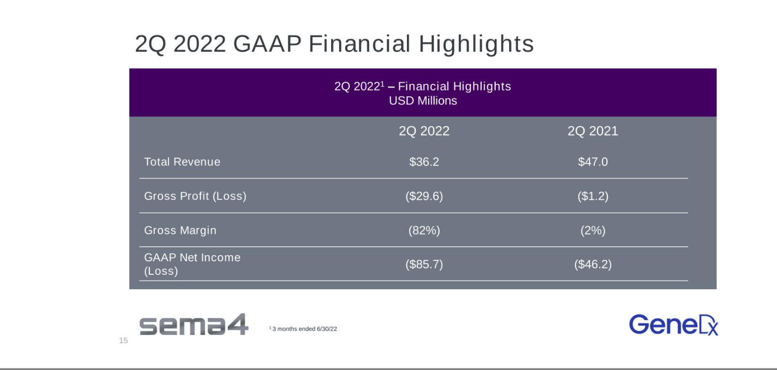

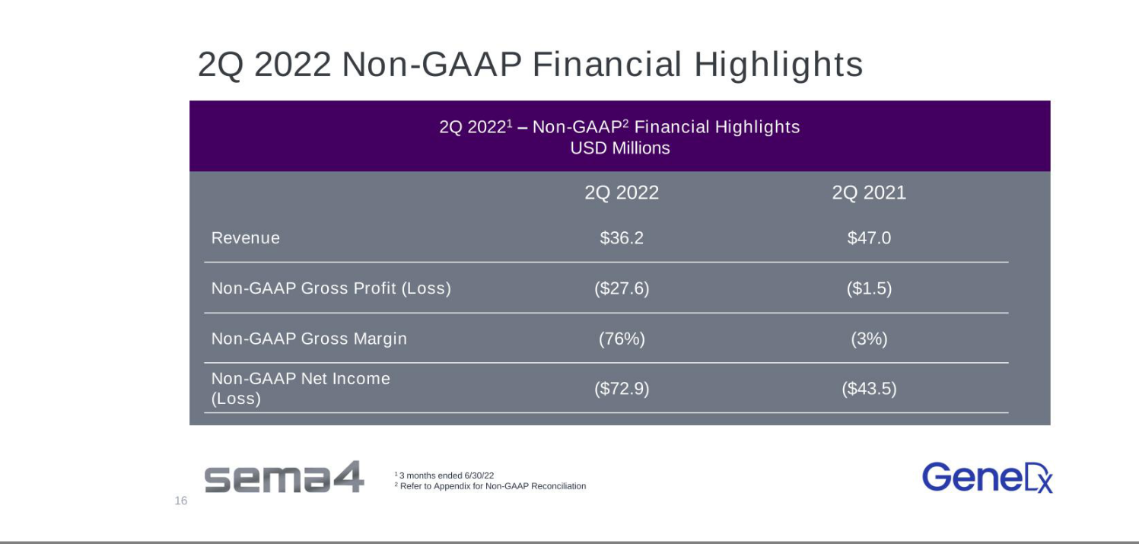

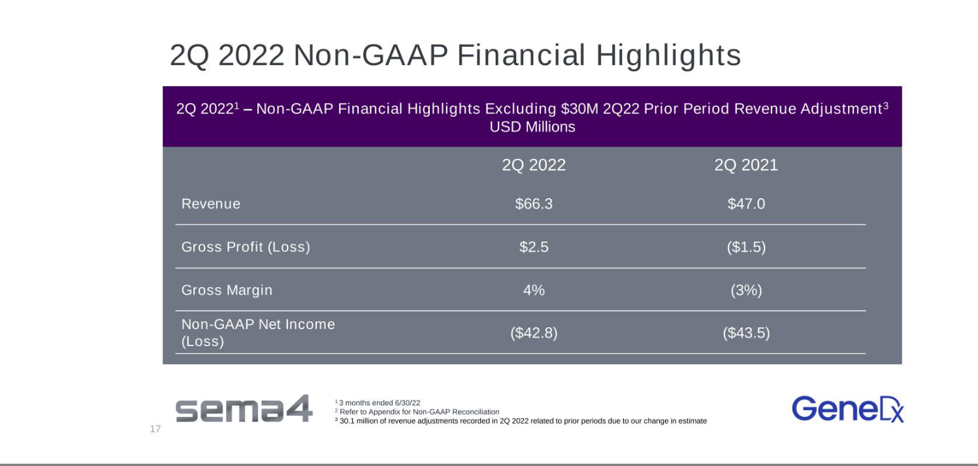

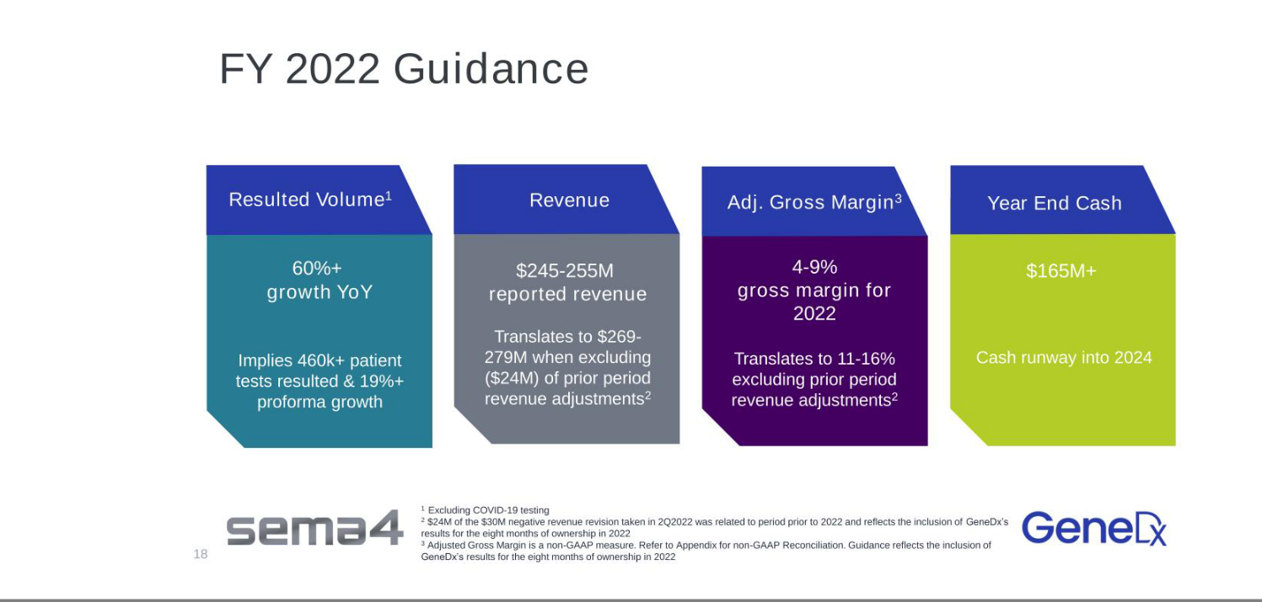

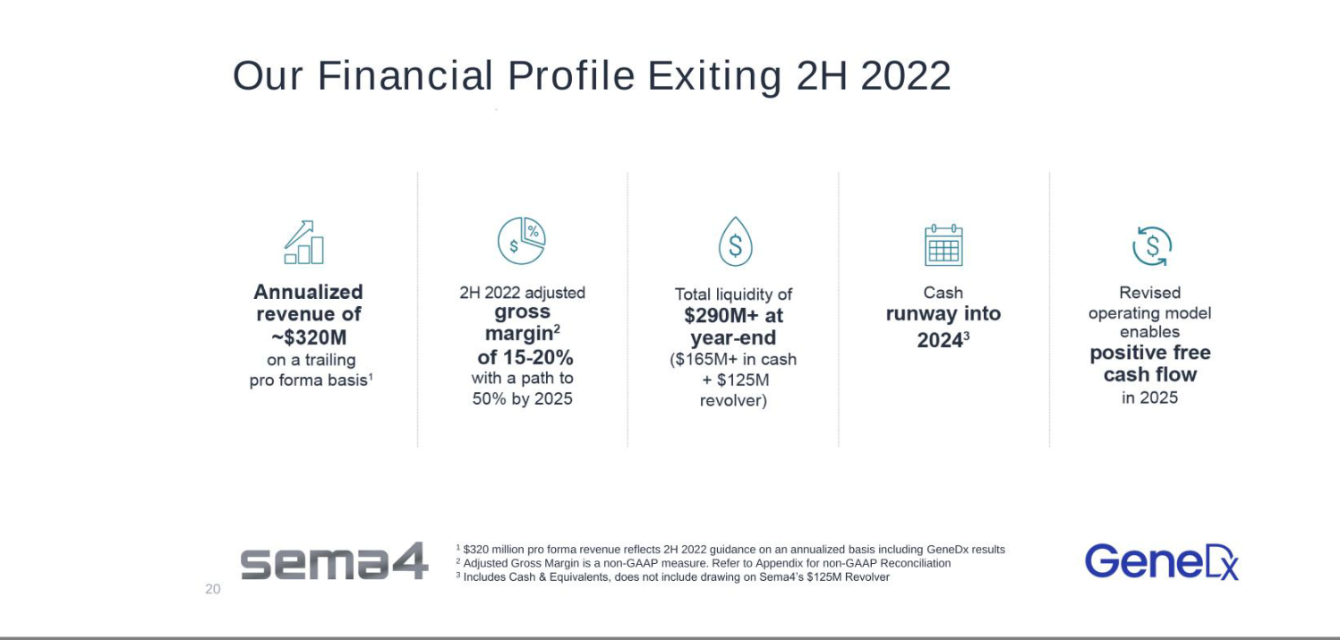

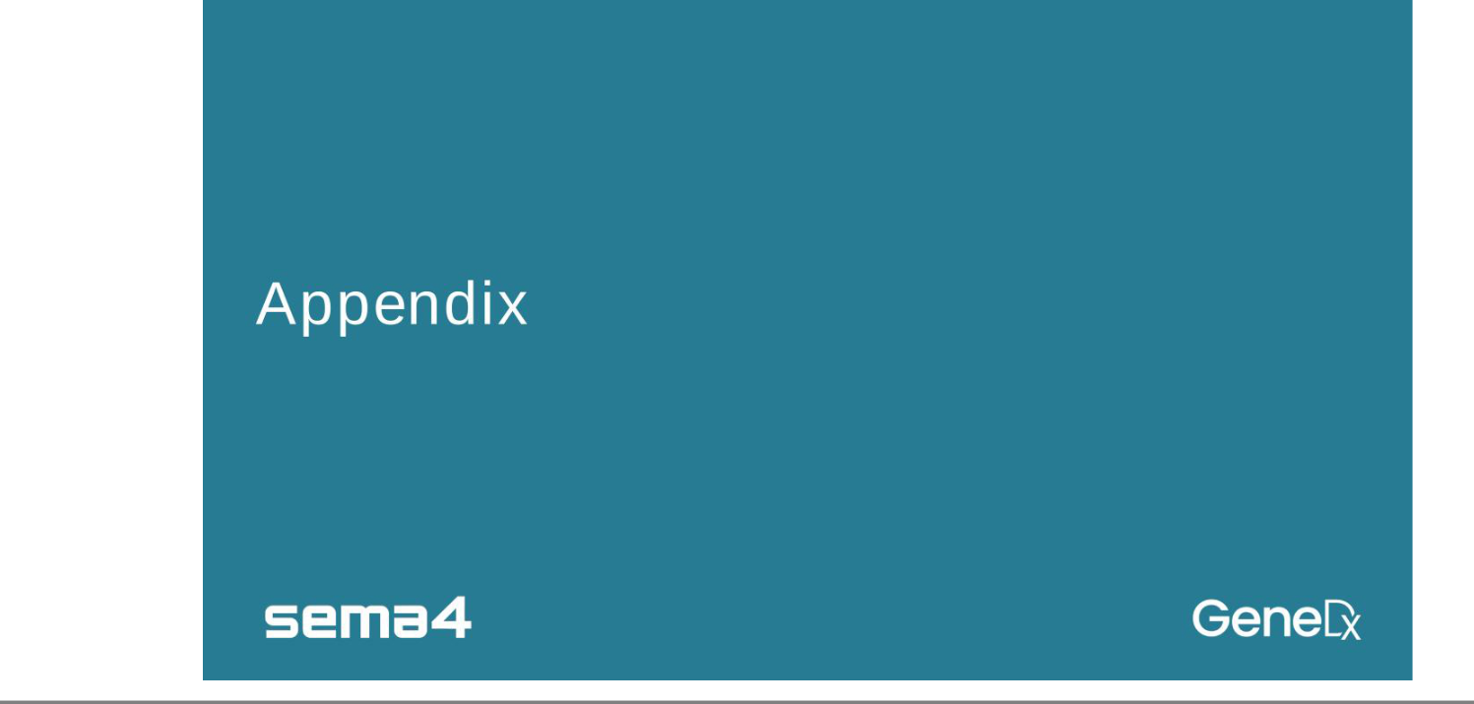

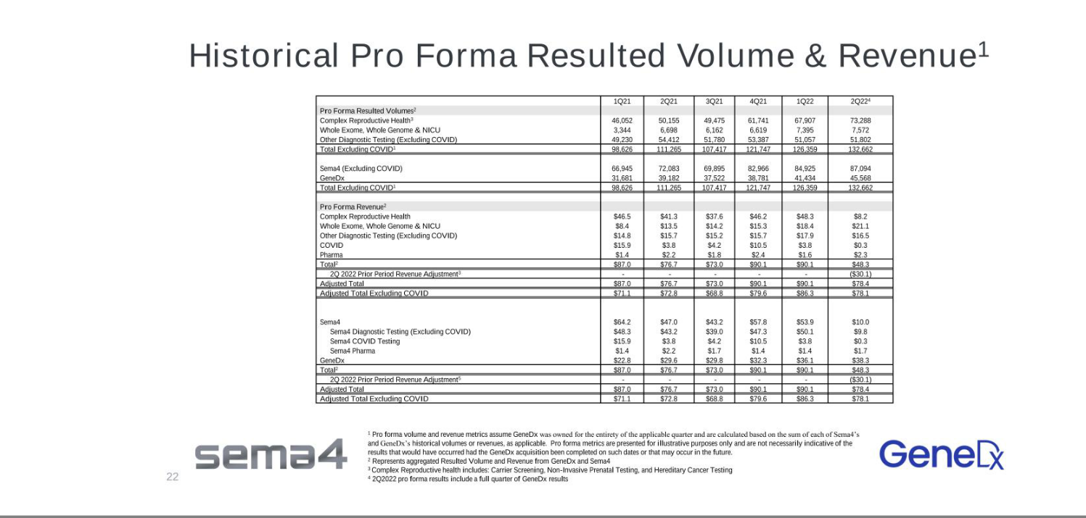

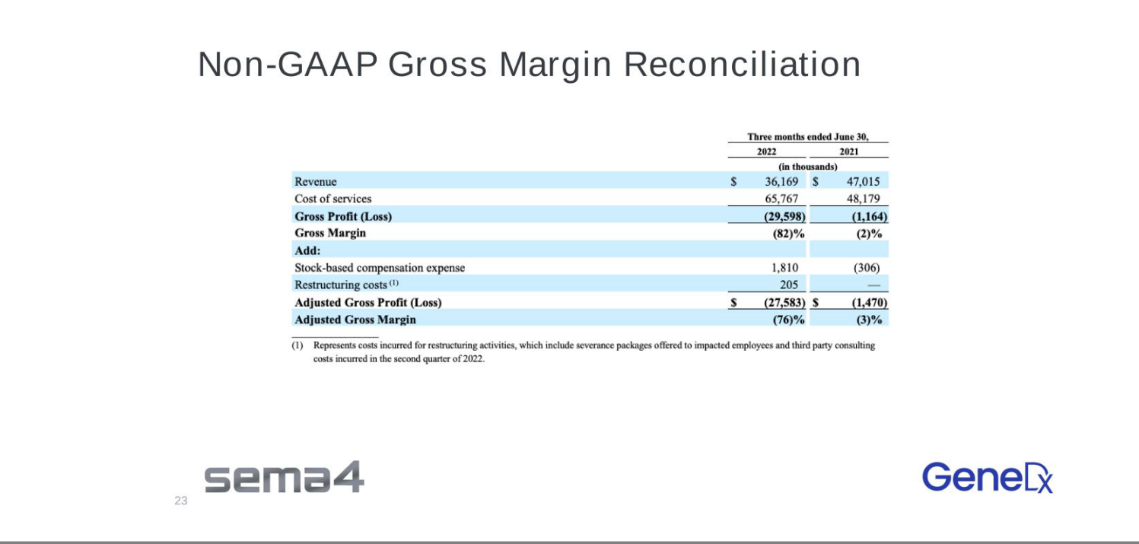

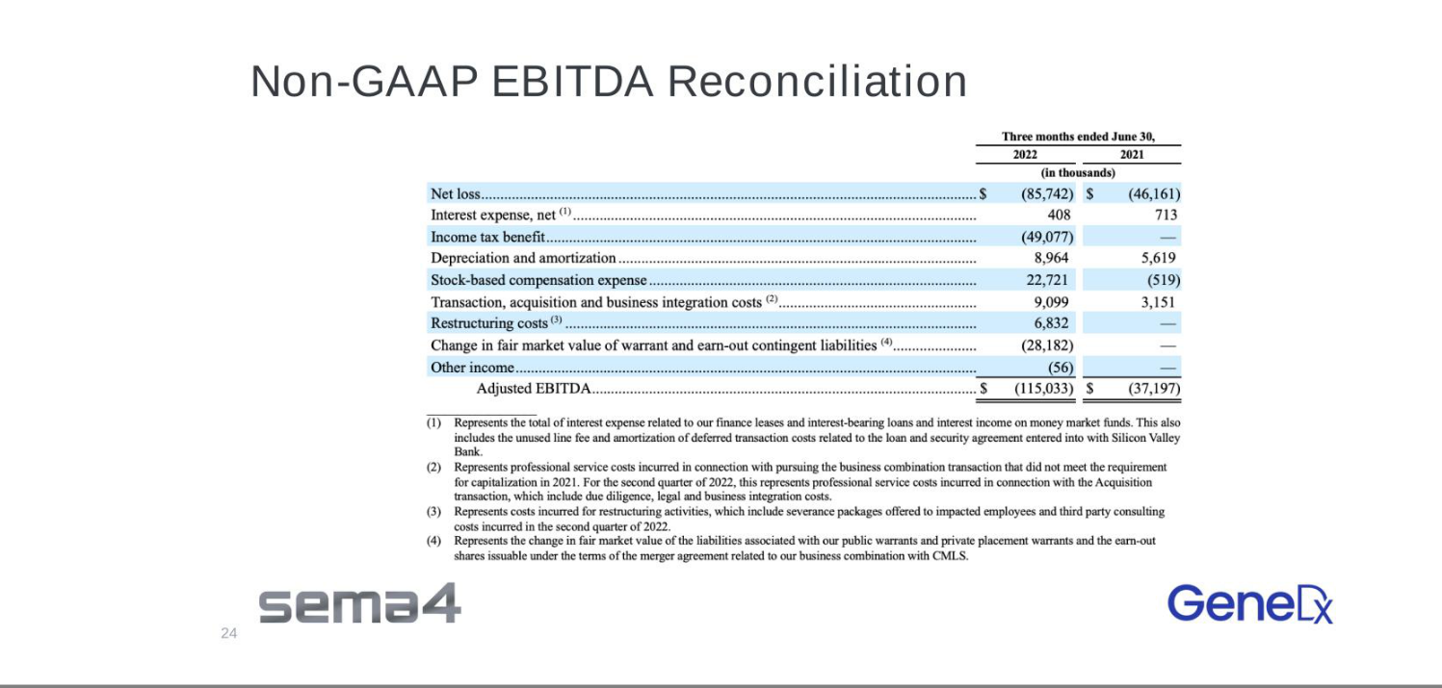

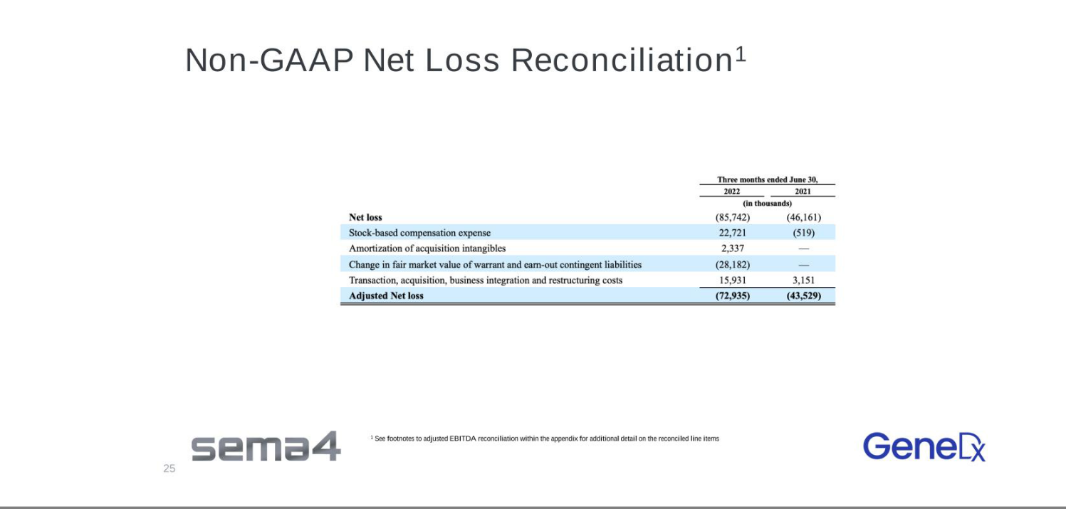

Exhibit 99.3

Sema4 Announces Changes to its Research & Development Leadership

Founder Eric Schadt steps down from the organization, including his role as President & Chief R&D Officer

Matthew Davis named Chief Technology & Product Officer to further drive the company’s mission to unlock insights from data, leading to healthier lives

STAMFORD, CT — August 15, 2022 — Sema4, a health insights company, today announced changes to its Research & Development (R&D) leadership. Founder Eric Schadt is resigning from his role as President & Chief R&D Officer, as well as his position on the Board of Directors, effective immediately. Joining the R&D organization and the company’s management team is Matthew Davis, PhD, who will serve as Chief Technology & Product Officer.

Dr. Davis brings more than 20 years of experience in enterprise product and technology development, including significant expertise in the genomics space. He will work particularly closely with Sema4 Chief Science Officer Gustavo Stolovitzky, who is responsible for research initiatives, to drive scientific and product innovation and to deliver on the company’s data and artificial intelligence (AI) strategy for health system and biopharma partners.

“Eric’s departure from Sema4 marks the start of a new chapter for the company. I would like to thank Eric for his contributions to Sema4 over the years,” said Ms. Stueland. “Eric’s vision has been instrumental in getting Sema4 to where it is today. We wish him well in all his future endeavors.”

Ms. Stueland continued: “I am delighted to welcome Matt to our leadership team, especially as we move into a new phase of commercial scale fueled by customer-centric scientific innovation. Matt has a proven track record in bringing cutting edge technology products and applications to market, which will enable us to further meet the needs of healthcare providers and patients. His leadership and acumen in harnessing innovation will play a key role in delivering critical offerings to ultimately realize a future where precision medicine is truly the standard of care.”

Dr. Davis was most recently Head of AI & Data at Invitae Corp., where he led strategy development and supported the engineering organization in the application of AI to problems in genetics, operations, and decision support tools for internal and external customers. He also led the unification of product and technology strategy following key acquisitions made by Invitae.

Previously, Dr. Davis served as a group leader at IBM Research where he oversaw the research and development of enterprise product platforms and applications to facilitate human interaction with AI systems. During his time at IBM Research, his academic research leveraged methods in AI and machine learning to solve user problems in social computing, personalization, and recommendation systems. Dr. Davis has published a significant amount of academic research on computer science and genetics.

“Sema4 has an outstanding reputation for delivering scientific excellence and data-driven health intelligence,” said Dr. Davis. “I look forward to joining this incredibly talented team to help drive our product strategy and roadmap, and to also introduce new technology processes that can further accelerate the insights we provide to patients, health systems, and pharma partners.”

About Sema4
Sema4 is a patient-centered health intelligence company dedicated to advancing healthcare through data-driven insights. Sema4 is transforming healthcare by applying AI and machine learning to multidimensional, longitudinal clinical
and genomic data to build dynamic models of human health and defining optimal, individualized health trajectories. Centrellis™, our innovative health intelligence platform, is enabling us to generate a more complete understanding of disease and wellness and to provide science-driven solutions to the most pressing medical needs. Sema4 believes that patients should be treated as partners, and that data should be shared for the benefit of all.

For more information, please visit sema4.com and connect with Sema4 on Twitter, LinkedIn, Facebook and YouTube.

Investor Relations Contact:
Joel Kaufman
investors@sema4.com

Media Contact:
Radley Moss
radley.moss@sema4.com

